

Amplifier and Filter

Electronics Projects: Cable-Monitor and Radar-Sensor

# Abstract

Weak sensor signals must be amplified to fully drive an ADC input. An anti-aliasing filter is often required to prevent signal distortion by sampling. The single supply voltage already used for the microcontroller should also be used for the amplifiers and filters. This document explains some possibilities and circuits that are useful with weak high impedance input signals, which will be further processed by a microcontroller. For ease of use, two filter design tools are proposed.

Table of Content

Abstract 1

1. Anti-Aliasing-Filter 2

2. RC Lowpass and Highpass Filter with gain 3

3. Sallen-Key Lowpass Filter without gain 3

4. Multiple-Feedback Lowpass Filter with gain 4

5. Multiple-Feedback Bandpass Filter with gain 4

6. High-Impedance, High-Gain and Low-Noise 5

7. Single-Supply and Virtual-GND 6

8. Filter Design Tools 7

(c) Hanspeter Hochreutener, [hhrt@zhaw.ch](mailto:hhrt@zhaw.ch), 19.07.2023

# Anti-Aliasing-Filter

The Nyquist theorem says that the sampling frequency fs must be at least double the highest frequency component present in the signal.

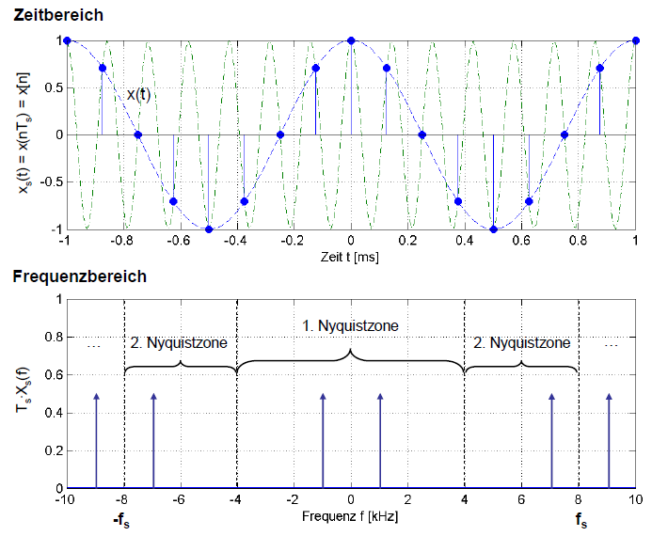

Figure 1: Aliasing: With a sampling frequency of 8kHz a 1kHz sine wave and a 7kHz sine wave have identical samples and cannot be distinguished in the digital domain.

As shown in the above figure, a violation of the Nyquist theorem yields to ambiguity and the signals cannot be distinguished in the digital domain.

To prevent aliasing all the components with a frequency above fs/2 must be removed before sampling. Such a lowpass filter is called anti-aliasing filter.

In practice, the cutoff frequency of the anti-aliasing filter must be chosen 3 to 10 times lower than the sampling frequency because the filters have a transition band where the signal is not enough attenuated.

Increasing the filter order by placing several filters in series, narrows the transition band and allows the sampling frequency to be reduced, which in turn reduces the computing load for the microcontroller.

# RC Lowpass and Highpass Filter with gain

By adding just a few capacitors to a non-inverting operational amplifier, it is possible to get simple lowpass and highpass filters at nearly no cost.

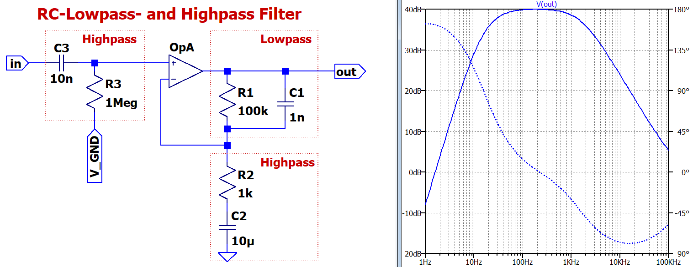

Figure 2: RC filters added to a non-inverting amplifier with 40dB gain. C1 & R1 = lowpass, C2 & R2 = highpass (DC-decoupling for virtual-GND), C3 & R3 = highpass (input DC-decoupling).

gain ≈ 1+R1/R2  
cutoff-frequencies fgx ≈ 1/(2π∙Rx∙Cx)  
input-impedance ≈ R3

First order RC filters, unfortunately, have a broad transition region. Second (or higher) order active filters have a steeper transition region, and a lower sampling frequency can be chosen.

Often used second order filters are Sallen-Key and multiple-feedback filters, because they only need one operational amplifier.

# Sallen-Key Lowpass Filter without gain

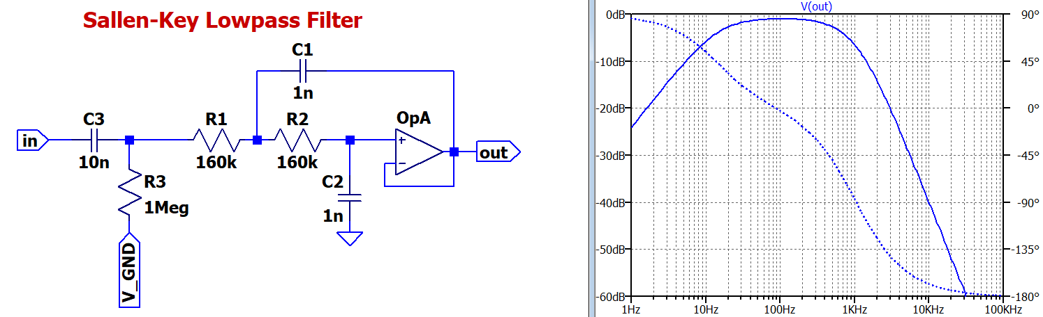Figure 3: Sallen-Key lowpass filter with small transition region and 0dB gain.

gain = 1 = 0dB  
input-impedance ≈ R3 => which is generally quite high  
DC-decoupling-cutoff-frequency ≈ 1/(2π∙R3∙C3)  
Filter design tool: <http://sim.okawa-denshi.jp/en/OPseikiLowkeisan.htm>

The disadvantage of this circuit is that the signal is not amplified. However, by choosing different component values it would be possible to reach a higher gain.

But, because of the positive feedback topology, Sallen-Key filters are very sensitive to component tolerances. Quite expensive high precision capacitors and resistors would be needed. Therefore, Sallen-Key filters generally are not used for high gain applications.

# Multiple-Feedback Lowpass Filter with gain

The multiple-feedback filters have only negative feedback paths and are thus less affected than Sallen-Key filters by component tolerances. This is especially true for high gain.

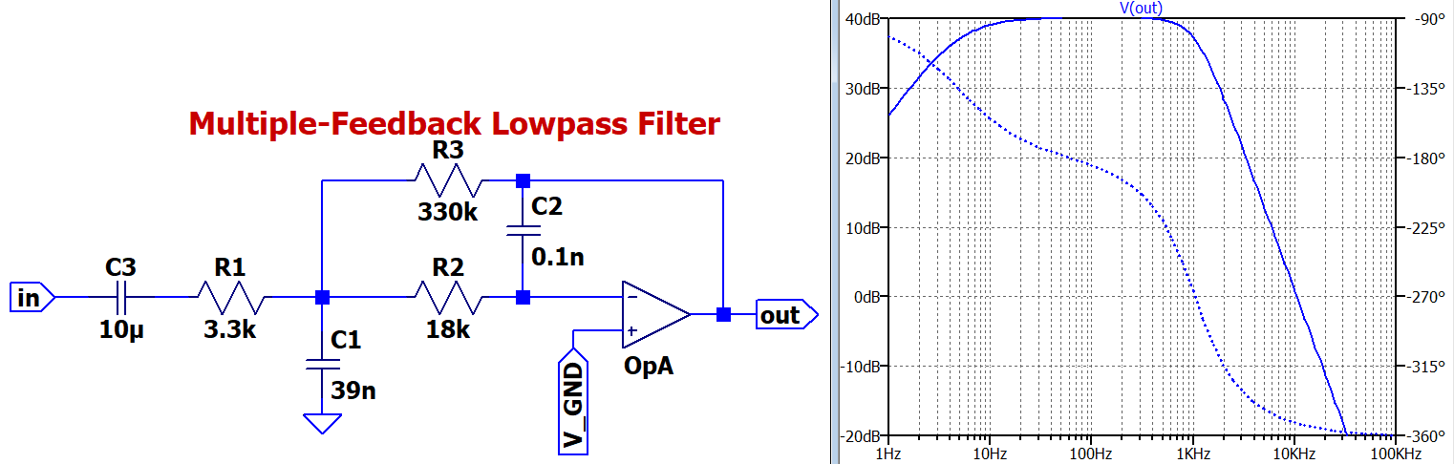Figure 4: Multiple feedback lowpass filter with small transition region and 40dB gain

gain ≈ -R3/R1  
input-impedance ≈ R2 => which is generally quite low  
DC-decoupling-cutoff-frequency ≈ 1/(2π∙R1∙C3)  
Filter design tool: <http://sim.okawa-denshi.jp/en/OPtazyuLowkeisan.htm>   
(multiple feedback filters are inverting => gain is a negative number)

# Multiple-Feedback Bandpass Filter with gain

For bandpass filtering multiple-feedback filters are preferred over Sallen-Key filters.

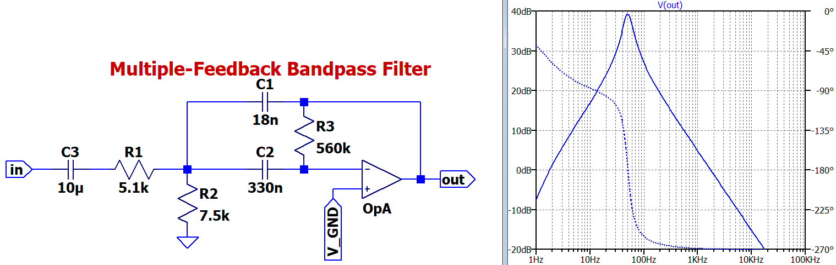Figure 4: Multiple feedback bandpass filter with 40dB gain.

gain ≈ -R3/R1  
input-impedance ≈ R1 => which is generally quite low  
DC-decoupling-cutoff-frequency = 1/(2π∙R1∙C3)  
Filter design tool: <http://sim.okawa-denshi.jp/en/OPtazyuBakeisan.htm>   
(multiple feedback filters are inverting => gain is a negative number)

# High-Impedance, High-Gain and Low-Noise

In both project modules, Cable-Monitor and Radar-Sensor, noise-sensitive signals in the mV-range from high-impedance sources must be amplified by 40dB to 60dB to fully drive the ADC at the microcontroller input.

Sallen-Key filters have a high input impedance but should not be used with substantial gain.

Multiple-feedback filters can provide gain and filtering at the same time but have a relatively low input impedance.

Thus, a non-inverting operational amplifier circuit (with filtering) is needed as input stage.

These solutions can handle all the issues mentioned in the title of the section:

* RC lowpass and highpass filter  
  Advantage: Simple circuit with only one operational amplifier.  
  Disadvantage: Poor filtering requires a higher sampling frequency and probably a more sophisticated digital signal processing.
* RC lowpass and highpass filter followed by Sallen-Key lowpass filter  
  Advantage: Good filtering requires much lower sampling frequency.  
  Disadvantages: First operational amplifier must provide all the gain. Circuit needs two operational amplifiers.
* RC lowpass and highpass filter followed by multiple-feedback low/bandpass filter  
  Advantages: Good filtering requires much lower sampling frequency. Gain can be evenly distributed between both operational amplifiers.  
  Disadvantages: Circuit needs two operational amplifiers. Signal is inverted (can be fixed by a minus sign in the software).

Furthermore, some PCB layout design rules must be observed because the weak input signals are susceptible to pick up noise or alien signals. The following measures are useful:

* Route sensitive inputs far away from output signals, digital wires and power supplies.
* Keep the wires with sensitive signals short.
* Filter the power supply voltage and the virtual-GND.
* Limit the bandwidth of the amplifier by filtering out signal components of no interest.
* Be aware that filtering with big capacitors implies a longer settling time at power up.

# Single-Supply and Virtual-GND

Classical operational amplifier circuits use symmetric plus and minus dual supplies. The signals as well as the feedback circuits (which define gain and frequency response) are referred to GND.

In battery operated devices or in combination with a microcontroller, one single supply of +3V is preferred for complexity and cost reasons.

The ADC input voltage range is often from 0V (GND) to 3V (or 2.5V). The input signals of a few mV must be amplified and a DC-offset of 1.5V (respectively 1.25V) added.

In applications (such as the Cable-Monitor and the Radar-Sensor) where the signal portion of interest is an alternating voltage (and the DC voltage is irrelevant) it is simple to modify the circuits for single-supply. In between GND and +3V a stable virtual-GND is inserted. From the operational amplifier point of view the virtual-GND is the zero reference, the GND is the minus supply and the +3V is the plus supply.

All the circuits shown above have already been modified with DC-decoupling capacitors (which act also as highpass filters) and with virtual-GND offset.

The simplest way to provide a virtual-GND is a resistive voltage divider. The virtual-GND is bypassed to GND by one or more capacitors to eliminate noise from the supply.

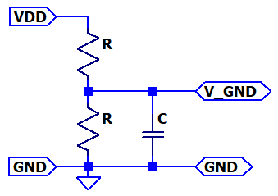 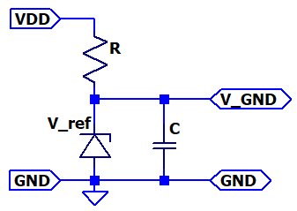

Figure 5: Simple virtual-GND circuits, suitable for high-ohmic loads.

These circuits work fine, if all the resistors and components connected to the virtual-GND have a very much higher impedance compared to the voltage divider resistance. Otherwise, a crosstalk from the output to virtual-GND occurs and could distort the signal or even lead to instability of the circuit. Furthermore, the DC current drawn from components connected to the virtual-GND must be significantly lower than the bias DC current of these circuits.

The capacitors must be big enough to filter even the lowest frequency components present in the signal and must maintain low impedance at higher frequencies, particularly to filter narrow spikes from digital clocks.

The resistor connected to GND could be replaced by a bandgap voltage reference of 1.25V or 2.5V.

The voltage divider could be fed by the ADC reference voltage if this is available.

# Filter Design Tools

Filter design tools can be found on the internet. Each tool has its strengths and its limitations. Two tools are proposed and presented.

[**http://sim.okawa-denshi.jp/en/Fkeisan.htm**](http://sim.okawa-denshi.jp/en/Fkeisan.htm)

is a good tool for filters up to order three:  
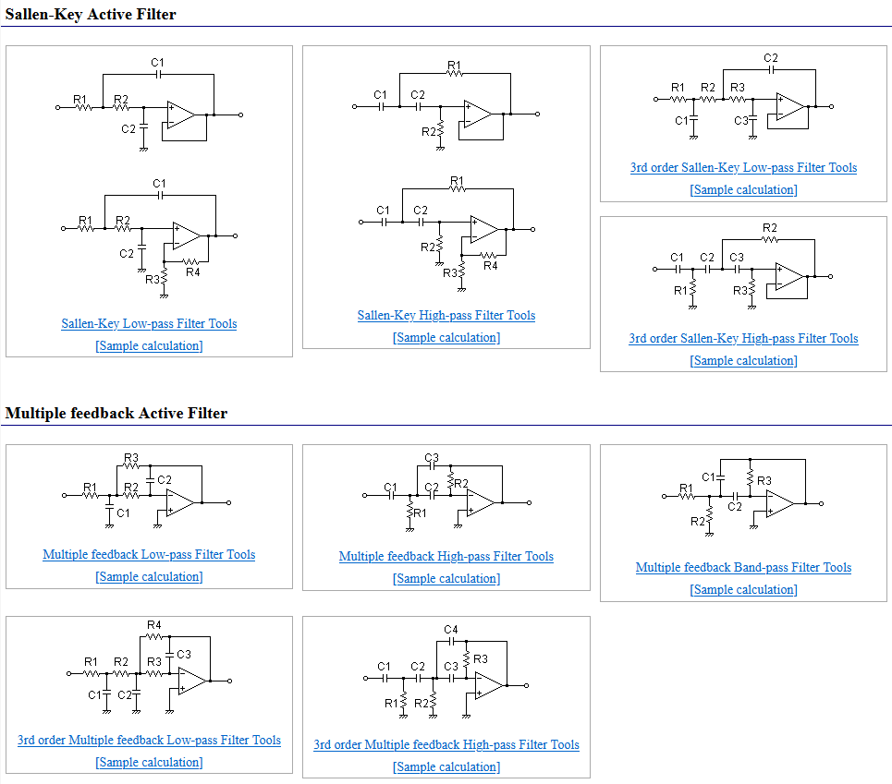

This tool can calculate the transfer function for given values:  
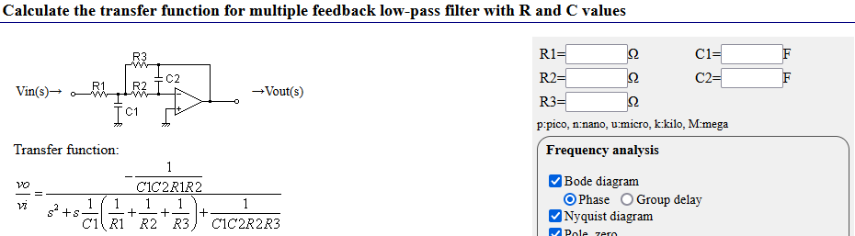

And it can calculate the components for given parameters:  
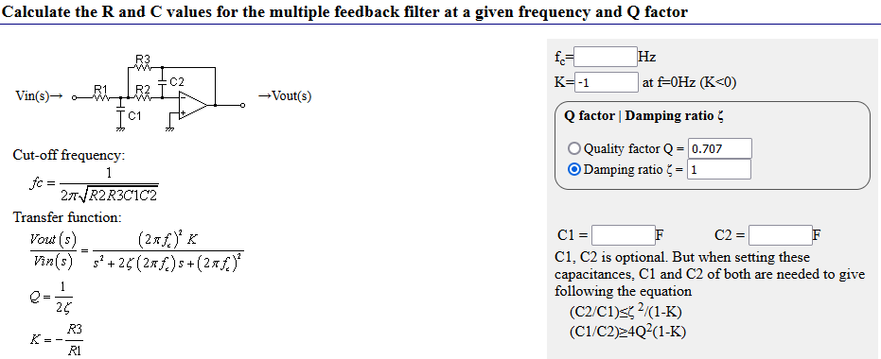

[**https://tools.analog.com/en/filterwizard/**](https://tools.analog.com/en/filterwizard/)

This tool calculates the required filter order for given specifications:  
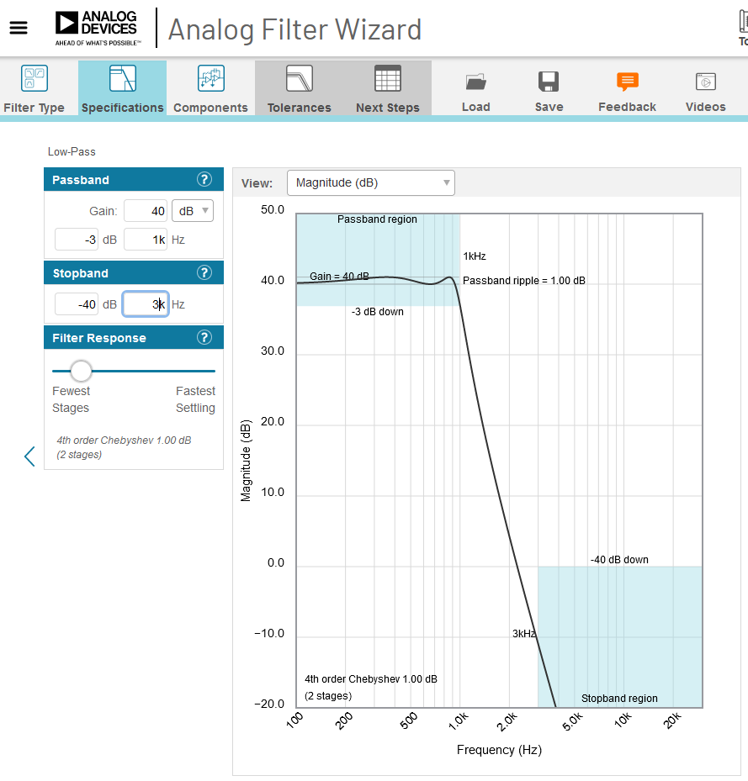

It outputs the number of stages and the respective parameters:  
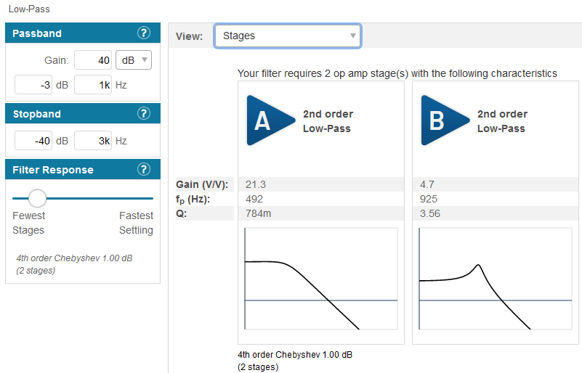

Circuits with component values are suggested:  
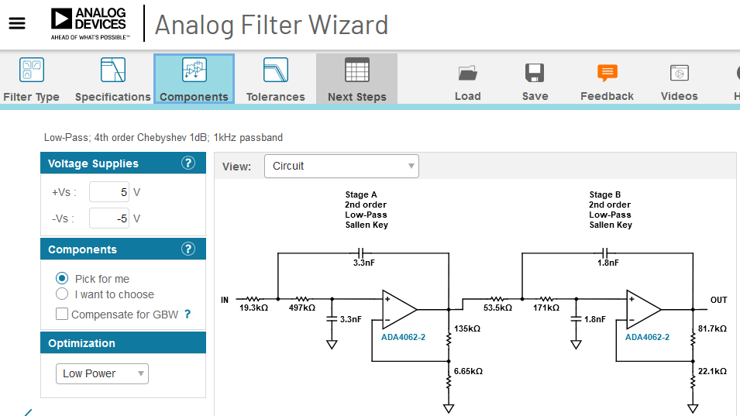

If some gain is required, it is often better to select “Components => I want to choose”:  
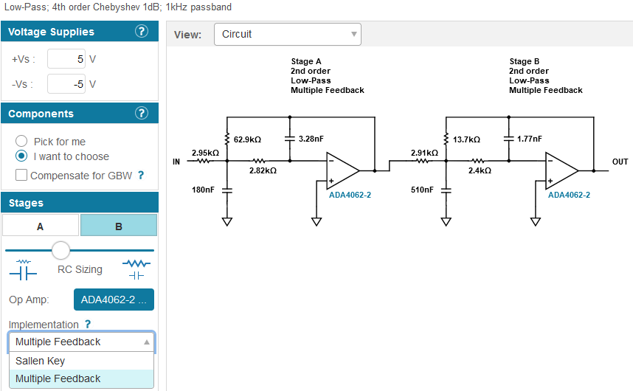  
and change to “Multiple Feedback” for each stage.  
With “RC Sizing” the values of resistors and capacitors can be adjusted.

The tolerances tab shows how good the real filter with component tolerances will perform:

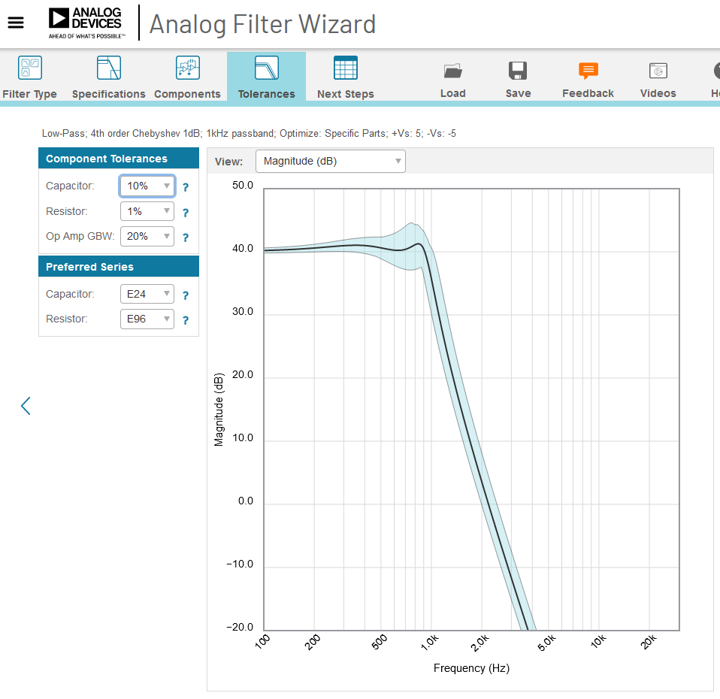

Caution:

The tool always suggests using Sallen-Key filters. However, if the gain is not 0dB, multiple feedback filters have a better performance. This can be selected manually.