

Detecting 50Hz Signals

Electronics Project 1: Cable-Monitor

# Abstract

The Cable-Monitor estimates the distance to a cable or wire by measuring the induced signal strength of the 50Hz mains grid. The sensor not only picks up the 50Hz component, but also noise and electro-magnetic fields from other devices. Once the received signal has been amplified, filtered and converted to an array of numbers by the analog-to-digital-converter, the signal strength must be determined. As the signal is weak and might be noisy, calculating the peak-to-peak value is only a rough estimation. Some sort of bandpass filtering should be considered to remove noise and signals from other sources. This document discusses estimation of the signal strength based on the raw signal, as well as bandpass filtering in the time and in the frequency domain. Whereas filtering in the time domain is descriptive, filtering in the frequency domain is much more direct and efficient.

Table of Content

Abstract 1

1. Introduction 2

2. Calculate the Strength of the Raw Signal 2

2.1. Peak-to-Peak Value 2

2.2. Peak-To Peak Value, Average over some periods 2

2.3. Root-Mean-Square of AC portion 3

3. Noisy Signal 3

3.1. Filtering in the Time Domain 4

3.2. Signal Strength in the Frequency Domain 4

3.3. Digital Signal Processing (DSP) Libraries 5

(c) Hanspeter Hochreutener, [hhrt@zhaw.ch](mailto:hhrt@zhaw.ch), 03.08.2021

# Introduction

The picked-up electric or magnetic field strengths are a function of the distance. To estimate distance, angle and current of the cable, the signal strength must be calculated from the measured signal. If the signal to noise ratio (SNR) is good, this is possible without further filtering and could be used as a first approach. A good signal to noise ratio means that the desired 50Hz component radiated by the mains cable is stronger than the noise picked up by the sensors and the amplifier noise. Some methods are introduced in section 2 Calculate the Strength of the Raw Signal.

If, however, the signal is noisy these methods are a function of the noise and not of the looked-for 50Hz component. The SNR deteriorates at farer distances and in the vicinity of switching power supplies and the like. It might be necessary to filter out the desired 50Hz component before calculating the signal strength. Some common methods for filtering can be found in section 3 Noisy Signal.

# Calculate the Strength of the Raw Signal

## Peak-to-Peak Value

The peak-to-peak value is easy to calculate. In a for-loop search maximum and minimum over all samples. PP = Max - Min

## Peak-To Peak Value, Average over some periods

The disadvantage the above method is that a single peak in noise can increase the value and affect the estimation of the 50Hz component.

A standard solution to reduce noise is averaging. For sinusoidal signals, an averaged peak-to-peak estimation can be found with the following easy to implement formula (PPA = peak-to-peak average):

$$PPA=\frac{1}{2}⋅\frac{\sum{\left|x_{n}-x_{n-1}\right|}}{ number_of_periods}$$

The absolute values of the difference from one sample to the next are summed up. The sum is then divided by the number of enclosed signal periods. The averaging reduces the noise by a factor of $\sqrt{number_of_periods}$.

**Note:**To get this average right, sampling must be done over a whole number of signal periods. E.g., sampling over 100ms spans exactly 5 periods of 50Hz.

## Root-Mean-Square of AC portion

Further reduction of the noise is possible by calculating the root-mean-square (RMS) value, because this comprises averaging over all samples and not only over a few peak-to-peak values.

The DC-offset must first be removed to get the RMS value of the AC portion only. $$avg= \frac{\sum{x_{n}}}{N} {rms}^{2}= \frac{\sum{{\left(x_{n}-avg\right)}^{2}}}{N}$$

**Note:**To get the root-mean-square value right, sampling has to be done over a whole number of signal periods. E.g. sampling over 100ms spans exactly 5 periods of 50Hz.

**Note:**Even heavy averaging cannot achieve error-free results. Nevertheless, averaging or calculating the rms value reduces the unwanted effect of noise, e.g., a single spike, on the calculation of the signal strength.

# Noisy Signal

In the Cable-Monitor device sensors pick up the electric and magnetic fields of a mains cable or wire. As the fields are weak and other electronics devices may be running in the vicinity the sensor signals might be quite noisy. Knowing that the signal of interest has a frequency of exactly 50Hz a bandpass filter can be used to remove most of the unwanted noise.

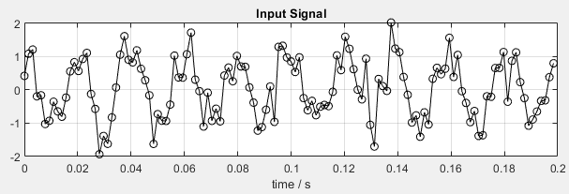

Figure 1: Noisy 50Hz signal. It is impossible to recognise a 50Hz periodicity in this signal

The bandpass filter can be realised by an analog circuit or by an algorithm in the microcontroller. The common approach is to add some capacitors and resistors in the mandatory analog preamplifier for a rough filtering at little cost. After analog-to-digital-conversion the signal can be filtered further in the digital domain. Very selective filters can be realised here, because increasing the filter order is just a matter of processing power and comes at no cost for additional hardware. Digital filtering can be done in several ways, which are discussed in the next sections.

## Filtering in the Time Domain

Instead of an analog bandpass filter a digital bandpass filter is used. It can be implemented as finite impulse response (FIR) or as infinite impulse response (IIR) filter. With a correct filter design similar results as with an analog filter can be achieved.

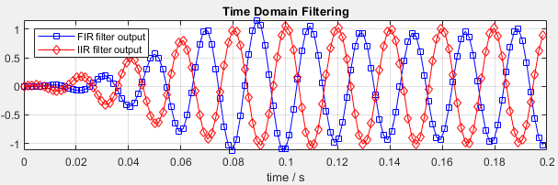

Figure 2: Digital bandpass filtering removes noise and the 50Hz signal is clearly visible

Filtering in the time domain yields directly an output signal with little delay, similar to an analog filter. This signal shows very clearly the efficiency of the noise reduction. As the signal energy is the key value in the Cable-Monitor application, it is necessary to calculate the energy over a block of samples in a second step.

The different properties of FIR and IIR filters are not relevant here as only the signal strength is of interest and processor load is not a limiting factor for the low frequencies involved.

See the Matlab-script **Bandpass_Filtering.m** for the simulations, including the calculation of the filter-coefficients.

## Signal Strength in the Frequency Domain

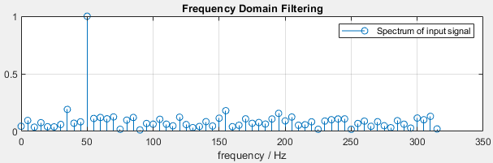

Figure 3: The input signal in the frequency domain shows a maximum at the expected 50Hz

The Fast-Fourier-Transform (FFT) directly computes the frequency spectrum of a block of input samples. The absolute value of the output line corresponding to 50Hz yields directly the sought-after signal strength. The other frequencies are of no interest here, as they represent just the noise.

As the FFT can be understood as a bandpass filter followed by RMS calculation, the FFT has a huge computational advantage over the indirect route via sample-by-sample filtering with an FIR or IIR filter followed by the calculation of the root-mean-square value of a block.

**Note:**To get an optimal result from the FFT, sampling has to be done over a whole number of signal periods (prevent the so called leakage effect). E.g. sampling over 100ms spans exactly 5 periods of 50Hz.

**Note:**  
The FFT needs block sizes of a power of 2. E.g. N = 64 samples. Combined with N∙Ts = 100ms defines the sampling frequency fs = 64/100ms = 640Hz

## Digital Signal Processing (DSP) Libraries

The DSP library for the microcontroller has these highly optimized functions for filtering:

* FIR filter: **arm_fir_init_f32()** and **arm_fir_f32()**
* IIR: **arm_biquad_cascade_df2T_init_f32()** and **arm_biquad_cascade_df2T_f32()**
* Real FFT spectrum calculation: **arm_rfft_fast_init_f32()** and **arm_rfft_fast_f32()**Supported FFT lengths are 32, 64, 128, 256, 512, 1024, 2048, 4096.

The documentation of the DSP library is in the file **index.html** in the folder **Drivers/CMSIS/docs/DSP/html**