

Sensing Electric and Magnetic Fields

Electronics Project 1: Cable-Monitor

# Abstract

Every wire with an electrical potential against its surroundings has an electric field. Associated with this field is a capacitance. The strength of the field and the value of the capacitance decrease with distance. For a given voltage at a known frequency the distance can be determined from the measured electric field. The neutral and the protecting earth conductors shield some of the electric field. Furthermore, the shielding is direction dependent. A good estimation of the distance is still possible if more than one sensor is used.

Whenever an electric current flows, a magnetic field is present. This field is proportional to the current. Again, the strength of the field decreases with distance. For a phase conductor the distance is known from the measurement of the electric field and the current can be calculated from the measured magnetic field. However, the neutral conductor has no electrical potential, hence no electric field and it is impossible to calculate the distance and thus the current. In a cable with phase and neutral, both wires generate a magnetic field. As they have different polarity, the fields nearly cancel out. Only in the ultimate vicinity, a resulting field remains, and it should be possible to estimate the current.

(c) Hanspeter Hochreutener, [hhrt@zhaw.ch](mailto:hhrt@zhaw.ch), 04.04.2020

Table of Content

Abstract 1

1. Electric Field 3

1.1. Electric Field of the Phase Conductor 4

1.2. Electric Field of the Neutral Conductor 4

1.3. Field of a Cable with Phase and Neutral 4

1.4. Field of Cable with Phase, Neutral and Protecting Earth 4

1.5. Distance and Direction of the Cable 4

1.6. Sensor Model 5

1.7. Calculate the Distance 6

1.8. Estimate the Direction 6

2. Magnetic Field 7

2.1. Magnetic Field of One Wire 7

2.2. Magnetic Field of Two Wires in a Cable 8

2.3. Hall Sensor 9

2.4. Pickup Coil as a Sensor 9

2.5. Current flowing through One Wire 9

2.6. Current flowing through Two Wires 10

2.7. Calculate the Current 10

3. Checklist 11

4. Conclusion 11

# Electric Field

For simple geometries, the electric field and its associated capacitance can be calculated. See <https://en.wikipedia.org/wiki/Capacitance>

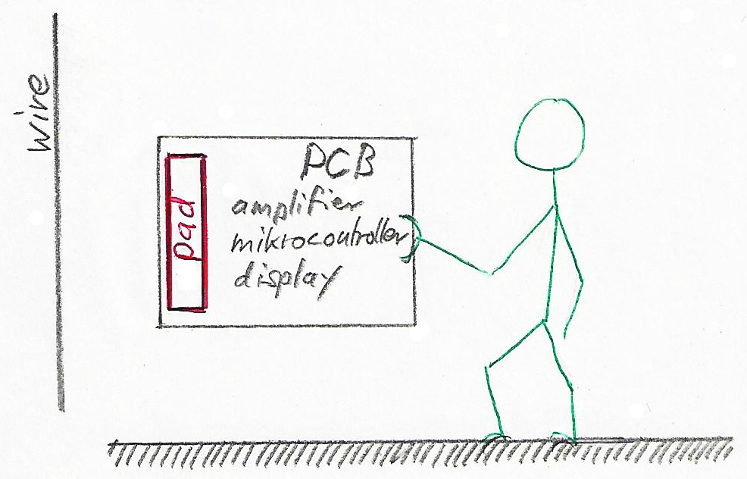

Figure 1 Situation of a person holding a PCB with a pad to pick up the electric field

A pad on a PCB picks up the electric field. The PCB has a capacitance to earth via the person holding the device. Unfortunately, this is quite a complicated geometry and there is no formula for this.

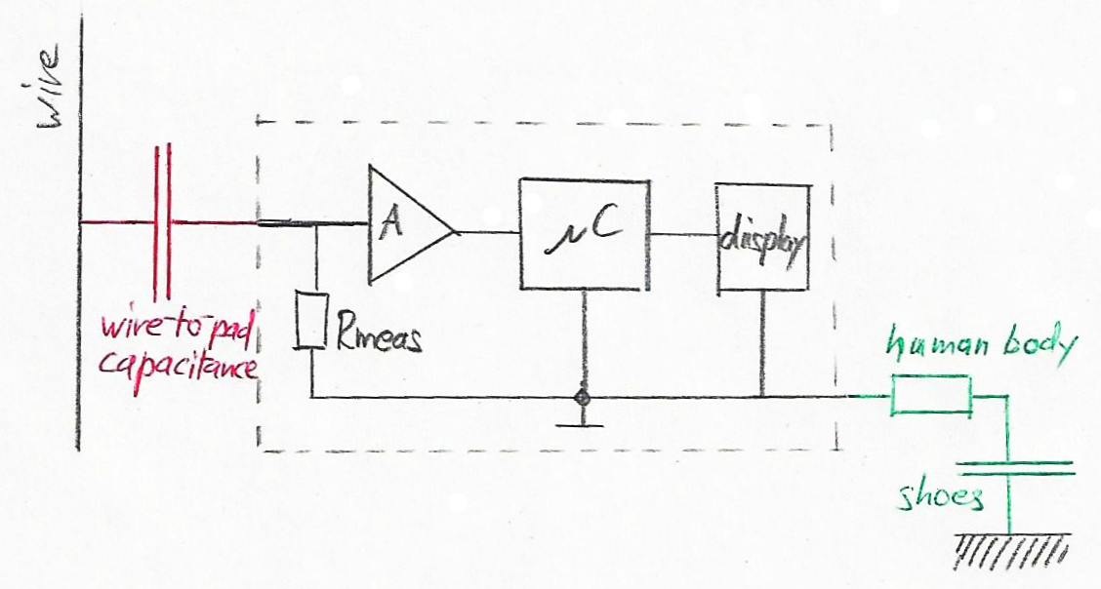

Figure 2 Equivalent electric circuit

The capacitance is proportional to the surface and inversely proportional to the distance of the plates. The capacitance of the shoe soles is hence much bigger than the wire-to-pad-capacitance and can be neglected in the calculation (two capacitors in series => the smaller is dominant). The electrical resistance of the human body with about 1.5kΩ is much lower than Rmeas and can also be neglected.

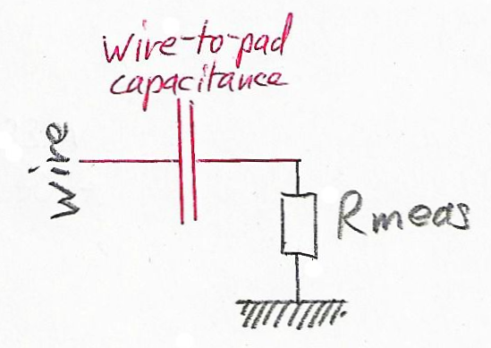

Figure 3 Simplified electrical circuit

It remains to calculate the capacitance wire-to-pad. Unfortunately, there is no formula for this geometry and a realistic approach must be chosen: parallel-plate or parallel-wires or a combination of both depending on the distance?

## Electric Field of the Phase Conductor

The alternating voltage in the phase conductor causes an alternating current flow through the wire-to-pad capacitor. This current can be measured via the resistor connected to the pad. This current decreases with increasing distance. The distance is thus a function of the current.

## Electric Field of the Neutral Conductor

As the neutral conductor is on the same earth potential as the person, no current flows through the wire-to-pad capacitance and it is not possible to detect this wire.

For the same reason it is not possible to find a water pipe or any other metal object.

## Electric Field of a Cable with Phase and Neutral

The neutral conductor shields some of the electric field. The shielding effect is higher if it is in between phase and sensor. In average, the field is about half as strong as for a phase conductor alone. This has been verified by measurement.

## Field of Cable with Phase, Neutral and Protecting Earth

The neutral and the protecting earth shield some of the electric field of the phase conductor. The shielding effect again is direction dependent. In average the field is about one third compared to that from the phase conductor alone.

## Distance and Direction of the Cable

With one pad, it is possible to calculate the distance to the wire or cable.

With two pads, also the direction of the wire or cable can be estimated roughly.

Note that a cable has a direction dependency because of the shielding effect of the neutral and protecting earth conductors. Thus, the distance is not only a function of the signal.

## Sensor Model

A calculation of the capacitance wire-to-pad has been done using a reasonable approach for the formula for a given geometry of the cable and the pad. The result is therefore only an approximation to the real value. Even if it is sufficiently accurate for the amplifier design, the exact value for the gain has probably to be adjusted experimentally.

The Matlab script **E_B_Field.m** (which is stored in the same folder as this document) calculates an approximation of the capacitance wire-to-pad.

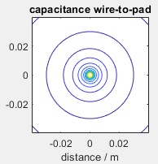

Figure 4: Capacitance wire-to-pad in function of distance and angle

As expected, the capacitance is depending on the distance but not on the angle.

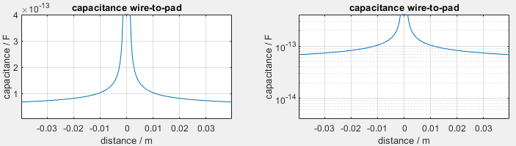

Figure 5: Capacitance wire-to-pad in function of distance (linear and logarithmic scales)

The capacitance decreases rapidly at first and much slower with increasing distance. The implication is that the capacitance is a monotone function of the distance and the sensitivity or resolution is better for short distances.

The capacitance wire-to-pad is around 0.1pF only. The current through the capacitor can easily be calculated as the mains voltage and frequency are known to be 230V @ 50Hz. A suitable resistor value and amplifier gain must be chosen in order to fully drive the ADC input. This signal is very small and it has to be heavily amplified. Meaning that the amplifier and filter design are critical.

## Calculate the Distance

As the formulas used for the above simulation are rough approximations, it is not possible to calculate the distance from the signal level. However, it is possible to measure the signal level for some known distances and store the values in a table.

The theory states that the electric field is inversely proportional to the distance. Thus, also the distance is inversely proportional to the field and can be approximated by the following function where the constants a and b are matched by using a table with measured samples of the electric field at some distances.

Equation 1: Approximate calculation of the distance

It is also possible to use a look-up-table, with the electric field as index and the distance as corresponding table entry.

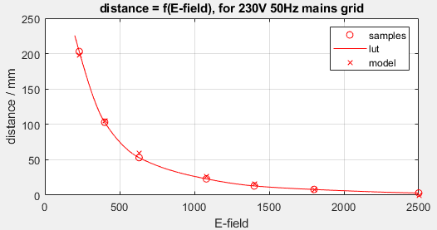

Figure 6: Distance = f(E-field) approximated by a look-up-table and by a model

How a look-up-table can be calculated and then imported and used in a C file is described in the Matlab script **LookUpTable.m** .

Note that for a reproducible calibration a person has to touch the GND potential on the PCB as shown in *Figure 1 Situation of a person holding a PCB with a pad to pick up the electric field* .

## Estimate the Direction

The direction might be calculated with a formula using the ratio of the pad signals as input. It is also possible to use a look-up table here.

# Magnetic Field

The Matlab script **E_B_Field.m** (which is stored in the same folder as this document) also calculates an approximation of the magnetic field.

## Magnetic Field of One Wire

For simple geometries, the magnetic field can be calculated. The magnetic field of a long straight wire is

Equation 2: Magnetic field of a wire

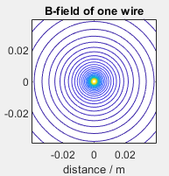

Figure 7: Magnetic field of one wire in function of distance and angle

Not surprisingly, the magnetic field of one wire is independent of the angle.

Note: The magnetic lines of force are vectors: The sensors must be oriented perpendicularly.

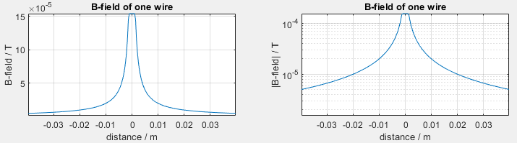

Figure 8: Magnetic field of one wire in function of the distance (linear and log.)

The magnetic field is a hyperbolic function of the distance. Compared to the above-calculated electric field and capacitance between wire and pad in *Figure 5*, the magnetic field in *Figure 8* decreases much more rapidly. That means that it is much more difficult to measure the magnetic field.

## Magnetic Field of Two Wires in a Cable

For electrical fields the superposition law is applicable. In the case of two wires, the magnetic fields of each wire can be calculated separately and then added up to get the resulting field. As the current in both conductors flow in different directions, the sign of the magnetic field is also different and the fields partially cancel out.

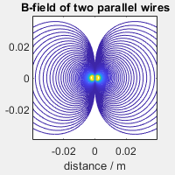

Figure 9: Magnetic field of two wires in function of distance and angle

At a glance, one can see that perpendicular to the plane of the wires the fields cancel out completely. At least two sensors in different places and/or orientation are necessary to detect such a magnetic field. The question is, which geometry is most suitable if one does not know how the wires lie in the cable.

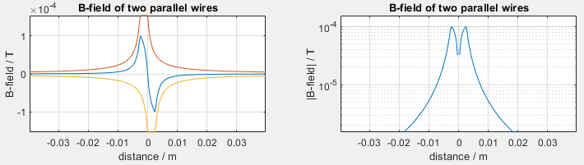

Figure 10: Magnetic field of two wires in function of distance (linear and log.)

Even in the plane of the wires, the fields cancel out rapidly. Compare *Figure 10* to *Figure 8* . Thus, it is only possible to measure the magnetic field in the immediate proximity.

## Hall Sensor

A magnetic field can be measured with a hall sensor.

Hall sensors have a typical sensitivity of about 10mV/mT. Considering the above calculation of the magnetic field, the signal is in the range of 1mV. A high amplifier gain is required, and the amplifier and filter design are critical.

A specific issue with many hall sensors is their relatively poor power supply rejection ratio, both on offset and gain. The temperature also has a substantial influence on hall sensors. Some hall sensors, as e.g. the DRV5053VA, have an internal voltage regulator and chopper stabilized amplifiers with temperature compensation combined with higher sensitivity.

## Pickup Coil as a Sensor

As the magnetic field is an alternating field with the frequency of the mains, it induces a voltage in a coil.

Basic formulas for an inductor coil:

Equation 3: Basic formulas for coils

The Matlab script **Uinduced.m** (which is stored in the same folder as this document) calculates the induced voltage.

Playing around with different parameters yields:

* The induced voltage is in the order of 1mV. This is similar as with the hall sensor.
* The voltage is proportional to the frequency. The coil will easily pick up even weak magnetic fields radiated by switching power supply up to 1MHz. A **low pass filter is required** in the amplifier stage.
* The voltage is proportional to the **diameter** of the coil.
* The voltage is proportional to the square root of the **inductance** and the **length**.
* This works with an **unshielded coil** only. By definition, shielded coils do not emit or pick up external magnetic fields.

## Current flowing through One Wire

*Equation 3* states that the voltage is proportional to the magnetic field.

*Equation 2* says that the current can be calculated if the distance is known.

As demonstrated in section *1.5 Distance and Direction of the Cable*, the distance can be estimated by measuring the electric field.

## Current flowing through Two Wires

Compared to the situation with one wire, two additional problems occur:

* Perpendicular to the plane of the wires the magnetic field disappears completely. At least two sensors at different locations are required.
* The magnetic field is decaying extremely fast with increasing distance because the fields of both wires cancel partly out. It is only possible to give a rough estimation with the sensors in the immediate vicinity of the cable.
* Tests with a prototype suggest that more than two sensors might improve the chance to estimate the current correctly.

## Calculate the Current

For a given (calibration) current the magnetic field is a function of distance and wire or cable configuration. With the help of a model or a look-up-table this magnetic field can be estimated using a similar approach as in chapter *1.7 Calculate the Distance* .

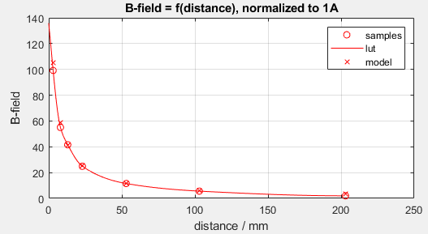

Figure 11: B-field = f(distance) approximated by a look-up-table and by a model

The actual current can then be calculated:

Equation 4: Estimated current

# Checklist

* What is the optimal size for the pads which pick up the electric field?
* Where on the PCB should the pads be placed?
* Which signal level can be expected?
* What are reasonable values for Rmeas and amplifier gain?
* How can the look-up table entries experimentally be determined?
* Chose the sensor for the magnetic field: coil and/or hall sensor?
* Where on the PCB should they be placed and with which orientation?
* How can the proportionality factor for the current experimentally be determined?

# Conclusion

With adequate amplification and filtering, it is easy to measure the distance of a wire or cable connected to the mains. Using two pads, the direction to the cable can also be detected.

The current flowing through one wire can be approximated by additionally measuring the magnetic field.

The current flowing through a cable can only be roughly estimated in the immediate vicinity. At least two sensors are required at different places very close to the cable, because the magnetic fields of the phase and the neutral conductor cancel out each other in the plane of the wires.

The coils or hall sensors must be oriented perpendicular to the magnetic lines of force.