


Hardware Report
  - Cable-Monitor
  - 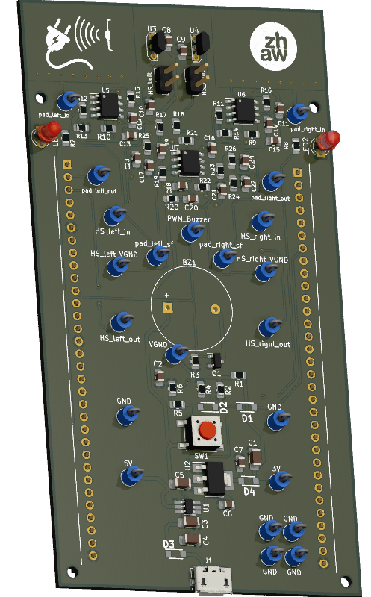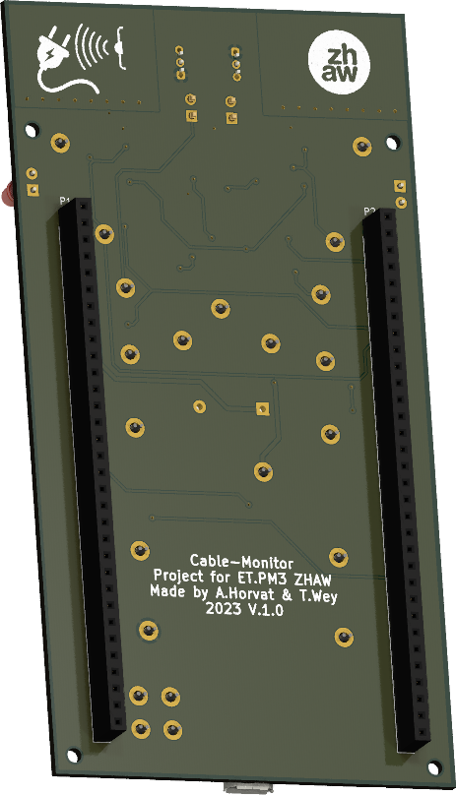
  - Authors: A.Horvat & T.Wey
Institute: ZHAW
Lecturers: Andreas Ehrensperger & Igor Matic
  - Subject: Project Module 3
  - Date: 20 October 2023

Abstract
As part of the Project Module 3 in the 5th Semester, the objective was to develop a Cable-Monitor. This device should be able to find hidden cables in walls, floors and ceilings by measuring the electromagnetic- and electrostatic fields of the cable. By making use of the display from the provided development Kit, the user is guided to the approximate location of the cable, also audible feedback is provided using a buzzer. Furthermore, useful information such as the current and voltage, is showed on the display. To be able to measure such small signal, an amplifier had to be used. The amplification was also paired with a Multi-Feedback-Bandpass-Filter (MFB) to eliminate unnecessary frequencies and filter out the wanted 50Hz signal. Subsequently, the signal is fed into an Analog-to-Digital- Converter (ADC) and read by the Microcontroller. The final product aimed to detect various types of cables, including one- or two-phased cables, and featured an intuitive touch interface. The challenge extended beyond the realms of hardware and software to effective teamwork, as the project was a collaborative effort between two individuals. Successful completion required meticulous planning and coordination between team members.

Done

Table of Contents
Abstract 1
1. Introduction 3
2. Specifications 3
3. Evaluation 3
4. Development 4
5. Implementation 5
6. Testing 5
7. Project Management 5
8. Conclusion 5
9. Source list 5
10. Figure list 5
11. Appendix 5

Introduction
The purpose of this hardware report is to comprehensively detail the Cable-Monitor project, encompassing specification, evaluation, development/Implementation, testing and project management. The initiation of the project was facilitated by the provision of several documents, including documentation templates, circuit designs, layouts, and program code frameworks. The primary objective is the successful creation of a functional device capable of sensing a power cable through both electrostatic and electromagnetic fields. The device is designed to measure the distance to the cable and accurately gauge the current flowing through it. The acquired data is then presented on a touch display. Ultimately, the report aims to capture the entire lifecycle of the Cable-Monitor project, from conceptualization to realization, ensuring a clear understanding of the processes involved in achieving a fully operational and effective device.

Very good Done

Specifications
The Cable-Monitor must fulfil these requirements:
- Detect a mains cable at a distance of up to 200mm
- Display the distance to the cable in the range 5mm to 100mm with a precision of ±30%
- Display the angle to the cable in the range of ±45° with a precision of ±15°
- Battery powered, preferably with auto shut down when no longer used
- Menu with these items
  - Start single measurement
  - Start accurate measurement (averaging: mean and standard deviation)
Optionally it is desirable to implement some additional features, like:
- Display current in the range of 1A to 10A with a precision of ±50%
  - for a single-phase wire (at mains potential) up to a distance of 10mm
  - for a cable with phase, neutral and protecting earth up to a distance of 5mm
- Add menu items for current measurement
  - on a single-phase wire
  - on a cable with phase, neutral and protecting earth
- Further menu items, like
  - turning the cable monitor off
  - calibration of distance (with look up table in non-volatile memory)
- Alarm
  - when cable distance is too big (= cable is disconnected)
  - with overcurrent
  - data logger functionality
- Other extensions of functionality are welcome and encouraged by the lecturers
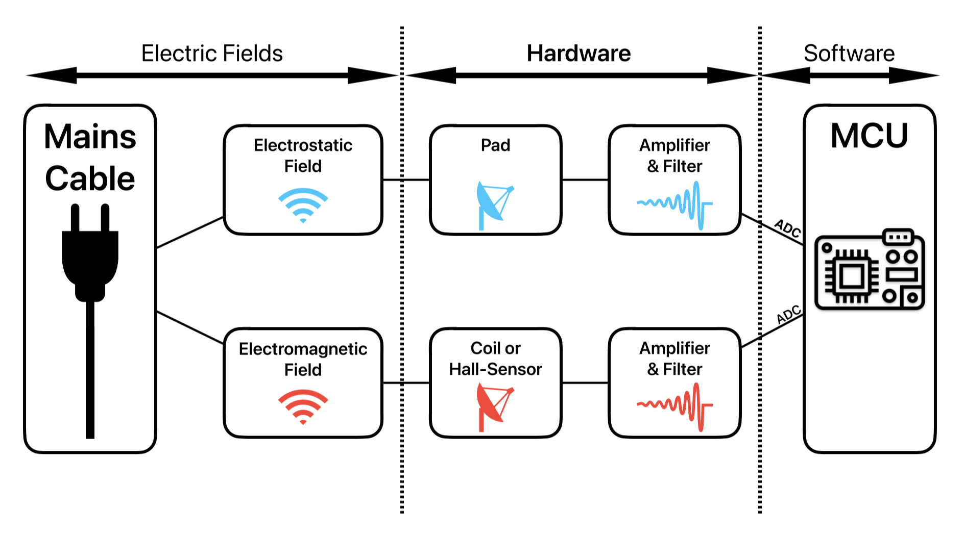
Figure 1 Block Diagram
This list comes from a provided file -> add this info in footnote

Evaluation
The abstract is a means of advertising one’s work. Online search databases usually only contain the abstracts.
After skimming an abstract, the reader decides if the content seems relevant or not.
The abstract is a concise and short description of the complete work. The content is thus similar to that of the report and includes
- Motivation for and context of the project
- Problem statement
- Solution approach
- Achieved results
The abstract is formatted as one single paragraph. It is a third to a half page long. Shorter is better, as long as the essential information is included.

Development

Power supply etc.

Electrostatic field
This section describes how the wire-to-pad capacitance was calculated using the provided MATLAB script (appendix xy). The script is designed for square pads, thus the approximate length x had to be calculated first:
$$x=\sqrt{l⋅b} = \sqrt{22,86mm⋅15,62mm}=19,89mm$$
The result is then further used to determine the wire-to-pad capacitance using the provided62

Electromagnetic field
- Title page with authors, date, company, etc.
- Abstract
- Table of contents
- Introduction
with subject, circumstances, conditions, expectations, ...
- Specifications, functionality and block diagrams
Aspects may be purpose, primary (and secondary) functions, parameters (ranges, limits), interfaces, HW and SW requirements, user interface, time, cost, ...
This must be well defined before the development starts!
- Evaluation of different solution possibilities
Summarize each possibility in terms of the specifications and the functionality.
Extract what is specific to each solution.
Justify and explain the decision for a particular solution.
- Development
Document circuit design, formulas, simulation, dimensioning of component values.
- Implementation
Schematics with description of inputs, outputs, special components
PCB layout with explanation of the layout concepts (analog, digital, power, EMI, ESD)
- Document the tests
Testplan with description, test conditions, expected results and acceptable tolerances, measured results, comparison and verdict, discussion and remarks
More about testing is in the file HW_ Testing.docx.
- Project management
Timeline with milestones
Definition of work packages and assignment to team members
Comparison of planned and real workload
- Conclusion
Achieved results
Outlook and reflection
- Appendix with
References or bibliography
Schematics, PCB layouts, calculations, tables with test data, code snippets
Folder structure with explanation for digital documentation on USB stick or cloud.
The appendix contains all the information that is not needed for fluent reading.
As a rule, diagrams go in the main text, data tables in the appendix.

Implementation
Form and style of the HW report must follow the customary practice for academic writing as presented in the file Academic Writing_summary.docx in the folder Writing HW Report.
Read that summary carefully before starting to write and read it again after writing a first draft.

Testing

Project Management

Conclusion

Source list

Figure list
Figure 1 Block Diagram 4
Figure 2 Main schematic 8
Figure 3 Pad Amplification and filtering schematic 9
Figure 4 Hall-Sensor amplification and filtering schematic 10

Appendix

A Schematics
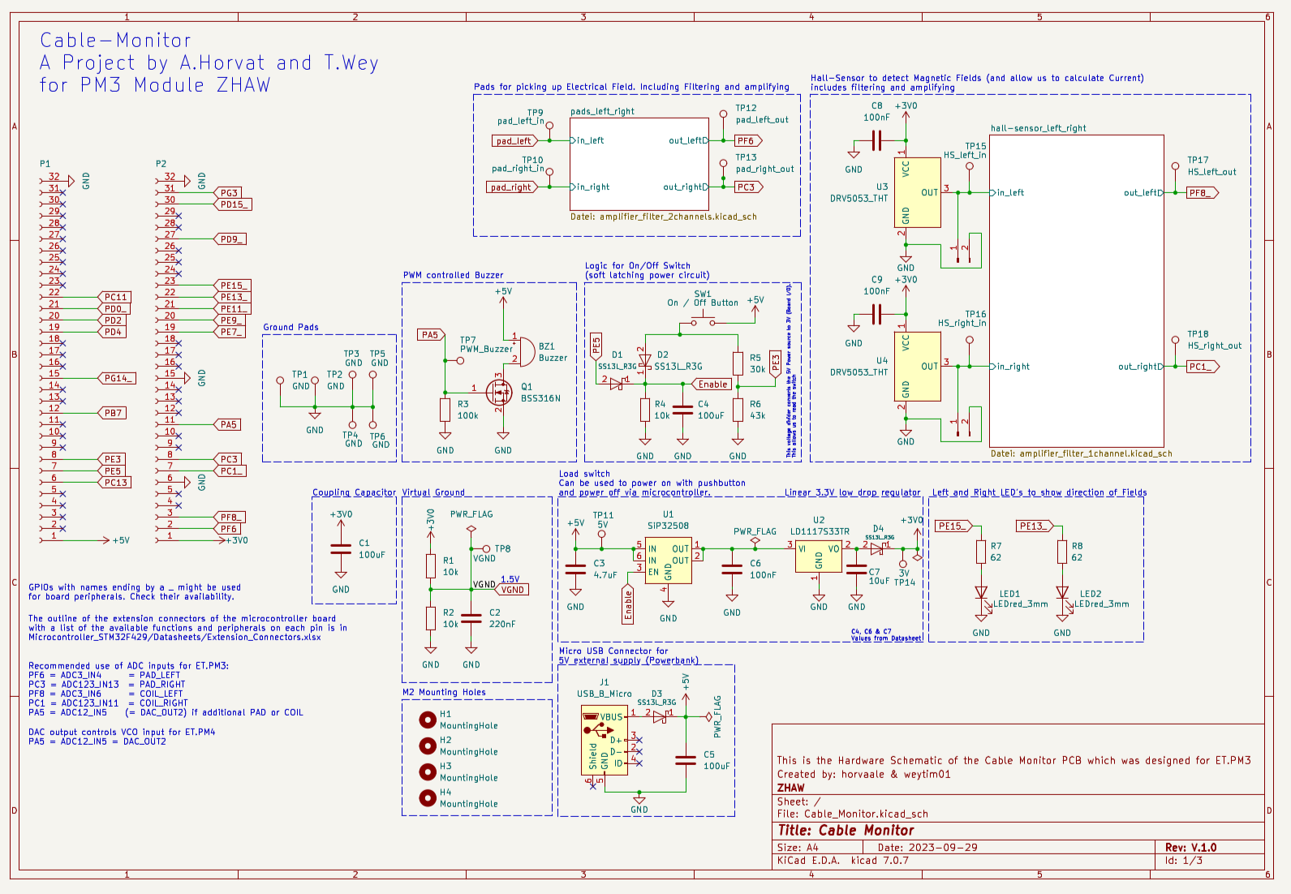
Figure 2 Main schematic
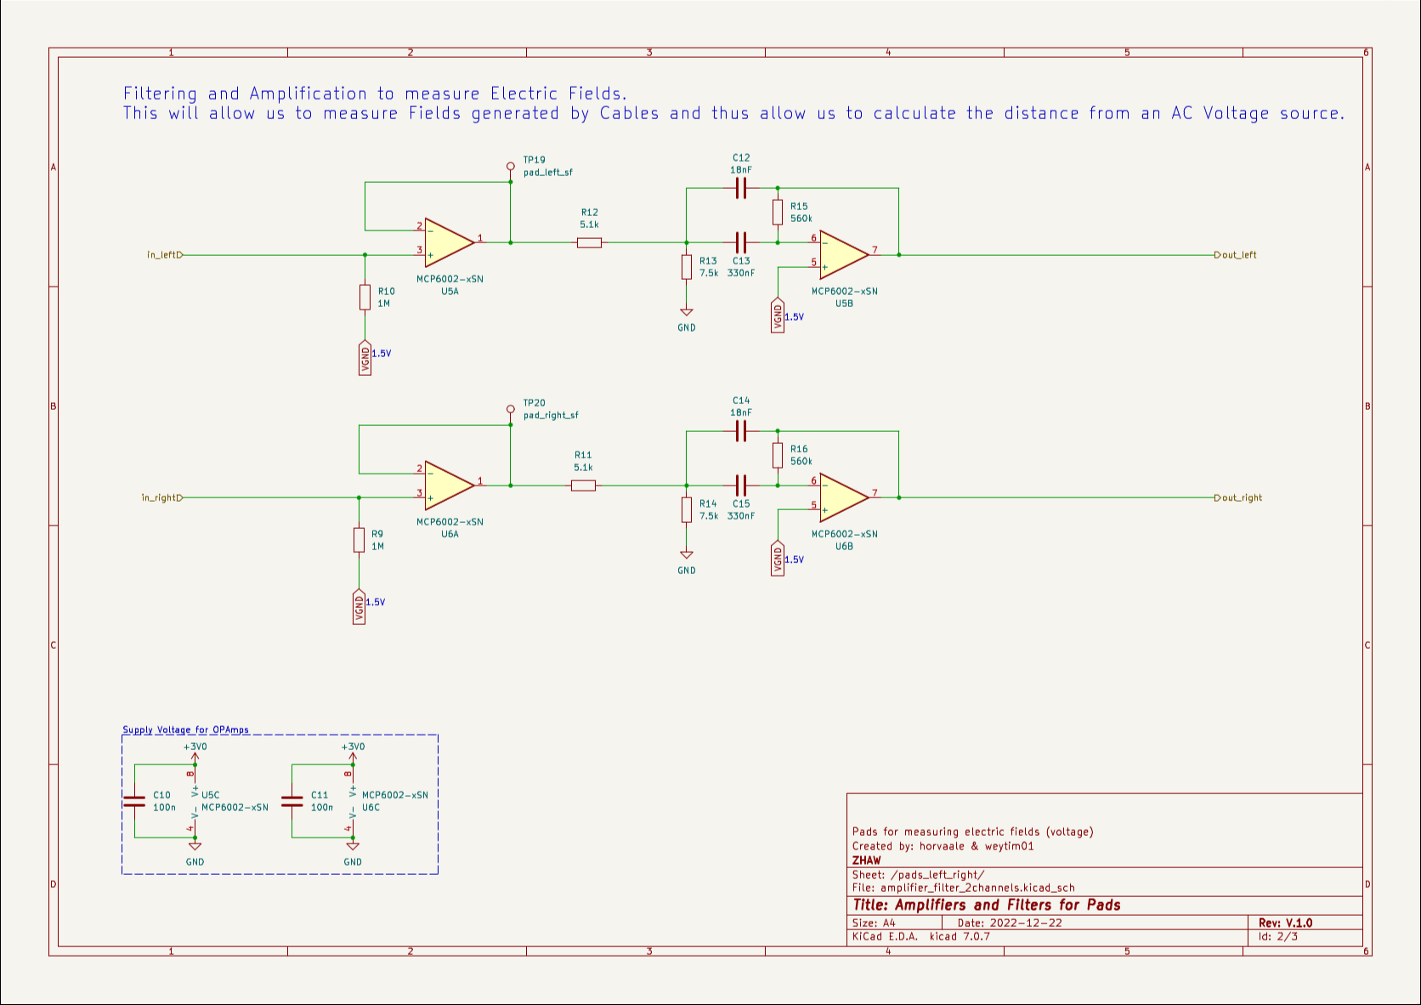
Figure 3 Pad Amplification and filtering schematic
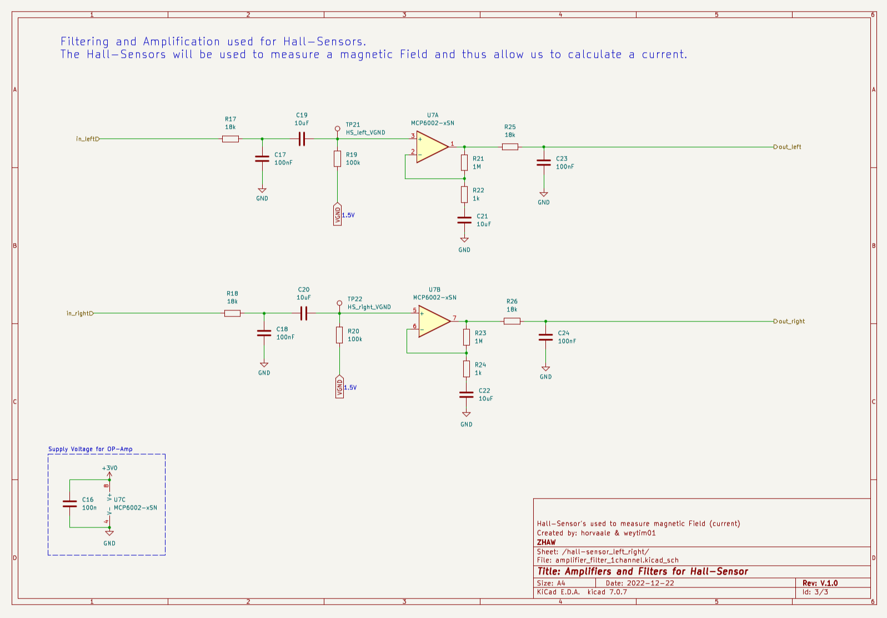
Figure 4 Hall-Sensor amplification and filtering schematic

B PCB
