|  |  |  |  |  |  |  |
| --- | --- | --- | --- | --- | --- | --- |
| № | Сущность | Название атрибутов | Тип данных | Ограничение | Идентификаторы | |
| 1 | machineType | id | int |  | PK |  |
|  |  | name | nvarchar | 50 |  |  |
| 2 | machine | id | int |  | PK |  |
|  |  | name | nvarchar | 50 |  |  |
|  |  | startDate | date |  |  |  |
|  |  | period | nvarchar | 50 |  |  |
|  |  | endDate | date |  |  |  |
|  |  | machineTypeId | int |  | FK | id |
| 3 | detail | id | int |  | PK |  |
|  |  | name | nvarchar | 50 |  |  |
|  |  | number | nvarchar | 50 |  |  |
| 4 | detailForMachins | id | int |  | PK |  |
|  |  | detailId | int |  | FK | id |
|  |  | machineId | int |  | FK | id |
| 5 | gender | id | int |  | PK |  |
|  |  | name | nvarchar | 50 |  |  |
| 6 | employee | id | int |  | PK |  |
|  |  | firstName | nvarchar | 50 |  |  |
|  |  | lastName | nvarchar | 50 |  |  |
|  |  | patronymic | nvarchar | 50 |  |  |
|  |  | genderId | int |  | FK | id |
| 7 | street | id | int |  | PK |  |
|  |  | name | nvarchar | 50 |  |  |
| 8 | warehouse | id | int |  | PK |  |
|  |  | number | nvarchar | 50 |  |  |
|  |  | houseNumber | nvarchar | 50 |  |  |
|  |  | space | float |  |  |  |
|  |  | streetId | int |  | FK | id |
| 9 | invoice | id | int |  | PK |  |
|  |  | warehouseId | int |  | FK | id |
|  |  | detailId | int |  | FK | id |
|  |  | employeeId | int |  | FK | id |
|  |  | date | date |  |  |  |
|  |  | price | float |  |  |  |

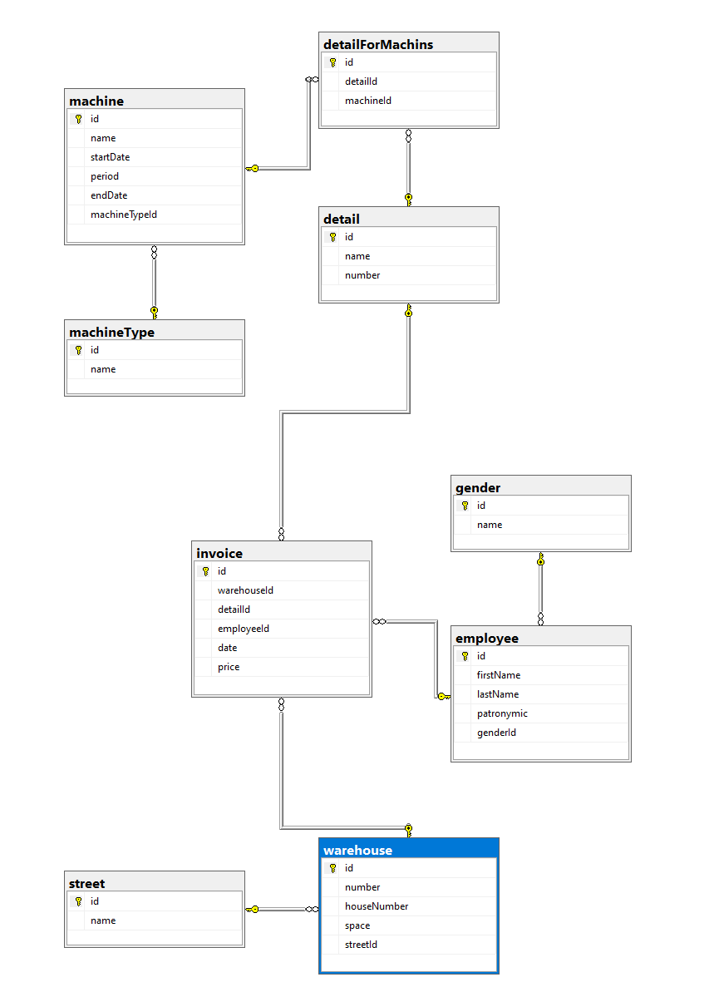

|  |  |  |  |  |
| --- | --- | --- | --- | --- |
| id | number | houseNumber | space | streetId |
| 1 | 1 | 1А | 300 | 1 |
| 2 | 2 | 43 | 236 | 2 |
| 3 | 3 | 12 | 423 | 3 |
| 4 | 4 | 7 | 643 | 4 |
| 5 | 5 | 34 | 278 | 5 |
| 6 | 6 | 2 | 343 | 6 |
| 7 | 7 | 6 | 744 | 7 |
| 8 | 8 | 3 | 1495 | 8 |
| 9 | 9 | 7 | 359 | 9 |
| 10 | 10 | 89 | 657 | 10 |

|  |  |
| --- | --- |
| id | name |
| 1 | Пушкина |
| 2 | Чкалова |
| 3 | Гагарина |
| 4 | 8 марта |
| 5 | Терешковой |
| 6 | Березовая |
| 7 | Уральская |
| 8 | Тополева |
| 9 | Салмышская |
| 10 | Дальнореченская |

|  |  |
| --- | --- |
| id | name |
| 1 | Токарно-винторезный |
| 2 | Сверлильный |
| 3 | Расточный |
| 4 | Шлифовальный |
| 5 | Притирочный |
| 6 | Хонинговальный |
| 7 | Зубообрабатывающий |
| 8 | Фрейзерный |
| 9 | ЧПУ |

|  |  |  |  |  |  |
| --- | --- | --- | --- | --- | --- |
| id | name | startDate | period | endDate | machineTypeId |
| 1 | c3c9m2xm39 | 2022-11-01 | 2 года | 2024-11-01 | 1 |
| 2 | 2c968749 | 2024-11-01 | 3 года | NULL | 1 |
| 3 | x794 m00 | 2022-11-02 | 1.5 года | 2024-11-02 | 2 |
| 4 | 57m894 | 2024-11-02 | 2 года | NULL | 2 |
| 5 | 9x83n403 | 2022-11-03 | 2.5 года | 2024-11-03 | 3 |
| 6 | z293 74 | 2024-11-03 | 8 месяцев | NULL | 3 |
| 7 | x93m7 | 2022-11-04 | 11 месяцев | 2024-11-04 | 4 |
| 8 | 92c6573 | 2024-11-04 | 3 года | NULL | 4 |
| 9 | c74bc764 | 2022-11-05 | 4 года | 2024-11-05 | 5 |
| 10 | x84n5m | 2024-11-05 | 2 месяца | NULL | 5 |
| 11 | xserm | 2022-11-06 | 2 месяца | 2024-11-06 | 6 |
| 12 | x5780 | 2024-11-06 | 3 месяца | NULL | 6 |
| 13 | x7n | 2022-11-07 | 5 лет | 2024-11-07 | 7 |
| 14 | 9c2n0 | 2024-11-07 | 3 года | NULL | 7 |
| 15 | cn73cdeasd | 2022-11-08 | 2 года | 2024-11-08 | 8 |
| 16 | x930 | 2024-11-08 | 3 года | NULL | 8 |
| 17 | lxsk78 | 2022-11-09 | 1 год | 2024-11-09 | 9 |
| 18 | x20j3 | 2024-11-09 | 1 год | NULL | 9 |
| 19 | 0lk7 | 2020-12-01 | 5 лет | 2022-12-01 | 3 |
| 20 | 78h52349 | 2020-01-01 | 7 лет | 2022-12-01 | 7 |

|  |  |  |  |  |  |
| --- | --- | --- | --- | --- | --- |
| id | warehouseId | detailId | employeeId | date | price |
| 1 | 1 | 1 | 1 | 2024-01-18 | 234,3 |
| 2 | 2 | 2 | 2 | 2024-03-22 | 553 |
| 3 | 3 | 3 | 3 | 2024-02-12 | 2389 |
| 4 | 4 | 4 | 4 | 2024-06-09 | 344 |
| 5 | 5 | 5 | 5 | 2024-02-03 | 2836 |
| 6 | 6 | 6 | 6 | 2024-08-05 | 564 |
| 7 | 7 | 7 | 7 | 2024-11-23 | 648 |
| 8 | 8 | 8 | 8 | 2024-02-12 | 897 |
| 9 | 9 | 9 | 9 | 2024-12-02 | 678 |
| 10 | 10 | 10 | 10 | 2024-04-05 | 764 |

|  |  |
| --- | --- |
| id | name |
| 1 | мужской |
| 2 | женский |

|  |  |  |  |  |
| --- | --- | --- | --- | --- |
| id | firstName | lastName | patronymic | genderId |
| 1 | Тимур | Зуев | Кириллович | 1 |
| 2 | Матвей | Карпов | Данилович | 1 |
| 3 | Андрей | Федосов | Владимирович | 1 |
| 4 | Маргарита | Маслова | Тимофеевна | 2 |
| 5 | Елизовета | Савельева | Александоровна | 2 |
| 6 | Лев | Кожевников | Миронович | 1 |
| 7 | Роборт | Антонов | Дмитриевич | 1 |
| 8 | Злата | Новикова | Тимофеевна | 2 |
| 9 | Ульяна | Некрасова | Глебовна | 2 |
| 10 | Дмитрий | Егоров | Данилович | 1 |
| 11 | Мария | Жданова | Тихоновна | 2 |
| 12 | Иван | Михайлов | Тимофеевич | 1 |
| 13 | Аделина | Белова | Захаровна | 2 |
| 14 | Артем | Максимов | Артемович | 1 |
| 15 | Киррил | Михайлов | Николаевич | 1 |
| 16 | Анна | Киселева | Львовна | 2 |
| 17 | Артем | Калмыков | Данилович | 1 |
| 18 | Валерия | Иванова | Ивановна | 2 |
| 19 | Полина | Зорина | Александровна | 2 |
| 20 | Есения | Никольская | Тимофеевна | 2 |

|  |  |  |
| --- | --- | --- |
| id | detailId | machineId |
| 1 | 1 | 1 |
| 2 | 2 | 2 |
| 3 | 3 | 3 |
| 4 | 4 | 4 |
| 5 | 5 | 5 |
| 6 | 6 | 6 |
| 7 | 7 | 7 |
| 8 | 8 | 8 |
| 9 | 9 | 9 |
| 10 | 10 | 10 |
| 11 | 11 | 11 |
| 12 | 12 | 12 |
| 13 | 13 | 13 |
| 14 | 14 | 14 |
| 15 | 15 | 15 |
| 16 | 16 | 16 |
| 17 | 17 | 17 |
| 18 | 18 | 18 |
| 19 | 19 | 19 |
| 20 | 20 | 20 |

|  |  |  |
| --- | --- | --- |
| id | name | number |
| 1 | 834 | 1 |
| 2 | c90di | 2 |
| 3 | c034j | 3 |
| 4 | x24c59 | 4 |
| 5 | e74n | 5 |
| 6 | cciju | 6 |
| 7 | c90 | 7 |
| 8 | c98 | 8 |
| 9 | 8s3 | 9 |
| 10 | v7 | 10 |
| 11 | xdb63 | 11 |
| 12 | 9sdj | 12 |
| 13 | e987 | 13 |
| 14 | 3cs | 14 |
| 15 | 93m | 15 |
| 16 | djf7 | 16 |
| 17 | 94e8 | 17 |
| 18 | dfk2 | 18 |
| 19 | dk2 | 19 |
| 20 | skd2 | 20 |

