- select category_name, sum(rec_Price)
from product
inner join product_category on product.category_id = product_category.category_id
group by category_name
having sum(rec_Price) > 60000
order by sum(rec_Price) desc
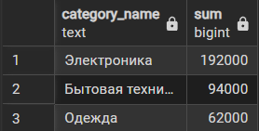
- select status_name, contract_number
from supply_status
inner join supply on supply_status.status_id = supply.status_id
limit 5
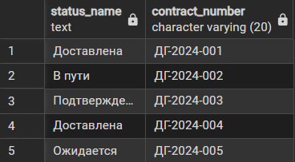
- SELECT sp.supply_id, s.brand, sp.delivery_date, ss.status_name
FROM supply sp
INNER JOIN supplier s ON sp.supplier_id = s.supplier_id
INNER JOIN supply_status ss ON sp.status_id = ss.status_id
ORDER BY sp.delivery_date DESC
LIMIT 10;
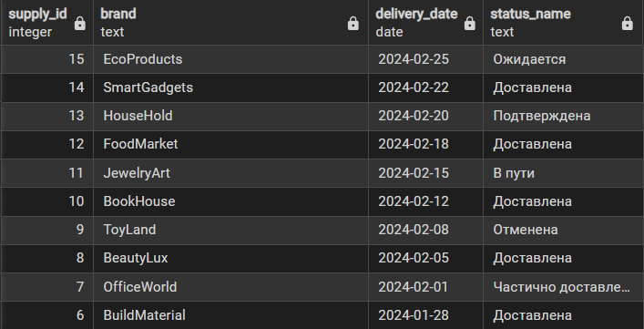
- SELECT pc.category_name, COUNT(p.product_id) as product_count
FROM product p
INNER JOIN product_category pc ON p.category_id = pc.category_id
GROUP BY pc.category_name
ORDER BY product_count DESC
LIMIT 10;
