When deployed with ClickOnce, we will get parameters from the URL

In GUI->Properties->Publish->Options…

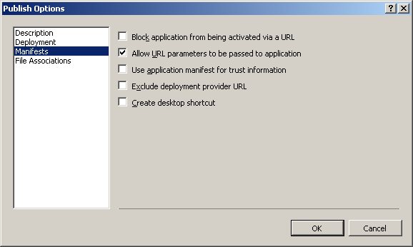

To be able to debug with parameters on the command line:

In GUI->Properties->Security

Set “This is a partial trus application” and click on “Advanced…”

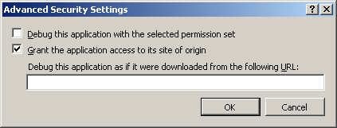

# .netCharting

The chart library can be found in \\ncecdlib\SoftEng\DotNetCharting

It is also on the web: [www.dotnetcharting.com](http://www.dotnetcharting.com)