

PARTICIPANT INFORMATION SHEET AND INFORMED CONSENT FORM
Project title: Object-graph fMRI Study
Lead researcher: Timon Kunze (tkunze@sissa.it)
Principal investigator: Davide Crepaldi
Co-Investigator: Mona Garvert
Institution: International School for Advanced Studies (SISSA), Trieste, Italy

What is this document?
This document explains what kind of study we are conducting, what your rights are, and how your data will be processed. You may keep this document for your records. Before deciding if you want to participate in this study, you should read this information carefully and ask the researcher any questions you might have using Prolific’s messaging tool or by sending an email to: tkunze@sissa.it.
Nature of the study
We are investigating how human’s remember which things are connected and which things are not.
Procedure
The experiment consists of two main parts that take place on two different days.
In the first part of the experiment, we will show you a two-dimensional environment on a computer screen that contains different objects. Your task will be to click on these objects and search for an animal that may be hidden inside them. After each trial, we will ask you several multiple-choice questions about what you have seen. It takes approximately 1–1.5 hours and will either be completed at home or at our research facilities.
If you successfully complete the first part successfully, we will invite you to take part in the second part. Here, we will show you object images on the screen. Your task will be to answer multiple-choice questions about what you remember from the first session. You will indicate your answers by pressing buttons on a keyboard. This lasts ca. 1 hour.
After this task, we will ask you a few additional questions (lasting approximately 10 min) and then the experiment will be finished.
Compensation
The total completion time is estimated to be 2.5 hours, about 1.5 hour for the first session and about another for the second session. You will be compensated either with course credits or at a rate of €9 per hour, depending on the prior agreement.
Data Protection and Privacy
All data collected thanks to your participation and to the participation of other participants will be treated confidentially. The behavioral data will initially be stored on a secure web server located in Hessen (Germany), later it will be moved to our personal computers, and to secure servers maintained by SISSA in Trieste, Italy. Eventually, the data will be made freely and publicly available in research archives or in scientific publications along with that of many other participants. However, we will never disclose your identity information.
You may withdraw your data at any time up to 31 November 2026 by writing to tkunze@sissa.it without having to provide an explanation. After this we cannot guarantee that your fully anonymous data will not have been placed in the public domain.
More generally, the data collected will be processed in accordance with privacy laws and in accordance with Legislative Decree 30 June 2003 n. 196 "regulation concerning the protection of personal data", as amended by Legislative Decree n. 101/2018, and the new European regulation 679/2016 (General Data Protection Regulation – GDPR). The person in charge of the GDPR is Dr. Valentina Carollo - email: dpo@sissa.it or rdp@sissa.it; PEC: protocollo@pec.sissa.it.
Before giving your consent to participation, please remember that you can ask researchers any clarification on any aspect of the study.
If you decide to take part in the study, please complete the following:
By accepting and participating in this study, you agree to the following:
- To be at least 18 years old.
- To have carefully read all the information relative to the study;
- To have been informed about the objectives of the research;
- To have had the opportunity to ask questions about any aspect of the experimental procedure and have obtained satisfactory answers;
- To be aware of the inconvenience that may be caused by the experiment;
- To have received satisfactory assurances concerning the privacy and the confidentiality of the data collected
- To be aware of the opportunity to withdraw at any stage of the study.

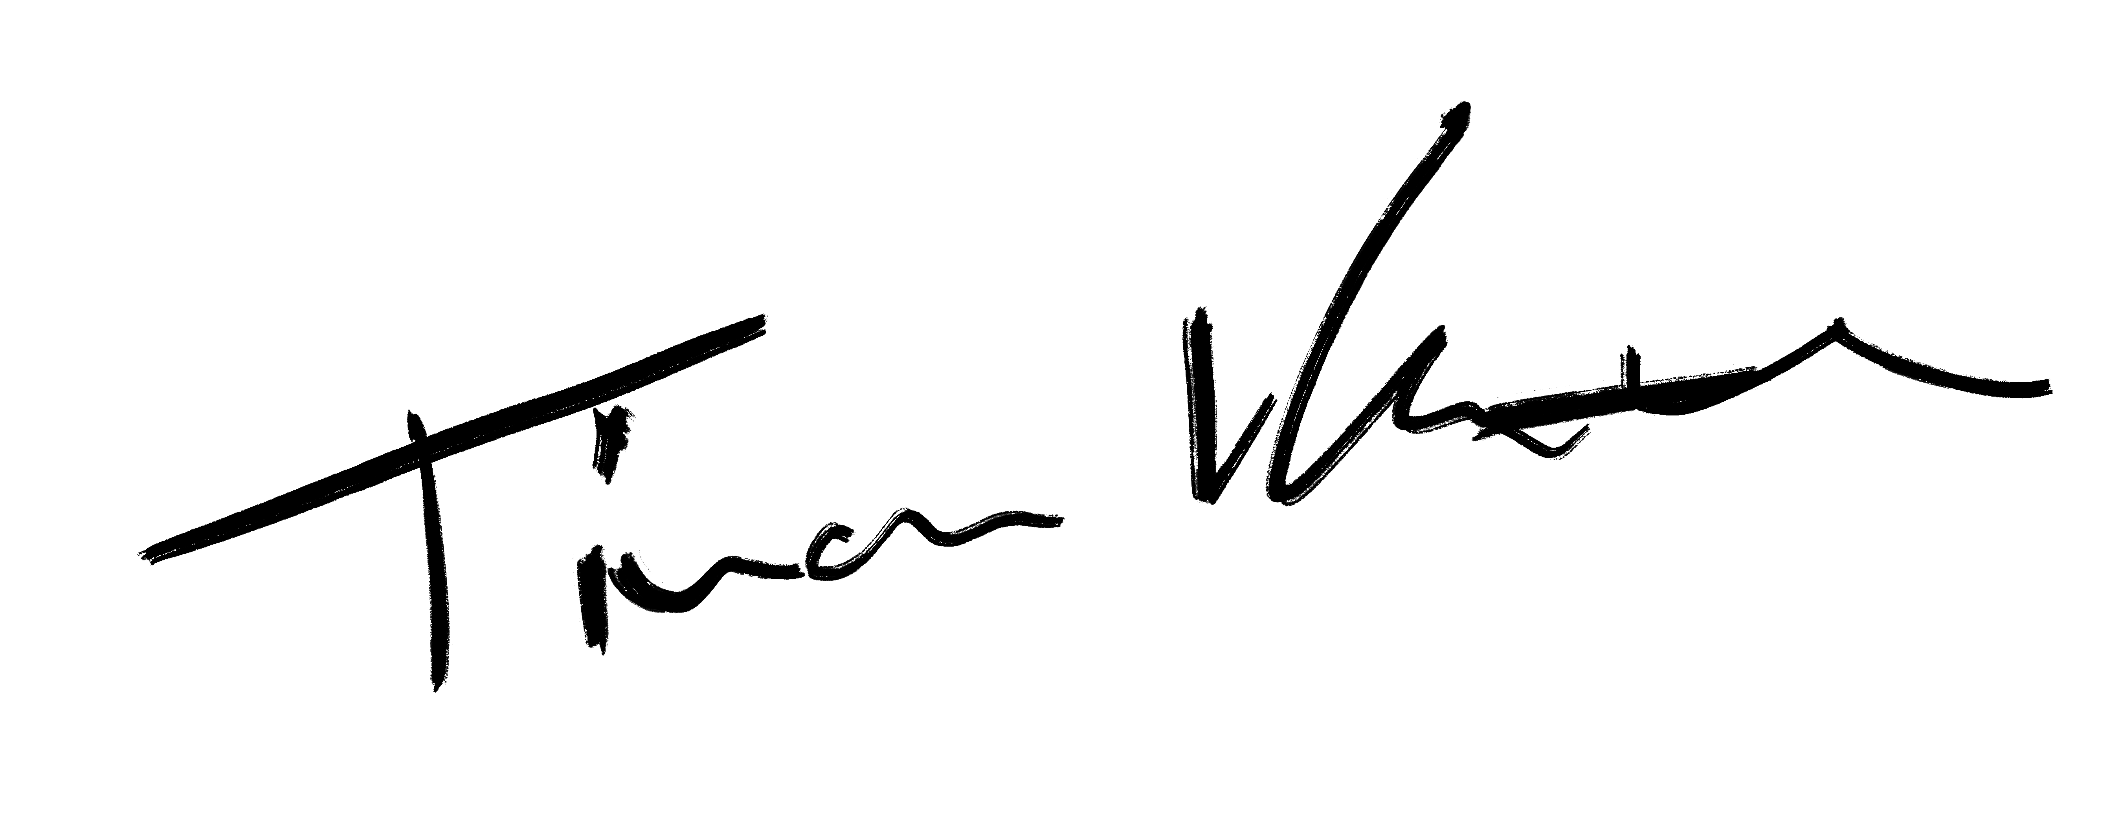
Voluntary participation and the right to withdraw from the study
Your participation in this research project is entirely voluntary. If you withdraw from the study during data collection, we will delete your data at that time. Note however, that in some circumstances, you will not get paid in accordance with the guidelines of Prolific.

Data: 15.04.2026
Il Ricercatore: ____________________________

