The goal of this project is to build a Windows-based cybersecurity threat knowledge graph. It integrates information from MITRE ATT&CK, NVD/CVE, and CWE. This knowledge graph covers essential cybersecurity entities. It includes: threat actors, attack techniques, attack tactics, platforms, products, vulnerabilities, weaknesses, and severity ratings. By using OWL and RDF in the semantic models, these entities are connected with each other through specific properties that can be read by a computer and used to perform basic analysis.
This project contains two connected analysis perspectives. The first perspective describes the perspective of the attacker. The attacker uses the techniques in ATT&CK. Each technique is grouped into a specific tactic. Some of these techniques are for the Windows platform. The second perspective describes a specific software problem. CVE vulnerabilities affect Windows products, and they are also related to CWE weakness categories. It also has a CVSS severity, which can show whether the vulnerability is severe or not. Then I use the Windows platform to connect these two information sources. However, this project can’t produce the result that a particular threat actor used a particular technique, because the original data does not always support this relationship.
The motivation for creating this project is to learn some practical skills in cybersecurity and data engineering. It is used to build a foundation for work in cybersecurity and data management. By building knowledge graph from the data in the real world, I can learn data integration, ontology design, visualization, and SPARQL queries. By focusing only on Windows, I can help limit the number of vulnerabilities, and it is the most widely used operating system, which has a lot of ATT&CK data. Also, in this way, the study can have a clear scope.
The main users of this project are analysts and cybersecurity researchers. Analysts can use this system to explore which techniques can be used in Windows and also learn about severe vulnerabilities in certain Windows versions. Meanwhile, cybersecurity researchers can use it to deeply analyze the relationship between techniques and vulnerabilities. By integrating different data sources into a semantic model, this knowledge graph can support more efficient analysis than reading raw data individually.

1.2
This knowledge graph is designed to answer:
- Which ATT&CK techniques and tactics for Windows will be used in the graph?
- Which Windows software is affected by the CVEs?
- Which actor-techniques are associated with CVE-severity records and share context with the Windows platform?
These questions guide the ontology design and entities. The first question mainly focuses on MITRE ATT&CK attack actors. The second question focuses on CVE information, focusing on software risks. The last question integrates both perspectives on a Windows platform and visualizes the relationship between the two sources.

2.1
This project follows a structured knowledge graph development process. First of all, the scope of the project is limited to Windows-based cybersecurity threat information. This restriction made the project easier to manage, and at the same time, we can integrate cybersecurity data from all sources.
Secondly, I began to build an ontology framework at protégé. The prefix of this ontology is cti, which means Cyber Threat Intelligence. In the ontology, the main classes are: Threat actor, attack techniques, attack tactics, platforms, attack campaign, operating system, software, vulnerability, weakness, and severity level. The object properties define relationships between these classes. For example, a vulnerability has severity “severityLevel”, and a threat actor uses technique “AttackTechnique”. Also, by adding OWL restrictions to the knowledge graph, each vulnerability affects at least one software product and has at least one weakness.
Thirdly, the ontology is saved in Turtle or TTL format. It is separated from all instances. The ontology file contains basic structural information. It includes classes, properties, and restrictions. The instance TTL file contains selected instances of ATT&CK, CVE, CWE, and Windows products.
Meanwhile, I use a Python Jupyter notebook to get all the information from the website. Then also use Python to clean the data and put them into RDF triples. I use ATT&CK data to select technologies, tactics, and threat actors related to Windows. Also use the NVD API to get selected CVE records. Each of them contains the affected Windows product, severity, and CWE ID.
Finally, I use SPARQL to get the data needed for the graph, and then use pandas and matplotlib to do the analysis and visualization. The data will be presented in tabular and graph form to answer related questions.

2.2
Figure 1 shows the conceptual model of the ontology. It contains the main classes and relationships. This model has two related parts: the attacker model based on ATT&CK, and the vulnerability model based on CVE/CWE. These two parts are connected through the Windows platform and software. The following section will explain classes, properties, and restrictions.
2.2.1
The ontology contains ten main classes. They are used to model threat actor behavior, the Windows environment, and vulnerability information. In the ontology, Operating System is defined as a subclass of software product. The table below provides a clear view of each class and its description.
Category | Description | Example
ThreatActor | A group that performs the attack | APT29
AttackCampaign | A specific campaign done by a threat actor | None
AttackTechnique | Technique used by actor | T1053.005
AttackTactic | Tactic used by actor | InitialAccess
Platform | Place where software runs | Windows
SoftwareProduct | A software product that can be influenced by a certain vulnerability | Windows11_23H2
OperatingSystem | Software product that provides an operating environment | windows_server_2012_
Vulnerability | A specific security issue | CVE_2024_30051
Weakness | A software weakness | CWE-787
SeverityLevel | A description describing how severe a vulnerability is | HighSeverity

2.2.2
Ontology uses object properties to connect the classes above. These properties represent the relationship between entities, products, vulnerabilities, and threat actors. By defining its domain and range, it can support us in making variations and inferences. For example, if an entity is connected to another entity by affectsproduct, the reasoner can infer that the first entity is a vulnerability and the second vulnerability is a software product. In the table below, you can see more properties connected to classes.

Object property | Domain | Range | Description
usesTechnique | ThreatActor | AttackTechnique | Connects an actor and a technique
conductsCampaign | ThreatActor | AttackCampaign | Connects an actor and a certain campaign
belongsToTactic | AttackTechnique | AttackTactic | Connects the relationship between technique and tactic
applicableToPlatform | AttackTechnique | Platform | Connects technique and platform
affectsProduct | Vulnerability | SoftwareProduct | Connects vulnerability and product. It means a vulnerability in this product.
hasWeakness | Vulnerability | Weakness | Connects vulnerability and weakness. It means a specific weakness in a vulnerability.
hasSeverity | Vulnerability | SeverityLevel | Connects a vulnerability to its CVSS severity level.
belongsToPlatform | SoftwareProduct | Platform | Connects a product or system to its platform
Be aware that currently all of these properties are not defined as transitivity, symmetry, functional, inverse functional, reflexive, irreflexive, and asymmetry. It is intentional, because all the relationships in this project don’t need these properties. For example, if a threat actor uses a technique. It doesn’t mean all of this technique is from this actor. Meanwhile, if a vulnerability can affect a certain product, it usually doesn’t mean this product will affect this vulnerability. Because of this uncertainty between classes, these properties cannot be established.
2.2.3

The ontology model has two restrictions for vulnerabilities. These restrictions ensure that every vulnerability must be linked to a product and must have a weakness. The following table will introduce the restrictions and their meaning.
Restriction | Meaning
Vulnerability affects some SoftwareProduct. | It means every vulnerability affects at least one product.
Vulnerability has some Weakness. | It means every vulnerability has at least one weakness.
The keyword “some” means an existential restriction in OWL. For example, a affects some b means that for every a, there must be a related b for a.
These restrictions support building the basic structure of my knowledge graph. CVE vulnerability records cannot be isolated entities. It should be influenced by the Windows product and weakness. However, OWL is an open-world assumption. If a vulnerability doesn’t have its own product and weakness, the reasoner will not mark it as incorrect. It may even assume it exists and is not named yet.
2.3
The ontology provides a lightweight alignment to cyber ontology(UCO). I chose UCO because it gives cybersecurity a basic common semantic foundation. It includes network observable objects, identities, software, and other security concepts. Therefore, UCO is suitable for connecting a small clustered class ontology with broader cybersecurity entities, and doesn’t need to introduce other ontologies.
This alignment is a partial alignment. At first, I wanted to use equivalentClass to declare all the related classes; however, after I checked them one by one, it can’t be a one-to-one correspondence with my own ontology. My project is a Windows-based threat scope and directly uses the concepts in ATT&CK and CVE. This concept or entity is not always the same as the one in UCO. Therefore, my ontology uses seeAlso to align with UCO rather than equivalentClass.
Project class | Related UCO concept | Alignment rationale
SoftwareProduct | UCO software concept | Both represent a software product; however, project class mainly focuses on Windows projects.
ThreatActor | UCO identity | Both can represent an entity in cybersecurity. Project class focuses on threat actors.
Vulnerability | UCO vulnerability-related concept | Both describe the vulnerability of a system. In the class project, vulnerability is more focused on itself, not on related concepts.
This method records the relationship between UCO and my ontology class. Also, it keeps my own meaning of the project-specific classes. It also avoids claiming UCO is completely the same as project classes even though they have similar names and meanings.

2.4
This ontology uses OWL, and the RDS scheme is built in Protégé and downloaded as a Turtle file. The project namespace uses the prefix: cti. It means Cyber Threat Intelligence. For example, the class ‘cti: vulnerability’ means the ontology IRI followed by vulnerability.
The implementation is separated into two Turtle files: “windows-cyber-threat-ontology.ttl” and “windows-cyber-threat-instances.ttl”. In `windows-cyber-threat-ontology.ttl`, it contains the structure of the knowledge graph, including classes, properties, ranges, domains, restrictions, and UCO alignment. The file `windows-cyber-threat-instances.ttl` contains the instances I get from ATT&CK and CVE data. Separating instances and structuring them is easier for maintenance and reuse. Also, it is easier to add more instances and records without influencing the basic structure.
Every property is clearly defined by domain and range. For example, the domain of affectsProduct is vulnerability, and the range is softwareProduct. The restriction of vulnerability is shown by the subclass of vulnerability. Through this structure, protégé’s reasoner can infer new classes. For instance, an instance of operatingSystem can also be classified as softwareProduct. Figure 2 shows a screenshot of the ontology in protégé including classes and properties.
3.1
The instance of the ontology is from an external source. First, I used ATT&CK to get the threat actor, technique, tactics, and platform information. Then I filtered the data for techniques for attacking Windows. In the first graph, I selected five attack techniques: spear-phishing attachments, PowerShell, Windows command-line shell, scheduled tasks, and Windows Management Instrumentation (WMI). Then I used the relationships in the data to identify the threat actor who used these techniques.
From the NVD CVE API, I retrieved the vulnerability information. Then I selected four CVE records: CVE-2024-30051, CVE-2024-30078, CVE-2024-38063, and CVE-2024-38080. For each record, I get its CVE ID, the affected Windows product, and CVSS severity information. Meanwhile, from the data, I get the CWE ID. CWE ID is an identifier that can represent a general software weakness.
This dataset is a focused sample rather than a full copy of ATT&CK or NVD. In this way, I can keep the project controllable and meanwhile have the ability to show my ability to integrate information.
3.2
The project uses ‘importdata. ipynb, a Jupyter notebook, to turn instance data into the RDF type. ipynb ', a Jupyter notebook, ipynb ', a Jupyter notebook, ipynb ', a Jupyter notebook, ipynb ', ipynb ’, a Jupyter notebook, to turn instance data into the RDF type. This notebook uses Python to turn external data into triples that can be directly put into the knowledge graph.
For ATT&CK data, the notebook reads the STIX object, which is in JSON, and then filters out the type ‘attack-pattern’ and where the ‘x_mitre_platforms’ field contains ‘Windows’. Therefore, I get all the data that contains ‘Windows’ and expired or outdated technologies. Then, for every selected technique, the notebook will create an RDF entity. Setting the types as `cti: AttackTechnique` and adding the 'rdfs: label’. Then, through `cti:applicableToPlatform`, it is linked with ‘cti: Windows’. Therefore, every attack technique will be converted to an ‘attack tactic’ entity and linked by `cti:belongsToTactic` to technology.
Then, for vulnerability data, the notebook will send the request to every selected CVE ID to the NVD CVE API. Then, from the JSON API return, we can extract the CVE ID (the ID for the vulnerability), severity, CWE ID (the ID for weakness), and CPE (the ID for platform). After getting all this data, the notebook will generate new RDF triples to connect the vulnerability with the affected product, severity level, and weakness.
Each triple is added to the knowledge graph by using g.add() in RDFLib. Then, generate all the instances from the data and save them in the file: `windows-cyber-threat-instances.ttl`. However, the ontology architecture is stored separately in `windows-cyber-threat-ontology.ttl`. Figure 3 shows a selected CVE record.
By converting the original concept to the corresponding class in the ontology, outside data is successfully mapped to the project ontology. The following table summarizes the relationship between external data and local ontology concepts.

External data | Project ontology
intrusion set | ThreatActor
attack pattern | AttackTechnique
kill-chain phase | AttackTactic
Windows platform | Windows
CVE record | Vulnerability
CPE product | OperatingSystem
CWE identifier | Weakness
CVSS base severity | SeverityLevel
For instance, `CVE-2024-30051` is marked as a ‘vulnerability’. It uses ‘affectsProduct’ to connect with the Windows project and also uses ‘has severity’ to connect with a severityLevel. Meanwhile, ‘APT29’ is marked as a ‘threatActor’, and it uses ‘usesTechnique’ to connect with ‘spearphishing attachment ’, which we get from the attack pattern.
These mappings also support reasoning. Because ‘operatingSystem’ is a subclass of ‘softwareProduct ’, all the Windows instances we get from the NVD will be automatically assumed to be ‘softwareProduct’. In this way, I do not need to manually set every instance for these classes.
This integration will not build a direct relationship between threat actor and CVE. ATT&CK and NVD data are only associated at the platform level. This means the technique will only be applicable in Windows, and the affected product belongs to Windows. In this way, it can ensure the meaning of the original data.
4.1
Generating a knowledge graph integrates ontology structure with instances of ATT&CK, CVE, CWE, and CVSS. The ontology structure and instances are stored separately in different TTL files. The ontology structure file contains 48 RDF triples, and the instance file contains 223 RDF triples. Therefore, when both graphs are loaded together, the knowledge graph contains 271 RDF triples.
The ontology structure contains 10 classes and 8 object properties. The instance file contains 11 threat actors, 5 Windows-related techniques, 1 tactic, 4 CVE vulnerabilities, 5 CWE weaknesses, 2 severities, and 19 operation instances. Because ‘operatingSystem’ is a subclass of ‘SoftwareProduct’. The reasoner can infer that 19 operating systems are all software products.

Knowledge graph entities | Number
Triples in the ontology | 48
Triples in the instance | 223
Triples in the integrated graph | 271
Classes | 10
Object properties | 8
Threat actor | 11
technique instances | 5
tactic instances | 1
vulnerability instances | 4
weakness instances | 5
Severity-level | 2
Windows operating-system | 19

This table has two main interconnected areas. ATT&CK area contains threat actors, techniques, tactics, and the Windows platform. The vulnerability area contains CVE, product, CWE weakness, and severity. These two areas are connected through the Windows platform. Some techniques are applicable to Windows, and the affected software product also belongs to the Windows system. This enables the knowledge graph to keep the original meaning of the data and also integrate them for analysis.
5.
The knowledge graph uses classes, properties, and restrictions to support logical reasoning. Currently, the most important reasoning in the knowledge graph is about the relationship between the classes ‘operatingSystem’ and ‘softwareProduct’ in the ontology: operatingSystem is a subclass of softwareProduct. Therefore, when we get an instance of the Windows operating system, the reasoner will automatically infer that this instance is also a software product.
For example, `Windows11_23H2` is added as an ‘operatingSystem’. When the reasoner runs in the protégé begins, it will also be inferred as a ‘softwareProduct’. This inference is very important. It means NVD data through CPE provides affected Windows systems as a product through CPE information. Therefore, this subclass inference can correctly link all Windows operations to this vulnerability model. We don’t need to connect each instance one by one to these classes.
Meanwhile, this graph can also use domain and range to perform class inference. For example, if an entity uses ‘affectsProduct’ connected to another entity. The subject of it can be inferred as a ‘vulnerability ’, and the object can be inferred as a ‘softwareProduct’. Also, for ‘hasWeakness ’, the object or range of this property is Weakness, and ‘hasSeverity’ means the object can be inferred as ‘severityLevel’.
These inferences can help enhance the consistency of the knowledge graph. However, this reasoner will not identify a threat actor by using a certain CVE. Data can only support that an actor uses a specific technology, and CVEs indicate which Windows product. Figure 5 can show the result of the protégé inference.
6
After finishing the knowledge graph, I use SPARQL queries to search information from integrated data. During the query, I use the prefix: cti to reference the project ontology, and I use the prefix: rdfs to get readable labels. Every query is executed in the Jupyter notebook after all instances and the ontology are loaded.
The first query is used for finding CVEs and getting their severity, weakness, and affected Windows product. Then, I use these data to answer the question about which product is affected by the selected vulnerability.
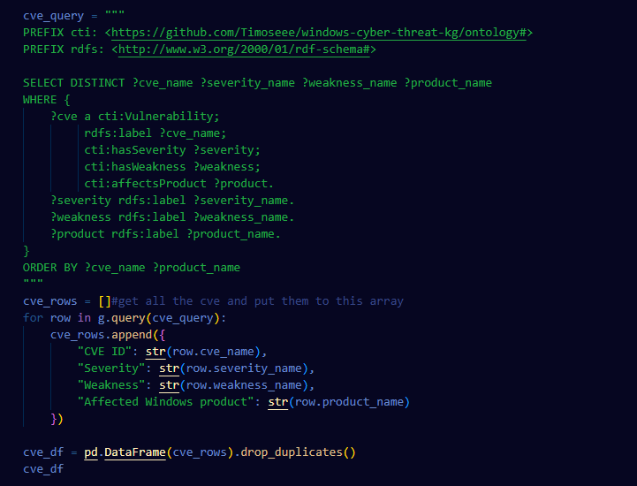
In the code, I use SELECT DISTINCT to remove duplicate rows. After getting all the results, I convert them into a pandas DataFrame and use it to calculate the number of Windows products affected by each CVE.
The second query is to count threat actors and their related attack techniques.
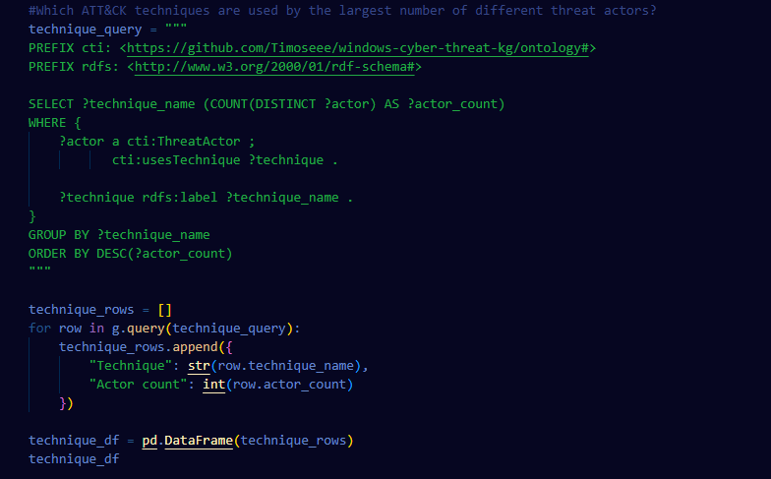
Like the first query, DISTINCT will count each threat actor for each technique only once. Then GROUP BY will generate every technique for a new row, and ORDER BY DESC means the technique used most will be placed first. Although the query didn’t filter Windows operating systems, all the data in the knowledge graph is about Windows. Therefore, we don’t need to filter again.
The last query integrates data from ATT&CK and CVE. The query is applicable to both threat actors, techniques, and affected products.
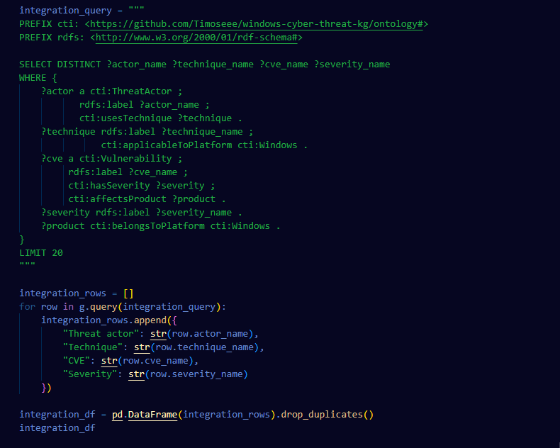
The query uses the Windows platform to summarize both data sources into one table. It doesn’t indicate that the actor uses certain technology. It only proves that the ATT&CK and CVE records are all related to Windows.
7
The data science pipeline is implemented in `analysis.ipynb`. This notebook uses RDFlib to download the ontology and instance TTL file of this project from GitHub. Then the notebook loads these two files into an RDF graph. The notebook uses an SPARQL query to get data from the graph we just loaded. After we get the data, it will be converted to a pandas DataFrame for better analysis and visualization.
The first analysis notebook uses CVE to get every vulnerability’s name, severity, weakness, and affected product. All the results will be stored in cve_df. Then the notebook uses the ‘groupby()’ and ‘nunique’ functions to calculate the number of different affected Windows products for each CVE and severity combination. The outcome will be stored in ‘summary ’ and shown in a bar chart named: “Number of Windows Products Affected by Each CVE”. This analysis answers which Windows products will be influenced by the technology related to the CVE.
The second analysis uses a technology query to calculate the number of threat actors related to each imported ATT&CK technique. All data is stored in ‘technique_df ’ and shown in the bar chart named "Threat Actors Using Each Windows ATT&CK Technique". This chart supports analysis of selected Windows techniques and shows the technique with the highest number of related threat actors.
Finally, I performed an integrated query and stored all the data into ‘integration_df ’. This result contains threat actor, technique, CVE ID, and severity level. The table shows that the notebook can get both information from ATT&CK and CVE. Then, doing the analysis does not mean that an actor will use a certain CVE.
8
This project shows that a knowledge graph can integrate information from different cybersecurity sources. Meanwhile, it can keep its semantics for every data point. Based on the Windows platform, it can help me manage it more easily, and I’m more familiar with Windows. The knowledge graph separates ontology and instance into two different TTLs. It can easily add more instances in the future if needed.
However, there is one major limitation during building the project. Currently, the knowledge graph only uses a selected ATT&CK and CVE data sample rather than a full dataset. Meanwhile, even though I integrated two sources, there is no clear source that can prove there is a direct relationship between the two sources. For now, the knowledge graph cannot infer whether a specific threat actor exploited a specific vulnerability. So, in future work, I will focus on adding more CVEs and ATT&CK techniques. Also, I will try to find relationships that can prove a relationship between two sources.

Generative AI is used in this project as a tool for brainstorming, searching, and summarizing. It is used to explain technical terms about cybersecurity and build my basic understanding of cybersecurity. The author did ontology design, data selection, coding, handling queries, and building the knowledge graph.

