Spletni portal za vizualizacijo podatkov

Maturitetna naloga

Avtor: Mentor:

Timotej Žavski Mentor: Koren Jaka prof. strok. predmetov

Table of Contents

Ozadje in cilji 3

Spletni portal za vizualizacijo podatkov 4

Arhitektura 4

Uporabnikova Izlušnja 4

AI generirana koda 4

Implementacija in integretacija 4

References 5

Footnotes 6

Tables 7

Figures 8

Uvod

V prihajajočih straneh boste brali o spletni aplikaciji ali drugače rečeno o spletnem orodju, ki sem ga razvil.

# Arhitektura

[The first two heading levels get their own paragraph, as shown here. Headings 3, 4, and 5 are run-in headings used at the beginning of the paragraph.]

# Uporabnikova Izlušnja

[To update the table of contents (TOC), apply the appropriate heading style to just the heading text at the start of a paragraph and it will show up in your TOC. To do this, select the text for your heading. Then, apply the style you need.]

AI generirana koda. [Include a period at the end of a run-in heading. Note that you can include consecutive paragraphs with their own headings, where appropriate.]

Implementacija in integretacija. [When using headings, don’t skip levels. If you need a heading 3, 4, or 5 with no text following it before the next heading, just add a period at the end of the heading and then start a new paragraph for the subheading and its text.] (Last Name, Year)

Povzetek. [Like all sections of your paper, references start on their own page, as shown on the page that follows. The body of the References section uses the Bibliography style. For more detailed information on formatting references, see the APA Style Manual, 6th Edition. (Last Name, Year)

References

Last Name, F. M. (Year). Article Title. *Journal Title*, Pages From - To.

Last Name, F. M. (Year). *Book Title.* City Name: Publisher Name.

Footnotes

1[Add footnotes, if any, on their own page following references. For APA formatting requirements, it’s easy to just type your own footnote references and notes. To format a footnote reference, select the number and then apply the Footnote Reference. The body of a footnote, such as this example, uses the Normal text style. (Note: If you delete this sample footnote, don’t forget to delete its in-text reference as well.)]

Tables

Table 1

[Table Title]

|  |  |  |  |  |
| --- | --- | --- | --- | --- |
| Column Head | Column Head | Column Head | Column Head | Column Head |
| Row Head | 123 | 123 | 123 | 123 |
| Row Head | 456 | 456 | 456 | 456 |
| Row Head | 789 | 789 | 789 | 789 |
| Row Head | 123 | 123 | 123 | 123 |
| Row Head | 456 | 456 | 456 | 456 |
| Row Head | 789 | 789 | 789 | 789 |

Note: [Place all tables for your paper in a tables section, following references (and, if applicable, footnotes). Start a new page for each table, include a table number and table title for each, as shown on this page. All explanatory text appears in a table note that follows the table, such as this one. Use the Table/Figure style to get the spacing between table and note. Tables in APA format can use single or 1.5 line spacing. Include a heading for every row and column, even if the content seems obvious. To insert a table, on the Insert tab, tap Table. New tables that you create in this document use APA format by default.]

Figures

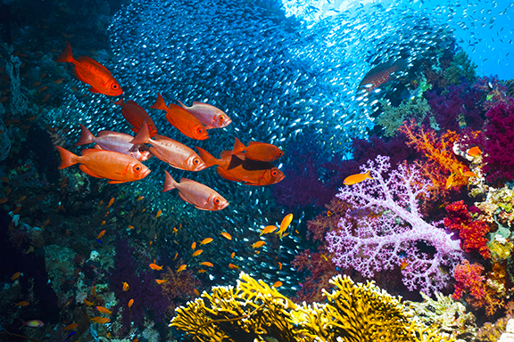

Figure 1. [Include all figures in their own section, following references (and footnotes and tables, if applicable). Include a numbered caption for each figure. Use the Table/Figure style for easy spacing between figure and caption.]

For more information about all elements of APA formatting, please consult the APA Style Manual, 6th Edition.