1. git log --oneline
Output:
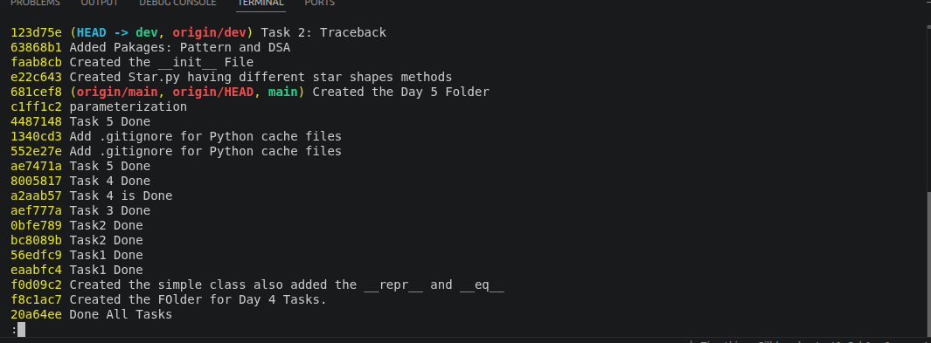
The git log --oneline command displays the commit history of a Git repository in a short and easy-to-read format. Each line represents one commit and contains a short commit hash followed by the commit message. In my output, the latest commit is 123d75e with the message "Task 2: Traceback", which means this is the most recent snapshot of my project. The label (HEAD -> dev, origin/dev) indicates that my current branch is dev, the HEAD pointer is currently pointing to this branch, and the remote branch origin/dev is also at the same commit. Each commit shown in the log represents a complete snapshot of the repository at that moment in time, not just the changes made. For example, the commit "Added Packages Pattern and DSA" represents the version of my project after I added the package structure, while "Created the init File" represents the snapshot after adding the package initialization file. This command helps me review the history of my project and understand how it evolved over time.

2. git diff main
Output:
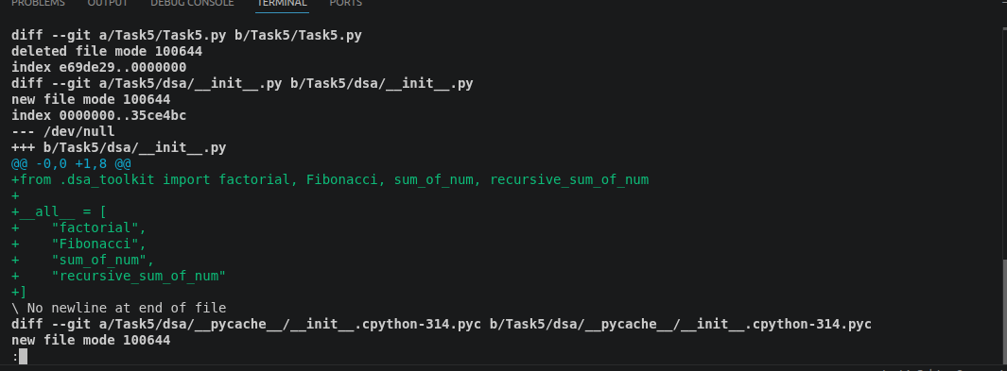
The git diff main command compares my current branch (dev) with the main branch and displays all the differences between them. It shows which files have been added, modified, or deleted, along with the exact lines that have changed. In my output, Git indicates that Task5.py was deleted and that a new file, Task5/dsa/__init__.py, was added. The lines beginning with a + symbol represent code that has been added in my current branch. For example, I added the statement from .dsa_toolkit import factorial, Fibonacci, sum_of_num, recursive_sum_of_num, along with the __all__ list that specifies which functions should be publicly available when the package is imported. This diff allows me to verify exactly what changes I have made before creating a pull request or merging my branch into main. It is also the same information that reviewers see when they review a pull request.

