Practical 2

Timothy Whitaker u22744968 Stefan Jansen van Rensburg u22550055

University Of Pretoria

COS 221

# Task 1:

* User
* Client
* Branch
* Account
* ATM
* Contract
* CIT
* Transactions

# Task 2:

* Client (client_id, fullname (name, surname), age, sex, location(address, postal_code), contact_details, total_money)
* Branch (branch_code, locations, open_hours, open_days, contact_details)
* Account (acc_number, client_id, acc_type, balance, branch_code)
* ATM (atm_id, location (address, postal_code), last_filled_date, cash_available, branch_code)
* Contract (contract_code, cit_code, start_date, end_date)
* CIT (cit_code, name, location(address, postal_code))
* Transaction (acc_number, transaction_type, date, amount, source)

# Task 3:

* Branch Locations:
  + Branch_Locations (branch_code, location(address, postal_code))
* Contact Details:
  + Branch_Contact (branch_code, contact_details(cell_number, email_addr))
* Contact Details:
  + Client_Contact (client_id, contact_details (cell_number, email_addr))

# Task 4:

* Client – total_money is derived from all the accounts that belong to the client.

# Task 5:

Yes - contact_details can be null if the client does not have contact details e.g. no phone or email.

# Task 6:

6.1. No, a time limit would need to be added to the account entity for this to be possible.

6.2. Yes, this model allows for any denominated account as it has no restrictions on denominations due to the use of the ‘money’ type.

6.3. No, the model would need to store the users details to achieve this.

6.4. Yes, this model stores the cell phone number and email address of a client. Additionally, the ID number of the client could be saved.

# Task 7:

# Task 8:

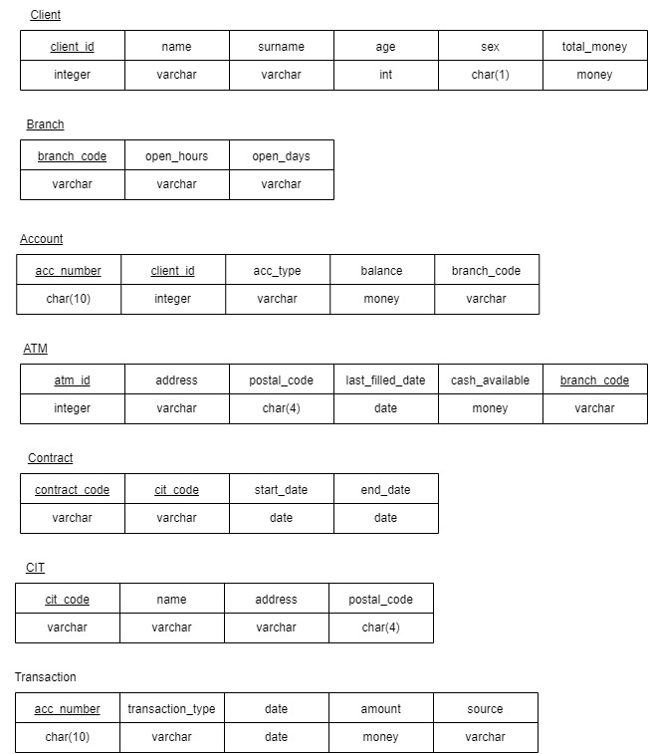Step 1+2: Mapping of regular and weak entity types. – Regular and weak entity types were added, and primary keys and foreign keys were added. Composite attributes were broken down into simple attributes.

Step 3-5: Mapping of relationship types – 1:1, 1:n, m:n relationships were mapped.

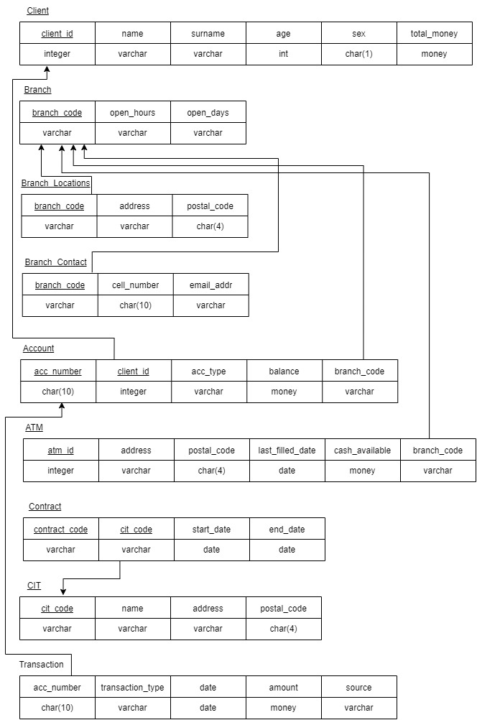Step 6-7: Mapping of multivalued attribute – All attributes that are multivalued were broken down into new relations.