COS 221 Practical 4

u22744968

Timothy Whitaker

2023

# Task 2:

2.1. My chosen canned application is MySQL Workbench since it was already installed the installation screen gives different options.

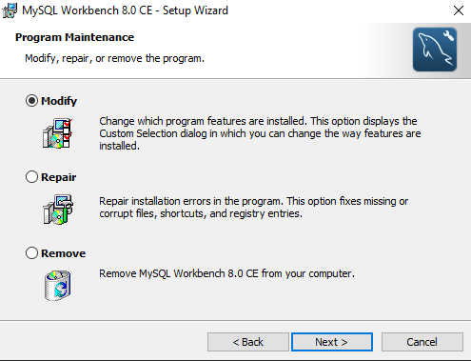

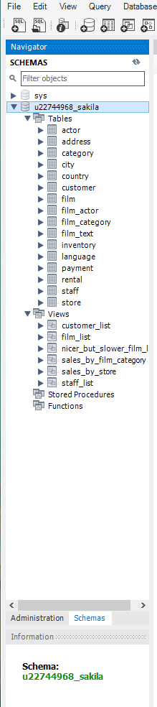2.2.

# Task3:

3.1.

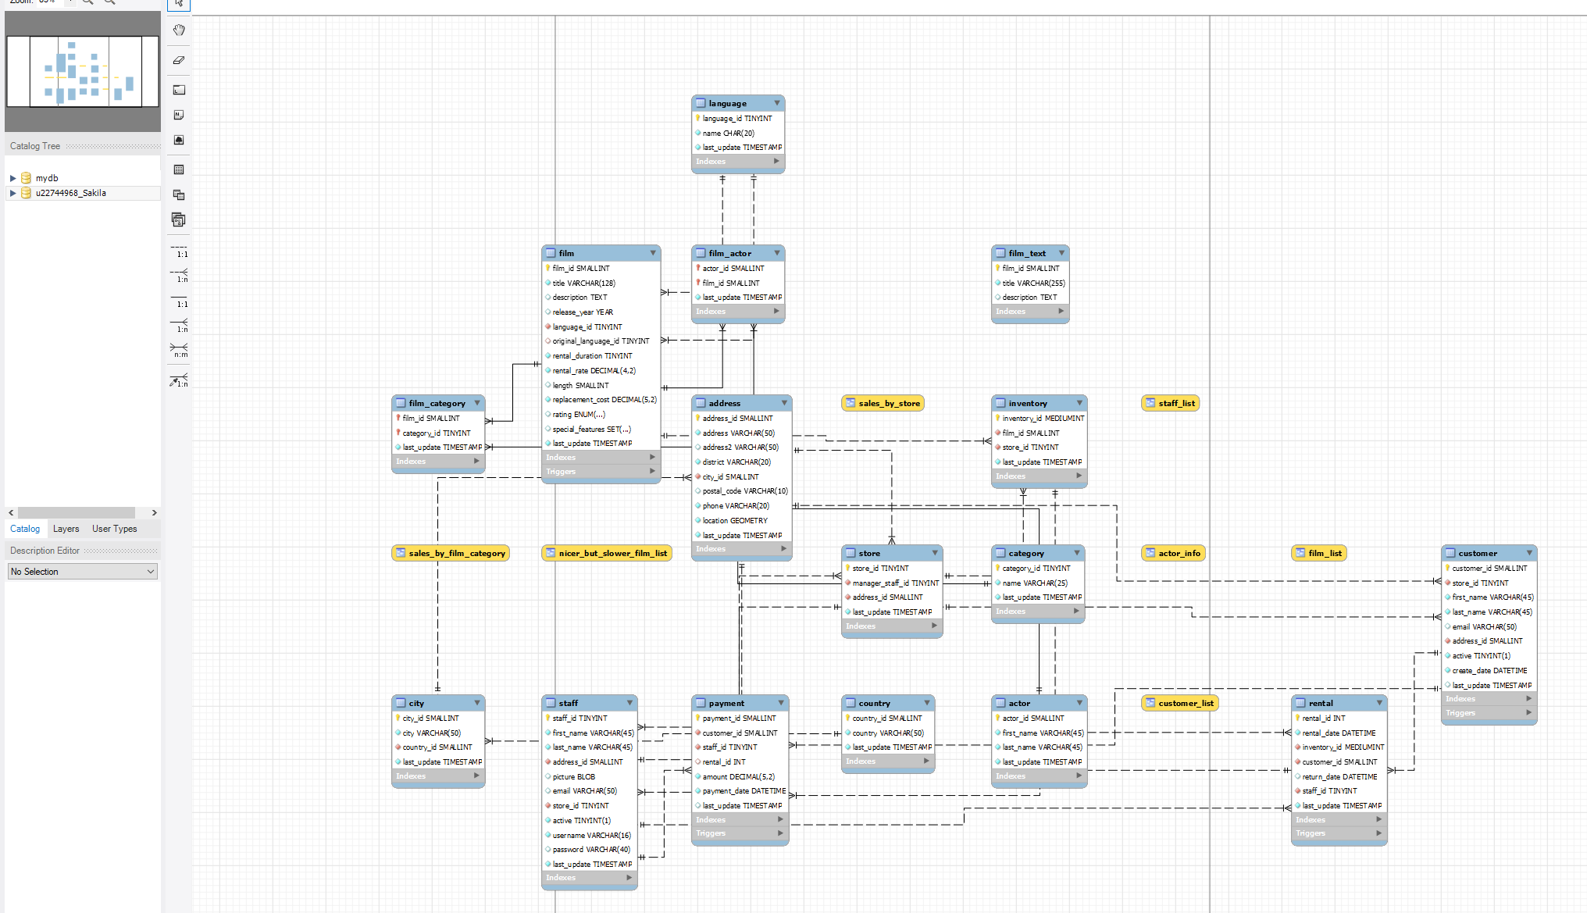

3.2.

Store(store_id, manger_staff_id, address_id, last_update)

store_id : Is stored as a TINYINT of maximum 3 digits, cannot be null, must be positive (unsigned) and is auto incremented. It is the Primary Key and links to the staff table foreign key with a 1:n relation – that is 1 store can have n staff.

manager_staff_id Is stored as a TINYINT of maximum 3 digits, cannot be null, must be positive (unsigned) and must be unique. It is a foreign key that that links to the staff table primary key with a 1:n relationship – that is 1 manager can manage n stores.

address_id: Is stored as a SMALLINT of maximum 5 digits, cannot be null and must be positive (unsigned). It is a foreign key that links to the address table primary key with a 1:n relation – that is 1 address can have multiple stores.

last_update: Is stored as a TIMESTAMP and cannot be null. Its default value is the current timestamp of when the table was last updated.