Ballistic Gelatin Testing and
the Analytic Hierarchy Process

Short Abstract:

After the 1986 Miami Shootout, the FBI analyzed the gunfight. They concluded that agents were unnecessarily injured and killed because the ammunition they used lacked “stopping power”. They determined criteria for better ammunition. This project applies those criteria and models them using the Analytic Hierarchy Process (AHP) to look at 6 types of ammunition and see which of the six would have best suited the FBI that day. The result of the AHP indicates that .357 Magnum Winchester 125 gr PDX1 Defender best meets the criteria.

Medium Abstract:

The 1986 Miami Shootout was one of the most devastating gunfights in law enforcement history. It pitted eight FBI agents against two banks robbers. Two FBI agents were killed, five were wounded, and one was uninjured. Both bank robbers were eventually killed, but one was shot six times and the other twelve times before succumbing to gunshot wounds. The fact that the bank robbers were able to keep fighting, even though heavily wounded, led the FBI to doubt the “stopping power” of their ammunition. The FBI agents were armed with revolvers chambered for .357 Magnum, revolvers chambered for .38 Special, and semi-automatic handguns chambered for 9mm. Revolvers chambered for .357 Magnum can fire .357 Magnum, .38 Special, and .38 Special +P ammunition. The FBI agents were all using .38 Special or .38 Special +P ammunition that day.

In the aftermath of the gunfight, the FBI decided to determine what type of ammunition would offer sufficient “stopping power”. They concluded that the ammunition would need to penetrate 12”-18” into ballistics gelatin and reliably expand to meet their needs. This project also includes kinetic energy as a criterion.

This project looks at revolver ammunition and uses the Analytic Hierarchy Process (AHP) to determine which of six types of ammunition would have best met the FBI requirements during the 1986 FBI Shootout. The result of the AHP indicates that .357 Magnum Winchester 125 gr PDX1 Defender best meets the criteria.

Introduction:

After the 1986 Miami Shootout the FBI concluded that the type of ammunition used by the FBI lacked “stopping power”. In the aftermath, they set out to find a better round to use. They concluded that the new round must penetrate 12”-18” and reliably expand. Ultimately, they decided on a round called the 10mm Auto. Although this round produced the result they were looking for, it was also very high in recoil and difficult for agents to manage. They would later adopt the .40 S&W round. Other law enforcement agencies also followed suit. However, since 1986 bullet designs have changed and law enforcement agencies have changed back and forth between various rounds (9mm, .40S&W, .357 Sig, and .45 ACP). They haven’t gone back to revolvers, not because of the round, but because of the lack of ammunition capacity.

This project will look at currently manufactured rounds that could have been fired from the revolvers used by the FBI agents during the shootout. The project will focus on .38 Special, .38 Special +P, and .357 Magnum. Note that none of the FBI agents carrying .357 Magnum chambered revolvers were actually using .357 Magnum ammunition that day; they were using .38 Special +P, which has a lower velocity. The project focuses on these rounds because they all have the same diameter (.358 in.), can be fired from the same gun, could have been used that day if they had been available, and have a wide spectrum of velocity that ranges from 700 ft/s to about 1,900 ft/s. Since kinetic energy is .5mv², mass, and particularly velocity, have a great effect on the energy dump into a target.

Since there are multiple criteria for finding the ammunition with optimal stopping power, we cannot simply optimize one characteristic. Therefore, we must look at all criteria and prioritize it. The Analytic Hierarchy Process (AHP) allows for multiple criteria to be analyzed, prioritized, and weighted. We will be using three criteria for analyzing the ammunition. We will analyze penetration, expansion, and kinetic energy. Although kinetic energy wasn’t specifically part of the FBI guidelines, it allows us to see when the round does penetrate, expand, and stop, how much energy in ft*lb it imparts to the ballistic gelatin.

AHP has four steps:

- Decomposing the decision making process into a hierarchy
- Making pairwise decisions and establishing priorities among the elements in the hierarchy
- Synthesizing judgments to obtain a set of overall weights for achieving the goal
- Evaluating and checking the consistency of judgments

We have three criteria: penetration will be the first priority, reliable expansion the second priority, and kinetic energy the third priority.

We will analyze the following six types of ammunition:

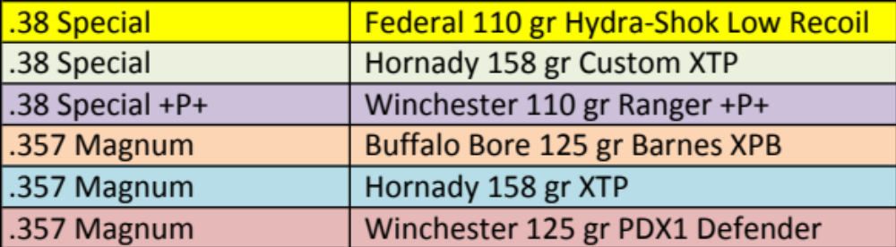

Using AHP we will determine which one of these best fits our set of criteria.

Model:

We will use the following data for our model:

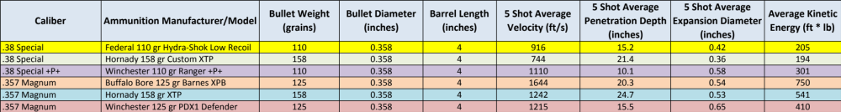

The first step in AHP is to determine the criteria hierarchy (in order of importance), which is:

- Penetration – First priority
- Reliable Expansion – Second Priority
- Amount of Kinetic Energy – Third Priority

Then we will make pairwise comparisons of each type of ammunition to each other type of ammunition and determine, using a rating scale, how much one contributes to each priority criterion compared to how much the other contributes to each priority criterion in relation to each other.

There will be n-choose-2 pairs, so in our case 6-choose-2 = 15 pairs.

We use the following guidelines:

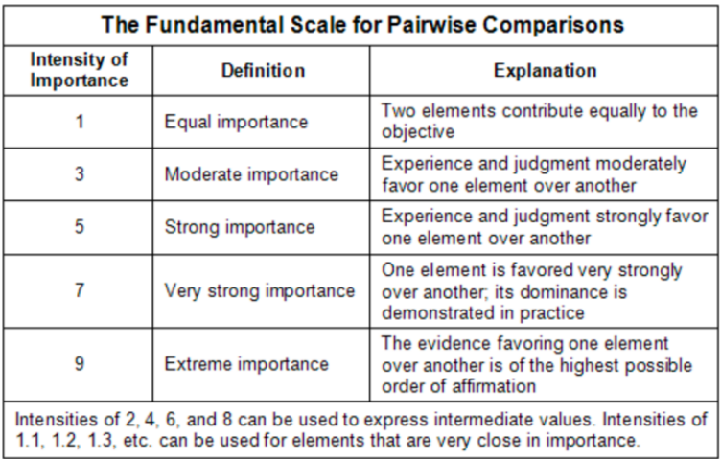

For example: Penetration

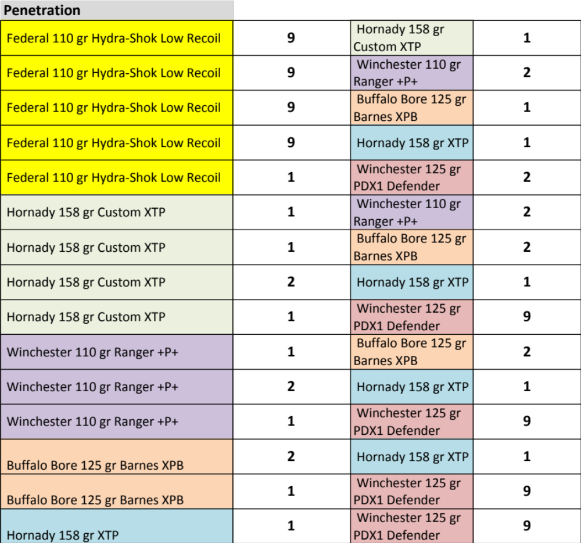

We specifically look at, how each pair compares when looking at how each contributes to the criterion at hand. In this pairwise example, .38 Special Federal 110 gr Hydra-Shok Low Recoil contributes much more positively to the 12”-18” penetration criterion we are looking for compared to .357 Magnum Hornady 158 gr XTP because the Federal averages 15” (right in the middle) whereas Hornady over-penetrates at 24.7” (which in a real case scenario could hit innocent bystanders behind the target). Although this comparison is not “exact” there is a check and balance system built into AHP which we will discuss shortly.

All criteria must be compared for each type of ammunition. Once all of the pairwise comparisons are made, the results must be put into a matrix. In the matrix, the row item is compared to the column item. Looking back at the pairwise comparisons, if the number for the row item is greater than the number for the column item, that space is filled by that greater number. If the number for the column item is greater, then the space is filled with the value of the smaller number divided by the larger number. This is best seen with an example.

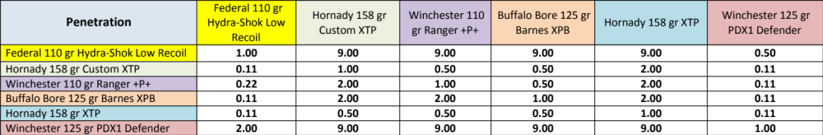

Note that each ammunition type compared with itself is equal to one, since when compared, they contribute equally.

The next step is to square the matrix, which will result in matrix M2, then we square matrix M2, resulting in matrix M3, then we square matrix M3, resulting in matrix M4.

We then find the normalized eigenvectors of matrix M4 and these become our priority rankings for each ammunition type.

Matrix 4:

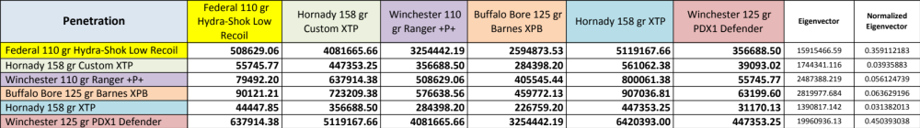

Priority Rankings (Set next to Matrix 1):

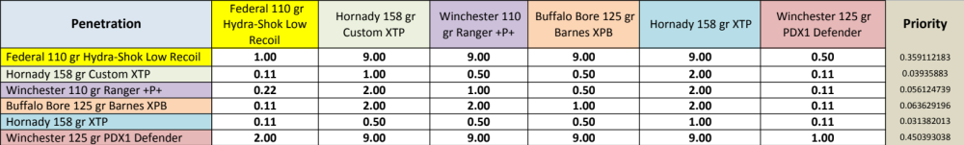

Next, we must check the validity of our work. We first determine weighted rankings for each row in Matrix 1.

Row 1 would be calculated as follows:

1(0.359112183) + 9(0.03935883) + 9(0.056124739) + 9(0.063629196)+ 9(0.031382013) + 0.5(0.450393038) = 2.298761709

The following rows are calculated using the same scheme resulting in:

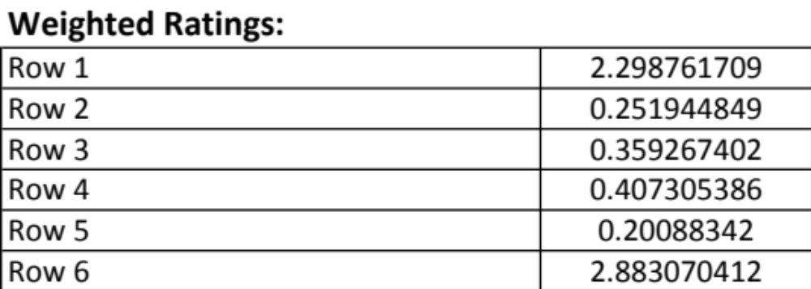

We then must find an approximation of Lambda(max) which is found by dividing each weighted row by the associated priority, thus row one is calculated using:

(2.298761709)/(0.359112183) = 6.401235648

The following rows are calculated using the same scheme resulting in:

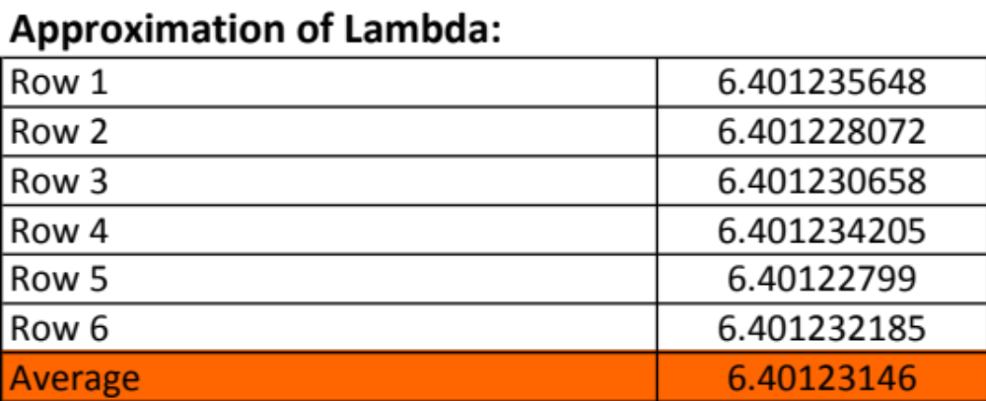

The first check for validity is to note whether or not Lamdba Average is approximately equal to n, which it is in this case. It is valid.

Next we determine the consistency index (CI) using the formula:

CI = (Lambda(max) - n)/ (n-1), where n is the number of elements that we compared in matrix 1. In this case:

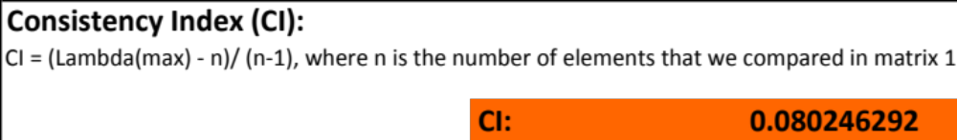

Finally we must determine the consistency ratio (CR). This is what tells us whether there is inconsistency in our pairwise comparisons, which would lead to inaccuracy in our final results. A CR > 0.10 indicates that there is a concern of inconsistency in our pairwise comparison.

CR = CI/RI

RI is determined by looking up the Alonso and Lamato value for RI found at:

https://pdfs.semanticscholar.org/13f1/b74fb9cb5764e399cf213a01274ade280d06.pdf

In this case RI = 1.2479

This gives us a final CR of:

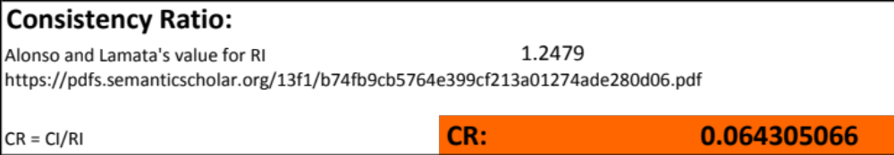

For penetration we see that our CR < .10 and can conclude that our pairwise comparisons are consistent.

Once priority rankings are determined for all criteria, we must rank the criteria itself using the same method.

For this project, a template using “if” statements was created in Excel. This allowed for all calculations to be done simply by adjusting the comparison numbers.

The final calculations multiply the criterion weight by the priority score for each type of ammunition for that criterion giving a total weighted score for each criterion for each ammunition type. The total weighted scores are summed for each ammunition type and this results in a final score for the ammunition type itself (ranging over all criteria). The final scores are compared and ranked. In this case .357 Magnum Winchester 125 gr PDX1 Defender ammunition ranked number one overall.

Results:
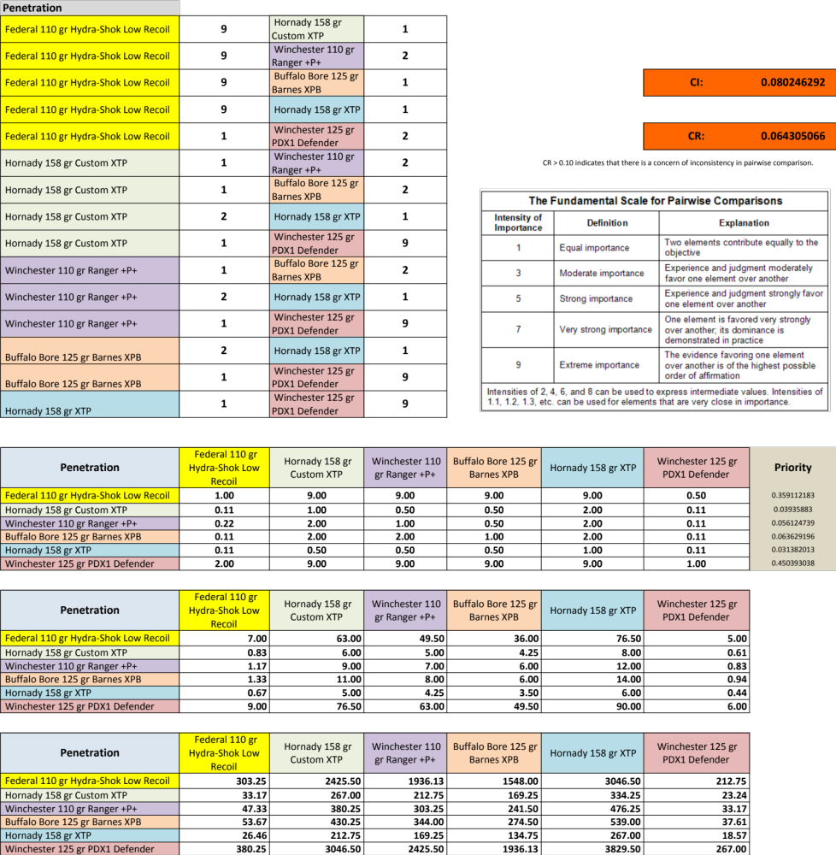

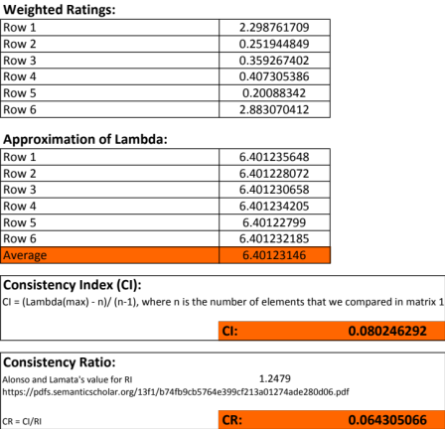

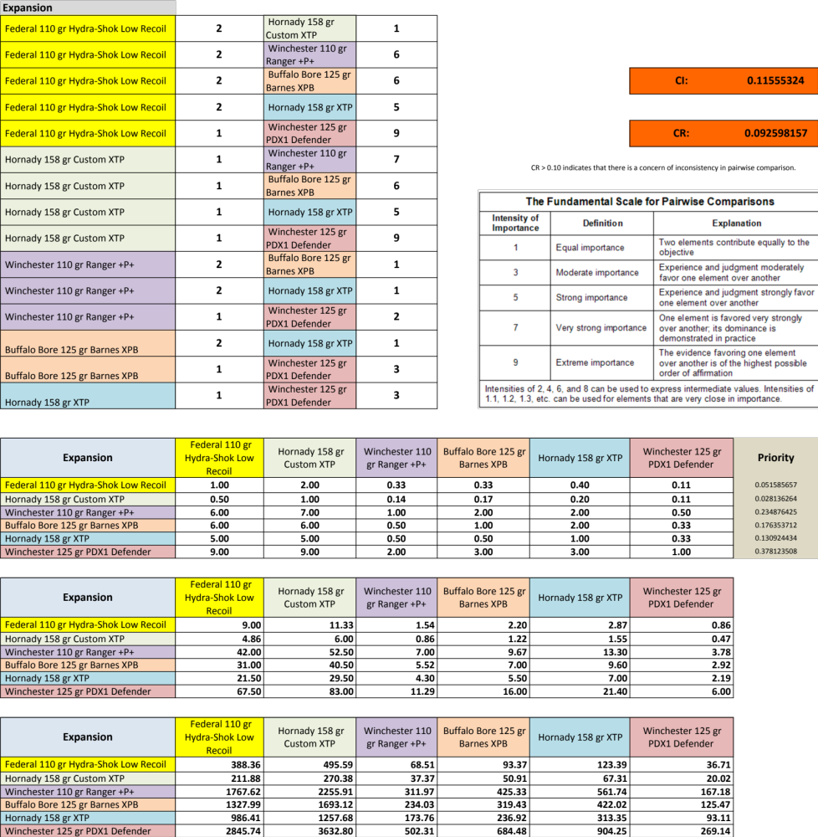

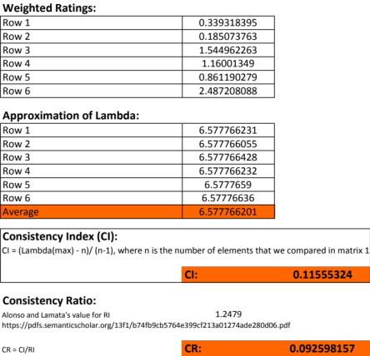

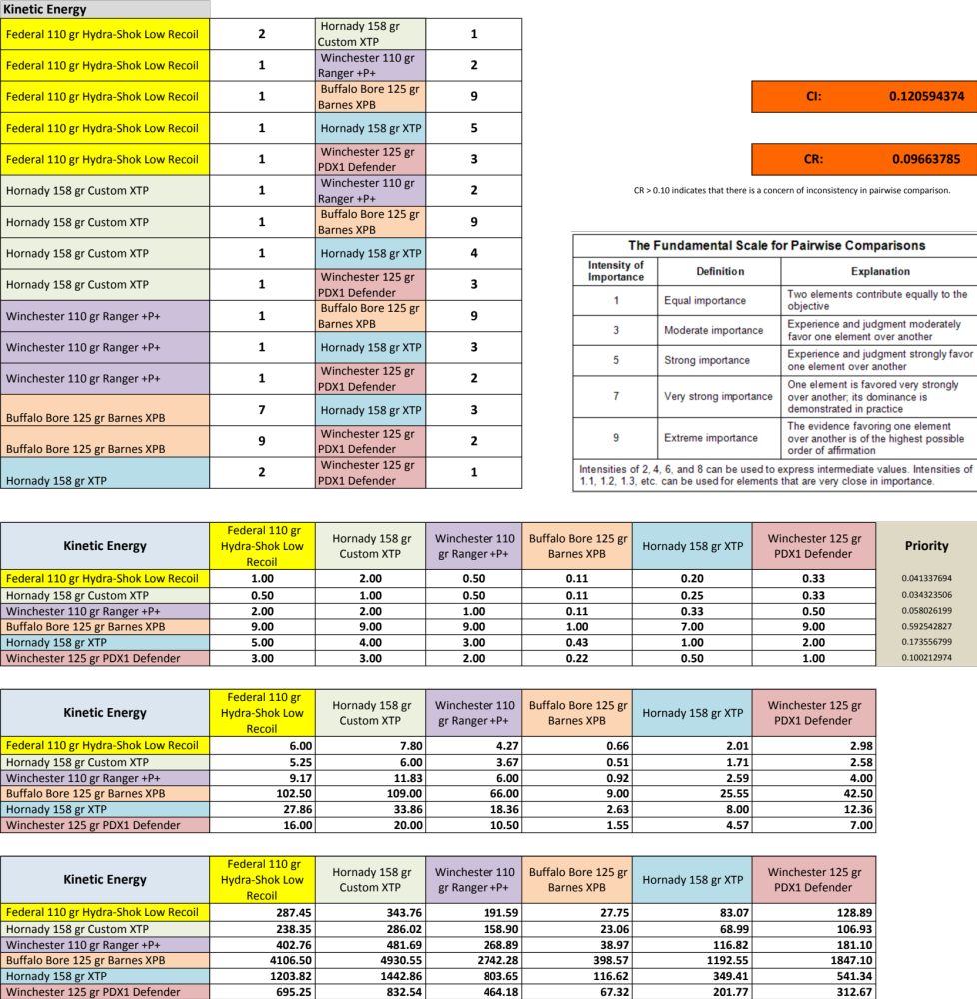

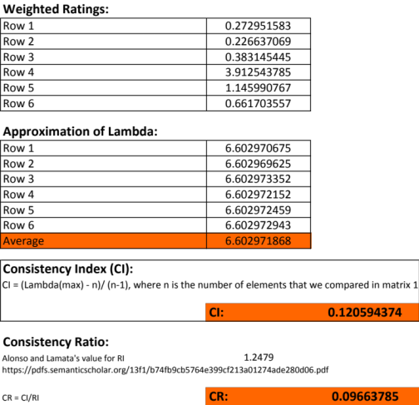
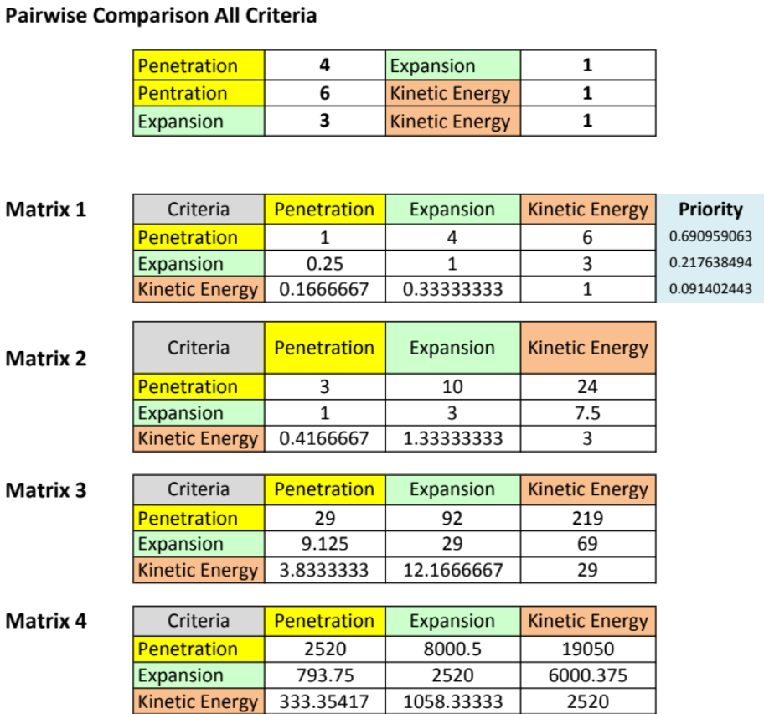

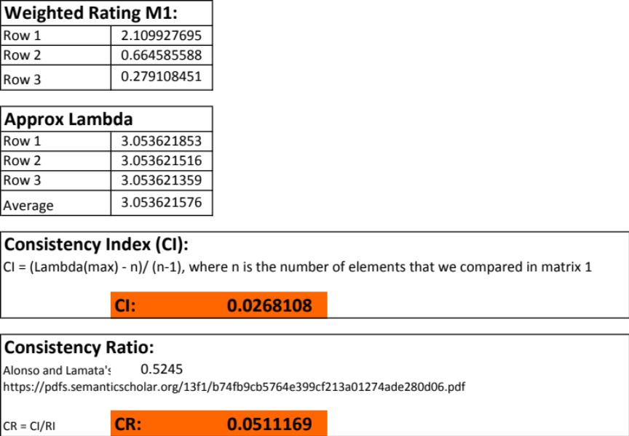

Final Rankings:

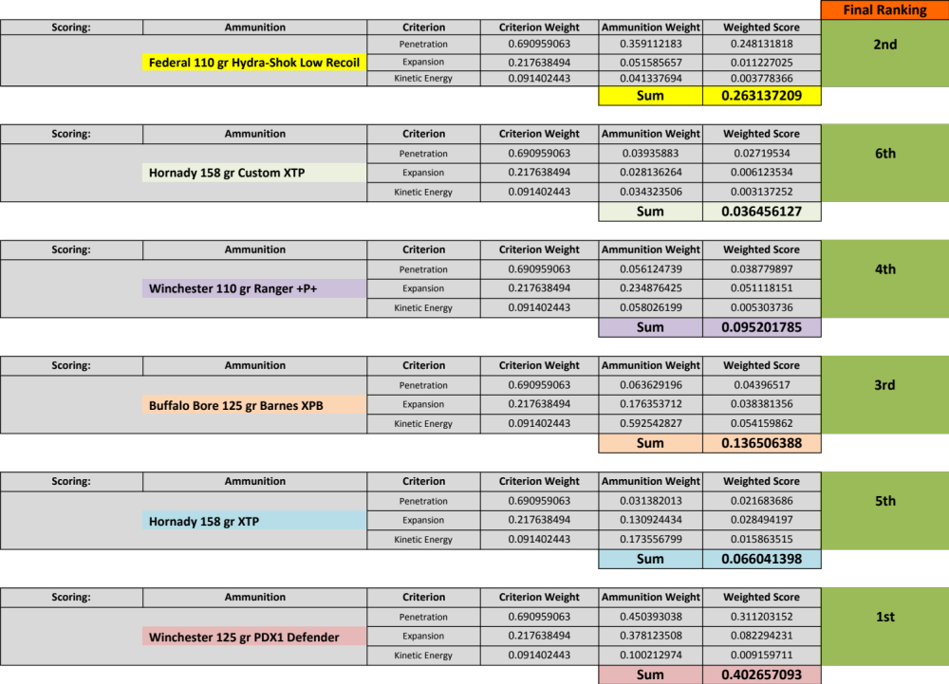

Conclusions:

Since the CR < .10 for all calculations, we can conclude that our pairwise comparisons were consistent. The ammunition type .357 Magnum Winchester 125 gr PDX1 Defender ranked number one. Looking at the data we see it has 15.5” of penetration, 0.65 inches of expansion, and 410 ft*lb of kinetic energy. We must note that in a real world situation, recoil would also be an important part of the criteria for this model. Unfortunately, we cannot calculate recoil without knowing exactly how much powder was used to manufacture each ammunition type. Recoil is the most likely reason that the FBI agents were using .38 Special +P ammunition instead of .357 Magnum ammunition. It is also the reason that the first round chosen by the FBI after their ballistic gelatin tests, the 10mm Auto, was later dropped for the .40 S&W. It is interesting to note that the second best ranked ammunition type is low-recoil .38 Special ammunition. Looking at the data, we can also see that bullet design must play a role in both penetration and expansion as Winchester Ranger 110 gr. +P+ has a higher velocity than Federal 110 gr Hydra-Shok Low Recoil, but penetrates less.

It should be noted that these six ammunition types were chosen from a list of over seventy ammunition types specifically because they could illustrate the AHP process, not because they were the best contenders. Although the Buffalo Bore ammunition came in third place, it can be seen that this is because of its failure to satisfy the penetrate criterion because it over-penetrates. It does not mean it lacks stopping power, as it penetrates more than enough to breach gelatin, expands, and carries a large amount of kinetic energy. Thus Buffalo Bore failed not because it lacked “stopping power”, but because it may have too much stopping power. If it does over-penetrate it will also not dump all of its kinetic energy into the target.

Looking at the six ammunition types, the final conclusion may have been clear from looking at the data. However, this project shows that the AHP process works. If we had more criteria it would be more difficult to pick out a winner at a glance.

Real world usage of AHP for ammunition testing would likely have the following added criteria: recoil, handgun ammunition capacity, flash, noise, gun weight, reload speed, and fire rate. These would obviously increase the size of the matrices and make for many more calculations.

Bibliography:

Modern Reloading (2nd Edition) by Richard Lee 2011

Consistency in the Analytic Hierarchy Process: A New Appraoch
Jose Alonso and M. TeresaLamata scores – (May 15, 2006)
https://pdfs.semanticscholar.org/13f1/b74fb9cb5764e399cf213a01274ade280d06.pdf

Lucky Gunner Labs – Chris Baker - (April 4, 2017)
http://www.luckygunner.com/labs/revolver-ballistics-test/#357mag

How to Do AHP Analysis in Excel – (March 1, 2012)
Khwanruthai Bunruamkaew
file:///Users/StandardUser/Downloads/How%20to%20do%20AHP%20analysis%20in%20Excel.pdf

Analytic Hierarchy Process - (Accessed - June 11, 2017)
https://en.wikipedia.org/wiki/Analytic_hierarchy_process

AHP Exercise Project for Project Management – (No Date)
http://www.ccunix.ccu.edu.tw/~kcchen/PM/Exercises/AHP/AHP1%20Example%201%20-%20Extended.xlsx

https://en.wikipedia.org/wiki/1986_FBI_Miami_shootout - (Accessed - June 11, 2017)

Appendix A:

Proposal 1:

Introduction:

Since the invention of smokeless powder in 1884, modern firearms and ammunition have gone through an extensive evolution process. Numerous guns and calibers have come and gone, but the most reliable and effective have managed to stick around for over one hundred years. From the mid-nineteenth century until the present day firearms have become a mainstay of hunting, sport target shooting, law enforcement, crime, and self-defense. Like many tools, firearms have evolved over time to become more efficient and effective. The military and law enforcement are always on the leading edge of firearms technology. However, in terms of effectiveness, it is the ammunition that provides the end result, whether that is hitting a target, stopping a bad guy, or putting meat on the table. Unfortunately, some choose to use these tools for purposes detrimental to society such as robbery, murder, and intimidation.

What we are going to look at here is a case of the “good guys” versus the “bad guys”. The impetus for this modeling project is a 1986 bank robbery spree that ended in what is now known as the infamous 1986 FBI Miami Shootout. The full details of the case can be easily found on the Internet. The details we are interested are:

- 8 FBI agents engaged in a firefight with 2 bank robbers
- 2 of the FBI agents were killed and 5 were injured
- The 2 bank robbers were military veterans with combat experience and heavily armed
- The bank robbers were shot multiple times, but survived long enough to continue fighting, thus wounding and killing FBI agents
- The FBI determined after the shootout that the ammunition used by the FBI agents were inadequate, thus they began the most extensive testing ever done to determine which firearm and cartridge would prove adequate for FBI field agents
- They used ballistics gelatin and a host of other tools to perform these tests
- The ammunition used by the FBI agents in the shootout consisted of 9mm (semi-auto), .38 Special +P (revolver), and 00 Buckshot (shotgun). Most of the FBI agents had revolvers chambered in .357 Magnum, but were loaded with .38 Special +P ammunition

For this modeling project we will take a close look at handgun ammunition. The .358 class of ammunition makes an excellent specimen for us to look at. The firearm for our model is a 4 inch revolver chambered to fire .357 Magnum ammunition. Although .38 Special and .357 Magnum appear to be different rounds, their designated names are misleading. Both the .38 Special and .357 Magnum fire a bullet that is .358 inches in diameter, and in fact a revolver chambered in .357 Magnum can fire .38 Special, .38 Special +P, and .357 Magnum ammunition. This is exactly what the FBI agents were doing, they had .357 Magnum revolvers loaded with .38 Special +P ammunition. This ammunition, as well as the 9mm ammunition used by one of the agents, proved to have inadequate stopping power in the 1986 Miami Shootout. We will note that 9mm ammunition is .356 in. in diameter, thus in terms of diameter 9mm .358.

Since the .358 class of ammunition offers a wide spectrum of possible “stopping power” levels, it is an excellent fit for our model. FBI and law enforcement have since concluded that .38 Special is the minimum (marginally) acceptable “stopping power” round for defensive purposes and that .357 Magnum is a top performer in terms of “stopping power”. Within these categories there are, however, differences. For example, .357 Magnum can be loaded to extremely high pressures making it difficult to shoot (loud, high recoil, difficult follow-up shots), and thus less effective as a practical piece of ammunition. Thus, just saying that a round is .357 Magnum doesn’t tell us where it lies in terms of velocity, bullet weight, or bullet type. Since, the .358 class of ammunition includes .38 Special, .38 Special +P (an intermediate .358 round loaded to higher pressure than standard .38 Special but not yet to the level of .357 Magnum) and .357 Magnum, we will attempt to find the optimal loading for a defensive handgun round within the .358 spectrum.

The factors that we will look at are:

- m = mass = bullet weight (measured in grains [1 grain = 1/7,000 pounds)
- v = velocity in ft/s
- ke = kinetic energy = .5mv² in ft*lbs
- r = free recoil energy in ft*lbs
- p = penetration in inches
- expansion = increase in bullet diameter as travels through gel in inches

The FBI tests concluded that the ideal round penetrates 12”-18” in ballistics gel and reliably expands. It must dump as much kinetic energy as possible while limiting recoil so that it can be fired accurately and follow-up shots can occur. Over-penetration leads to both possible unintentional collateral damage behind target and loss of kinetic energy dump into the target.

We will impose the following constants: 4” Ruger GP100 (40 ounce) revolver with 4.2 inch barrel, a hollow point bullet weighing 125 grains, the same powder for all loadings.

Since kinetic energy is directly related to mass and velocity, our powder load will determine velocity. The following velocities are general guidelines for the three rounds in the .358 class of ammunition we are looking at (nobody ever really agrees on the exact number – but they are always close):

- .38 Special can be loaded from about 700 ft/s to 900 ft/s
- .38 Special +P can be loaded from about 900 ft/s to 1200 ft/s
- .357 Magnum can be loaded from about 1100 to 1900 ft/s

We must note that there is some overlap. As .38 Special +P reaches its maximum allowable pressure it is right around the minimum pressure for .357 Magnum. This is because the .357 Magnum was designed to push the .38 Special to the next level. It does this by using a longer (but same diameter) case, which allows for more gunpowder, thus higher velocities. This is why all revolvers chambered in .357 Magnum can fire .39 Special ammunition.

Proposed Work:

Goal: Put ourselves in the position of one of the FBI agents armed with a .357 Magnum revolver and determine the optimal piece of .358 diameter ammunition for stopping a “bad guy”. We must:

- Penetrate 12”-18” into ballistics gel (without over-penetration)
- Achieve bullet expansion (overcome a minimum velocity)
- Determine velocity that offers the most ke while avoiding over-penetration and allowing for manageable recoil (to be determined). Velocity must be at least of a high enough magnitude for the projectile to leave the barrel.
- [Optionally minimize flash and decibels]

Methodology: Use the Analytic Hierarchy Process (AHP) and Excel to formulate the best solution to reach our goal. (Information directly from www.researchgate.net). This involves:

- Decomposing the decision making process into a hierarchy
- Making pairwise decisions and establishing priorities among the elements in the hierarchy
- Synthesize judgments to obtain a set of overall weights for achieving the goal
- Evaluate and check the consistency of judgments
- Use Excel to determine optimum solution, which in this case will be the optimum velocity for a .358 diameter bullet fired from a revolver chambered for .357 Magnum

Possible Graphs:

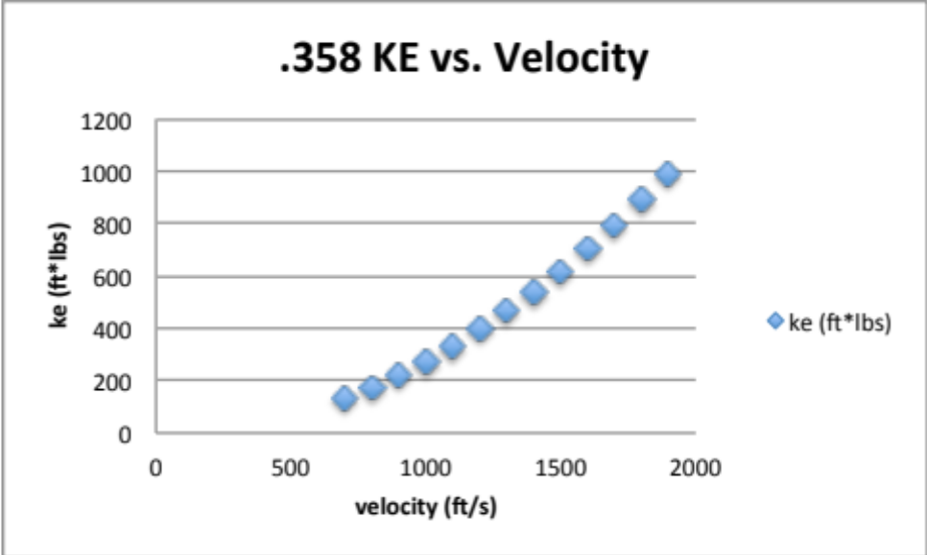

References:

https://www.researchgate.net/file.PostFileLoader.html?id=568ccf6e6307d969908b4567&assetKey=AS%3A314813178155009%401452068718561

https://en.wikipedia.org/wiki/1986_FBI_Miami_shootout

Lee Precision Modern Reloading 2nd Edition New Format – By Richard Lee

https://www.americanrifleman.org/articles/2012/8/29/handgun-stopping-power-sizing-up-your-options/

Professor Ross’s Proposal 1 Comments:

Hi,
You cited data at
https://www.americanrifleman.org/articles/2012/8/29/handgun-stopping-power-sizing-up-your-options/
but I think the data at
http://www.luckygunner.com/labs/self-defense-ammo-ballistic-tests/
might be better to use, because it shows not only the average
penetration but also the variability.

I just noticed that if you click on a bullet in its table of results,
it takes you to a page of just that bullet's results, which includes
the depth of each of the 5 trials. That way you don't have to read it
off the mini-graph. For example,
http://www.luckygunner.com/380-auto-80-gr-hp-barnes-tac-xpd-20-rounds#geltest

You said
"We will impose the following constants: 4” Ruger GP100 (40 ounce)
revolver with 4.2 inch barrel, a hollow point bullet weighing 125
grains, the same powder for all loadings."

But I thought part of what we were considering changing was the bullet
weight and powder amount. In some sense, why do I care if the weight
and powder amounts vary across options, as long as the output results
are what I want? But, we might want smaller powder amounts, as a
measure of flash and noise, as one of our criteria? (rather than
saying all powder amounts must be equal).

You listed these as criteria:

· m = mass = bullet weight (measured in grains [1 grain =
1/7,000 pounds)

· v = velocity in ft/s

· ke = kinetic energy = .5mv2 in ft*lbs

· r = free recoil energy in ft*lbs

· p = penetration in inches

· expansion = increase in bullet diameter as travels through
gel in inches

but I think you also want to add something about consistency of
penetration. You could do that in a few ways:
a) StdDev of penetration depth across the trials of that bullet,
b) probability of being over 18 inches, based on a Normal distribution
(?) fitted to the 5 penetration depths for that bullet
c) similar to (b) but probability of being under 12 inches.

Also, I don't think you want just plain penetration as a criterion,
because each criterion is usually something we want to either minimize
or maximize. Consider using instead abs(penetration - 15 inches), the
deviation from the midpoint of 12 and 18.

Prof. Ross

