1.

#include <stdio.h>

#include <stdlib.h>

#include <string.h>

#pragma warning(disable:4996)

int main(int argc, char* argv[]) /*argv[1]：输入文件名；argv[2]：输出文件名*/

{

char** s;

int Num = 0, max = 4; /*字符串数目与容量*/

int range; /*供排序*/

FILE* fin, *fout;

if (argc != 3)

{

printf("Parameter input error!\n");

exit(-1);

}

s = (char**)malloc(sizeof(char*) * max); /*定义字符串数组*/

if (!s)

{

printf("ERROR!\n");

exit(-1);

}

for (int i = 0; i < max; ++i) /*分配max个字符串空间*/

{

if (!(s[i] = (char*)malloc(sizeof(char) * 82)))

{

printf("ERROR!\n");

exit(-1);

}

}

fin = fopen(argv[1], "r"); /*读入文件*/

if (!fin)

{

printf("Cannot open the file %s!\n", argv[1]);

exit(-1);

}

fout = fopen(argv[2], "w"); /*读出文件*/

if (!fout)

{

printf("Cannot open the file %s!\n", argv[2]);

exit(-1);

}

while (1)

{

if (!(fgets(s[Num++], 82, fin))) break;

if (Num == max) /*达到最大值，重新分配内存*/

{

int oldMax = max;

char** tmp = (char**)malloc(sizeof(char*) * max * 2);

if (!tmp)

{

printf("ERROR!\n");

exit(-1);

}

max *= 2; /*容量乘2*/

for (int i = 0; i < max; ++i)

{

if (!(tmp[i] = (char*)malloc(sizeof(char) * 82)))

{

printf("ERROR!\n");

exit(-1);

}

}

for (int i = 0; i < Num; ++i) /*拷贝字符串*/

strcpy(tmp[i], s[i]);

for (int i = oldMax - 1; i >= 0; --i) /*释放原内存*/

free(s[i]);

free(s);

s = tmp;

}

}

--Num;

range = strlen(s[Num - 1]); /*考察最后一个字符串末尾是否有换行符*/

if (s[Num - 1][range - 1] != '\n')

{

s[Num - 1][range] = '\n';

s[Num - 1][range + 1] = '\0';

}

range = Num - 1;

while (range > 0) /*排序字符串*/

{

for (int i = 0; i < range; ++i)

{

if (strcmp(s[i], s[i + 1]) > 0)

{

char* tmp = s[i];

s[i] = s[i + 1];

s[i + 1] = tmp;

}

}

--range;

}

for (int i = 0; i < Num; ++i) /*输出字符串*/

fprintf(fout, s[i]);

for (int i = max - 1; i >= 0; --i) /*释放内存*/

free(s[i]);

free(s);

fclose(fout); /*关闭文件*/

fclose(fin);

return 0;

}



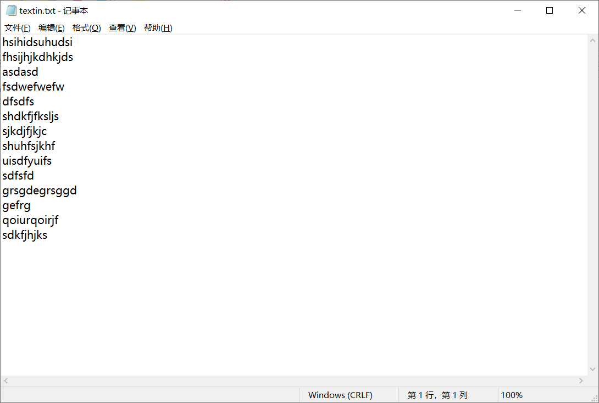

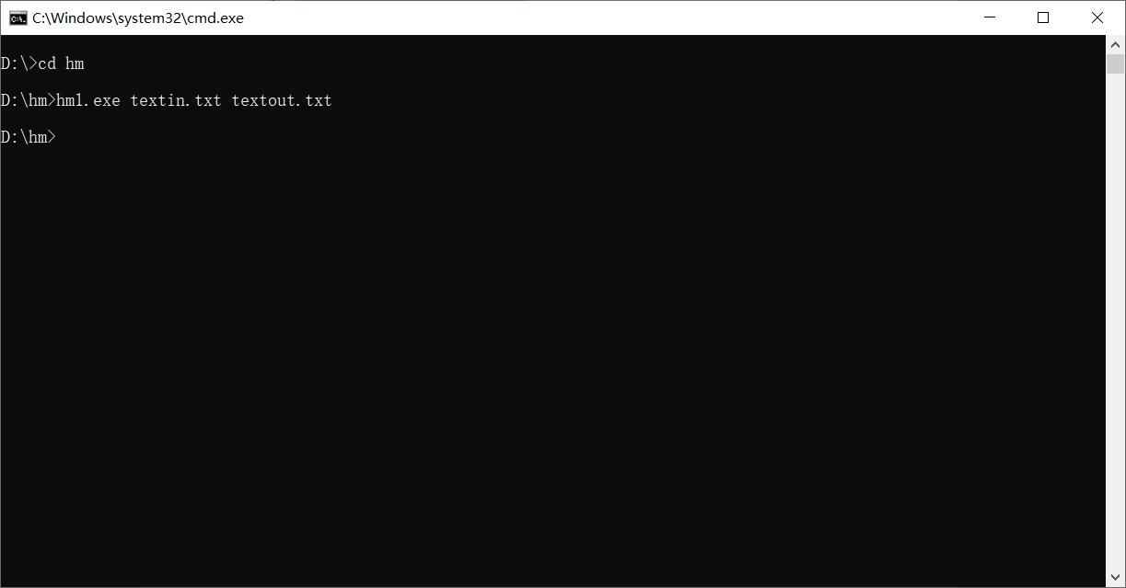

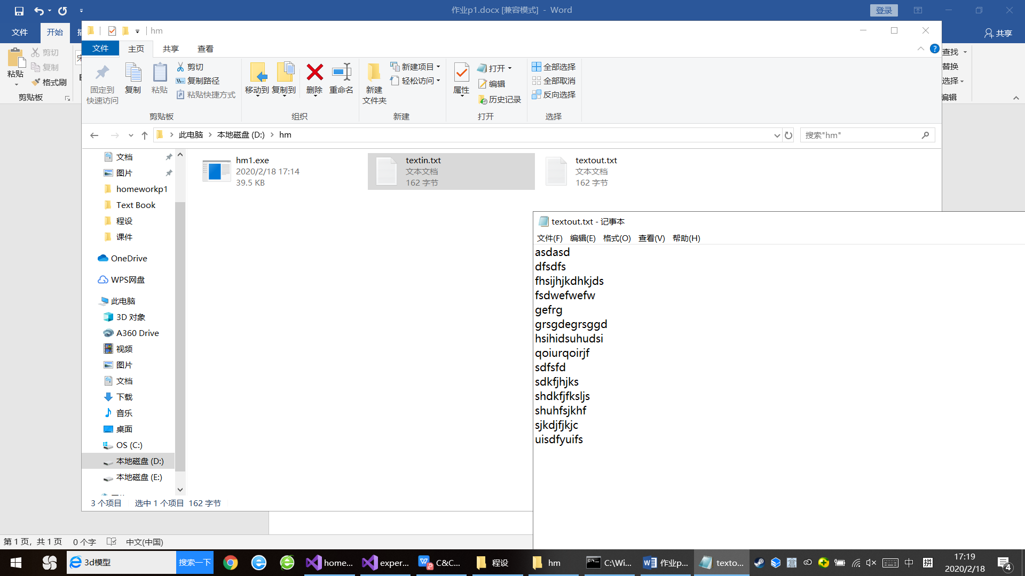

2.

#include <stdio.h>

#include <stdlib.h>

#include <string.h>

#pragma warning(disable:4996)

typedef unsigned char UCHAR;

inline UCHAR rev(UCHAR x) /*反转*/

{

x = (((x & 0x0f) << 4) | ((x & 0xf0) >> 4)); /*相邻四位反转*/

x = (((x & 0x33) << 2) | ((x & 0xcc) >> 2)); /*相邻两位反转*/

x = (((x & 0x55) << 1) | ((x & 0xaa) >> 1)); /*相邻一位反转*/

return x;

}

int main(int argc, char* argv[]) /*argv[1]：输入文件名；argv[2]：输出文件名*/

{

UCHAR form[256]; /*存储反转值*/

UCHAR* buffer;

FILE* fin, * fout;

int max = 16;

size_t now;

if (argc != 3)

{

printf("Parameter input error!\n");

exit(-1);

}

for (register int i = 0; i < 256; ++i)

{

form[i] = rev((UCHAR)i);

}

if (!(fin = fopen(argv[1], "rb")))

{

printf("Cannot open the file %s!\n", argv[1]);

exit(-1);

}

if (!(fout = fopen(argv[2], "wb")))

{

printf("Cannot open the file %s!\n", argv[2]);

exit(-1);

}

for (int i = 0; i < 256; ++i) /*初始化反转表*/

form[i] = rev(i);

buffer = (UCHAR*)malloc(sizeof(UCHAR) * max);

if (!buffer)

{

printf("ERROR!");

exit(-1);

}

while (1)

{

now = fread(buffer, sizeof(UCHAR), max, fin);

for (int i = 0; i < now; ++i)

buffer[i] = form[buffer[i]];

fwrite(buffer, sizeof(UCHAR), now, fout);

if (now < max) break; /*到达文件尾*/

free(buffer); /*增大每次读入量*/

max *= 2;

buffer = (UCHAR*)malloc(sizeof(UCHAR) * max);

if (!buffer)

{

printf("ERROR!");

exit(-1);

}

}

free(buffer);

fclose(fout);

fclose(fin);

return 0;

}

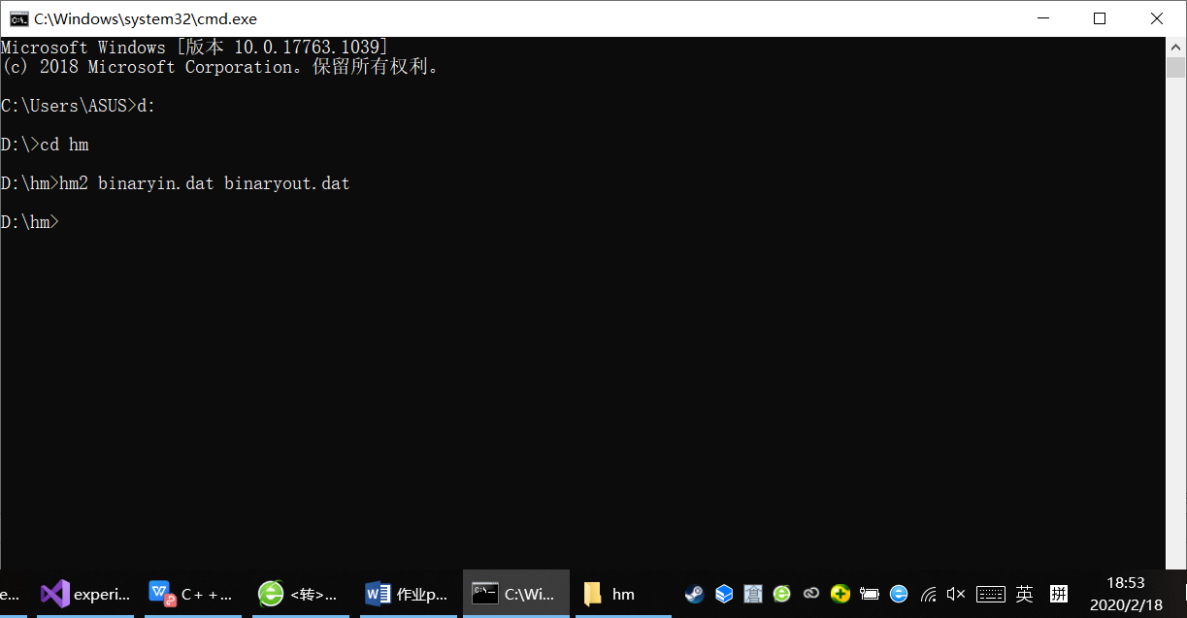



3. 探究题：

#include <stdio.h>

#include <string.h>

#include <stdlib.h>

#pragma warning(disable:4996)

char input[20000] = { 0 };

char output[20000];

char number[10][3] = { "零", "一", "二", "三", "四" , "五" , "六" , "七" , "八" , "九" };

char loword[4][3] = { "个", "十", "百", "千" };

char highword[13][3] = { "个", "万", "亿", "兆", "京", "垓", "秭", "穰", "沟", "涧", "正", "载", "极" };

#define MAX_NUM 52

inline long changeToNum(char* p) //将双字节字符转换成ANSI码值

{

return (unsigned char)p[0] * 0x100L + (unsigned char)p[1];

}

int main()

{

char zero[] = "０";

char nine[] = "９";

char* p = input, * q, * tmptr;

int outlen = 0, pN;

int zeroN, nineN, tmp, tmp1, tmp2;

int tmp3, zeronum, tmp4;

//char outputzero = 0; //刚才是否输出了'零'

zeroN = changeToNum(zero);

nineN = changeToNum(nine);

printf("请输入一段（不含空格、回车、Tab！！！！）的话：\n\n");

scanf("%s", input);

while (*p)

{

if (*p == '-' && ((*(p + 1) >= '0' && *(p + 1) <= '9') || (changeToNum(p + 1) >= zeroN && changeToNum(p + 1) <= nineN)))

{

strncpy(&output[outlen], "负", 2);

outlen += 2;

++p;

}

if (((*p) >> 7) & 1) //最高位为1

{

/*处理全角*/

pN = changeToNum(p);

if (pN >= zeroN && pN <= nineN)

{

if (pN == zeroN) //处理开头的0

{

p += 2;

while (changeToNum(p) == zeroN) { p += 2; } //去掉开头的多个零，只保留一个

p -= 2;

if (changeToNum(p + 2) < zeroN || changeToNum(p + 2) > nineN) //整数部分是零

{

strncpy(&output[outlen], "零", 2);

outlen += 2;

p += 2;

goto dot1;

}

p += 2;

}

if (changeToNum(p) == zeroN + 1 && (changeToNum(p + 4) < zeroN || changeToNum(p + 4) > nineN)) //10比较特殊，因为“1”不读

{

if (changeToNum(p + 2) >= zeroN && changeToNum(p + 2) <= nineN)

{

strncpy(&output[outlen], "十", 2);

outlen += 2;

if (changeToNum(p + 2) != zeroN)

{

strncpy(&output[outlen], number[changeToNum(p + 2) - zeroN], 2);

outlen += 2;

}

p += 4;

goto dot1;

}

}

q = p + 2;

while (changeToNum(q) >= zeroN && changeToNum(q) <= nineN)

{

q += 2;

}

tmp = (q - p) / 2;

if (tmp > MAX_NUM)

{

perror("\n这段话里包含过大的数字！\n");

exit(-1);

}

tmp -= 1;

tmp1 = tmp / 4;

tmp2 = tmp % 4;

if (tmp2 == 1 && changeToNum(p) == zeroN + 1 && changeToNum(p + 2) >= zeroN && changeToNum(p + 2) <= nineN) //十万、十亿等特殊，1不读

{

strncpy(&output[outlen], "十", 2);

outlen += 2;

if (changeToNum(p + 2) != zeroN)

{

strncpy(&output[outlen], number[changeToNum(p + 2) - zeroN], 2);

outlen += 2;

}

strncpy(&output[outlen], highword[tmp1], 2);

outlen += 2;

tmp2 = 3;

--tmp1;

}

while (tmp1 >= 0)

{

//遇到0

if (changeToNum(&p[(tmp - 4 * tmp1 - tmp2) * 2]) == zeroN)

{

tmp3 = tmp - 4 * tmp1 - tmp2 + 1;

zeronum = 1;

while (changeToNum(&p[tmp3 * 2]) == zeroN && tmp2 - zeronum >= 0)

{

++zeronum;

++tmp3;

}

if (zeronum == 4) //四位都是0

{

tmp4 = 0;

while (changeToNum(&p[(tmp3 + tmp4) * 2]) == zeroN)

{

++tmp4;

}

if (tmp4 == tmp1 * 4) //0延续到个位，直接判断小数点

{

p = q;

goto dot1;

}

//if (!outputzero) //刚刚没有输出'零'则输出'零'

{

strncpy(&output[outlen], number[0], 2);

outlen += 2;

//outputzero = 1;

}

tmp1 -= tmp4 / 4 + 1; //跳转到非零处

tmp2 = 3 - tmp4 % 4;

continue;

}

if (zeronum == tmp2 + 1) /*0延续到每个4位末尾*/

{

if (tmp1 > 0) //需要输出高级计数单位

{

strncpy(&output[outlen], highword[tmp1], 2);

outlen += 2;

//outputzero = 0;

}

--tmp1;

tmp2 = 3;

continue;

}

//if (!outputzero) //刚刚没有输出'零'

{

strncpy(&output[outlen], number[0], 2);

outlen += 2;

//outputzero = 1;

}

tmp2 -= zeronum;

continue;

}

//非零

//数字

strncpy(&output[outlen], number[changeToNum(p + (tmp - 4 * tmp1 - tmp2) * 2) - zeroN], 2);

outlen += 2;

//outputzero = 0;

if (tmp2 != 0) //不是个位

{ //位

strncpy(&output[outlen], loword[tmp2], 2);

outlen += 2;

}

--tmp2;

if (tmp2 == -1)

{

if (tmp1 != 0)

{

strncpy(&output[outlen], highword[tmp1], 2);

outlen += 2;

}

--tmp1;

tmp2 = 3;

}

}

p = q;

dot1:

//处理小数点

if (*p == '.')

{

++p;

if (changeToNum(p) >= zeroN && changeToNum(p) <= nineN)

{

strncpy(&output[outlen], "点", 2);

outlen += 2;

strncpy(&output[outlen], number[changeToNum(p) - zeroN], 2);

outlen += 2;

p += 2;

}

while (changeToNum(p) >= zeroN && changeToNum(p) <= nineN)

{

strncpy(&output[outlen], number[changeToNum(p) - zeroN], 2);

outlen += 2;

p += 2;

}

}

}

else

{

output[outlen++] = *(p++);

output[outlen++] = *(p++);

//outputzero = 0;

}

//int pN = changeToNum(p);

//if (pN >= zeroN && pN <= nineN)

//{

// /*转换成字符串*/

// /*拷贝进输出串*/

// /*修改p*/

//}

//else

//{

//}

}

else

{

/*if (*p == '-' && *(p + 1) >= '0' && *(p + 1) <= '9')

{

strncpy(&output[outlen], "负", 2);

outlen += 2;

++p;

}*/

if (*p >= '0' && *p <= '9')

{

if (*p == '0') //处理开头的0

{

++p;

while (*p == '0') { ++p; } //去掉开头的多个零，只保留一个

--p;

if (*(p + 1) < '0' || *(p + 1) > '9') //整数部分是零

{

strncpy(&output[outlen], "零", 2);

outlen += 2;

++p;

goto dot;

}

++p;

}

if (*p == '1' && (*(p + 2) < '0' || *(p + 2) > '9')) //10比较特殊，因为“1”不读

{

if (*(p + 1) >= '0' && *(p + 1) <= '9')

{

strncpy(&output[outlen], "十", 2);

outlen += 2;

if (*(p + 1) != '0')

{

strncpy(&output[outlen], number[*(p + 1) - '0'], 2);

outlen += 2;

}

p += 2;

goto dot;

}

}

q = p + 1;

while (*q >= '0' && *q <= '9')

{

++q;

}

tmp = q - p;

if (tmp > MAX_NUM)

{

perror("\n这段话里包含过大的数字！\n");

exit(-1);

}

--tmp;

tmp1 = tmp / 4;

tmp2 = tmp % 4;

if (tmp2 == 1 && *p == '1' && *(p + 1) >= '0' && *(p + 1) <= '9') //十万、十亿等特殊，1不读

{

strncpy(&output[outlen], "十", 2);

outlen += 2;

if (*(p + 1) != '0')

{

strncpy(&output[outlen], number[*(p + 1) - '0'], 2);

outlen += 2;

}

strncpy(&output[outlen], highword[tmp1], 2);

outlen += 2;

tmp2 = 3;

--tmp1;

}

while (tmp1 >= 0)

{

//遇到0

if (p[tmp - 4 * tmp1 - tmp2] == '0')

{

tmp3 = tmp - 4 * tmp1 - tmp2 + 1;

zeronum = 1;

while (p[tmp3] == '0' && tmp2 - zeronum >= 0)

{

++zeronum;

++tmp3;

}

if (zeronum == 4) //四位都是0

{

tmp4 = 0;

while (p[tmp3 + tmp4] == '0') ++tmp4;

if (tmp4 == tmp1 * 4) //0延续到个位，直接判断小数点

{

p = q;

goto dot;

}

//if (!outputzero) //刚刚没有输出'零'则输出'零'

{

strncpy(&output[outlen], number[0], 2);

outlen += 2;

//outputzero = 1;

}

tmp1 -= tmp4 / 4 + 1; //跳转到非零处

tmp2 = 3 - tmp4 % 4;

continue;

}

if (zeronum == tmp2 + 1) /*0延续到每个4位末尾*/

{

if (tmp1 > 0) //需要输出高级计数单位

{

strncpy(&output[outlen], highword[tmp1], 2);

outlen += 2;

//outputzero = 0;

}

--tmp1;

tmp2 = 3;

continue;

}

//if (!outputzero) //刚刚没有输出'零'

{

strncpy(&output[outlen], number[0], 2);

outlen += 2;

//outputzero = 1;

}

tmp2 -= zeronum;

continue;

}

//非零

//数字

strncpy(&output[outlen], number[p[tmp - 4 * tmp1 - tmp2] - '0'], 2);

outlen += 2;

//outputzero = 0;

if(tmp2 != 0) //不是个位

{ //位

strncpy(&output[outlen], loword[tmp2], 2);

outlen += 2;

}

--tmp2;

if (tmp2 == -1)

{

if (tmp1 != 0)

{

strncpy(&output[outlen], highword[tmp1], 2);

outlen += 2;

}

--tmp1;

tmp2 = 3;

}

}

p = q;

dot:

//处理小数点

if (*p == '.')

{

++p;

if (*p >= '0' && *p <= '9')

{

strncpy(&output[outlen], "点", 2);

outlen += 2;

strncpy(&output[outlen], number[*p - '0'], 2);

outlen += 2;

++p;

}

while (*p >= '0' && *p <= '9')

{

strncpy(&output[outlen], number[*p - '0'], 2);

outlen += 2;

++p;

}

}

}

else

{

output[outlen++] = *(p++);

//outputzero = 0;

}

}

}

output[outlen++] = '\0';

printf("\n\n%s\n", output);

return 0;

}

运行结果如下：

