**1.**

#include <iostream>

using namespace std;

class Point

{

private:

int x;

int y;

public:

Point() { x = y = 0; };

Point(int _x, int _y) : x(_x), y(_y) {};

Point(const Point& _Point) : x(_Point.x), y(_Point.y) {};

void Set(int _new_x, int _new_y) { x = _new_x; y = _new_y; }

Point& operator=(const Point& _new_Point) { x = _new_Point.x, y = _new_Point.y; return *this; }

void Print() const { cout << "(" << x << ", " << y << ")"; }

~Point() { cout << "The destructor of Point "; Print(); cout << " called!" << endl; }

friend class Rectangle;

};

class Rectangle

{

private:

Point left_bottom;

Point right_top;

static int Abs(int x) { return x > 0 ? x : -x; }

public:

Rectangle() {}

Rectangle(int _left, int _bottom, int _right, int _top) : left_bottom(_left, _bottom), right_top(_right, _top) {}

Rectangle(const Point& _left_bottom, const Point& _right_top) : left_bottom(_left_bottom), right_top(_right_top) {}

Rectangle(const Rectangle& _Rect) : left_bottom(_Rect.left_bottom), right_top(_Rect.right_top) {}

void Set(int _new_left, int _new_bottom, int _new_right, int _new_top);

void Set(const Point& _new_left_bottom, const Point& _new_right_top);

void Print() const;

int Area() const;

~Rectangle() { cout << "The destructor of Rectangle "; left_bottom.Print(); cout << ", "; right_top.Print(); cout << " called!" << endl; }

};

void Rectangle::Set(int _new_left, int _new_bottom, int _new_right, int _new_top)

{

left_bottom.Set(_new_left, _new_bottom);

right_top.Set(_new_right, _new_top);

}

void Rectangle::Set(const Point& _new_left_bottom, const Point& _new_right_top)

{

left_bottom = _new_left_bottom;

right_top = _new_right_top;

}

void Rectangle::Print() const

{

cout << "The left bottom corner: ";

left_bottom.Print();

cout << "; The right top corner: ";

right_top.Print();

cout << "." << endl;

}

int Rectangle::Area() const

{

return Abs(right_top.x - left_bottom.x) * Abs(right_top.y - left_bottom.y);

}

int main()

{

Point p1(6, 6), p2(8, 9);

Rectangle rec1, rec2(1, 1, 3, 4), rec3(p1, p2);

Rectangle rec4(rec2);

rec1.Print();

rec2.Print();

rec3.Print();

rec4.Print();

rec1.Set(3, 4, 100, 400);

rec2.Set(p1, p2);

rec2.Print();

cout << "Area of rec1: " << rec1.Area() << endl;

return 0;

}

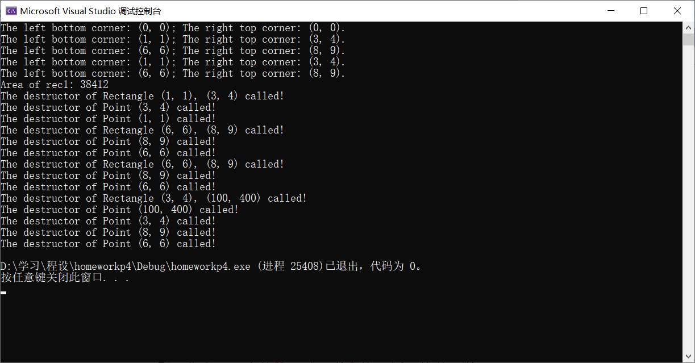

**2.**

#include <iostream>

#include <cmath>

#include <iomanip>

#include <cstdarg>

#include <ctime>

using namespace std;

class Ball

{

private:

int x;

int y;

int z;

int r;

const double PI = 3.14159265358979324;

public:

Ball() { x = y = z = r = 0; }

Ball(int _x, int _y, int _z, int _r) : x(_x), y(_y), z(_z), r(abs(_r)) {};

Ball(const Ball& _new_Ball) : x(_new_Ball.x), y(_new_Ball.y), z(_new_Ball.z), r(_new_Ball.r) {}

int GetX() { return x; }

int GetY() { return y; }

int GetZ() { return z; }

int GetR() { return r; }

void Set(int _new_x, int _new_y, int _new_z, int _new_r);

void Print() const;

double Volume() const { return 4.0 / 3.0 * PI * r * r * r; }

void Swap(Ball& b);

~Ball() { cout << "Destructor (" << x << ", " << y << ", " << z << " | " << r << ") called!" << endl; }

friend void Sort(Ball* b, int num);

};

void Ball::Set(int _new_x, int _new_y, int _new_z, int _new_r)

{

x = _new_x;

y = _new_y;

z = _new_z;

r = abs(_new_r);

}

void Ball::Print() const

{

cout << "Centre: (" << setw(5) << x << ", " << setw(5) << y << ", " << setw(5) << z << "), radium: " << setw(5) << r << ". ";

}

void Ball::Swap(Ball& b)

{

struct

{

int x;

int y;

int z;

int r;

} tmp = {x, y, z, r};

Set(b.x, b.y, b.z, b.r);

b.Set(tmp.x, tmp.y, tmp.z, tmp.r);

}

void Sort(Ball* b, int num)

{

for(int i = 0; i < num - 1; ++i)

for (int j = i + 1; j < num; ++j)

if (b[i].r > b[j].r)

b[i].Swap(b[j]);

}

int main()

{

srand(0);

Ball b1[10];

Ball* b2 = new Ball[20];

cout << "Static balls:" << endl;

for (int i = 0; i < 10; ++i)

{

b1[i].Set(rand(), rand(), rand(), abs(rand()));

b1[i].Print();

cout << "Volume: " << b1[i].Volume() << endl;

}

cout << endl << "-------------------------" << endl << endl << "Dynamic balls:" << endl;

for (int i = 0; i < 20; ++i)

{

b2[i].Set(rand(), rand(), rand(), abs(rand()));

b2[i].Print();

cout << "Volume: " << b2[i].Volume() << endl;

}

cout << endl << "=========================" << endl << endl;

Sort(b1, 10);

Sort(b2, 20);

cout << "After sorting: " << endl << endl << "static balls: " << endl;

for (int i = 0; i < 10; ++i)

{

b1[i].Print();

cout << "Volume: " << b1[i].Volume() << endl;

}

cout << endl << "-------------------------" << endl << endl << "Dynamic balls:" << endl;

for (int i = 0; i < 20; ++i)

{

b2[i].Print();

cout << "Volume: " << b2[i].Volume() << endl;

}

cout << endl << "=========================" << endl << endl;

int sumx = 0, sumy = 0, sumz = 0, sumr = 0;

double avex, avey, avez, aver, avev = 0.0;

for (int i = 0; i < 10; ++i)

{

sumx += b1[i].GetX();

sumy += b1[i].GetY();

sumz += b1[i].GetZ();

sumr += b1[i].GetR();

avev += b1[i].Volume() / 10.0;

}

avex = sumx / 10.0;

avey = sumy / 10.0;

avez = sumz / 10.0;

aver = sumr / 10.0;

cout << "Average:" << endl << endl;

cout << "Static balls: " << "Centre: (" << avex << ", " << avey << ", " << avez << "), radium: " << aver << ", Volume: " << avev << endl;

sumx = 0;

sumy = 0;

sumz = 0;

sumr = 0;

avev = 0.0;

for (int i = 0; i < 20; ++i)

{

sumx += b2[i].GetX();

sumy += b2[i].GetY();

sumz += b2[i].GetZ();

sumr += b2[i].GetR();

avev += b2[i].Volume() / 20.0;

}

avex = sumx / 20.0;

avey = sumy / 20.0;

avez = sumz / 20.0;

aver = sumr / 20.0;

cout << "Dynamic balls: " << "Centre: (" << avex << ", " << avey << ", " << avez << "), radium: " << aver << ", Volume: " << avev << endl;

cout << endl << "=========================" << endl << endl;

delete[] b2;

return 0;

}

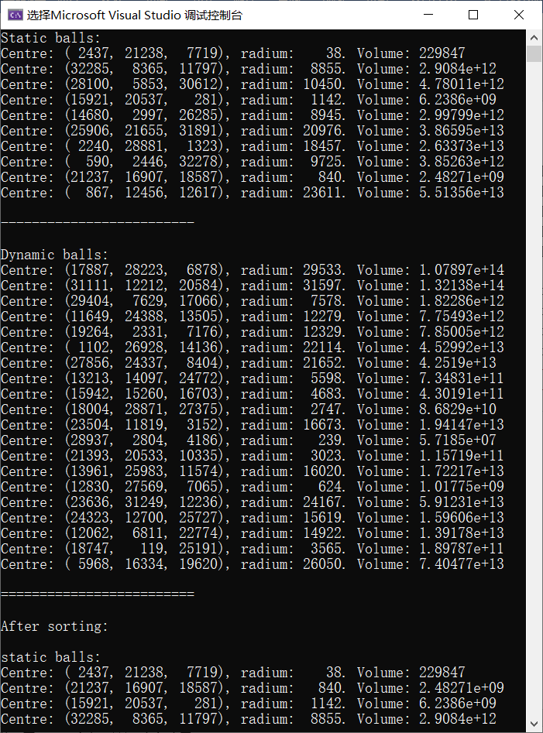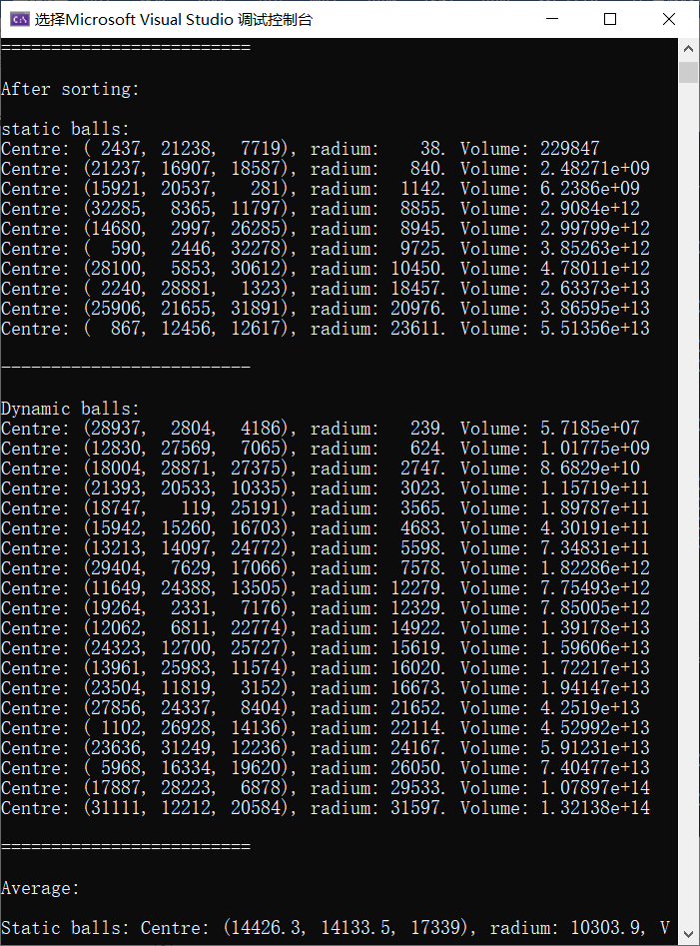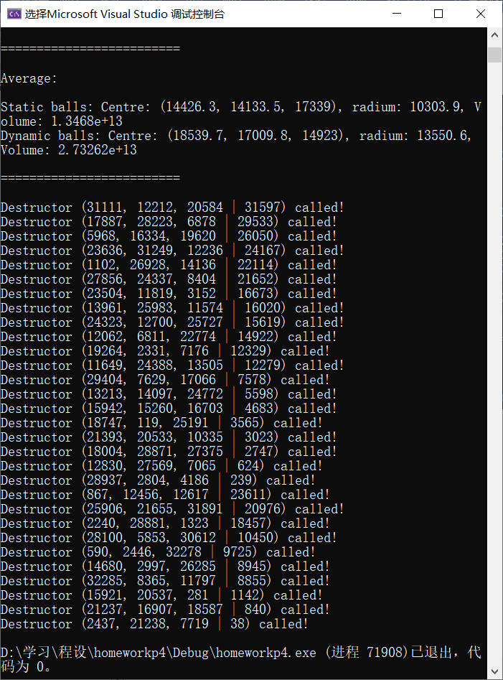

**3（探究题）.**

#include <iostream>

using namespace std;

class list_node

{

int data;

list_node* next;

friend class ordered_list;

};

class ordered_list

{

public:

ordered_list() { head = NULL; }

void insert(int ins);

void visit(void(*vis)(int&));

~ordered_list();

private:

list_node* head;

};

void ordered_list::insert(int ins)

{

list_node* newnode = new list_node;

newnode->data = ins;

if (head == NULL || head->data > ins)

{

newnode->next = head;

head = newnode;

return;

}

list_node* p = head, * q = head->next;

while (q)

{

if (q->data >= ins)

{

newnode->next = p->next;

p->next = newnode;

return;

}

p = q;

q = q->next;

}

p->next = newnode;

newnode->next = NULL;

}

void ordered_list::visit(void(*vis)(int&))

{

list_node* p = head;

while (p)

{

vis(p->data);

p = p->next;

}

}

ordered_list::~ordered_list()

{

list_node* p = head;

while (head)

{

p = head->next;

delete head;

head = p;

}

}

void output(int& i)

{

cout << i << " ";

}

int main()

{

ordered_list ol;

int k;

while (cin >> k)

ol.insert(k);

ol.visit(output);

return 0;

}

运行结果如下：

