Section 1: Project Summary

Project Title: Club App – Smart Table Ordering System
Core Idea:
A mobile-based table-ordering solution for clubs, restaurants, and lounges. Customers scan a QR code to access a digital menu, place orders, view order statuses, split bills, and give feedback. Staff can manage orders, inventory, notifications, and analytics through a dashboard.
Design Focus:
During this 3-week sprint, the team will focus on:
- UI/UX design: wireframes, user journeys, visual mockups, and prototype testing.
- Data Flow Diagram modeling: Level 0–2 diagrams, data stores, and process documentation.

Modules to Cover:
- Customer module (QR login, menu, order, payment, feedback)
- Staff/Admin module (dashboard, order tracking, inventory)
- System processes (data synchronization, analytics, notifications)

Section 2: Team Member Skills Overview
Member | Key Strengths | Relevant Skills
Maranatha James Ndege | Full-stack developer, backend logic design, RESTful API structure, UX planning | Django, MySQL, React Native, API flow design, system documentation
Chrispine Dzimbiri | Full-stack and UI/UX design experience, prototyping, project leadership | Flutter, Django, Figma, REST APIs, Agile, team leadership
Elijah Mhango | Data-driven developer, strong in documentation and front-end prototyping | Flutter, React Native, web design, data analysis, MySQL
Praise Tithe Khonje | Creative designer, multimedia and mobile UI experience | Flutter, React Native, Django, photography, design tools
Philimon Katambo | AI, web & mobile app development, embedded systems logic | Django, Flutter, ML design concepts, data modeling
Timothy Zikani Msiska | Organized planner, system analyst, UI/UX enthusiast, leadership skills | Python (Django), Flutter, documentation, project coordination
Timothy Wongani Mphande | Backend integration, DFD modeling, system analysis | Node.js, Django, databases, API & process flow mapping

Section 3: 3-Week Task Allocation Schedule

Sprint Duration: 3 Weeks (15 Working Days)
Start Date: Monday, Nov 10, 2025
End Date: Friday, Nov 28, 2025
Task/Responsibility | Assigned Member(s) | Start Date | End Date | Dependencies | Deliverables | Rationale
1. UX Research & Requirement Validation | Timothy Msiska, Elijah Mhango | Nov 10 | Nov 12 | None | UX research summary, user personas, requirements confirmation | Msiska’s analytical skill + Elijah’s documentation ensures accurate user insights.
2. User Journey Mapping (Customer & Staff flows) | Praise Khonje, Maranatha Ndege | Nov 11 | Nov 13 | Task 1 | Visual maps for user flow (login → order → payment) | Praise’s creativity complements Maranatha’s system logic understanding.
3. UI Wireframes (Low-Fidelity) | Chrispine Dzimbiri (Lead), Praise Khonje | Nov 13 | Nov 15 | Task 2 | Figma wireframes for all app modules | Chrispine’s prototyping and Praise’s front-end sense deliver strong visuals.
4. UI Wireframes Review & Adjustments | All members | Nov 16 | Nov 17 | Task 3 | Updated approved wireframes | Ensures all roles provide feedback for usability and consistency.
5. High-Fidelity UI Mockups (Color, Branding, Interactions) | Chrispine Dzimbiri, Elijah Mhango | Nov 18 | Nov 20 | Task 4 | Final design mockups in Figma or Adobe XD | Chrispine and Elijah have strong design and frontend tool experience.
6. Data Flow Diagram – Level 0 (System Overview) | Timothy Wongani Mphande, Philimon Katambo | Nov 12 | Nov 13 | Task 1 | Context diagram showing main entities and data flows | Mphande’s backend logic & Philimon’s data modeling expertise.
7. Data Flow Diagram – Level 1 (Major Processes) | Timothy Wongani, Maranatha Ndege | Nov 14 | Nov 17 | Task 6 | DFD Level 1 with labeled processes and data stores | Maranatha’s backend logic with Mphande’s analytical precision.
8. Data Flow Diagram – Level 2 (Detailed Subprocesses) | Philimon Katambo, Timothy Msiska | Nov 18 | Nov 21 | Task 7 | DFD Level 2 diagrams with detailed data paths | Both strong in structured system analysis.
9. Data Dictionary & Process Documentation | Maranatha Ndege, Elijah Mhango | Nov 21 | Nov 23 | Task 8 | Data dictionary (entities, attributes, sources) and process table | Balances backend design (Maranatha) and documentation clarity (Elijah).
10. UI/UX Prototype Integration & Demo Prep | Chrispine Dzimbiri, Praise Khonje, Timothy Msiska | Nov 24 | Nov 26 | Tasks 5, 9 | Interactive prototype demo and walkthrough slides | Final collaboration of design + analysis leads.
11. Final Review & Submission | All members | Nov 27 | Nov 28 | All tasks | Final UI/UX files, DFDs, documentation, presentation deck | Full team review to ensure alignment and readiness for next sprint.

Visually:
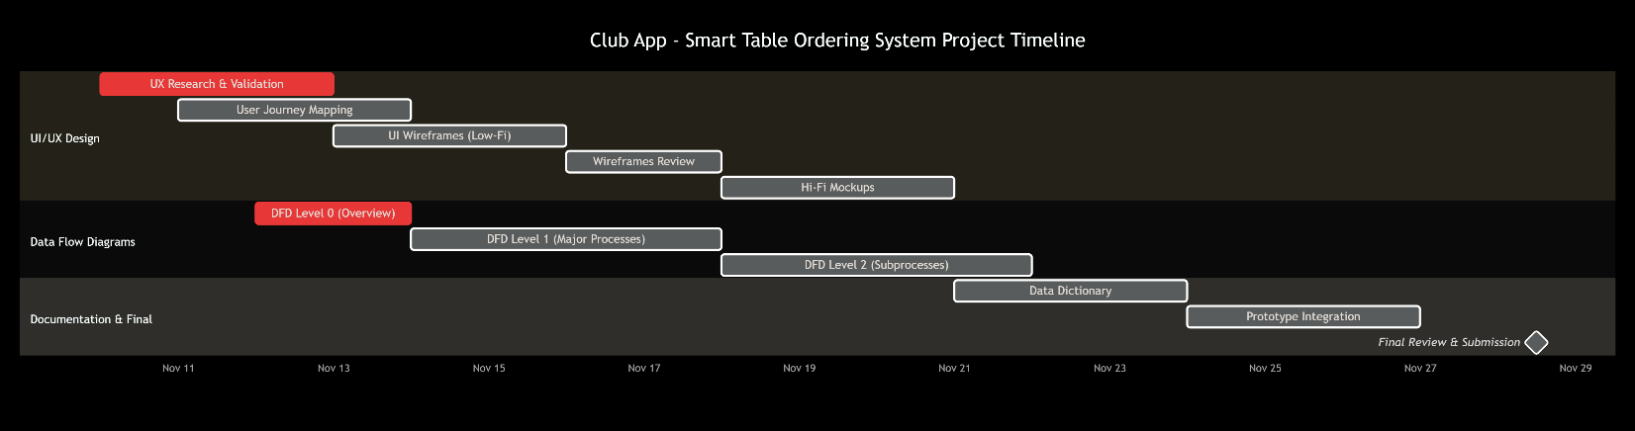

Section 4: Collaboration & Tool Recommendations

Tools to Use
Category | Recommended Tool
UI/UX Design | Figma (wireframing, prototyping), Adobe XD
DFD & System Modeling | Lucidchart, Draw.io,starUML
Collaboration | Notion / Trello for task tracking
Communication | WhatsApp group + weekly Google Meet
Documentation | Google Docs / Confluence

Sprint Check-in Plan
- Daily Stand-up: 15 minutes (each morning)
- Mid-Sprint Review: End of Week 2 (Nov 21)
- Final Review: End of Week 3 (Nov 28)

Deliverables Summary
- User personas and UX research report
- Full set of low and high-fidelity UI mockups
- DFD Level 0–2 diagrams
- Data dictionary and process documentation
- Final integrated design demo (interactive prototype)

✅ Summary Note
This plan strategically balances design and analytical tasks:
- Chrispine and Praise lead UI/UX creativity.
- Maranatha, Mphande, and Philimon handle logical DFD modeling.
- Elijah and Msiska ensure documentation, research, and coordination consistency.
By the end of Week 3, the team will have a complete design blueprint ready for the development phase.

