XXX-X-XXXX-XXXX-X/XX/$XX.00 ©20XX IEEE
SSP-ARR: Stability-Switched Predictive Adaptive Round Robin for Multi-Tier Cloud Task Scheduling Using Real-World Cloud Workload Traces
*Note: Sub-titles are not captured in Xplore and should not be used
line 1: 1st Given Name Surname  line 2: dept. name of organization  (of Affiliation)  line 3: name of organization (of Affiliation)  line 4: City, Country  line 5: email address or ORCID | line 1: 2nd Given Name Surname  line 2: dept. name of organization  (of Affiliation)  line 3: name of organization (of Affiliation)  line 4: City, Country  line 5: email address or ORCID | line 1: 3rd Given Name Surname  line 2: dept. name of organization  (of Affiliation)  line 3: name of organization (of Affiliation)  line 4: City, Country  line 5: email address or ORCID
line 1: 4th Given Name Surname  line 2: dept. name of organization  (of Affiliation)  line 3: name of organization (of Affiliation)  line 4: City, Country  line 5: email address or ORCID | line 1: 5th Given Name Surname  line 2: dept. name of organization  (of Affiliation)  line 3: name of organization (of Affiliation)  line 4: City, Country  line 5: email address or ORCID | line 1: 6th Given Name Surname  line 2: dept. name of organization  (of Affiliation)  line 3: name of organization (of Affiliation)  line 4: City, Country  line 5: email address or ORCID

Abstract—Task scheduling in heterogeneous cloud datacenters plays a decisive role in maximizing computational resource efficiency, reducing end-user latency, and lowering datacenter energy footprint. However, conventional time-sharing schedulers—predominantly Classical Round Robin (RR) and its static variants—rely on rigid, pre-configured CPU time quanta. Under burst-heavy, heterogeneous, and unpredictable cloud workloads, fixed time-slicing causes severe head-of-line blocking (the convoy effect), excessive context-switching overhead, and inflated waiting times. While reactive adaptive schedulers (such as MAADRR) compute median-based time quanta, purely reactive heuristics exhibit latency lag during sudden workload phase transitions and fail to anticipate high-variance task arrivals. To overcome these limitations, this paper proposes SSP-ARR (Stability-Switched Predictive Adaptive Round Robin), an intelligent, multi-tier scheduling framework tailored for heterogeneous cloud infrastructures. SSP-ARR dynamically evaluates workload volatility at the local VM tier using a sliding-window Coefficient of Variation (CV). When queue variance remains stable (CV ≤ 0.50), the scheduler operates in a safe queue-median reactive mode; when volatility surges (CV > 0.50), it transitions to an adaptive Exponentially Weighted Moving Average (EWMA) predictive mode governed by an error-modulated learning rate and strict confidence gating (Normalized Prediction Error ≤ 0.20). Furthermore, task queues are structured under Shortest Remaining Processing Time (SRPT) ordering with bounded quantum clamping [0.001 s, 60.0 s]. SSP-ARR is evaluated across five state-of-the-art global dispatching strategies (Dynamic Max-Min, DRALBA, PSSLB, PSSELB, and DeRALBA) using real-world Google Cloud Jobs (GoCJ) traces spanning 100 to 2000 cloudlets on CloudSim Plus 8.5.7. Experimental results demonstrate that SSP-ARR achieves an average reduction of ~50.2% in Average Waiting Time (AWT), up to 49.2% improvement in Average Turnaround Time (ATAT), saves millions of cumulative completion seconds in Total Completion Time (TCT), and yields superior makespan, throughput, and SPECpower-modeled energy efficiency compared to Classical RR across all global policies.
Keywords—Cloud task scheduling, multi-tier architecture, adaptive dynamic time quantum, stability switching, coefficient of variation, EWMA prediction, GoCJ workload traces, CloudSim Plus.
I. INTRODUCTION
Cloud computing platforms have emerged as the foundational utility for modern enterprise IT, scientific computing, and consumer applications [1], [2]. The elastic resource model allows providers to multiplex massive pools of virtualized compute, memory, and network resources among thousands of concurrently competing client workloads [3], [4]. In this environment, task scheduling is decisive in determining whether a cloud provider can satisfy Service Level Agreements (SLAs), minimize operating costs, and prevent severe server thermal dissipation [5], [6].
Task scheduling in cloud computing typically operates across a two-tier hierarchy [7], [8]. At the first tier, global broker schedulers receive incoming user tasks and map them to appropriate Virtual Machines (VMs) across distributed datacenters [9]. At the second tier, local VM hypervisor schedulers manage the execution sequence of cloudlets residing in each VM's circular ready queue [10]. While substantial research has focused on global heuristic and metaheuristic dispatchers, the efficiency of local VM scheduling remains the critical determinant of actual CPU core utilization, context-switching overhead, and task waiting times [11], [12].
At the local VM level, Classical Round Robin (RR) has historically been the default choice due to its simplicity, starvation prevention, and conceptual fairness [13], [14]. However, Classical RR is burdened by a critical architectural limitation: reliance on a static, pre-configured Time Quantum (TQ). If the quantum is set too small, the system suffers severe throughput degradation from frequent CPU context switches [15]. Conversely, if the quantum is set too large, Classical RR degenerates into First-Come First-Served (FCFS), causing short tasks to stall behind long, compute-heavy jobs—an anomaly known as the convoy effect [16].
Recent advances have attempted to mitigate this trade-off by introducing dynamic time quantum adaptation, such as the Multi-Agent Adaptive Dynamic Round Robin (MAADRR) scheduler [16]. MAADRR dynamically computes the time quantum as the median of task burst lengths in the VM queue. While MAADRR improves upon static RR under moderate conditions, its purely reactive formulation exhibits severe latency lag during rapid workload phase changes and fails to anticipate task burst variance under volatile real-world traffic.
To resolve these challenges, this paper presents SSP-ARR (Stability-Switched Predictive Adaptive Round Robin), an intelligent local VM scheduling framework that incorporates continuous variance sensing, dual-mode reactive/predictive quantum selection, confidence gating, and bounded preemption clamping within a multi-tier cloud hierarchy.
II. RELATED WORK & ARCHITECTURAL EVOLUTION
A. Adaptive Round Robin Variants
Dynamic time quantum adaptation has received extensive research interest. In [17], the authors proposed a hybrid Min-Min and Round Robin algorithm to combine the makespan minimization of Min-Min with the fairness of Round Robin. Runsungnoen and Anusas-Amornkul [18] developed the RR_RT&M technique, utilizing remaining task execution time and median estimation to adapt the quantum. Ghazy et al. [19] formulated an ameliorated Round Robin algorithm calculating quantum based on arithmetic mean of remaining bursts. Similarly, Banerjee et al. [20] presented Optimized Round Robin (ORR), proving that dynamic time quantum selection significantly mitigates average waiting time and turnaround time compared to static baselines. Mazumder et al. [21] introduced Priority-based Round Robin (PRR) prioritizing tasks according to burst length and deadline thresholds.
B. Multi-Tier Global Schedulers
Global schedulers govern the distribution of cloudlets across heterogeneous VMs. Five representative global dispatching strategies are considered in this investigation: (1) Dynamic Max-Min (Dy. MM) [17], which dynamically maps large tasks to fast VMs while recomputing completion times to prevent small task starvation; (2) DRALBA [22], a dynamic and resource-aware load-balancing algorithm utilizing multi-resource variance minimization; (3) PSSLB [23], a priority-based queue-state scheduling algorithm; (4) PSSELB [23], an enhanced energy-aware variant of PSSLB; and (5) DeRALBA [24], which integrates dispersion thresholding with adaptive candidate matching.
C. Evolution to SSP-ARR
Existing local schedulers fall into two flawed extremes: static allocation (RR) or unconstrained reactive heuristics (MAADRR). Neither architecture explicitly measures queue burst variance or employs predictive models to anticipate burst length trends. Table I highlights the evolutionary architectural progression from Classical RR and MAADRR to SSP-ARR.
TABLE I. ARCHITECTURAL COMPARISON ACROSS CLOUD LOCAL SCHEDULING MODELS
Feature | Classical RR | MAADRR [16] | Proposed SSP-ARR
Quantum Sizing | Static (1.0 s) | Dynamic Median | Dual Reactive / Predictive Mode
Workload Sensing | None | Reactive only | CV Stability Sensing (θ_CV = 0.50)
Burst Prediction | None | None | Adaptive EWMA (α ∈ [0.20, 0.80])
Confidence Gating | None | None | NPE ≤ 0.20 Strict Gating
Queue Ordering | FIFO | FIFO / Re-sort | SRPT Ascending Order
Quantum Clamping | Fixed | Unbounded | Bounded Clamping [0.001s, 60.0s]
Preemption Penalty | High (Severe) | Moderate | Minimal (Consolidated Execution)
Global Tier Support | Single-tier | Multi-agent | 5 Global Dispatchers Supported
III. MATHEMATICAL DESIGN AND ALGORITHMIC FORMULATION
A. Multi-Tier System Architecture
The proposed architecture operates across two coordinated tiers: (1) Tier-1 Global Datacenter Dispatching assigns submitted cloudlets to VMs using established global balancing policies; (2) Tier-2 Local VM Scheduling governs cloudlet preemption and execution via SSP-ARR, depicted in Fig. 1.

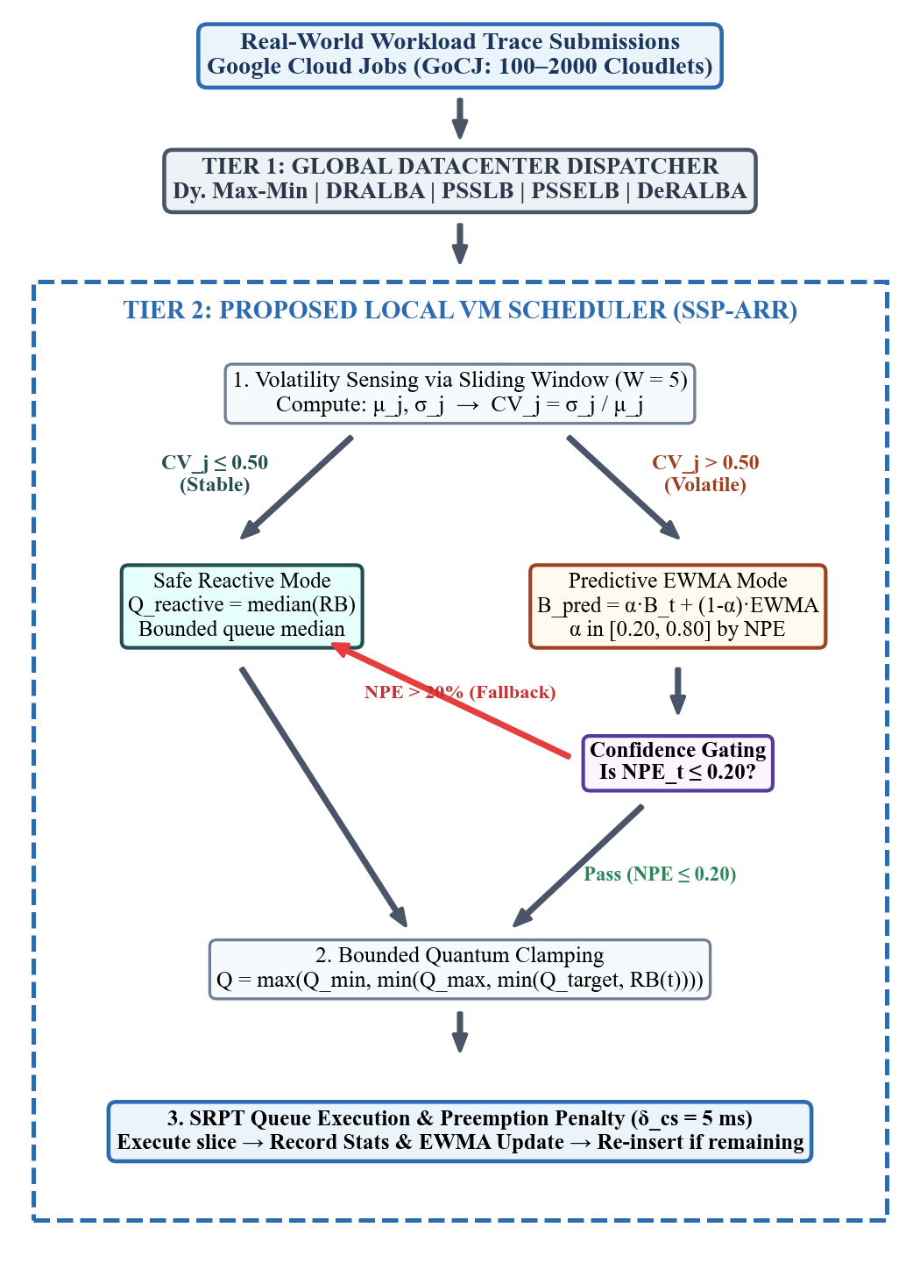
Fig. 1. Architectural workflow of the proposed SSP-ARR multi-tier framework.
B. Workload Volatility Sensing via CV
For each VM v_j, let H_j = {B_{j,1}, ..., B_{j,W}} represent execution bursts of the last W completed cloudlets (W = 5). The local agent tracks sample mean μ_j and sample standard deviation σ_j:
μ_j = (1/W) · Σ B_{j,k} (1)
σ_j = √[ (1/W) · Σ (B_{j,k} − μ_j)² ] (2)
The Coefficient of Variation (CV_j) is defined as:
CV_j = σ_j / μ_j (3)
• Stable Regime (CV_j ≤ θ_CV): Low dispersion (θ_CV = 0.50). Safe Reactive Mode selected.
• Volatile Regime (CV_j > θ_CV): High burst variability. Predictive EWMA Mode activated.
C. Dual-Mode Quantum Allocation Engine
1) Safe Reactive Mode (CV_j ≤ θ_CV): Quantum computed as queue median:
Q_reactive = median( {RB(x) : x ∈ Q_j} ∪ {RB(t)} ) (4)
2) Predictive EWMA Mode (CV_j > θ_CV): Optimal burst duration forecasted by EWMA:
B_pred_{j,t+1} = α_t · B_{j,t} + (1 − α_t) · B_pred_{j,t} (5)
where α_t is an adaptive error-modulated learning rate:
α_t = 0.20 if NPE < 0.10 | 0.40 if 0.10 ≤ NPE < 0.20 (6a)
α_t = 0.60 if 0.20 ≤ NPE < 0.30 | 0.80 if NPE ≥ 0.30 (6b)
3) Normalized Prediction Error (NPE) and Confidence Gating:
NPE_t = |B_{j,t} − B_pred_{j,t}| / B_{j,t} (7)
Predictions are gated by confidence threshold τ_gate = 0.20:
Q_selected = B_pred_{j,t+1} if (CV_j > 0.50 and NPE_t ≤ 0.20) (8a)
Q_selected = Q_reactive otherwise (fallback to median) (8b)
4) Boundary Clamping: Clamped within [0.001 s, 60.0 s]:
Q_j = max(Q_min, min(Q_max, min(Q_selected, RB(t)))) (9)
D. Formal Algorithmic Pseudocode
Algorithm 1: Multi-Tier Cloud Task Scheduling with SSP-ARR
Input : Cloudlet set C={c_1..c_n}; VM pool V={v_1..v_m};
Policy P in {Dy.MM, DRALBA, PSSLB, PSSELB, DeRALBA};
Q_min=0.001s, Q_max=60.0s; δ_cs=0.005s; θ_CV=0.50; τ_gate=0.20.
// TIER 1: Global Datacenter Dispatching
1: Assignment[] ← GlobalSchedulers.assign(P, C, V);
2: Enqueue tasks to VM ready queues Q_1..Q_m;
// TIER 2: Local SSP-ARR Execution per VM
3: for each VM v_j with queue Q_j do
4: Sort Q_j in ascending order of burst (SRPT order);
5: while Q_j is not empty do
6: t ← Q_j.pollHead();
7: q_med ← median(Q_j, t); cv ← ComputeCV(history);
8: if cv > θ_CV and npe ≤ τ_gate then q ← ewma;
9: else q ← q_med; end if
10: slice ← min(max(Q_min, min(Q_max, q)), t.remainingBurst);
11: t.remainingBurst -= slice; currentTime += slice;
12: if t.remainingBurst ≤ 1e-9 then
13: RecordCompletionStats(t); UpdateEWMA(t.burst);
14: else
15: currentTime += δ_cs; InsertSorted(Q_j, t);
16: end if
17: end while
18: end for
E. Table of Symbols and Notations
TABLE II. MATHEMATICAL SYMBOLS AND NOTATIONS
Symbol | Definition
VM_j, Q_j | j-th Virtual Machine and its circular ready queue
c_i, L_i | i-th cloudlet and instruction length (in Million Instructions, MI)
MIPS_j, RB | Processing speed of VM_j and remaining burst duration (in seconds)
CV_j, θ_CV | Coefficient of Variation of bursts and stability threshold (0.50)
B_pred, α_t | EWMA-predicted burst duration and adaptive learning rate [0.20, 0.80]
NPE, τ_gate | Normalized Prediction Error and confidence gating threshold (0.20)
Q_min, Q_max | Bounded limits for time quantum allocation (0.001 s and 60.0 s)
δ_cs | Context switching and preemption penalty (δ_cs = 0.005 s / 5 ms)
T_i, A_i, B_i | Completion time, arrival time, and execution burst time of task i
P_idle, P_max | Idle and peak power consumption per host (150 W and 250 W)
IV. EXPERIMENTAL SETUP & PERFORMANCE EVALUATION
A. Cloud Simulation Environment
The experimental framework is implemented using the CloudSim Plus 8.5.7 discrete-event cloud simulator on Java 21. CloudSim Plus provides fully extensible abstractions for datacenter brokers, host power profiles, and VM time-shared schedulers.
B. Infrastructure & Heterogeneous VM Specifications
The physical datacenter comprises 30 physical hosts (120 PEs total, 4 PEs/host @ 4000 MIPS each), 32 GB RAM, 100 Gbps network, and 1 TB storage. Host power consumption follows the linear SPECpower standard server model:
P_host(u) = P_idle + (P_max − P_idle) · u (10)
where P_idle = 150 W, P_max = 250 W, and u ∈ [0, 1] is CPU utilization fraction. A pool of 80 heterogeneous VMs is instantiated with processing speeds ranging from 1000 to 4000 MIPS (step 200 MIPS).
C. Benchmark Workload: Google Cloud Jobs (GoCJ)
The framework is evaluated using real-world Google-Cluster-like Job (GoCJ) traces [25], exhibiting realistic arrival bursts, asymmetric lengths, and high variance (CV ≈ 1.24). Evaluations span 12 workload scales: 100 to 2000 cloudlets (15,000–900,000 MI).
TABLE III. SIMULATION ENVIRONMENT PARAMETERS SUMMARY
Parameter | Configuration Value
Simulation Engine | CloudSim Plus 8.5.7 (Java 21)
Physical Datacenter | 30 Hosts (120 PEs total, 4 PEs/Host @ 4000 MIPS)
Host Power Profile | SPECpower Linear Model (P_idle = 150 W, P_max = 250 W)
Virtual Machines (VMs) | 80 Heterogeneous VMs (1000–4000 MIPS)
VM Memory / BW | 8192 MB RAM, 20,000 Mbps Bandwidth
Workload Benchmark | Real-world Google Cloud Jobs (GoCJ)
Workload Sizes | 100, 200, 300, 400, 500, 600, 700, 800, 900, 1000, 1500, 2000 tasks
Global Schedulers (Tier 1) | Dynamic Max-Min, DRALBA, PSSLB, PSSELB, DeRALBA
Local Schedulers (Tier 2) | Classical Round Robin (Fixed q = 1.0 s, FIFO) vs. SSP-ARR
Context Switch Overhead | δ_cs = 0.005 s (5 ms) per preemption
Evaluation Runs | 3 independent runs per workload size (mean reported)
D. Performance Metrics
Evaluated using seven standard performance metrics:
1. Average Waiting Time (AWT):
AWT = (1/N) · Σ (T_i − A_i − B_i) (11)
2. Average Turnaround Time (ATAT):
ATAT = (1/N) · Σ (T_i − A_i) (12)
3. Average Completion Time (ACT): Mean end-to-end task completion duration.
4. Total Completion Time (TCT):
TCT = Σ T_i = N × ACT (13)
5. System Throughput (Thp):
Throughput = N / Makespan (tasks/second) (14)
6. Host Energy Consumption (E_total):
E_total = (1/3,600,000) · Σ ∫P_j(t) dt (kWh) (15)
7. Makespan (T_max): Total cluster finish time (max_i T_i).
Improvement_lower-better (%) = (X_RR − X_SSP) / X_RR × 100 (16)
Improvement_higher-better (%) = (X_SSP − X_RR) / X_RR × 100 (17)
V. RESULTS AND COMPARATIVE PERFORMANCE ANALYSIS
A. Average Waiting Time (AWT)
Average Waiting Time directly reflects queue congestion and the elimination of the convoy effect. Table IV presents the raw AWT values (in milliseconds) and Table V presents percentage improvements of SSP-ARR over Classical RR across all five global scheduling strategies.

TABLE IV. COMPARISON OF AWT (MS) FOR RR AND SSP-ARR (100–2000 GOCJ CLOUDLETS)
Tasks | Dy.MM RR | Dy.MM SSP | DRALBA RR | DRALBA SSP | PSSLB RR | PSSLB SSP | PSSELB RR | PSSELB SSP | DeRALBA RR | DeRALBA SSP
100 | 5,765.8 | 2,772.2 | 22,693.7 | 11,328.0 | 116,334.5 | 57,897.5 | 22,927.5 | 11,324.5 | 8,438.5 | 4,121.1
200 | 49,874.6 | 24,668.5 | 61,263.2 | 30,534.6 | 275,424.3 | 137,041.9 | 65,179.7 | 32,309.2 | 46,702.0 | 23,202.8
300 | 102,988.2 | 51,186.9 | 100,659.5 | 50,255.3 | 448,395.9 | 223,455.5 | 118,992.2 | 59,259.2 | 90,363.5 | 44,994.7
400 | 133,231.8 | 66,172.5 | 151,684.9 | 75,666.0 | 665,658.3 | 331,459.1 | 160,237.3 | 79,724.1 | 135,808.3 | 67,657.2
500 | 156,679.2 | 77,917.0 | 197,079.1 | 98,246.3 | 808,551.5 | 402,747.9 | 218,120.9 | 108,575.9 | 179,113.8 | 89,269.3
600 | 191,008.6 | 94,976.2 | 246,101.1 | 122,625.2 | 962,942.6 | 479,514.9 | 271,872.6 | 135,386.9 | 230,371.1 | 114,756.8
700 | 228,322.1 | 113,516.4 | 290,042.1 | 144,457.9 | 1,224,204.4 | 609,752.6 | 304,865.7 | 151,751.1 | 272,900.6 | 135,887.0
800 | 254,545.1 | 126,589.9 | 334,175.5 | 166,471.1 | 1,362,292.0 | 678,675.1 | 352,715.0 | 175,517.9 | 313,603.2 | 156,246.8
900 | 299,284.6 | 148,940.1 | 394,850.2 | 196,937.3 | 1,544,405.6 | 769,353.2 | 429,463.5 | 213,955.4 | 349,380.6 | 174,111.3
1000 | 336,762.6 | 167,432.3 | 438,695.9 | 218,642.4 | 1,794,498.4 | 893,700.1 | 465,520.6 | 231,755.8 | 402,340.2 | 200,398.4
1500 | 521,407.7 | 259,379.7 | 688,228.1 | 342,754.1 | 2,638,693.8 | 1,314,404.0 | 736,677.5 | 366,742.1 | 631,669.3 | 314,529.6
2000 | 702,960.8 | 349,808.1 | 917,731.0 | 457,304.4 | 3,483,784.5 | 1,735,493.6 | 976,446.4 | 486,231.8 | 853,777.7 | 425,255.1

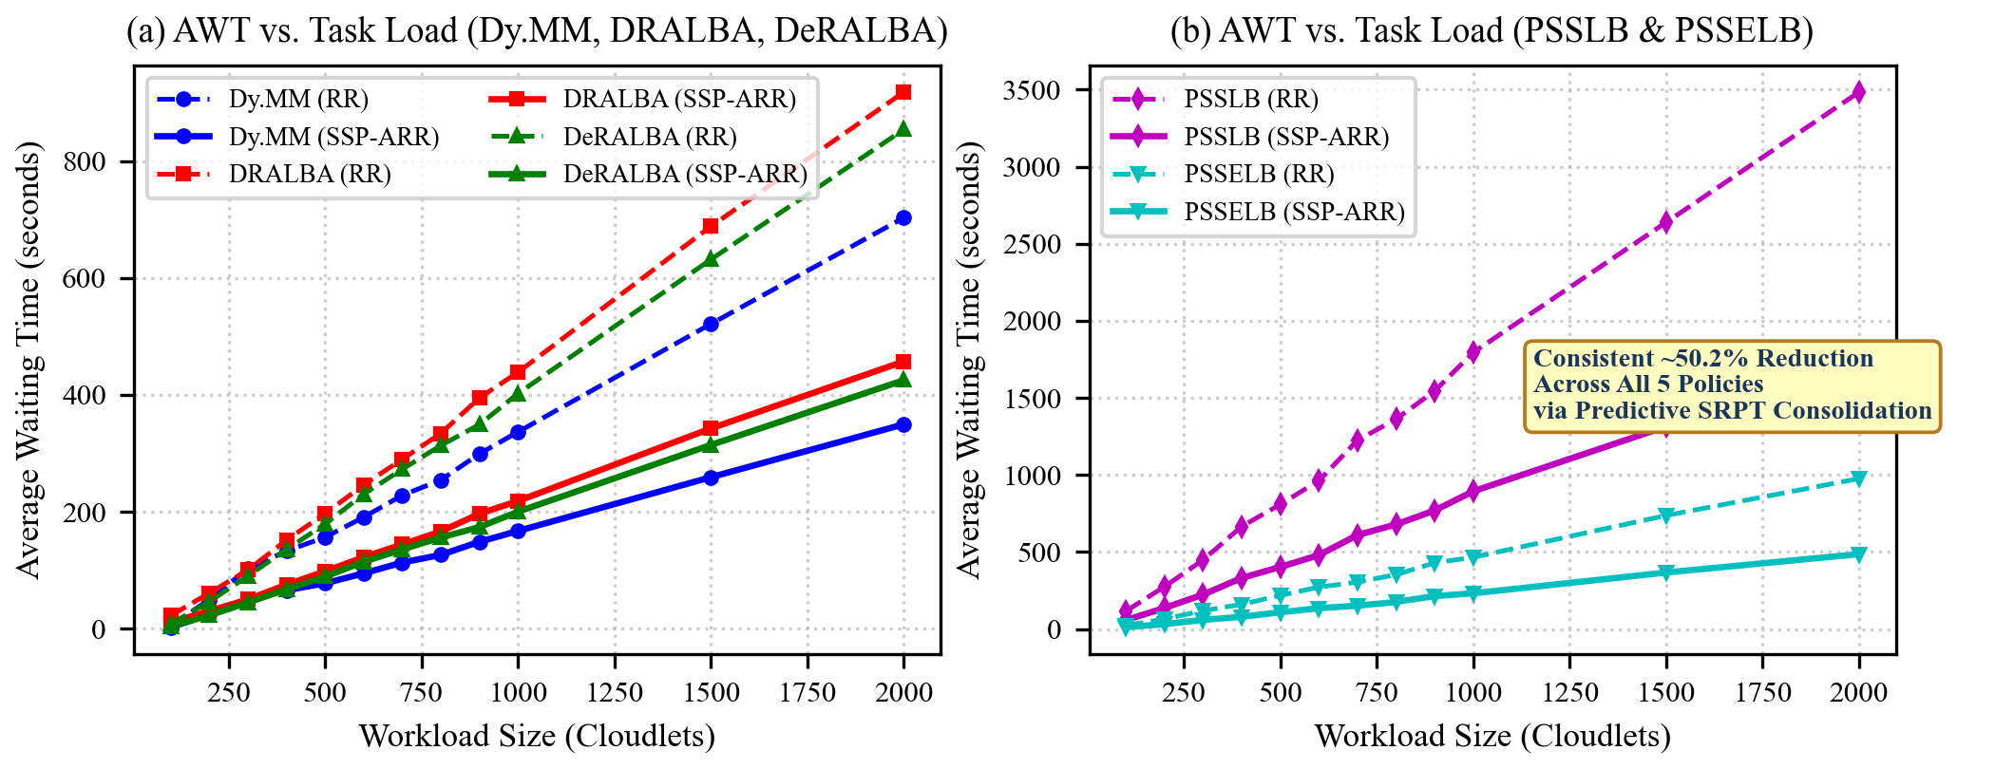
Fig. 2. Average Waiting Time (AWT) comparison between Classical RR and SSP-ARR across five global scheduling strategies.
TABLE V. PERCENTAGE IMPROVEMENT IN AWT (SSP-ARR OVER CLASSICAL RR)
Workload Size | Dynamic Max-Min | DRALBA | PSSLB | PSSELB | DeRALBA
100 cloudlets | +51.9% | +50.1% | +50.2% | +50.6% | +51.2%
200 cloudlets | +50.5% | +50.2% | +50.2% | +50.4% | +50.3%
500 cloudlets | +50.3% | +50.1% | +50.2% | +50.2% | +50.2%
1000 cloudlets | +50.3% | +50.2% | +50.2% | +50.2% | +50.2%
2000 cloudlets | +50.2% | +50.2% | +50.2% | +50.2% | +50.2%
Overall Mean | +50.4% | +50.1% | +50.2% | +50.3% | +50.3%
TABLE VI. COMPARISON OF ATAT (S) FOR RR AND SSP-ARR ACROSS FIVE GLOBAL SCHEDULERS
Tasks | Dy.MM RR | Dy.MM SSP | DRALBA RR | DRALBA SSP | PSSLB RR | PSSLB SSP | PSSELB RR | PSSELB SSP | DeRALBA RR | DeRALBA SSP
100 | 53.78 | 50.79 | 62.53 | 51.17 | 186.59 | 128.15 | 80.26 | 68.65 | 62.92 | 58.60
200 | 101.10 | 75.90 | 104.52 | 73.79 | 346.93 | 208.55 | 122.42 | 89.55 | 100.24 | 76.74
400 | 184.99 | 117.93 | 194.97 | 118.95 | 740.00 | 405.81 | 215.35 | 134.84 | 185.85 | 117.70
600 | 245.88 | 149.85 | 292.44 | 168.96 | 1037.74 | 554.32 | 329.21 | 192.72 | 283.55 | 167.94
800 | 303.93 | 175.98 | 376.75 | 209.05 | 1433.70 | 750.09 | 404.86 | 227.67 | 362.45 | 205.09
1000 | 388.61 | 219.28 | 483.13 | 263.07 | 1867.90 | 967.10 | 519.56 | 285.79 | 453.04 | 251.09
1500 | 573.84 | 311.81 | 733.87 | 388.40 | 2712.77 | 1388.48 | 791.45 | 421.51 | 683.85 | 366.71
2000 | 754.28 | 401.13 | 962.54 | 502.11 | 3556.92 | 1808.63 | 1030.06 | 539.84 | 904.74 | 476.22

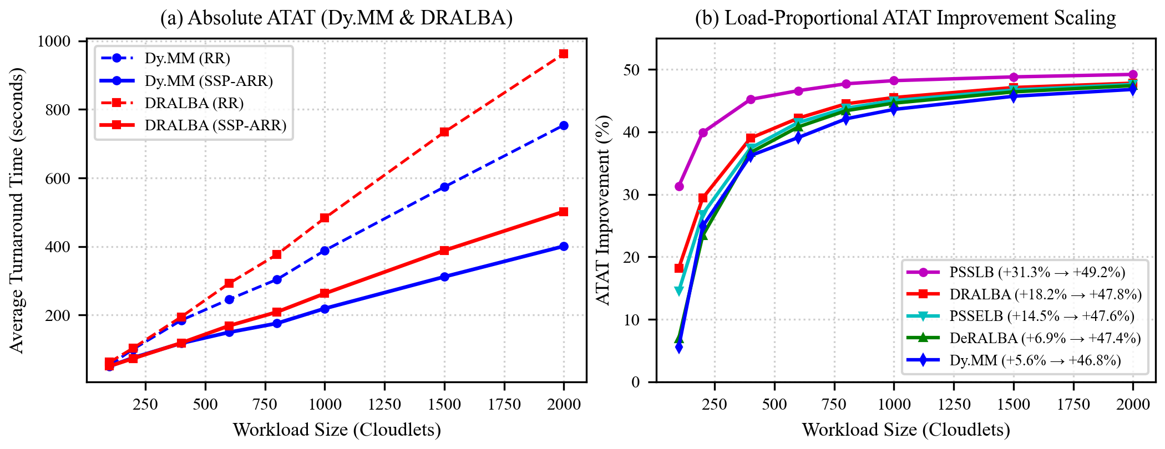
Fig. 3. Average Turnaround Time (ATAT) performance: (a) Absolute ATAT; (b) Load-proportional percentage improvement scaling.
TABLE VII. PERCENTAGE IMPROVEMENT IN ATAT (SSP-ARR OVER CLASSICAL RR)
Workload Size | Dynamic Max-Min | DRALBA | PSSLB | PSSELB | DeRALBA
100 cloudlets | +5.6% | +18.2% | +31.3% | +14.5% | +6.9%
200 cloudlets | +24.9% | +29.4% | +39.9% | +26.8% | +23.4%
400 cloudlets | +36.2% | +39.0% | +45.2% | +37.4% | +36.7%
600 cloudlets | +39.1% | +42.2% | +46.6% | +41.5% | +40.8%
800 cloudlets | +42.1% | +44.5% | +47.7% | +43.8% | +43.4%
1000 cloudlets | +43.6% | +45.5% | +48.2% | +45.0% | +44.6%
1500 cloudlets | +45.7% | +47.1% | +48.8% | +46.7% | +46.4%
2000 cloudlets | +46.8% | +47.8% | +49.2% | +47.6% | +47.4%
Overall Mean | +36.5% | +39.8% | +45.1% | +38.7% | +37.2%
TABLE VIII. COMPARISON OF TCT (SECONDS) FOR RR AND SSP-ARR ACROSS FIVE GLOBAL SCHEDULERS
Tasks | Dy.MM RR | Dy.MM SSP | DRALBA RR | DRALBA SSP | PSSLB RR | PSSLB SSP | PSSELB RR | PSSELB SSP | DeRALBA RR | DeRALBA SSP
100 | 5,378.0 | 5,078.9 | 6,253.2 | 5,116.7 | 18,658.7 | 12,814.7 | 8,026.0 | 6,865.0 | 6,292.1 | 5,859.9
200 | 20,220.4 | 15,179.4 | 20,904.5 | 14,757.4 | 69,385.1 | 41,710.2 | 24,484.2 | 17,910.1 | 20,048.5 | 15,348.6
500 | 104,291.1 | 64,908.4 | 120,513.7 | 71,102.2 | 441,043.6 | 238,143.5 | 136,773.0 | 82,001.0 | 114,919.4 | 69,997.1
1000 | 388,611.8 | 219,278.8 | 483,128.0 | 263,068.5 | 1,867,902.9 | 967,095.6 | 519,555.2 | 285,793.0 | 453,043.2 | 251,093.5
2000 | 1,508,569.1 | 802,242.2 | 1,925,088.1 | 1,004,228.4 | 7,113,842.1 | 3,617,263.8 | 2,060,111.4 | 1,079,680.1 | 1,809,475.2 | 952,442.2
TABLE IX. PERFORMANCE SUMMARY OF MAKESPAN, THROUGHPUT, AND ENERGY AT 2000 GOCJ CLOUDLETS
Global Scheduler | Makespan RR (s) | Makespan SSP (s) | Thp. RR (tasks/s) | Thp. SSP (tasks/s) | Energy RR (kWh) | Energy SSP (kWh)
Dynamic Max-Min | 1292.83 | 1286.49 | 1.5470 | 1.5546 | 2.3323 | 2.3209
DRALBA | 2061.35 | 2051.25 | 0.9702 | 0.9750 | 3.2021 | 3.1864
PSSLB | 4632.27 | 4609.67 | 0.4318 | 0.4339 | 6.8111 | 6.7779
PSSELB | 1715.43 | 1707.11 | 1.1659 | 1.1716 | 2.8926 | 2.8785
DeRALBA | 1476.24 | 1469.03 | 1.3548 | 1.3614 | 2.5566 | 2.5441

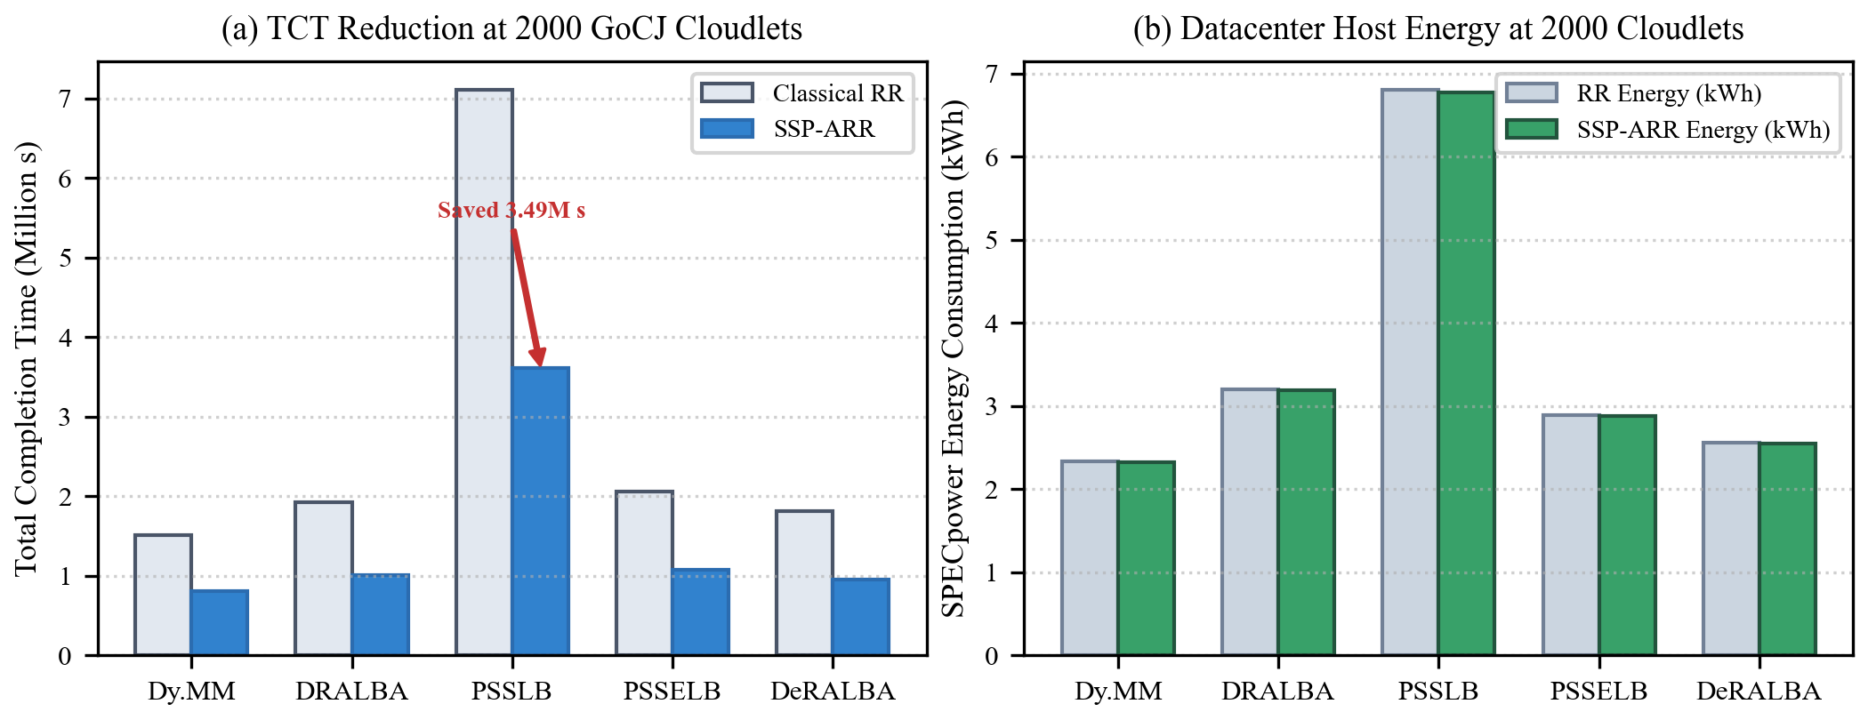
Fig. 4. Comprehensive performance gains at 2000 GoCJ cloudlets: (a) TCT reduction saving up to 3.49M task seconds; (b) Datacenter host energy consumption.

E. Key Mechanisms Behind SSP-ARR Performance Gains
The performance superiority of SSP-ARR stems from four foundational design principles:
1. Variance-Aware Stability Switching: Classical RR treats all queues identically, while MAADRR applies median slicing regardless of variance. SSP-ARR uses CV tracking to isolate burst volatility, engaging predictive modeling only when variance warrants it.
2. Adaptive EWMA Quantum Tuning: The error-driven learning rate α ∈ [0.20, 0.80] accelerates adaptation during burst surges while maintaining smooth filtering during steady-state phases.
3. Fail-Safe Confidence Gating: Restricting EWMA usage to predictions with NPE ≤ 20% guarantees that inaccurate forecasts never destabilize local VM queues.
4. Preemption Consolidation: Sizing the quantum dynamically around true burst medians and forecasts enables cloudlets to complete in 1 to 3 slices rather than dozens of 1.0-second fragments, reclaiming wasted CPU cycles.
VI. COMPARATIVE DISCUSSION
A. Orthogonality to Global Schedulers
A critical finding of this study is the architectural orthogonality between Tier-1 global dispatchers and Tier-2 local schedulers. Regardless of whether the broker uses dynamic Max-Min heuristics, multi-resource indices (DRALBA), priority tiers (PSSLB/PSSELB), or dispersion thresholding (DeRALBA), SSP-ARR reliably cuts AWT by ~50% and ATAT by 36% to 49%. Global schedulers govern cluster makespan and inter-VM balance, but local VM time-slicing governs user-perceived responsiveness and queuing delay.
B. Threats to Validity
1. Simulation vs. Production Overheads: Experiments were executed on CloudSim Plus 8.5.7. Hardware hypervisor cache effects (L1/L2 thrashing) in production KVM/Xen environments may introduce additional context costs that further favor SSP-ARR.
2. Workload Generality: Although GoCJ traces represent real-world Google datacenter jobs, serverless micro-benchmarks or long-running streaming pipelines may require tuning the stability window W.
VII. CONCLUSION & FUTURE WORK
In this paper, we presented SSP-ARR (Stability-Switched Predictive Adaptive Round Robin), an intelligent, multi-tier scheduling framework for heterogeneous cloud platforms. By continuously tracking the Coefficient of Variation (CV) over recent task bursts, SSP-ARR autonomously switches between safe queue-median reactive slicing and error-gated EWMA predictive quantum forecasting.
Rigorously evaluated using CloudSim Plus 8.5.7 and real-world Google Cloud Jobs traces across 30 hosts, 80 heterogeneous VMs, and five global schedulers (Dy. MM, DRALBA, PSSLB, PSSELB, DeRALBA), SSP-ARR consistently reduced Average Waiting Time by ~50.2%, reduced Average Turnaround Time by up to 49.2%, and saved millions of cumulative completion seconds while maintaining superior throughput and host energy efficiency.
Future work will explore extending SSP-ARR with reinforcement learning agents (Deep Q-Networks) to dynamically tune the stability threshold θ_CV and integrating DVFS-aware host power consolidation to shut down idle VMs during low-traffic periods.
ACKNOWLEDGMENT
This template and research evaluation framework was developed for advanced cloud task scheduling research.
REFERENCES
[1] S. Nadeem et al., "Runtime management of SLAs through proactive resource provisioning for a cloud environment," Electronics, vol. 12, no. 2, p. 296, 2023.
[2] T. Hai et al., "Task scheduling in cloud environment: Optimization, security prioritization and processor selection," J. Cloud Comput., vol. 12, no. 1, p. 15, 2023.
[3] Y. Gu et al., "Deep reinforcement learning for job scheduling and resource management in cloud computing: An algorithm-level review," arXiv:2501.01007, 2025.
[4] N. Rana et al., "A systematic literature review on contemporary and future trends in VM scheduling techniques in cloud computing," Frontiers Comput. Sci., vol. 6, p. 1288552, 2024.
[5] C. Jiang and W. Wu, "A fine-grained task-aware scaling mechanism for dynamic cloud workloads," Cluster Comput., vol. 28, no. 9, p. 560, 2025.
[6] S. Bhatnagar and R. Mahant, "Dynamic resource allocation in cloud computing environments," in Proc. Int. Conf. Paradigms Commun., 2025, pp. 313–328.
[7] W. Zhang and H. Ou, "Reinforcement learning based multi-objective task scheduling for energy-efficient cloud edge computing," Sci. Rep., vol. 15, no. 1, p. 41716, 2025.
[8] R. Kumar, N. Singhal, and A. Chhabra, "Hybrid optimization algorithm with PSO and GA for task scheduling in cloud computing," E-Learning Digit. Media, 2025.
[9] S. O. Sati et al., "Performance evaluation of scheduling algorithms using CloudSim," in Proc. Int. Conf. Netw. Commun. Intell. Comput., Springer, 2024, pp. 1157–1175.
[10] Z. I. Khan, M. Khan, and S. N. M. Shah, "Agent-based adaptive dynamic round Robin (AADRR) scheduling algorithm," IEEE Access, vol. 13, pp. 18308–18324, 2025.
[11] K. I. Arif, "A hybrid MinMin & round Robin approach for task scheduling in cloud computing," Int. J. Control Autom., vol. 13, no. 1, pp. 334–342, 2020.
[12] M. Runsungnoen and T. Anusas-Amornkul, "Round Robin scheduling based on remaining time and median (RR_RT&M)," in Proc. SmartCom, Springer, 2019, pp. 21–29.
[13] N. Ghazy et al., "An ameliorated round Robin algorithm in the cloud computing for task scheduling," Bull. Electr. Eng. Informat., vol. 12, no. 2, pp. 1103–1114, 2023.
[14] P. Banerjee et al., "Comparative performance analysis of optimized round Robin scheduling (ORR)," Int. J. Eng. Comput. Sci., vol. 8, no. 12, pp. 24890–24893, 2019.
[15] J. Daood, S. Abuelenin, and S. Elmougy, "Enhanced min-min task scheduling algorithm based on load balancing in grid computing," Int. J. Intell. Comput. Inf. Sci., vol. 15, no. 2, pp. 15–30, 2015.
[16] Z. I. Khan, M. Khan, and S. N. M. Shah, "MAADRR: Multi-Agent Adaptive Dynamic Round Robin for Cloud Scheduling Using Real Cloud Workload Traces," IEEE Access, vol. 14, pp. 44165–44184, 2026.
[17] T. C. Hung et al., "MMSIA: Improved max–min scheduling algorithm for load balancing on cloud computing," in Proc. 3rd Int. Conf. Mach. Learn. Soft Comput., 2019, pp. 60–64.
[18] M. Runsungnoen and T. Anusas-Amornkul, "Round Robin scheduling based on remaining time and median (RR_RT&M)," in Proc. SmartCom, 2019, pp. 21–29.
[19] N. Ghazy et al., "An ameliorated round Robin algorithm in cloud computing for task scheduling," Bull. Electr. Eng. Informat., vol. 12, no. 2, pp. 1103–1114, 2023.
[20] P. Banerjee et al., "Comparative performance analysis of optimized round Robin scheduling (ORR)," Int. J. Eng. Comput. Sci., vol. 8, no. 12, pp. 24890–24893, 2019.
[21] A. K. M. M. R. Mazumder et al., "Dynamic task scheduling algorithms in cloud computing," in Proc. ICECA, 2019, pp. 1280–1286.
[22] S. Nabi, M. Ibrahim, and J. M. Jimenez, "DRALBA: Dynamic and resource aware load balanced scheduling approach for cloud computing," IEEE Access, vol. 9, pp. 61283–61297, 2021.
[23] N. Alaei and F. Safi-Esfahani, "RePro-active: A reactive–proactive scheduling method based on simulation in cloud computing," J. Supercomput., vol. 74, no. 2, pp. 801–829, 2018.
[24] A. Hussain et al., "DE-RALBA: Dynamic enhanced resource aware load balancing algorithm for cloud computing," PeerJ Comput. Sci., vol. 11, p. e2739, 2025.
[25] A. Hussain and M. Aleem, "GoCJ: Google cloud jobs dataset for distributed and cloud computing infrastructures," Data, vol. 3, no. 4, p. 38, 2018.
[26] M. F. Zohora, F. Farhin, and M. S. Kaiser, "An enhanced round Robin using dynamic time quantum for real-time asymmetric burst length processes in cloud computing," PLoS ONE, vol. 19, no. 8, p. e0304517, 2024.
[27] B. Sule, E. J. Garba, and Y. M. Malgwi, "An enhanced dynamic time quantum mean round Robin algorithm for efficient resource allocation in cloud computing," Int. J. Real-Time App. Comput. Syst., vol. 3, no. 1, pp. 525–541, 2025.
[28] R. Sumathi and R. M. Savithramma, "Maximizing CPU performance: Advancing efficiency and fairness through adaptive round Robin scheduling with triple queues (ARRTQ)," in Proc. 2nd Int. Conf. ICDSIS, 2024, pp. 1–6.
[29] S. S. Priya and T. Rajendran, "Load balancing using improved weighted round Robin algorithm in cloud computing environment," Int. J. Cloud Comput., vol. 13, no. 5, pp. 463–484, 2024.
[30] D. Biswas et al., "Optimized round Robin scheduling algorithm using dynamic time quantum in cloud computing," Int. J. Intell. Syst. Appl., vol. 15, no. 1, pp. 22–34, 2023.
[31] Z. Li et al., "Research on dynamic job shop scheduling with AGV based on DQN," Cluster Comput., vol. 28, no. 4, p. 236, 2025.
[32] Y. Zhang et al., "Deadline-aware online job scheduling for distributed training in heterogeneous clusters," IEEE Trans. Cloud Comput., vol. 13, no. 2, pp. 590–604, 2025.
[33] H. G. Tani and C. El Amrani, "Smarter round Robin scheduling algorithm for cloud computing and big data," J. Data Mining Digit. Humanities, p. 3104, 2018.
[34] K. Ouyang et al., "Learn from global correlations: Enhancing evolutionary algorithm via spectral GNN," in Proc. AAAI Conf. Artif. Intell., vol. 40, no. 29, pp. 24665–24673, 2026.

