**Task A : Dynamic simulation of start and control of a chemostat.**

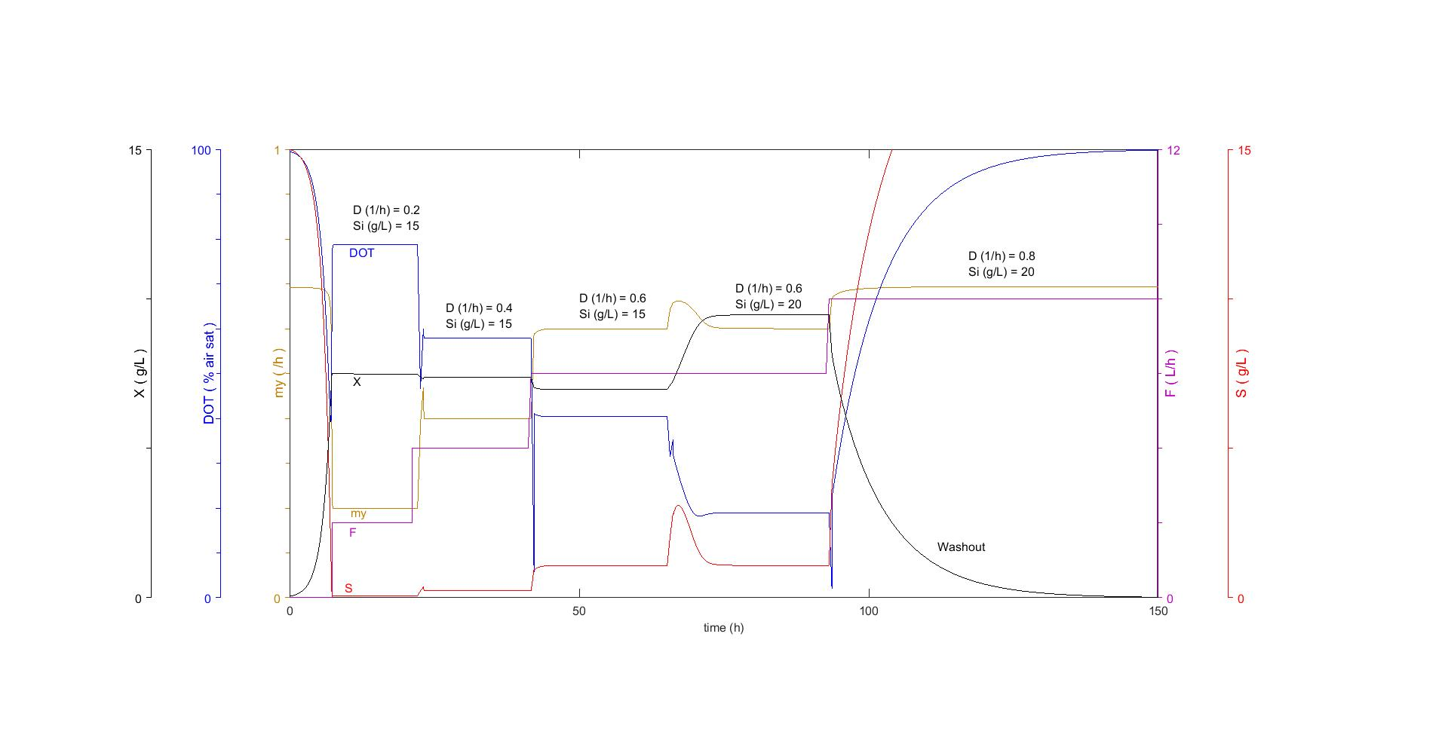

*Figure 1: Simulation of a chemostat cultivation while changing Si and D.*

*What are the effects of a change in Si? (Limited substrate in the inlet flow)*

Observation of the period between 50 to 80 hours when the concentration of substrate in the inlet flow was changed, we could observe that there was no change in the substrate concentration in the chemostat and in growth rate after a steady state has been reached when the dilution rate is unchanged. However, a higher concentration of cells was obtained in the process.

*What are the effects of a change in D? (The dilution rate of the reactor, Fin/VL)*

By observing the change in steady state when the inlet flow was changed, we could observe that my increased when F increased, until the dilution rate was 0.8. A change in the dilution rate had little change in the concentration of cells in the chemostat, but an effect on the substrate concentration in the chemostat at steady state.

*What happens when you set D>mumax? Why does this happens? Refer your answer to the model equations on page 4-5.*

At steady state, the dilution rate is equal to the growth rate (when the change in biomass is zero)  
  
*Equation 1*

$$\frac{dCx}{dt}=\left(µ-D\right)*Cx$$

When a steady state has been reached, my is equal to the dilution rate. When the dilution rate is higher than the maximum growth rate, the equation becomes negative, which means that cells leaves the chemostat faster than they are replenished, i.e a washout of the chemostat. What the simulation does not consider is the time it takes for the cells to adapt to the new dilution rate (ribosomal and gene regulation), where the time it takes between a new steady states after a change in dilution rate is about 1/D.

**Task B1. Compare your dynamic simulation with steady-state simulations**

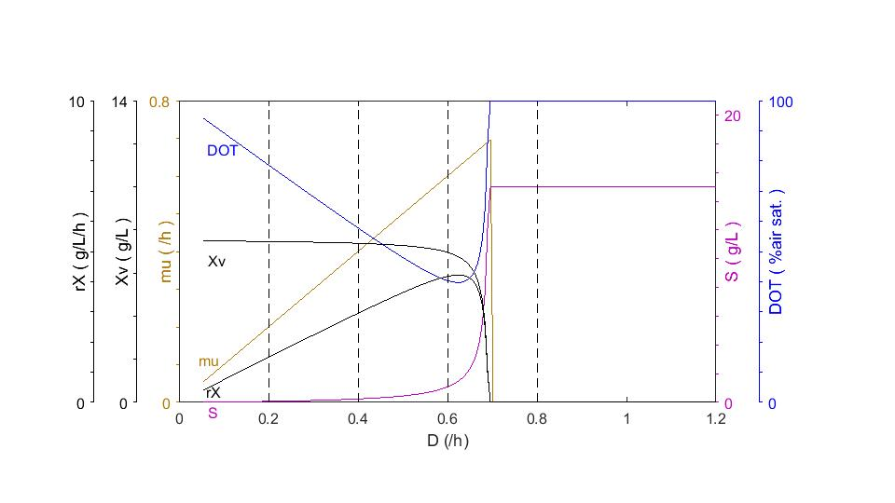

*Figure 2: simulation of steady-states*

*Does the steady-state simulation agree with the dynamic simulation?*

To some degree, the steady state simulation agrees with the dynamic simulation. In the dynamic simulation, only the total amount of biomass is accounted for, not the viable and productive biomass (cell death is assumed zero in the steady state simulation), which means that Xv is equal to the total amount of biomass in the dynamic simulation. The values of biomass, DOT and my are equal to the dynamic simulation. The conclusion is that the steady state simulation is a good approximation of the steady states in a chemostat.

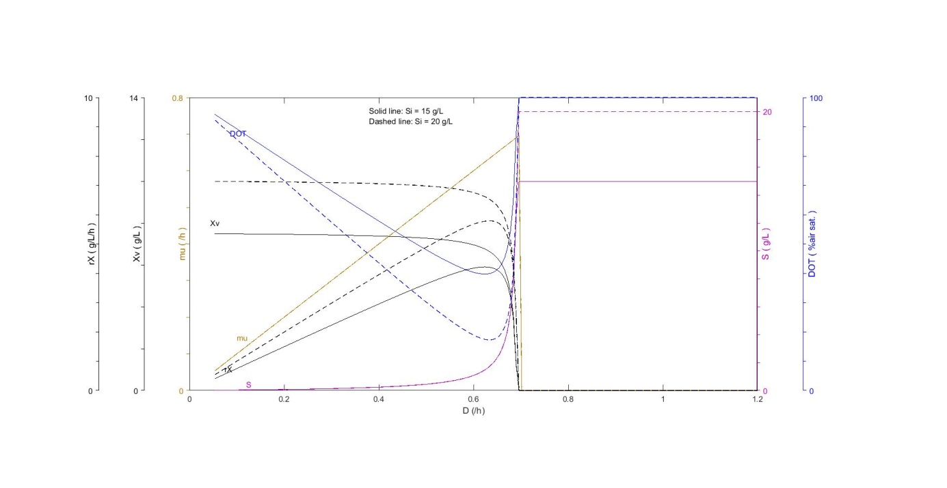

*Figure 3: simulation of steady-states with changed values of Si*

*How would you suggest to control biomass concentration and the specific growth rate in a chemostat?*

As observed in figure 3, changing the concentration of limiting substrate in the inlet flow does not affect the growth rate of the culture in the chemostat, but it will change the concentration of the biomass in the chemostat when the chemostat reaches a steady state. The most practical way to control the biomass concentration in the chemostat, would be by changing the dilution rate, since it would be impractical to change the substrate concentration when the chemostat is running. However, to achieve a higher cell concentration, changing the substrate concentration while increasing the dilution rate might be preferred.

**Task B2. Effects of maintenance (qm) and cell death (kd)**

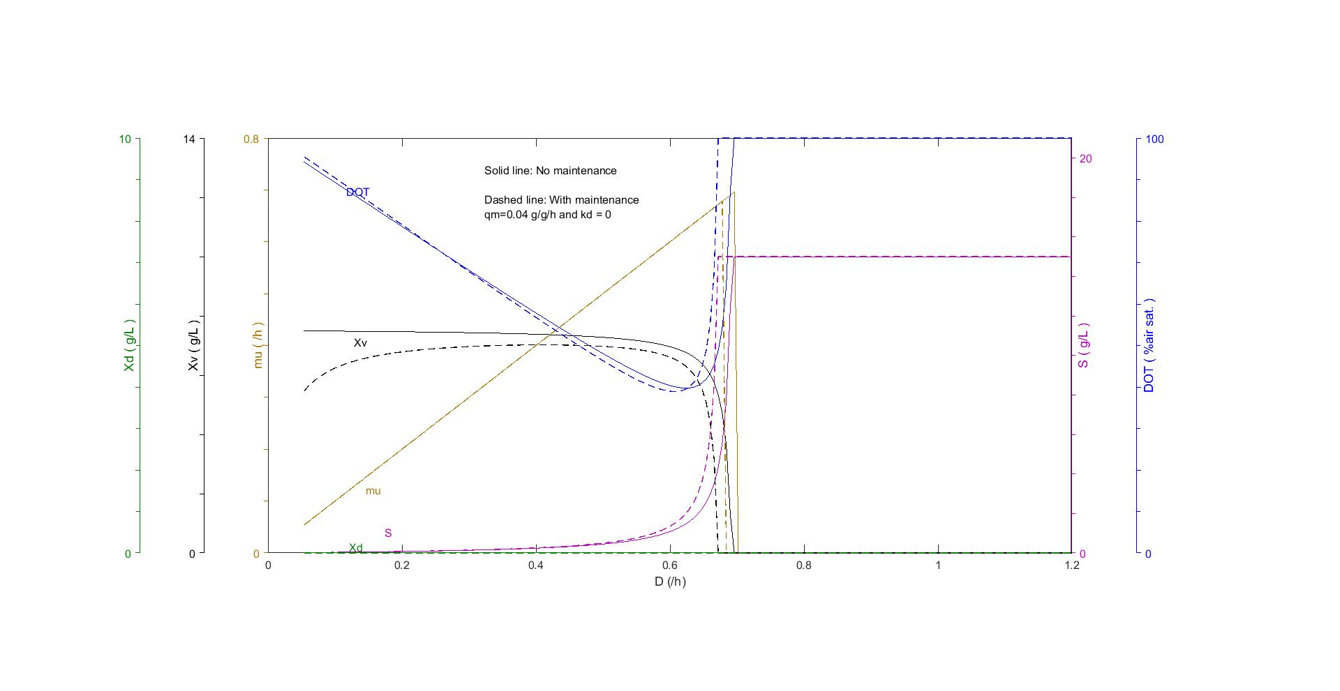

*Figure 4: simulation of steady-states with maintenance and no cell death*

In figure 4, a simulation is shown of steady states of a chemostat with and without maintenance of the cell. We can observe that maintenance of the cells will have a negative effect on the cell concentrations and that with low dilution rate, the steady state of biomass is significantly lower than without maintenance. A higher concentration of substrate in the chemostat is observed with cells that have maintenance, since a lower concentration of cells is obtained in the chemostat, due to less substrate is consumed by the cells. The growth rate of the cells are the same, which is equal to the dilution rate.

*Equation 2*

$$µ=\left(q_{s}- q_{m}\right)*Y_{em}$$

The equation above describes the growth rate depending on qs (substrate uptake rate of the cells), qm (maintenance) and Yem (biomass yield of the cells without maintenance). The equation tells us that since µ is equal to the dilution rate, qs in the cells with maintenance is higher than the cells without maintenance, due to the parameters qm and Yem are constant. The results are that cells with maintenance will wash out of the chemostat at a lower dilution rate, due to the maximum qs that the cells can achieve. (i.e qs max found in the Monod equation)

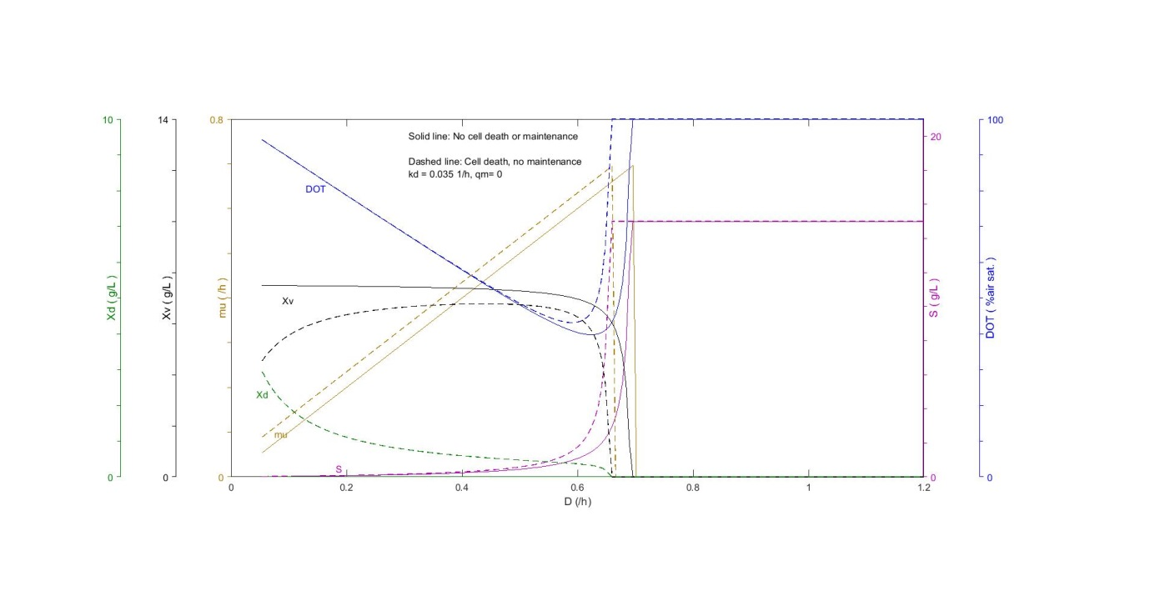

*Figure 5: simulation of steady-states with no maintenance and no cell death*

In figure 5, a simulation is shown of steady states of a chemostat with and without cell death. At low dilution rates, a higher concentration of dead cells are obtained and a low concentration of viable cells. The growth rate of the cells with cell death is higher at the same dilution rate as for the cells with no cell death. The explanation for this behavior is found in the equation below:

*Equation 3*

$$µ= δD+kd$$

In a chemostat at steady state with no cell death, the growth rate is equal to the dilution rate (δ is the biomass re-circulation factor, which is equal to one when there is no cell recycling). A culture with cells with a death rate will have a higher µ, due to the factor kd is added to the growth rate in steady state.

**Task B3. Effects of cell recycling**

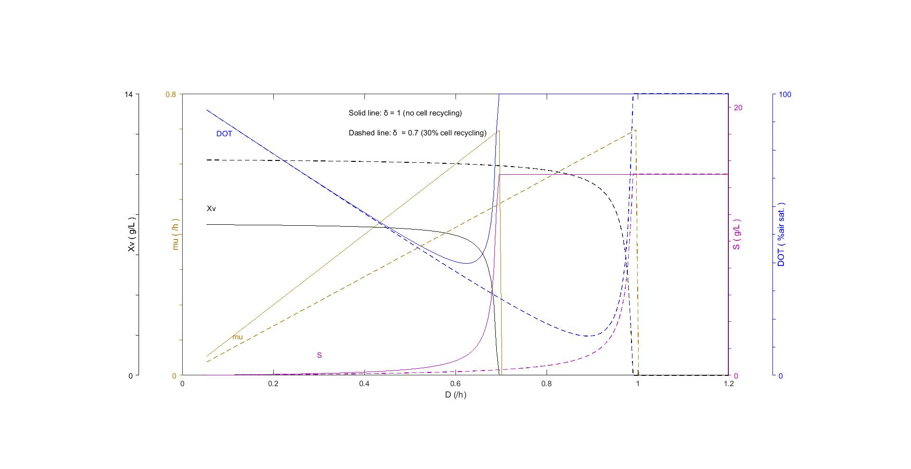

*Figure 6: simulation of steady-states with and without cell recycling*

*Which parameters are influenced by re-cycling, and how are they influenced? Refer also to model equations.*

By observing figure 6, we can observe that all parameters are affected changing the cell recycle factor. My for cell recycling is lower, the obtained cell concentration at steady state is higher, the washout point is at a higher dilution rate, which results in a lower value of DOT at high dilution rates. The factors that are affected by the cell recycling factor are shown below:

*Equation 4: Mass balance of biomass Equation 5: Specific growth rate*

H:\Matlab\Odling\chemostatexc\eq2.PNGH:\Matlab\Odling\chemostatexc\eq1.PNG

*Cell recycling is used in waste-water treatment (with activated sludge). Can you see advantages with that?*

There are many important advantages with cell recycling which could be used in the waste-water treatment. The growth rates of the microorganisms are lower with cell recycling, which is an advantage if a low biomass accumulation is preferred. A higher cell concentration is obtained, which is useful to more quickly break down and metabolize the pollution in the waste water that needs to be cleaned. A higher washout dilution rate point is advantageous, since a greater flow of waste water can be purified without washing out the microorganisms, which would result in a high concentration of microorganisms in the treated waste water. A lower substrate concentration (i.e the pollution/substances that needs to be removed from the waste water) is obtained with higher dilution rates.

**Task C1. Compare product concentration and productivity with Si= 15 and 20 g/L.**

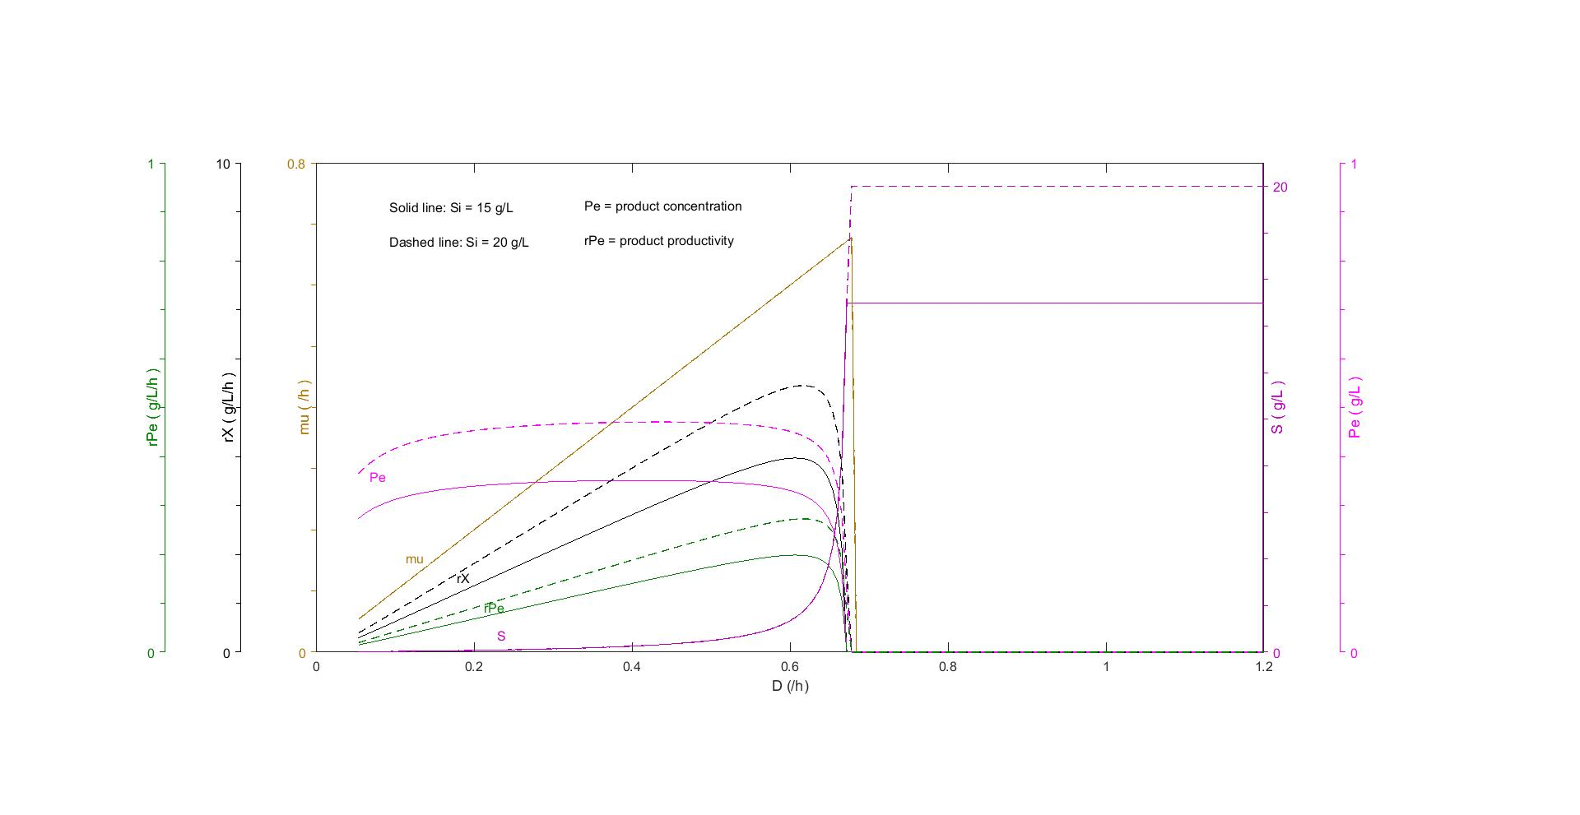

*Figure 7: simulation of steady-states and productivity and product concentrations (with maintenance)*

*How does the product concentration and productivity depend on D and Si?*

As observed in figure 7, increasing substrate concentration is proportional to an increase in substrate concentration, productivity and productive biomass.

**Task C2. Compare these results with a fed-batch**

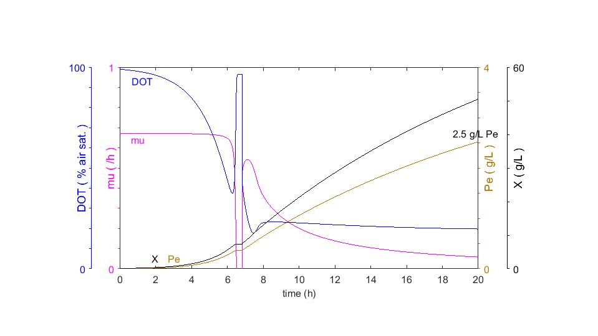

*Figure 8: Simulation of a Fed-batch and product concentrations*

*What’s difference in productivity and product concentration between these two process techniques?*

The average productivity of the cultivation can be calculated by dividing the final product concentration by the time by the end of the cultivation.

A much higher productivity but a lower product concentration is obtained in the chemostat, while in the fed batch, a lower productivity but higher product concentration is obtained. The benefits of a chemostat are that they are easier to control to both increase productivity and decreasing biomass.

**Task C3. Increase the product concentration in the chemostat by increasing Si**

By increasing Si and decreasing D, a concentration of product as high as a fed batch can be obtained as with a chemostat, while keeping a high productivity of the product.