**BATCH**

*Q1: Look at the mass balances for the different cultivation concepts. What do you have to do?*

Batch: Set inflow to 0. No mass leaves or goes in.

*Q2: What parameter(s) can be altered in order to reach a biomass of 2 g/L at the end of the batch? Make sure that the DOT (%) value is above 20%. Plot the following variables: DOT, X, S, V and mu (µ) against time.*

Changing limiting nutrient. S needs to be about 2 times end concentration of biomass (if maintenance is assumed to be 0 and Yx/s = 0.56).

Cx start affects speed.

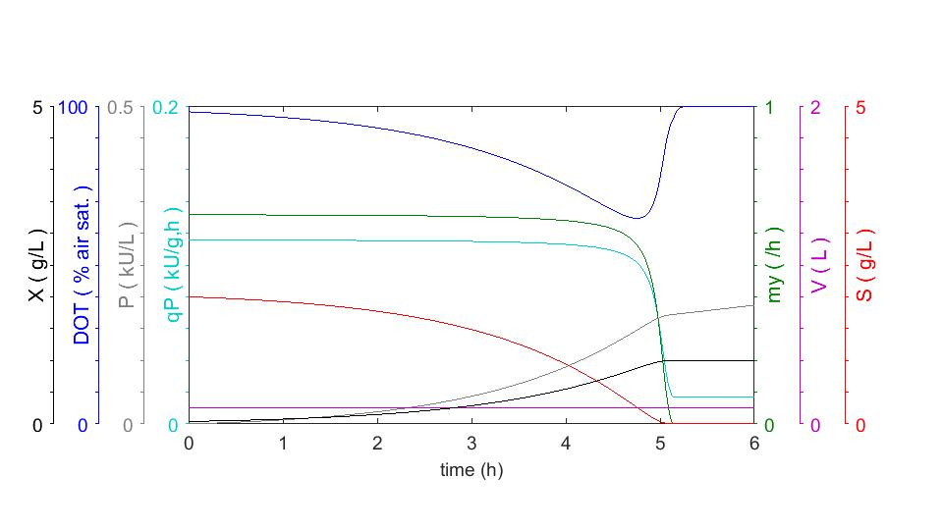

*Picture 1: maximum 2 g/l cells*

*Q3: What parameter (1) do you need to change in order to reach the same biomass within 5 hours?*

Substrate is still limited factor. About 10 g/L glucose is needed for biomass. To reach before 5 hours: change X initial to 1 g/l. Change KLa if DOT is limited.

*Q4: Make a good simulation of an overnight cultivation. Make sure that the cells are in log phase when you return in the morning. Ensure that the DOT is above 20% and that the biomass does not exceed 0.75 g/L. What simple equation can be used to determine the inoculum concentration (X0) without running a simulation?*

Cx=Cx0*e^my*t🡪 Cx/e^my*t = Cx0 🡨 fungerar förvånandsvärt bra IRL  
t=14 hours, my = depends on substrate concentration.

My=mymax*(Cs/(Ks+Cs)), mymax = point at 2*Ks: 0.668

qs=qsmax*(Cs/(Ks+Cs))

Cons s=qs*biomass

qs = g of substrate consumed / (time * g DryWeight)

…

Or limit the glucose by looking at the Yield! The bacteria cannot grow if not enough nutrients.

*Q5: Is it possible to alter the µ (mu) value during batch cultivation? What is the definition of a batch cultivation?*

Yes, it’s possible by cooling/heating the reactor, but you cannot add anything to the batch. Definition of batch: no in or outflow during cultivation. AND they grow at mymax

*Q6: What is the highest cell dry weight that you can reach in the batch.fig simulation? - Why is this not realistic in a real cultivation? Suggest a way to alter the program so that it becomes more realistic in regard to maximum cell mass.*

The program assumes that you can solve infinite glucose in the solution (i.e 10 kg glucose/1 kg water), which is not possible. By adding a limit of glucose concentration in the solution, the simulation would be more realistic.

### **Fed batch** Constant feed profile

*Q7: If you are sitting by the reactor in the lab, how do you know when to start the feed? What measurement or signal can you look at?*

By either looking at the glucose concentration (easy way) or by looking at the cellmass (difficult and unpractical).

*Q8: How do you select an appropriate feed rate? What equation do you need to use?*

You use the Monod equation: My=mymax*(Cs/(Ks+Cs)). By measuring substrate concentration and if mymax is known (which is easy to achieve and measure, by having Cs>>>Ks). By keeping Cs at a constant conc, the growth will be constant.

F0=(X*µ*V)/(Yxs*sin)

Constant feed rate equation.

*Q9: Simulate a fed-batch with a constant feed. What happens to the main parameters when you start the feed? What happens to µ and S if your set the feed higher than specified by the equation? What happens if you set the feed lower?*

V increases linearly, my does not reach zero when substrate is limited (since new substrate is added by the inflow) and x keeps increasing linearly after S conc reaches 0.

If feed is lower: S conc drops to 0 and x increases linearly. DOT reaches 0 exponentially and then spikes and lowers linearly.

If feed is higher: S conc goes towards feed conc and x increases linearly. DOT reaches 0.

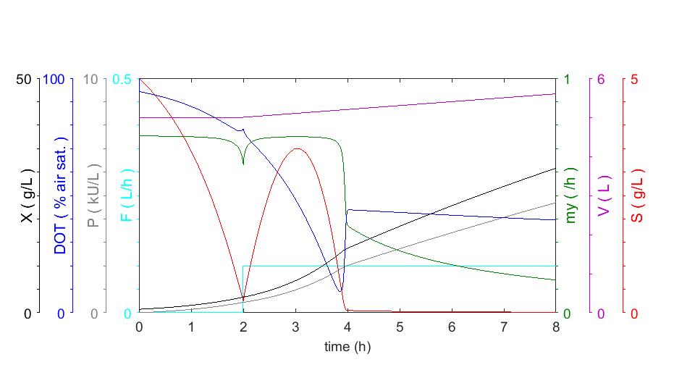

*Picture 2: Just enough feed*

*Q10: Why is µ not constant when you use a constant feed?*

X increases, which results that more glucose consumed per hour increases exponentially while glucose is added by a constant rate. When the consumption rate is higher than the addition rate, the substrate concentration decreases which results in a lower my.

### **Fed batch** Exponential feed profiles

*Q10: Simulate a fed-batch with µ = 0.5 during the feed phase (this means that you have to set SFR=0.5 and calculate F0 correctly). Just as before, run a batch to determine Fstart. Then you can run the exponential feed. When do you encounter DOT limitation? What is the feed at this point?*

My = 0.5, Mymax (point at 2*Ks) = 0.668  
My=mymax*(Cs/(Ks+Cs))

My/mymax*(Ks+Cs)=Cs 🡪 (My/mymax)*Ks = (1- My/mymax)*Cs  
Cs=((My/mymax)*Ks)/(1- My/mymax)=0.1488 g/l for mu = 0.5  
qs=qsmax*(Cs/Ks+Cs) = 1.4*0.1488/0.1488+0.05 = 1.0479 gs/gxh  
  
Cs feed = 500g glucose/l: qs*x*vl = Cs feed*Vfeed 🡪 Vfeed = qs*x*vl/Cs feed 🡪 qs * x0 * vl0/Csfeed = F0 = 0.00785925

If you assume Yem = Yxs you can use the equation

F0=(X*µ*V)/(Yxs*sin)

Whereas sin = 500 g/l. The equation results in a much easier calculation but require assumption on the yield of the substrate.

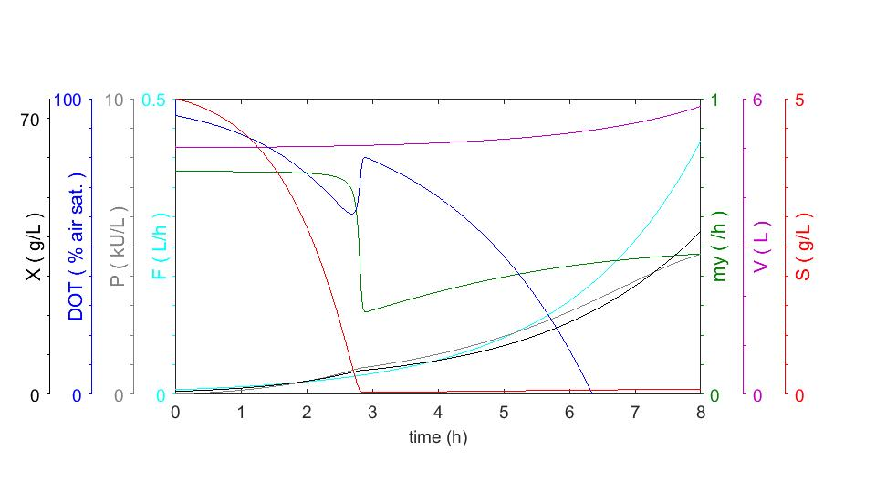*Picture 3: Start at t = 0 with feed calculated to 0.00785925 l/h. Converges towards my=0.5*

No feed: t = 1.9 h, S conc reaches 0.1488 g/l. X = 2.662 g/l 🡪 0.02699 l/h feed required

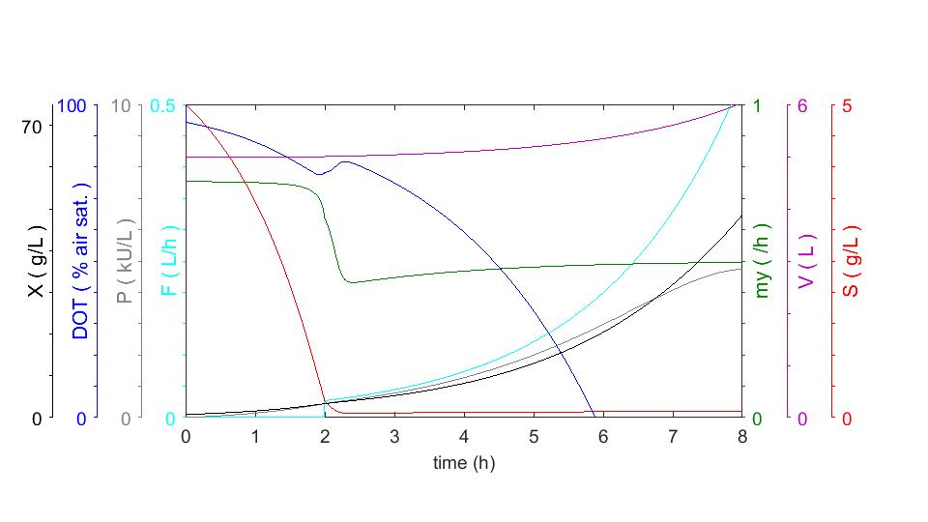*Picture 4: Start at t = 2 with feed calculated to 0.02699 l/h. Converges towards my=0.5*

Problems with these simulations: No significant DOT change at the batch end 🡪 difficult to measure when you have reached the end of the batch.

*Q11: Use the answer from the previous question to set Fmax. What happens to µ during the different feed phases?*

*a) What biomass do you reach within 8 hours?*

*b) What biomass can you reach within 8 hours with µ = 0.2 during the exponential feed phase (remember to recalculate insert correct SFR and F0 values for this feed!)? Why?*

t=0: Substrate concentration drops. This results in a drop of my when the concentration reaches about 1 g/l. At t=2h, the feed is initiated and the substrate concentration is then constant which results in a constant my. Fmax can be calculated by looking at DOT. The value of DOT should not be lower than 20%. Therefore, Fmax should be set so that when DOT reaches zero, the feed at the time should be constant. At 5.4 hours, DOT reaches 20%. Fmax should be set to the rate at t=5, by using the equation

F=F0*e^(SFR*t), t = 5.4-2

Which gives Fmax to about 0.1477 liters/h

1. About 45.7 g/l biomass with a volume at about 6 l: 🡪 274.2 g biomass after 8 hours.
2. My=0.2 🡪 Cs=0.213675 g/l 🡪 qs=0.41916 gx/gs*h 🡪F0 (at t=2) = 0.011158 l/h  
   🡪 10 g/l cells at V=5.12 🡪 51.2 g cells after 8 hours.

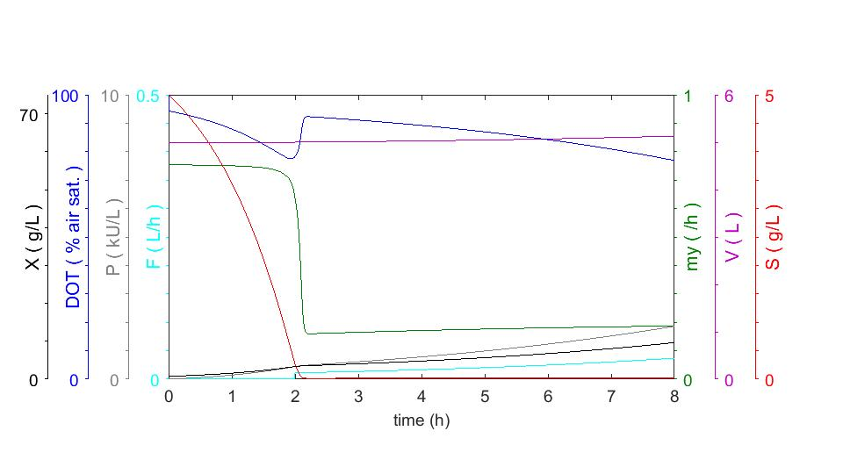*Picture 5: Start at t = 2 with feed calculated to 0.011158 l/h. Converges towards my=0.2*

*Q12: What are the benefits/drawbacks of running a constant feed vs. an exponential feed?*

Exponential feed is a great method to keep the cells growing at a constant exponential rate.

Constant feed is a good method to grow cells at a constant, linear rate.

*Q13: Design a fedbatch to determine the qm of the strain in the simulation. Does this value agree with the value listed in the constants table?*

Not enough time to do this question