Project Sprint #2

The Solitaire game is described in CS449HomeworkOverview.docx. You should read the description very carefully.

Your submission must include the GitHub link to your project, and you must ensure that the instructor has the proper access to your project. You will receive no points otherwise.

GitHub link:

In this assignment, you aim to implement the minimum features including choosing the board size and type, starting a new game, making a move, determining if a game is over. The following is a sample GUI layout.

The implementation of a GUI is required. You should make every attempt to make your code easy to extend. It is required to separate the user interface code and the game logic code into different classes (refer to the TicTacToe example). xUnit tests are required.

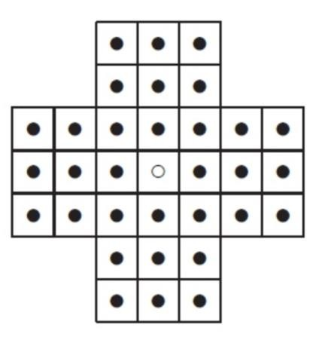

Board size

Board Type

English

Hexagon

Diamond

New Game

7

Figure 1. Sample GUI layout of the Sprint 2 program

Deliverables:

Demonstration (8 points)

Submit a link to a video of no more than three minutes, clearly demonstrating that you have implemented the required features and written some automated unit tests. In the video, you must explain what is being demonstrated. No points will be given without a video link.
YouTube/Panopto link:

 | Feature
1 | Choose board size and type
2 | Start a new game of the chosen board size and type
3 | Making a move
4 | Checking the end of game
5 | Automated unit tests

Summary of Source Code (1 points)

Source code file name | Production code or test code? | # lines of code
move.py | Production code | 105
board.py | Production code | 94
GUI.py | Production code | 217
main.py | Test code | 78
test_game.py | Test code | 101
 | Total | 595

You must submit all source code to get any credit for this assignment.

Production Code vs User stories/Acceptance Criteria (3 points)

Update your user stories and acceptance criteria from the previous assignment (if required) and ensure they adequately capture the requirements. Summarize how each of the following user story/acceptance criteria is implemented in your production code (class name and method name etc.). If you are not using an OOP, then adapt the tables accordingly.

User Story ID | User Story
1 | Choose board size and type
2 | Start a new game of the chosen board size and type
3 | Making a move
4 | Checking the end of game

User Story ID and Name | AC  ID | Class Name(s) | Method Name(s) | Status (complete or not) | Notes (optional)
1 Choose a board size and type | 1.1 | Board | create_board(self) | complete | This is a generic method inherited by child classes (EnglishBoard, DiamondBoard, HexagonBoard) the selection of the child class through the GUI handles which board gets selected
 | 1.2 | EnglishBoard | create_board(self) | Complete | Creates an English board of chosen size
 | 1.3 | DiamondBoard | create_board(self) | Complete | Creates a Diamond board of chosen size
 | 1.4 | HexagonBoard | create_board(self) | Complete | Creates a Hexagon board of chosen size
2 Start a new game of the chosen board size and type | 2.1 | N/A (GUI function) | new_game() | complete | The GUI starts with a standard English Board of 7 as the default but new game can be selected at any time and boards/sizes can be configured prior to the selection
3 Make a move in a game | 3.1 | Move | validate_move(self, start_row, start_col, end_row, end_col) | complete | Validate move handles several different check including ensuring all numbers from the selection and the ending peg are valid in the matrix, check to make sure that the middle peg is present to be jumped, and ensuring the different move rules for Hexagon and English boards vs. the Diamond board.
 | 3.2 | Move | execute_move(self, start_row, start_col, end_row, end_col) | complete | After validating the move with the above method, This handles the changes of the numbers in the matrix
4 a game is over | 4.1 | Board | check_win(self) | complete | Uses a count to search through the matrix counting instances of “1” and if there is only 1 in count then it returns True otherwise False
 | 4.2 | Move | check_loss(self) | Complete | Checks to ensure that there are no valid moves left using validate_move() and if there are no valid moves left and more than 1 peg then the bool becomes True

Tests vs User stories/Acceptance Criteria (3 points)

Summarize how each of the user story/acceptance criteria is tested by your test code (class name and method name) or manually performed tests.

User Story ID | User Story
1 | Choose board size and type
2 | Start a new game of the chosen board size and type
3 | Making a move
4 | Checking the end of game

4.1 Automated tests directly corresponding to the acceptance criteria of the above user stories
You are required to use ChatGPT to create at least 2 unit tests. You also need to ensure that the generated test cases are correct and refine them if not. At the end of the submission, provide the screenshots of your ChatGPT prompts and answers, along with errors ChatGPT made and you fixed. You may also use another LLM, including hosted locally. Points will be deducted if no screenshots are provided.

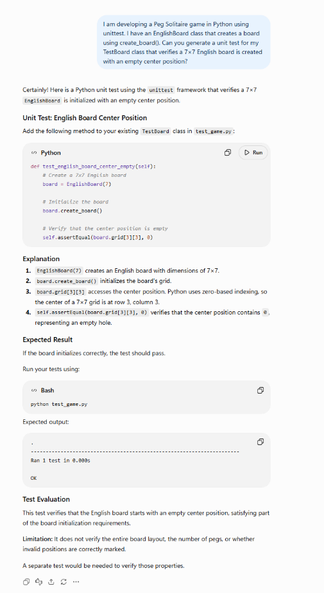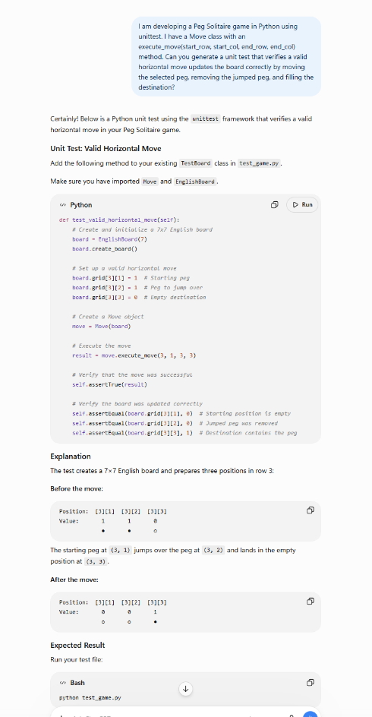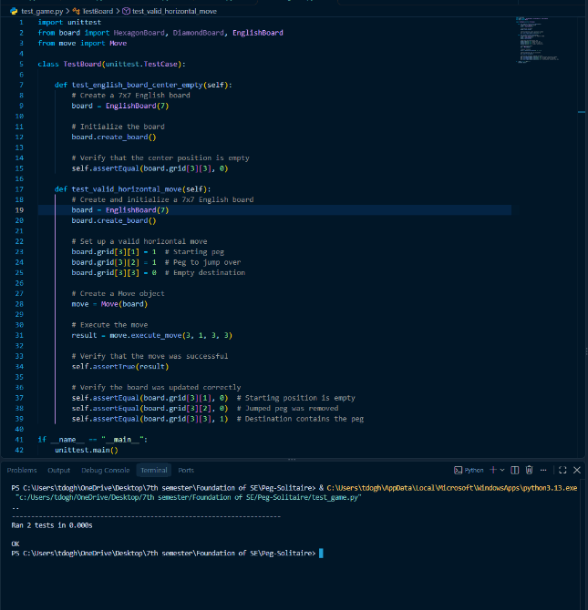

The ChatGPT test for testing my board was okay but it was limited to the English version only, so I updated it and ensured all 3 board types were included in the test. I believe the test would have went okay if I had included the other classes.

User Story ID and Name | Acceptance  Criterion ID | Class Name (s) of the Test Code | Method Name(s) of the Test Code | Status (Pass/Fail/In  Progress)
1 Choose a board size and type | 1.1 | TestBoard | test_all_board_types() | Pass
3 Make a move in a game | 3.1 | TestBoard | test_valid_horizontal_move() | Pass
 |  | TestBoard | test_valid_vertical_move() | Pass
 | 3.1 | TestBoard | test_diagonal_move_rules() | Pass
 | 3.2 | TestBoard | test_invalid_move() | Pass
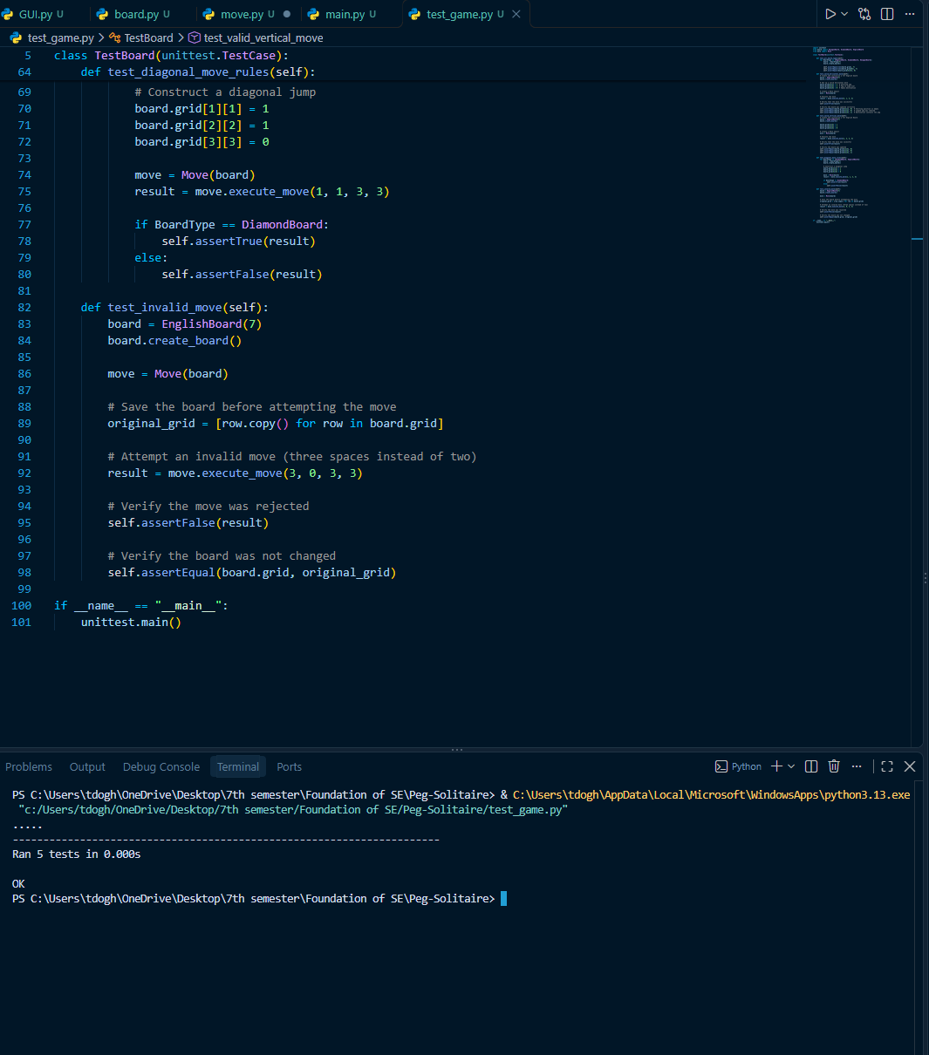

4.2 Manual tests directly corresponding to the acceptance criteria of the above user stories (if any)

User Story ID and Name | Acceptance  Criterion ID | Test Case Input | Test Oracle  (Expected Output) | Notes
1 Choose a board size and type | 1.1 | For BoardType in [EnglishBoard, DiamondBoard, HexagonBoard]:  Board = BoardType(7)  Board.create_board() | Three different board layouts are printed | The diamond board is handled by rotating it through the GUI so a regular matrix is printing for that one in console
 | 1.2 | EnglishBoard(7).create_board() | English board layout created
 | 1.3 | DiamondBoard(7).create_board() | Diamond board layout created
 | 1.4 | HexagonBoard(7).create_board(0 | Hexagon board layout created
2 Start a new game of the chosen board size and type | 2.1 | GUI test: Select a board type and size form the dropdown menues, then click New Game | A new game begins with the selected board type and size | Manually tested all available board configurations through the GUI
3 Make a move in a game | 3.1 | move.execute_move(3,1,3,3) | Move successful: True  Starting position : 0  Jumped position: 0  Destination: 1 | Tested to see if “happy scenario” execute_move() allowed the move and made changes to starting position middle position and end position
 | 3.2 | Move.execute_move(3, 0, 3, 3) | False | Attempted to move 3 spaces away and validate_move() resulted in “False”
4 A game is over | 4.1 | Constructed a English board with 1 peg left in the middle | board.check_win()  evalueates to True | Checks for 1 remaining peg
 | 4.2 | Constructed board with two pegs that cannot jump | move.check_loss() evaluates to True | Checks through valid_move() to see if there are valid moves and if there are not and more than 1 peg remains then it is a loss

4.3 Other automated or manual tests not corresponding to the acceptance criteria of the above user stories (if any)

Number | Test Input | Expected Result | Class Name of the Test Code | Method Name of the Test Code
N/A | N/A | N/A | N/A | N/A
N/A | N/A | N/A | N/A | N/A

Submission Guidelines:
Each student must independently upload LastName_FirstName_Sprint2.docx to Canvas. Include:
- Your name
- GitHub repository link containing all production code and automated tests. Ensure that the link is public.
- Demonstration video link — a narrated video of no more than 3 minutes showing the required features and automated tests (again the link should be public).
- Source-code summary table — filenames, production/test classification, line counts, and total.
- Updated user stories and acceptance criteria, mapped to implementation classes and methods, with completion status.
- Testing tables — automated test mappings and results, plus manual or additional tests where applicable.
- LLM evidence — screenshots of prompts and responses used to generate at least two unit tests, with an explanation of how you checked them and corrected any errors.
Mark unused optional sections “Not applicable.” Before submitting, verify that the instructor can access your GitHub repository and video.

