Project Sprint #1

The Solitaire game is described in CS449HomeworkOverview. You should read the description very carefully.

In this assignment, you aim to specify the requirements (i.e., user stories and acceptance criteria) of the target software that allows a human player to play a Solitaire game. These requirements will be fully implemented by the end of sprint 3. The minimum features include choosing the board size and type, starting a new game, making a move, determining if a game is over. The following is a sample GUI layout.

Board size
7
Board Type  - English  - Hexagon  - Diamond | 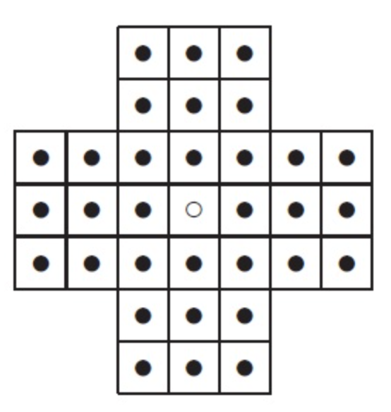 | New Game
Figure 1. Sample GUI layout of the first working program by the end of Sprint 3

Use the following tables to document your user stories and acceptance criteria.

You are required to use the free ChatGPT or another LLM to complete two user stories and two of their respective acceptance criteria. You must ensure that the generated user stories are correct and fix them if not. At the end of the submission, provide screenshots of your LLM prompts and answers, along with the description of errors the LLM made that you had to correct. Points will be deducted if no screenshots/description are provided.

For the other user stories and acceptance criteria, you are not required to use LLM.

- User Stories (3 points)

- User Story Template: As a <role>, I want <goal> [so that <benefit>]

ID | User Story Name | User Story Description | Priority | Estimated effort (hours)
1 | Choose a board size | ChatGPT, “As a player, I want to choose the size of the Peg Solitaire board so that I can play on a board that matches my preferred game length and difficulty” | 4 | 2
2 | Choose the board type | As a player, I want to choose the type of the Peg Solitaire board so that I can play on a board that matches my preferred shape of board | 5 | 2
3 | Start a new game of the chosen board size and type | As a player, I want to start a game with the chosen board type and size so that I can play my desired Peg Solitaire game | 1 | 2
4 | Make a move in a game | ChatGPT, “As a player, I want to make a valid move by jumping one peg over an adjacent peg into an empty space so that I can remove pegs from the board and progress toward completing the game” | 2 | 4
5 | A game is over | As a player, I want the game to end when all remaining pegs do not have an adjacent peg with a space beyond it so that I know when the game is over and my play can be assessed as a win or loss | 3 | 2

- Acceptance Criteria (AC) (12 points): Add/delete rows as needed.

User Story ID and Name | AC  ID | Description of Acceptance Criterion | Status (completed, toDo, inPprogress)
1. Choose a board size | 1.1 | AC 1.1 Successful selection of a board size ‘happy scenario’  Given the player is presented with the available board size options  When a board size is selected  Then the game displays a Peg Solitaire board using the chosen dimensions | toDo
2. Choose the board type | 2.1 | AC 2.1 Successful selection of a board type ‘happy scenario’  Given the player is presented with the available board type options  When the player selects the board type  Then the game displays the selected Peg Solitaire board type | toDo
3. Start a new game of the chosen board size and type | 3.1 | AC 3.1 Successful start of a new game with the chosen board size and type  Given the player selects the board size and type  When the player selects begin  Then the game correctly loads the previously selected board size and type | toDo
3. Start a new game of the chosen board size and type | 3.2 | AC 3.2 Start of a new game without selection of a boards size or type  Given the player does not select the board size or type  When the player selects begin  Then the game loads the default board size and type | toDo
4. Make a move in a game | 4.1 | AC 4.1 Successfully moving a peg in the board ‘happy scenario’  Given the player selects a peg that has an adjacent peg with an empty space directly beyond it  When the player attempts the move  Then the selected peg moves to the empty space and the jumped peg is removed | toDo
4. Make a move in a game | 4.2 | AC 4.1 Attempting to make an invalid move ‘negative scenario’  Given the player selects a peg that does not have an adjacent peg with a space beyond it  When the player attempts the move  Then the selected peg does not move and an “invalid move” message is displayed | toDo
5. A game is over | 5.1 | AC 5.1 Game over winning scenario  Given the game is currently in progress  When the player completes a move leaving only one peg on the board  Then a message “You win” is displayed with the ability to close the message and select a new game | toDo
5. A game is over | 5.2 | AC 5.2 Game over with multiple pegs left  Given a game is in progress with more than one peg remaining  When no valid moves remain  Then the game ends and displays a “Game over” message along with the number of pegs remaining with the ability to close the message and select a new game | toDo

ChatGPT AI user prompts and evaluations
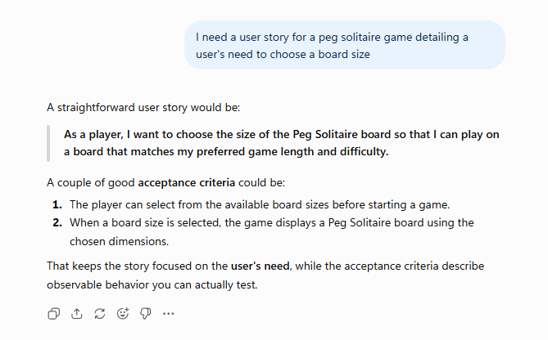

The 1st user story and acceptance criteria. I like the user story because it follows the layout of “As a <role>, I want <goal> [so that <benefit>]” and it communicates the customer's wants in their own language. However, the first user story attempted to match board size to length and difficulty. While the board size being matched to length of game is okay it should not speak to the difficulty of the game. The first acceptance criterion, however, does not follow the Given-When-Then template. Although the criterion describes expected functionality, it should be rewritten using the format. The second acceptance criterion better defines the boundaries of the user story by describing an expected result that can be tested to determine whether the user story has been correctly implemented.

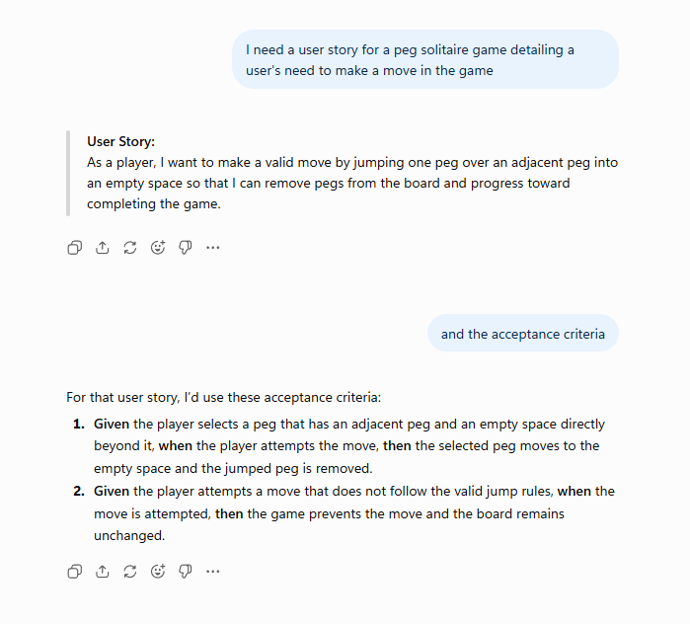
The 2nd user story correctly follows the “As a <role>, I want <goal> [so that <benefit>]” format. It also correctly identifies that making moves is necessary for the player to progress toward completing the game. However, the user story may be more detailed than necessary because it describes the specific mechanics of a valid move. These details could instead be defined within the acceptance criteria. Overall, the user story clearly communicates the player's goal and the benefit of being able to make a move. The first acceptance criterion seems like it correctly describes in detail what constitutes a valid move helping to close the gap between customer and developer. It follows the Given-When-Then format and in doing so gives detailed information that can be tested to determine if the user story has been correctly implemented. The second acceptance criterion does not describe what the valid jump rules are that it mentions. It does follow the Given-When-Then format but there is no way to tell from the criterion itself that the user’s expectations for completion have been met.

