Project Competitor Research
Introduction
For the creation of the Project Smart Parking Platform, three already established parking systems will be analyzed to determine their strengths and weaknesses and determine what features should be added to the developing parking platform. The three platforms to be analyzed are SpotHero, ParkWhiz, and ParkMobile.

SpotHero
SpotHero is a parking reservation service created in 2011 by Mark Lawrence and Larry Kiss that provides a way for drivers to find more than 14,000 garages, lots, and valets in over 400 North American cities.
- Strengths:
  - Mobile applications are available for both Android and IOS
  - Upfront pricing of parking spots and duration
  - Allow for account creation using established Google and Apple accounts
- Weaknesses:
  - No map display in minimized view of web application
  - Lack of street parking options; only allow for lot and garage parking
  - Cannot search for parking based on events happening until after searching location for first time
ParkWhiz
ParkWhiz is a parking reservation system created by Flash Parking located in Austin, TX that aims to provide a hassle-free way to book a parking space, have no surprise pricing, and provide quick parking. They provide services in North America to a select number of cities.
- Strengths:
  - When parking space is selected, integrated map automatically updates to show location on map
  - Can search for parking based on events scheduled in city
  - Provide multiple digital payment methods
- Weaknesses:
  - Parking does not show all details about parking space; must select show all details option
  - Only two options available to filter parking spaces; other systems have more than two
  - Web GUI has graphical errors when viewed in a mimimized/shortened window that ruin visual flow

ParkMobile
ParkMobile is a parking reservation system owned by Arrive that has been in service since 2008. It provides service to select cities in the United States and aims to provide both easy parking and easy payment using their mobile app.
- Strengths:
  - When looking for parking spots, map is automatically displayed with multiple parking options
  - A toggle option to see events happening in the area and find parking around them
  - Selecting the date and time is in one window for both beginning and end of parking
  - Mobile applications are available for IOS and Android
- Weaknesses:
  - Web application opens a new window tab for different website sections; unnecessary number of tabs to find information
  - Web application prioritizes users to download mobile applications instead of using the website to find parking
  - The alternative to finding parking using “Zone Parking” is unclear in how it is used in comparison to using the city to find parking

CarParka Smart Parking Platform
Based on the strengths and weaknesses of the three parking reservation systems, we will ensure our parking platform takes up the strengths of the other systems while ensuring their weaknesses are not implemented to the system. For CarParka to be successful, the parking system will have these features:
- Have equal development to both website and mobile applications to ensure both are reliable to use for reserving parking spots
- Drivers/users can also see possible events scheduled and reserve parking near events
- When selecting dates and time, users can select them in the same window and allow for option to select time separately
- Have multiple filters to find the right parking spot for users
- System will show pricing upfront to the user before selecting a specific parking spot

Software Requirements Specification (SRS)
Project: CarParka Smart Parking Platform
Version: 1.4
Date: 10.08.2026

1.Introduction

1.1 Purpose
This document defines the requirements for the CarParka Smart Parking Platform. CarParka Smart Parking Platform was founded and created by $oftware ¢orp in collaboration with the City of Houston as there was an increasing need to improve the parking experience in the downtown area as the city is quickly growing in population. The City of Houston requested proposals to develop a parking management platform and $oftware ¢orp’s proposal was ranked the highest out of all the proposals from how we will show the real-time data, integrate payment to the application, provide a simple yet effective user experience, making security a top priority, and provide the lowest implementation cost.
The CarParka Smart Parking Platform is designed to help drivers locate, reserve, and pay for parking garages in real time. It is made to be available on both web and mobile applications that will show parking availability information, navigation assistance, and have management tools for parking operators.
The document will detail the scope of what the parking management platform aims to achieve, the functional and nonfunctional requirements, and the use cases in how the the parking management platform will function for both drivers and parking operators.

1.2 Project Scope
The scope of the project for the CarParka Smart Parking Platform is part of the City of Houston’s initiative to improve the overall downtown area driving experience. The following project scope requirements have been discussed and approved by the City of Houston, as well as objectives that are out of scope for this project.
In Scope
The parking platform will include these key components:
- User Registration & Authentication
- Real-Time Parking Space Availability
- Interactive Map Displaying Available Parking Locations
- Parking Reservation Capability
- Digital Payment Processing
- Reservation History & Receipts
- Administrative Dashboard for Parking Operators
- Occupancy Reporting & Analytics
- Notification & Alerts for Users
- Integration with External Mapping/Navigation Services
Out of Scope
The parking platform will not include these components for the project:
- Public Transportation Integration
- Parking Enforcement Integration
- Electric Vehicle Charging Management
- Predictive Parking Availability

2.Overall Description
- Users:
  - Drivers and Vehicle Owners
  - Parking Facility Operators
  - City Transportation Departments
  - System Administrators
  - Finance and Billing Personnel
  - Mobile Application Users
  - Third-Party Payment Providers
- System Environment:
  - Web-Based
  - Mobile Application (Android and IOS)
- Constraints:
  - $5 Million Budget
  - 4 Month Timeline (September 2026 – December 2026)
  - Dependence on Third-Party Services and APIs
  - Compliance with security and privacy requirements, city ordinance and laws

3.Functional Requirements
- FR1: The system will allow users to register and log in securely using multifactor authentication methods
- FR2: The system will allow users to see available parking spots around their desired destination
- FR3: The system will generate weekly and monthly reports and email them to authorized personnel
- FR4: The system will allow users to see past reservation history and transactions
- FR5: The system will allow users to use digital payment options like Google Pay and Apple Pay on top of using standard credit/debit payment methods

4.Non-Functional Requirements
- NFR1: The system will provide 99.99% uptime
- NFR2: The system will update parking availability every 30 seconds from the parking garage
- NFR3: The system will allow users the option to save their preferred method of payment
- NRF4: The system will have the option to allow for a satellite view of the application map
- NRF5: The system will automatically log out users after a certain period has passed

5.Use Case Examples
- 5.1: Finding a Parking Spot
  - Actor: Driver
  - Goal: Search for a Parking Spot in Downtown Houston, TX
  - Steps:
    - Open the website or mobile application
    - Ensure user is on the home page
    - Select “Find Location” search bar and enter destination of Downtown Houston, TX
    - After destination is entered, select the desired date and time
    - Press the search button to find parking spot based on entered information
- 5.2: Registering a New Driver
  - Actor: Driver
  - Goal: The driver creates a new account for the Parking Platform
  - Steps:
    - Open the website or mobile application
    - User presses the “Sign Up” button (option does not show if an account is logged in)
    - The user either can make an account using a Google or Apple account, or continue with the new user registration
    - Fill out information (first name, last name, phone number, email, etc) and complete sign up
    - Verify account creation using email verification to complete sign up
- 5.3: Placing a Parking Reservation
  - Actor: Driver
  - Goal: The driver makes a paid parking reservation
  - Prerequisite: The driver has already searched for a parking spot and is ready to pick a spot
  - Steps:
    - User selects the parking spot in the available list or on the map
    - After selecting the parking spot in the available list and viewing the parking spot details, the user selects the “Reserve” button
    - If user is not logged in, takes user to login page or select option to “Reserve as a Guest”; user selects either option
    - User enters vehicle information (license plate) and payment method
    - User clicks on “Confirm Reservation” button
    - A reservation confirmation page shows up and gives the required information to enter and exit the parking facility
    - An email confirmation will also be sent to the user’s inbox
- 5.4: Creating a weekly financial report
  - Actor: Finance and Billing Personnel
  - Goal: Create a Weekly Financial Report and Email to Personnel
  - Steps:
    - User opens website and selects the “Employee’s Login”
    - After login and authentication, user is directed to the dashboard
    - User selects the “Finance” section of the dashboard
    - User selects drop-down menu to select the required week and selects “Generate Report” button
    - Website generates report and report is sent to user email
- 5.5: Get Navigation to Parking Spot
  - Actor: Driver
  - Goal: After making reservation of parking spot, the system provides a link to map application to drive to destination
  - Prerequisite: The reservation needs to be paid and reserved
  - Steps:
    - After reservation is paid, a link of the parking spot address is provided in the confirmation screen and also sent with the email; the link redirects user to their preferred navigation app (Google Maps or Apple Maps)
    - User clicks on the link and redirects to the map application to start navigation
- 5.6: Cancel a Parking Reservation
  - Actor: Driver
  - Goal: Cancel a Parking Reservation
  - Prerequisite: Parking reservation must be made and is made at least 10 minutes prior to scheduled time
  - Steps:
    - User selects the user profile and selects the dashboard
    - In the dashboard, user selects on upcoming reservation to cancel
    - From selected reservation, user selects “Cancel Reservation” button
    - The system verifies the cancellation request is made at least 15 minutes prior; if made within 10 minutes the system will reject the request
    - The user is prompted to confirm they want to cancel the parking reservation
    - User confirms cancellation; a cancellation page will appear confirming cancellation and refund user
- 5.7: Viewing Parking Reservation History
  - Actor: Driver
  - Goal: Driver Views Parking Reservation History
  - Steps:
    - User logs in to website or mobile application
    - User selects user profile and clicks on user dashboard
    - In user dashboard, user selects “Reservations” section
    - In “Reservations” page, user filters to past reservations and how many days since reservation
    - User sees past reservations and can select reservations to see location details and make another reservation if needed
- 5.8: Getting Parking Receipt for Parking Spot
  - Actor: Driver
  - Goal: Driver Obtains a Receipt of Parking Reservation with Required Information to Exit Parking Garage and Have Proof of Purchase
  - Prerequisite: User is in user dashboard and selected the Reservations section of dashboard
  - Steps:
    - User selects on reservation
    - In the parking spot reservation page, user clicks on “Receipt” button
    - System generates PDF of receipt containing the parking lot information, the proof of purchase details, and required QR code to scan at the gate when exiting the garage
    - User has option to save PDF locally to device of their choice
- 5.9: Receiving Parking Notifications
  - Actor: Driver
  - Goal: Driver sets up Parking Notifications on Mobile Application
  - Steps:
    - User logs in to account in mobile application
    - User selects user profile and selects the user dashboard
    - In user dashboard, user selects “Alerts” settings
    - In “Alerts” setting, user can enable what notifications can be displayed with an enable button, and can turn off notifications by selecting the enable button again to disable it
- 5.10: Extending a Parking Reservation
  - Actor: Driver
  - Goal: Driver Extends a Parking Reservation by a Selected Amount Verified by the Parking Garage
  - Prerequisite: The parking reservation is paid, and reservation is still within the allocated timeframe
  - Steps:
    - User logs in to website or mobile application using their account
    - User selects user profile and selects user dashboard
    - In user dashboard, user selects “Reservation” section of dashboard
    - In reservation section, user selects the currently running reservation
    - In parking reservation page, user selects option to “Extend Reservation”
    - From extend reservation page, user selects how much time they want to extend the reservation (minimum amount is 30 minutes)
    - After selecting extension time, user is prompted to enter payment information using either the method used for the intital reservation, or using a new method
    - Once payment method is selected, user confirms payment and reservation extension
    - A confirmation page is shown and tells the user the reservation is paid and extended, followed by the system sending a confirmation email to the user
- 5.11: Managing the Parking Garage
  - Actor: Parking Facility Operator
  - Goal: The Parking Operators Manage the Parking Garage using the Dashboard for Operators
  - Steps:
    - User logs in to Parking Operator account on the website application
    - User selects the Operator Dashboard section
    - In Operator Dashboard, the user has the option to select any parking space to view information about parking space; parking spaces are separated on each webpage by floors
- 5.12: Disabling Parking Spots for Maintenance
  - Actor: Parking Operator
  - Goal: Parking Operator Needs to Disable a Parking Spot to Perform Maintenance
  - Steps:
    - User logs in to Parking Operator account on the website by selecting the login option
    - User selects the Operator Dashboard section
    - In Operator Dashboard, the user selects the floor the designated parking spot is on
    - Once floor is selected, Parking Operator selects parking spots to disable by clicking on checkboxes to uncheck the parking spots from the system
    - When the required parking spots are selected, Operator selects the “Disable Parking Spot” button to disable the parking spots for the reservation system
    - For drivers who have already parked in the parking spots before they are disabled, the parking spot will not be disabled until the driver leaves the parking garage by scanning the QR code at the exit gate
- 5.13: Managing User Accounts
  - Actor: System Administrator
  - Goal: System Administrator Manages the User Account for Updates and Deletion
  - Steps:
    - User logs in to website using the System Administrator account
    - Once logged in, user selects the Administrator Dashboard section on the home page
    - In the dashboard, the user selects the “Accounts” subsection
    - In the accounts subsection, administrator can filter the accounts in the parking system by roles (Drivers, Parking Operators, Finance & Billing, City Transportation Departments)
- 5.14: Deleting a User Account
  - Actor: System Administrator
  - Goal: When Requested by the User, System Administrator Deletes the Account
  - Prerequisite: System Administrator is logged into Administrator account and is at the Administrator Dashboard on the website
  - Steps:
    - On administrator dashboard, user selects the “Accounts” subsection
    - In accounts subsection, user can search for the required user using the accounts search bar
    - When user is entered in search bar, user selects the search button
    - User selects on the user account and verifies the account profile to ensure the correct user account was selected
    - At the bottom of the user account profile, user selects option to “Remove Account”
    - Once option is selected, user is prompt to confirm the account will be removed
    - After confirmation, the user types in the administrator password to ensure final validation the account will be disabled from the parking system
    - After password is entered, the system will disable the user account in the database and be archived
    - An account removal confirmation screen is shown to the user and an email is sent to the user that the account was removed
- 5.15: Logging Incident Reports
  - Actor: Parking Operator
  - Goal: Parking Operator Enters a Report to the System of Incidents that Happen
  - Steps:
    - User logs into Parking Operator account on website
    - User selects the Operator Dashboard section on the home page
    - In the dashboard, the user selects the “Incident Report” subsection
    - In the subsection, user selects the “File Report” button on the top left of the webpage
    - The button redirects the user to a page similar to a physical copy of the Incident Report and fills out the required information
    - Once the information is complete, user submits the reports and is put on “Pending Review” status; the system sends report to Transportation Department for review
- 5.16: Adding Payment Method
  - Actor: Driver
  - Goal: Add a Method of Payment to Pay for Reservations
  - Steps:
    - Driver logs in to User account
    - Driver selects Dashboard section on home page
    - In the dashboard, user selects “Payment Method” subsection
    - Driver is taken to page with all available payment methods that were added; the default payment method is at the top of the list
    - To add new payment method, driver clicks on “Add Payment Method” button
    - Driver fills out required payment method information and can choose to make the payment method the default payment method.
    - Driver submits payment method form and takes it back to Payment Method webpage with confirmation banner
    - Email is sent to driver email confirming added payment method
- 5.17: Getting Customer Support
  - Actor: Driver
  - Goal: If the driver has questions about the reservation application, the driver can interact with a chatbot to answer questions
  - Steps:
    - On any webpage except the login page in the application, the bottom right contains the chatbot with a message symbol
    - Clicking on message symbol opens text box to enter question to chatbot

6.Work Breakdown Structure
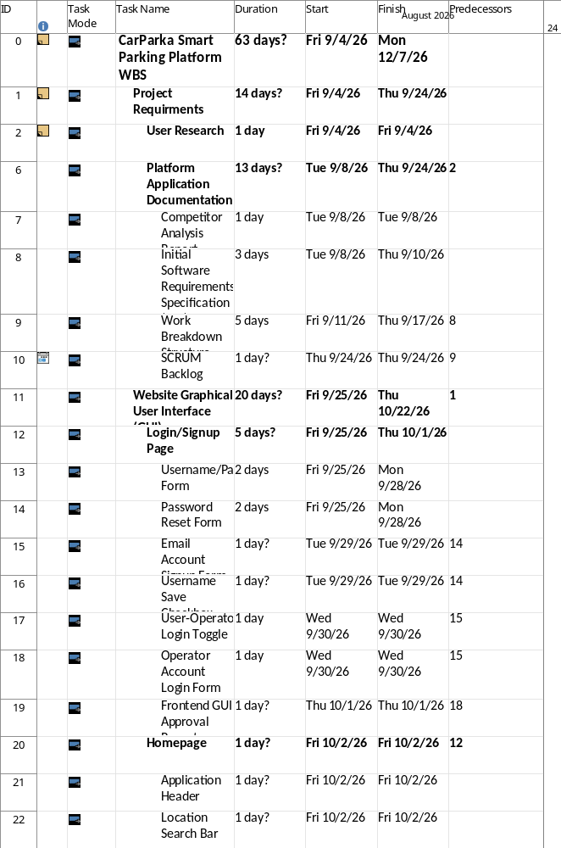
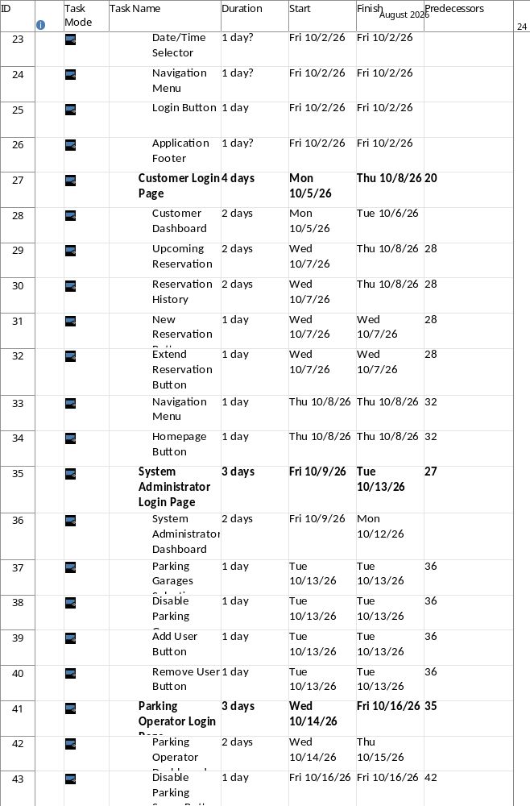
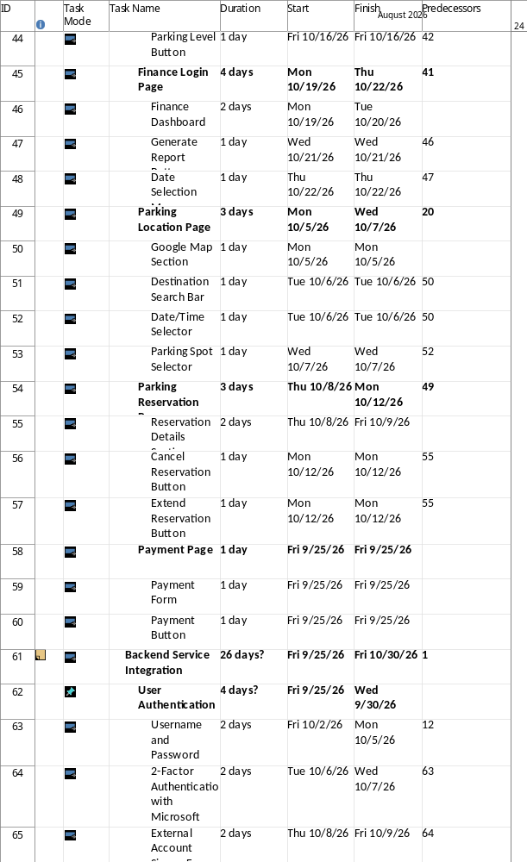
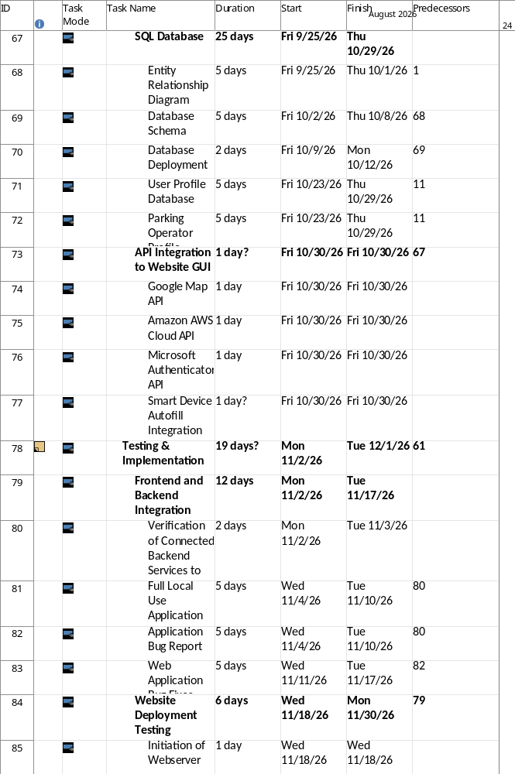
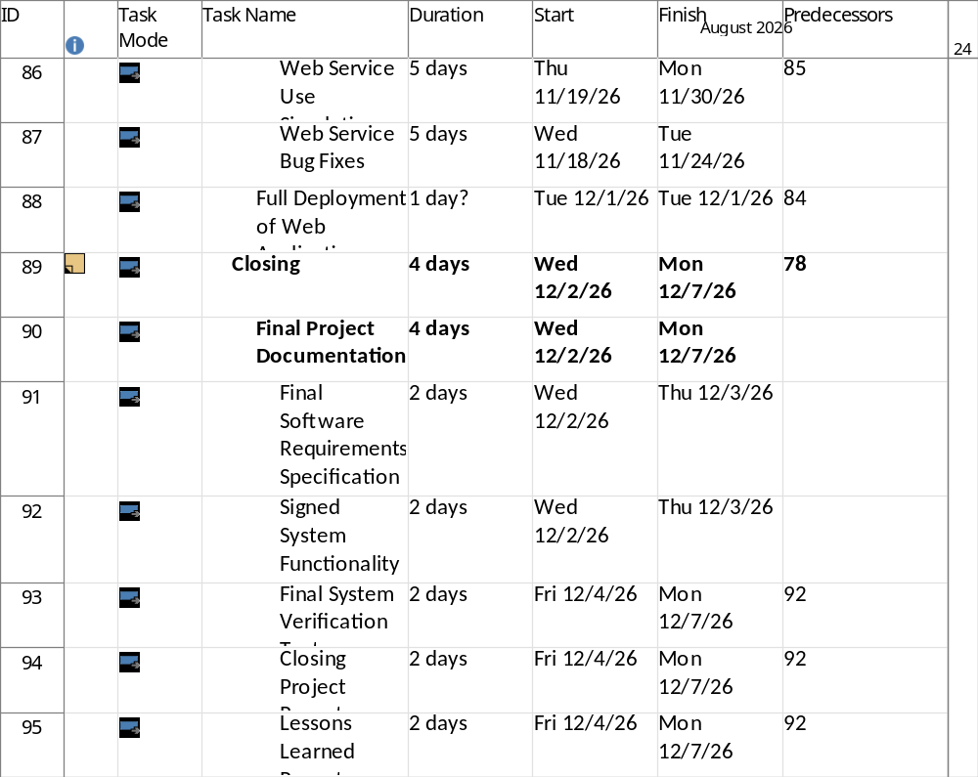
7.Gantt Chart
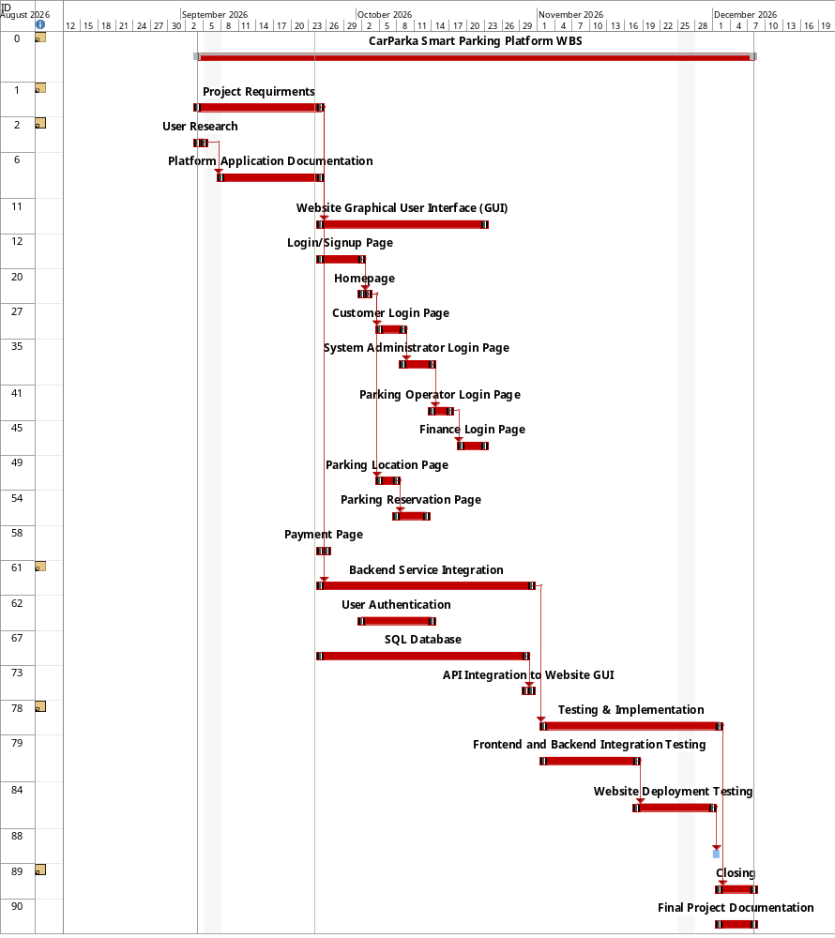

8.Sprint 1 & 2 Backlog
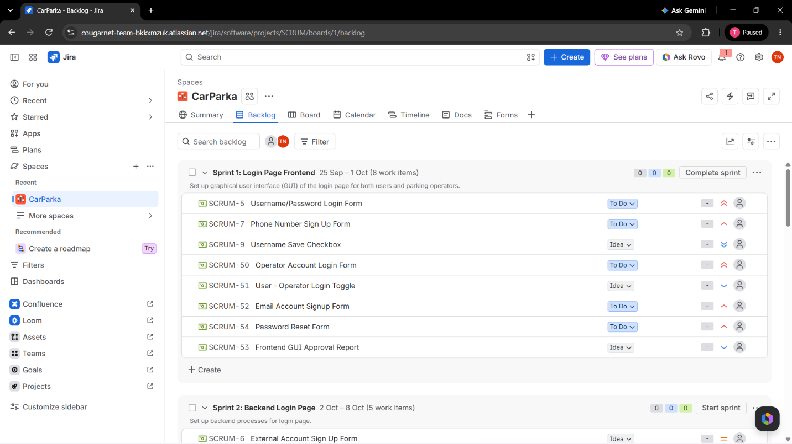
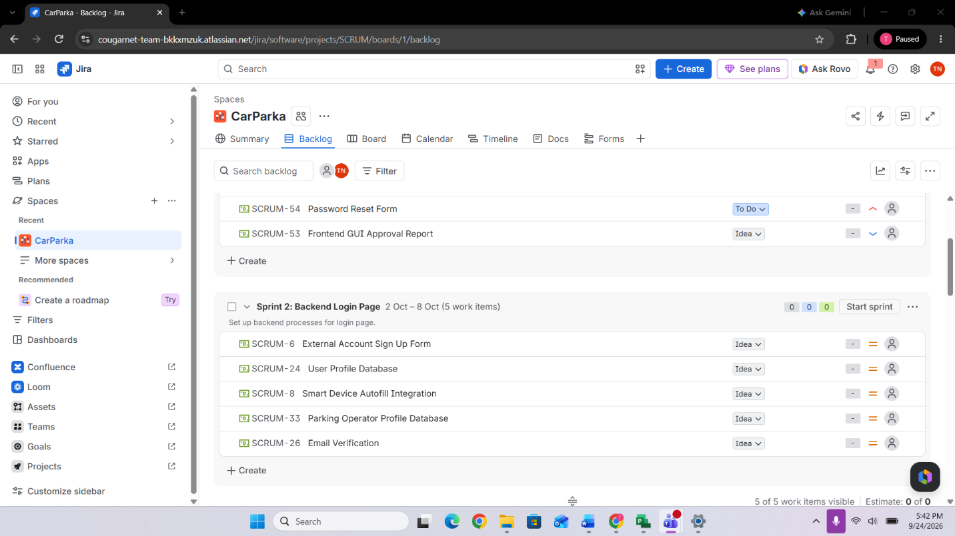

9.Backlog
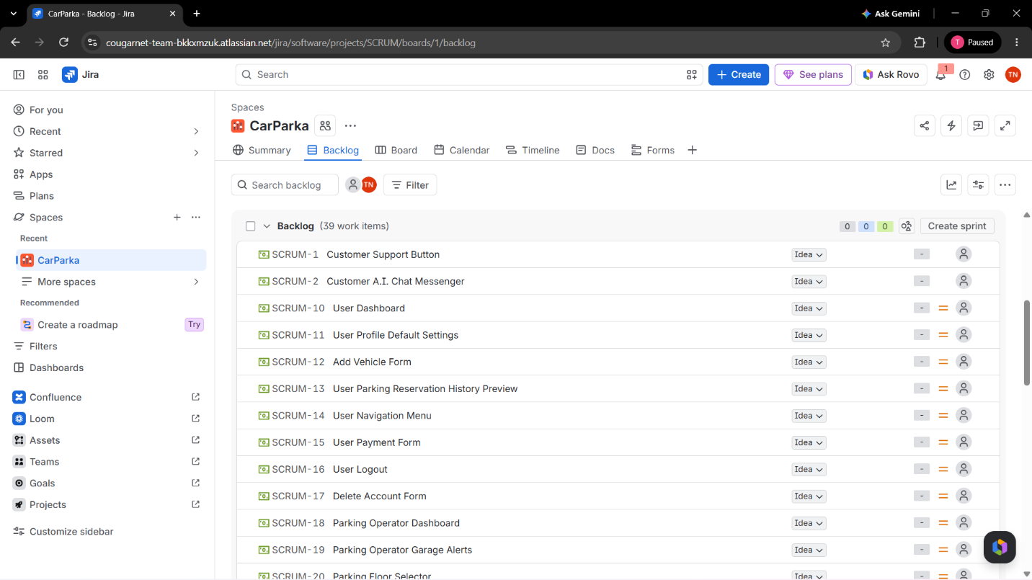

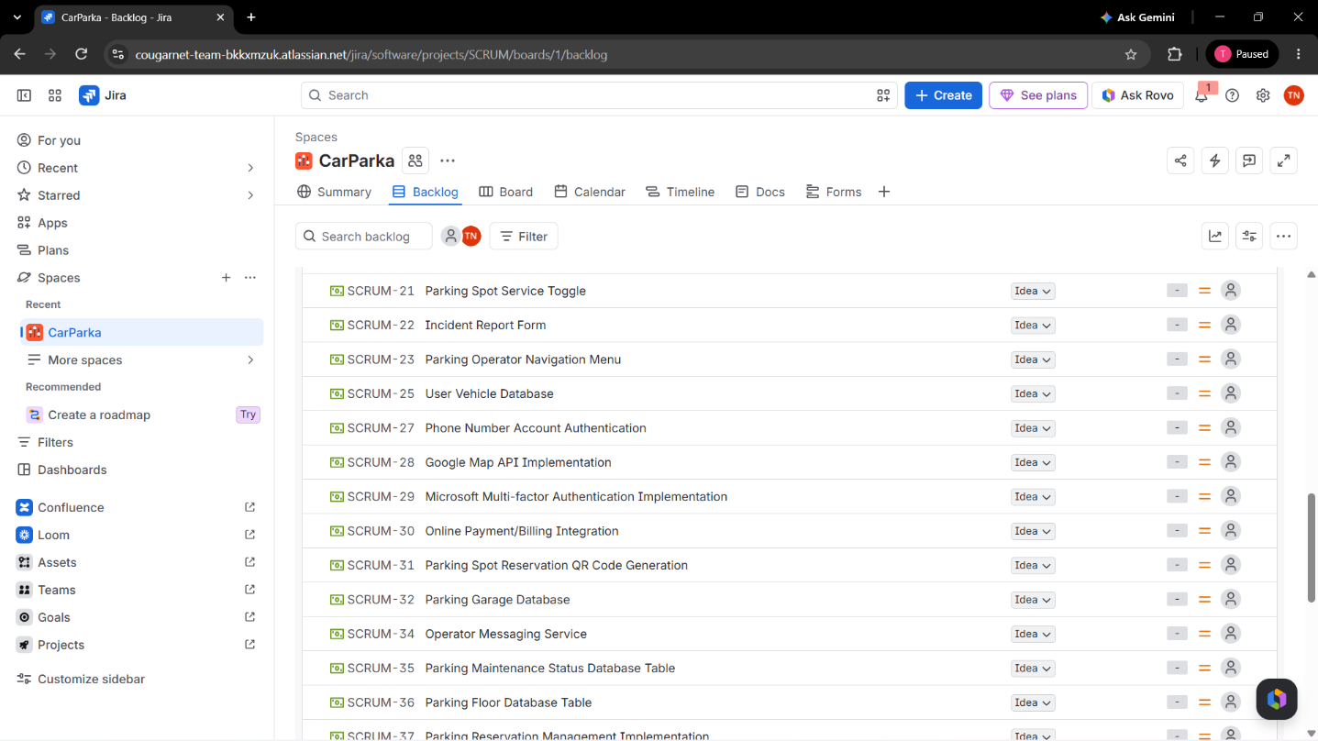

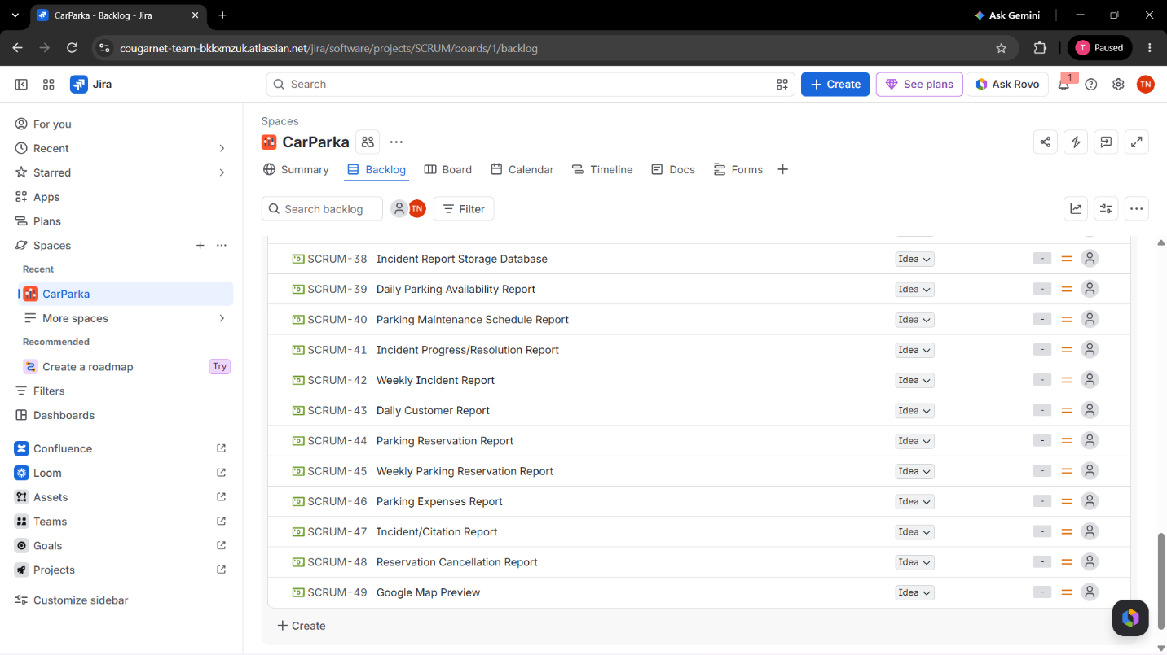

10.Risk Management List
Technical Risks:
- Incomplete or Incorrect Software Requirements
- Device Compatability with Application
- Incorrect Data Formats
- Outdated/Exposed API Connection to Third-Party Applications
Schedule Risks:
- Holiday/Vacation Resulting in Developer Unavailability
- Natural Disasters Causing Project Delays
- Staff Unavailability from Sick Leave
- Missed Deadlines Causing Scheduling Delays
Financial Risks:
- Service Outage Costs
- Application Maintenance Costs
- Costs of Repair after a Natural Disaster
- Financial Loss from Third-Party Parking Payment Failures
People Risks:
- Insufficient Parking Operator Training
- Users with Lack of Technical Knowledge
- Loss of Experienced Knowledge in App Development
- Stakeholders Requesting Additional Functionality

11.Risk Register
ID | Description | Probability | Impact | Owner | Response Strategy | Status/Notes
R-01 | Incorrect Data Formats | Low | Medium | Database Lead | In the database, enforce data format and provide checks | Planned to execute in future Sprint
R-02 | Device Compatability with Application | Low | Low | QA Tester | Development of application will use the least amount of resources possible using cloud operations | Reference devices that have longterm-support and highlight the oldest supported device
R-03 | Service Outage Costs | Medium | High | IT Infrastructure Manager | Establish backup servers and configure cloud providers to utilize more resources during outage period | Planned during future Sprint after configuration of frontend
R-04 | User with Lack of Technical Knowledge | High | Medium | Support Lead | During development, establish an FAQ with common questions and provide a step-by-step guide to user application features | Consider a usability test with sizeable sample size with people outside of developers and stakeholders
R-05 | Application Maintenance Costs | High | High | IT Manager | Set a maintenance schedule for the application to apply updates to security and functionality | Planned for Sprint during implementation timeframe
R-06 | Natural Disasters Causing Project Delays | Low | High | Project Manager | Develop procedures to plan for possible natural disasters in the region. Set up backups and failsafes outside of region. | Research in progress
R-07 | Loss of Experienced Knowledge in App Development | High | High | Developer Lead | During Sprints, add documentation of what was done and fixes made to encountered problems | Rough drafts in progress
R-08 | Costs of Repairs after Natural Disaster | Low | High | Project Manager | Plan out the potential cost of the required service to keep application running | Review in process
R-09 | Staff Unavailability from Sick Leave | Low | Low | Project Manager | Plan for how many employees can do the task at a minimum, then set up work schedules to ensure that any person out will not fall below the minimum | Report from first Sprint in progress
R-10 | Incomplete or Incorrect Software Requirements | Medium | Low | Project Manager | Plan for the minimum requirements needed for application to work | In progress with initial Sprint

12.Communication Plan
From our team of 20 members, we will split the team to 2 teams in which each team will have a daily stand-up that will last between 10-15 minutes. After the standup, the team leaders of both teams will meet for the day and discuss how things are going.

Every week, the teams will get together and perform a live demo of what was accomplished for that week and discuss what the next steps will be and what improvements can be made. This weekly meeting would last about 30 minutes.

Once a month, the team will get the stakeholders to show the progress of all the sprints that occurred to receive feedback and verify to them that progress is being made on the project. This monthly meeting would last no longer than 1 hour.

13.Roles & Resources
Roles:
- Project Manager = plan how the CarParka Smart Parking Platform project is broken into parts, track the project progress from schedule and budget, coordinate with Scrum Master, and report project progress to the City of Houston each month.
  - Name = Timothy Nammathao
- Developers = build the CarParka platform from the webpage, mobile application, and database design
  - Web Developer
    - Name = Ricky Abbot (Lead)
    - Name = Shay Marks
    - Name = Michael Summers
    - Name = Arianna Vincent
  - Mobile Developer
    - Name = Mikayla Newton (Lead)
    - Name = Andre Calderon
    - Name = Chelsey Hanson
    - Name = Amy Reeves
  - Database Developer
    - Name = Jennifer Thomson
    - Name = Tate Salman
- QA Testers = verify the platform is functioning correctly and meets the operating requirements. They will also report bugs to developers.
  - Web Tester
    - Name = Jamie Tart
    - Name = Theodore Lasso
  - Mobile Tester
    - Name = Jessical Levy
    - Name = Mark Fischer
  - Database Tester
    - Name = Mitchelle Handler
    - Name = Sian Sutton
- UX Designer = creates the user desing documents on how users navigate the website and mobile application, and recommends improvements from testing feedback
  - Name = Anastasia Homer
- Scrum Master = organize the sprint meetings and daily stand-ups, tracks sprint progress, and remove the obstacles slowing down the development team
  - Name = Perry Bright
  - Name = Aaron Aguirre
- DevOps = set up and maintain the cloud hosting, deployment process, backup the servers, and monitor the system to meet uptime requirements
  - Name = Cooper Fisher
- Subject Matter Expert = Provide parking operations knowledge; how garages and operators work and help validate requirements for the operator dashboard. They also support the operator training of the application.
  - Name = Kasey Lucas
- Product Owner = the City of Houston; own how the final product turns out, approves the project requirements, and accepts the completed work.
  - Name = City of Houston

Cost Plan
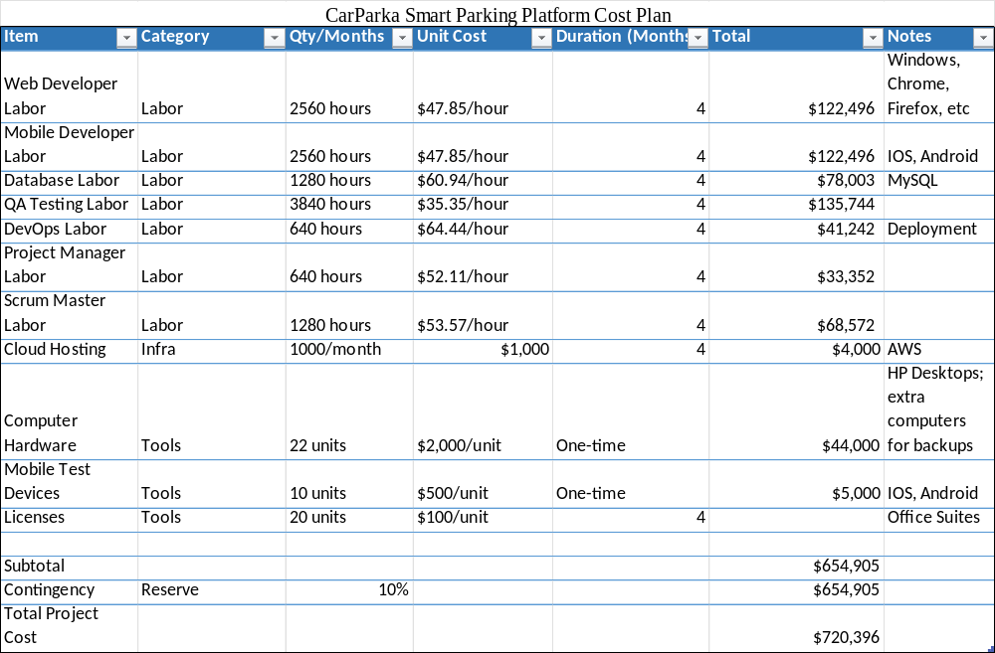

Monthly Cashflow
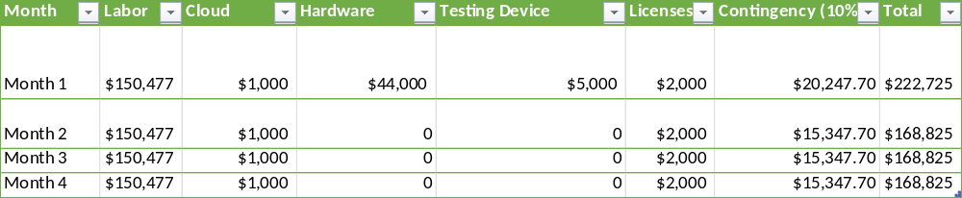

RACI Matrix
