Visual interfaces effect on player performance in virtual reality

A dissertation submitted in partial fulfilment of   
the requirements for the degree of   
MASTER OF ENGINEERING in Computer Science

In

The Queen’s University of Belfast

By  
Timothy O’Neill

06/03/2015

Acknowledgements

Abstract

Fully immersive experiences into virtual reality (VR) will become common place in the next decade, with that comes the need for research to make sure that these experiences are the best they can possibly be, Visual interfaces used in games are key to tracking a players progress, providing feedback to the player and helping them navigate the environment, Using a fabricated scenario created in Unreal Engine4 [1] in conjunction with the Oculus rift [2], we will track metrics and then ask the participant to fill in a questionnaire to discover what categories of Visual interfaces work best in the oculus rift compared to a traditional gaming setup, existing games have made changes specifically for VR however most have been done as side projects to main development and such are not their most optimum, This paper will be a useful resource for any developer tackling VR development specifically with any design and implementation choice they need to make on Visual Interfaces.

Introduction

VR has been in existence since the 1950’s primarily used by the military for training or hobbyists to escape into a virtual world, it has been growing steadily over the past few years with technology becoming cheaper and more accessible, and this has cumulated with VR Company Oculus being bought by Facebook for two billion dollars [12], funded by Facebook Oculus will release the first consumer affordable VR device the Oculus rift. Many large companies are now picking up VR development even going as far as developing with VR as their primary platform for playing the game such as EVE Valkyrie [13], this paper in particular focuses on the importance of the use of visual interfaces to provide feedback to players on their performance, the results of this paper will guide developers into the best interfaces to use to make sure the player while enjoying the immersive nature of VR is still able to play the game to the best of their ability.

Background

Visual Interfaces.

Games have always required ways of giving feedback to a player, Visual interfaces play a key role in performing this task, While other interfaces such as audio and haptic exist most games still use visual interfaces for the majority of their feedback. They can be broken down into four categories [3].

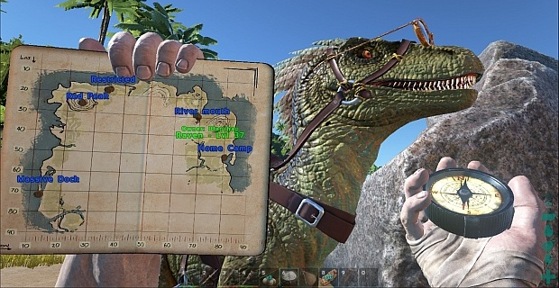Interfaces part of the game narrative.

Figure 1. Ark Survival Evolved

Diegetic interfaces are a part of the characters story, they tend to be presented with an animation of a character raising a map or opening a hologram menu as not to interrupt their immersion in the game world. An example of this is Ark survival Evolved which uses a diegetic interface for the players map and compass.

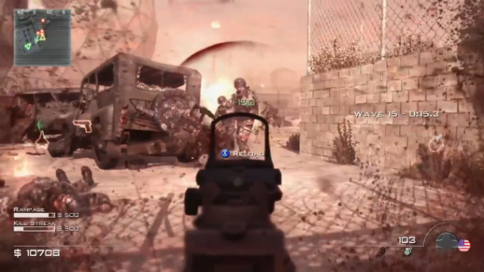Meta interfaces are still a part of the avatars narrative, they take the form of temporary information such cornering suggestions in a rally game. An example of this is call of duty that uses Meta interfaces to show where the player is being attacked from as can be seen in Fg 2, this draws the player further into the game world by showing a blood splatter and reducing visibility.

Figure 2. Call of duty

Interfaces not part of the game narrative.

*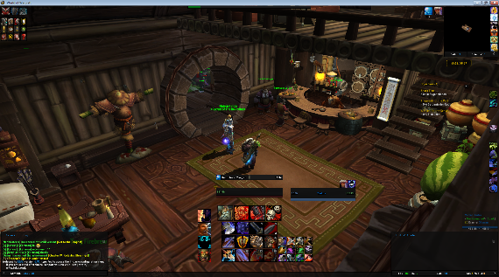*Non Diegetic interfaces are not apart of the avatars narritive but are visible to the player they provide information such as health, ammo count or in the form of a minimap for the player. A good example of this is world of warcraft that shows the player health, mana, spells, map and much more as shown in Fg 3.

Figure 3. World of Warcraft

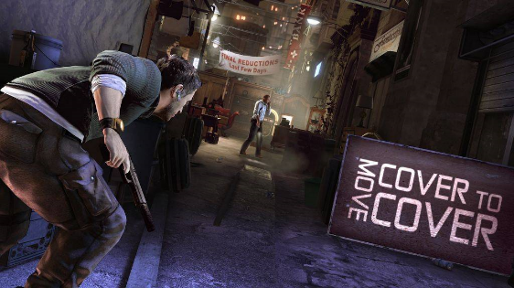Spatial interfaces are used when there’s a need to break the narrative in order to provide more information to the player than the avatar would be aware of, they take the form of glowing trails on the ground or instructions on walls. An example of this splinter cell conviction that uses spatial interfaces to display the current task to the player as seen in Fg 4.

Figure 4. Splinter Cell Conviction

Examples of visual interfaces in virtual reality games.

Many early adopters and indie dev’s are already creating and changing existing games and experiences for virtual reality this section outlines some of these and the adjustments they have made for virtual reality[4].

Euro Truck Simulator 2.

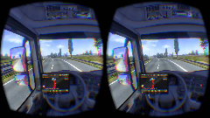Euro truck simulator 2 places the player in the position of a truck driver in Europe requiring them to deliver cargo, the game helps the player perform this task using several interfaces, in the normal game is uses extensively non diegetic interfaces for the sat nav of the vehicle, delivery details, email, money etc. It also uses spatial elements such as road signs and indicators on other cars, In the oculus version of the game the developers stripped out the non-diegetic sat nav and turned it into a diegetic interface by placing it constantly on the dashboard of the vehicle allowing the player to naturally look at it any time, they also turn the general interfaces into a floating diegetic interface that hovers above the steering wheel, all other spatial elements remain the same in the game.

Figure 5. Euro Truck Simulator 2

Half-life 2.

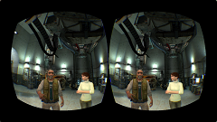Half-life 2 is a first person shooter, it extensively uses non-diegetic interfaces to help the player keep track of their ammo health and Armor, it also uses Meta interfaces to help the player identify where an enemy is shooting them from, Half-life is set up two ways depending on the controller used in conjunction with the oculus rift, Using just the oculus rift on its own the developers left everything as is, however if the user is using a controller such as the razer hydra [5], they remove all the non-diegetic interfaces for ammo, health and Armor and replace them with diegetic ones on the players wrist and gun, the meta interfaces are unchanged.

Figure 6. Half Life 2

War Thunder

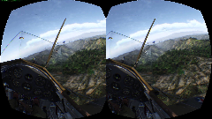War Thunder places the player at the controls of a fighter plane participating in multiplayer dogfights, it primarily has a cut back interface but has some key non diegetic elements, and the planes speed, altitude and throttle are all displayed, a reticule for where the gun of the plane is aiming is displayed, scores of each of the teams are also displayed in a similar manner along with a mini-map of the battlefield, Spatial indicators appear to help identify targets and their relative distance, In the oculus rift they strip away all these interfaces, It uses the diegetic interfaces of the cockpits dials to display speed, altitude, and throttle, The game also gets rid of score board and places it in a meta interface that has to be brought up by button press, The spatial elements are also replaced with meta interface arrows that point at the enemies in your vicinity.

Figure 7. Warthunder

Surgeon Simulator

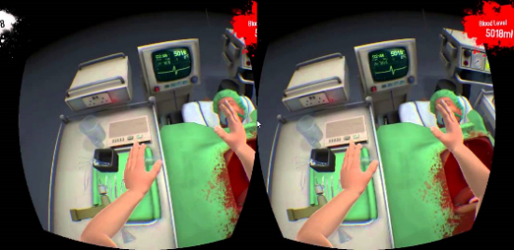Surgeon Simulator puts the player in charge of various surgical procedures, the player has to perform the surgery as quickly as possible while keeping the patient healthy represented by blood loss, the Time and amount of the patient have are shown twice with 2 interfaces there is a spatial interface of a heart monitor in the game world that shows both the blood level and time, there is also a non-diegetic interface that displays the blood level and time constantly on in the top right and left respectively.

Figure 8. Surgeon Simulator

Dead space interface post mortem

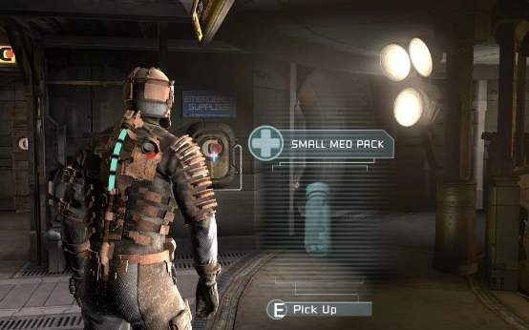The Dead space game series was famously the first to use a fully diegetic interface Fg 9, the following section is from a talk given by Lead UI Designer Dino Ignacio at GDC 2013 [6].  
The designers wanted the game to be as immersive as possible due to it falling into the horror genre, This meant their choice was to implement a fully diegetic interface to the user for game feedback, They also made the decision of the players character being view at all times, even if it is just his arm, in Fg 9, you can clearly see the players health represented by the light blue tube on the avatars back. However in the third instalment of the game the designers wanted to expand the crafting system in the game to include further mechanics to allow the player to change their weapons.

Figure 9. Dead Space 1 Screenshot

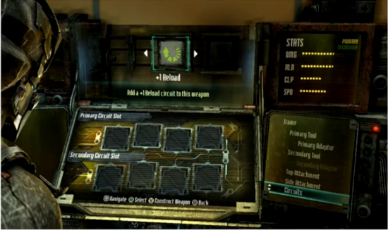The first iteration of the design is shown in Fg 10, it was a diegetic interface conveying all the various parts of putting together a gun or upgrade, Although this fitted their mission statement of always using diegetic interfaces and having the avatar in view, It soon became apparent that the interface crippled the usability of the game, developers opted for using the in game debugging console commands instead of the interface because it was so unusable.

Figure 10. Initial bench design DS3

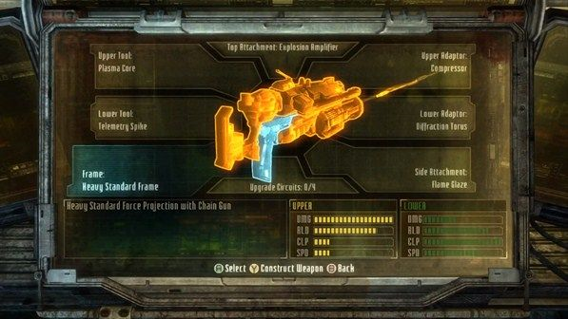Eventually the final design came together as shown in Fg 11, it is non diegetic and vastly improved the ability for the user to interact and be able to use the interface in order to complete the task of building a weapon, this is a good example of previous issues that games have faced long before the advent of virtual reality, it also helps to reinforce the importance of this research through a solid example where design and implementation compromises had to be made to enable the player to be able to accomplish a goal.

Figure 11. Final bench design DS3

Previous Studies.

The oculus rift offers interaction from a first person perspective from previous case studies into the First person shooter genre [7] we know the following.

Figure 12. Distribution of information amongst the visual, auditory and haptic channels

From Fg 12. We can clearly see that a vast majority of feedback to the player in a first person game is done through visual interfaces, this is very important for virtual reality were it is primarily a first person experience, this shows the importance of this research into user interface (UI) design for games.

Evaluating Interfaces.

The following section outlines empirical papers that have done experiments into interfaces and user performance it discusses their findings and any pitfalls they fell into.

Evaluating two interfaces for searching a database [9].

The paper outlines two alternative user interface designs that are exposed to user testing to measure user performance in a database query task.

They create two interfaces for a database one comprising of a drop down box and another a dialogue box, they are interested in the time taken by each user to look up a randomised phone number using the interfaces. Firstly experts with nine or more years of experience were consulted to make estimates on how much time would need to be taken for each interface, in addition the experts were split into three groups, hot, warm below is outlined what affect this had on their exposure to the system.

* Hot – Access to the system for longest time period.
* Warm – Access to the system for a mean of the hot and cold time period.
* Cold – Very little access to the system for a time period.

The study also uses GOMS (Goals, Operators, Methods, and Selection rules) [11], GOMS is analysis tool for creating estimates of user performance, with the estimates from the expert group and the GOMS user testing was performed, this involved getting twenty students to use the software, the users had no experience but were shown how to use the interfaces and allowed to practice.  
At this point a cost benefit analysis was performed it was noted that expert analysis would have a higher cost to it than a student’s group as would the cost of having to perform GOMS analysis.

Conclusions

The paper concludes showing that user testing performed very closely to the “Hot” expert estimate, this shows that user testing is an accurate measure of user performance, however the testing is not always a perfect predictor of real world performance. It was also noted that hot estimates were as accurate as user testing but cost substantially more.

Use to this research.

The paper helps identify the need for an experiment to evaluate user performance it shows that user testing is the best means to attain meaningful data, although it does warn of the variability of testing and that a large sample should be attained to get a good average, it also shows time as a heuristic to track when evaluating two interfaces which will be beneficial to my experiment.

Driving an armoured vehicle using a head-mounted display [10].

This paper outlines an experiment for testing the effectiveness of head-mounted display (HMD) and a head tracker for driving an armoured vehicle compared to traditional direct view and periscope view.

The main focus was to compare the HMD system to the periscope view direct view was used as a control for the experiment, the participants were then tasked with driving the vehicle over rough and paved terrain, on the paved terrain the vehicle had to pass through a funnel of cones and slalom, the number of pylons knocked over were counted.

Conclusion

The experiment showed that the user performance with the HMD was better than that of the periscope system on both paved and rough terrain, HMD users also performed faster in some sections of the off road, although it is mentioned that even better results could be attained for the HMD if the drivers were more experienced with the technology.

Use to this research

This research highlights the importance of hen investigating HMD technology such as the Oculus to compare to the existing standard, In the case of this paper it may be beneficial to run the experiment both on the Oculus and a standard computer setup and compare the results to see if they are comparable or vastly different.

Evaluating three different interfaces for a mobile game [8].

The paper implements three user interfaces for a scroll shooter video game on an iPod Touch and test their effectiveness and how enjoyable they are to the user.

The game is structured to have three interfaces, simulated button, touch gesture and accelerometer, seven levels of difficulty are defined for the player to play, and over the course of the game the following metrics are tracked.

* Total time played.
* Number of projectiles fired.
* Number of player projectiles that connected with enemy ships.
* Number of enemy ships destroyed.
* Time the ship spends moving in each of the eight directions.

The game screen was segmented into nine distinct zones, the amount of time the player spends in each zone is also tracked.

During the test sessions the tester is given a questionnaire prior to participating in the experiment the first questionnaire is there to ask some general information on the user, the users are also asked about their experience of with the videos games on mobile platforms, the participates are then allowed to practice the game for a maximum of three minutes, they then plays the full game with a specific interface. A questionnaire is then filled in with questions specifically on the interface. The process is repeated until all three interfaces have been used. After the experiment concludes the user fills in a questionnaire about their preferred user interface.

Conclusion.

The findings of the paper showed that the users preferred the accelerometer interface and this was backed up with the heuristics of their performance, however the research admits that the specific implementation they did of the interfaces may have affected the opinion of the user as the touch gesture was not like industry standard they had come accustom to, the researcher also notes that caution should be taken as the design heuristics are based on a single experiment involving one type of game.

Use to this research

This papers highlights that through questionnaire and game performance heuristics it is possible to gather data on the effectiveness of an interface, however caution is to be taken in the implementation of the interfaces with not breaking all ready pre-established patterns for implementing them.

Investigation Method

(Design of the experiment, theories, procedures etc., emphasis on how unique the research is)

Results and Analysis

(Collected results, how they were gathered, critical analysis of significance of the results, ideally by comparing with existing results)

Conclusions

References

[1] <https://www.unrealengine.com/blog>.

[2] <https://www.oculus.com/en-us/>.

[3] <http://www.thewanderlust.net/2010/03/29/user-interface-design-in-video-games/>

[4] <https://en.wikipedia.org/wiki/List_of_games_with_Oculus_Rift_support>

[5] <https://en.wikipedia.org/wiki/Razer_Hydra>

[6] <http://www.gamasutra.com/view/news/194145/Video_Designing_Dead_Spaces_immersive_user_interface.php>

[7] Erik Fagerholt, Magnus Lorentzon. 'Beyond the HUD User Interfaces for Increased Play Immersion in FPS Games'. *Chalmers University of Technology* (2009) Pg 30-32.

[8] Browne, Kevin, and Christopher Anand. 'An Empirical Evaluation Of User Interfaces For A Mobile Video Game'. *Entertainment Computing* 3.1 (2012). Web.

[9] Nielsen, J. and Philips, V. (1993) Estimating the relative usability of two interfaces: Heuristic, Formal, and empirical Methods Compared. InterCHI 93, ACM.

[10] A. B. Oving and J. B. F. Van Erp, “Driving with a head-slaved camera system,” in Proc. Hum. Factors EErgonom. Soc. 45th Annu. Meet, 2001, pp. 1372-1376

[11] Card, S.K., Moran, T.P., and Newell, A. (1983). *The Psychology of Human-Computer Interaction.* Erlbaum Associates, Hillsdale, NJ.

[12] <http://www.economist.com/blogs/schumpeter/2014/03/facebook-buys-oculus-vr-0>

[13] <https://www.evevalkyrie.com/>

Appendices