NOTTINGHAM TRENT UNIVERSITY

ENOX1, CCDC122 AND LACC1 ROLE IN PROGRESSION OF PROSTATE CANCER

by

TIMOTHY ONGABA

Project Report submitted in partial fulfilment of the requirements for an M.Sc. in Biomedical Sciences at the School of Science and Technology, Nottingham Trent University

Supervisor: Dr. Amanda Coutts (Ph.D)
2023

DECLARATION OF OWNERSHIP
This submission is the result of my work. All help and advice, other than that received from tutors, has been acknowledged and primary and secondary sources of information have been properly attributed. Should this statement prove to be untrue, I recognise the right and duty of the Board of Examiners to recommend what action should be taken in line with the University’s regulations on assessment contained in the Handbook.
Signed .... .......................... Date .......................................................

Acknowledgements
Table of acknowledgement

1: Training and mentoring in laboratory, field or computational techniques
Training in use and interpretation of data from cBioportal and Enrichr (Dr. Amanda Coutts)
List of Abbreviations
EFEMP2 Epidermal growth factor-containing fibulin-like extracellular matrix protein 2
ENOX1 Ecto-NOX Disulfide-Thiol Exchanger 1
PCa Prostate Cancer
RNA Ribose Nucleic Acid
CCDC122 Coiled-Coil Domain Containing 122
LACC1 Laccase Domain-Containing 1
TMB Tumour Mutational Burden
mCSPC Metastatic Castration Sensitive Prostate Cancer
mCRPC Metastatic Castration Resistant Prostate Cancer
KSRP KH-type splicing regulatory protein
SDA Stearidonic acid
EPA Eicosapentaenoic acid
Rap1 Ras-proximate-1

Abstract
Prostate cancer (PCa) continues to trend among top 3 cancers that kill men over 20 years in the United Kingdom and the world at large despite extensive research and resources directed towards its treatment and prevention. In the application of a hallmark of survival mechanisms by the cancer, our study used mRNA seq data to identify genes that are increasingly mutated with progressing PCa from a cohort of 491 PCa patients. Having found ENOX1, CCDC122 and LACC1 deep deletion with increasing age of diagnosis. Pathway analysis of implicated genes was done. Previous individual and combined role of these genes in PCa progression was not known but thanks to this study, pathways like estrogen biosynthesis, KSRP signalling, omega 3 and 6 fatty acid biosynthesis and, Rap1 signalling could be druggable targets in PCa patients with these gene deep deletions.
Introduction
Background to the investigation
Prostate cancer (PCa) is the most frequently diagnosed cancer in men in 132 countries with a 7.3% incidence worldwide. It is the second cause of cancer deaths in men in 48 of 185 sampled countries worldwide^{1,2}. One in 8 men will be diagnosed with prostate cancer in the UK while one disease from the disease every 45 minutes. The number of PCa cases are projected to rise by 15% in the UK between 2023 to 2025 indicating an ever-increasing trend ³.

PCa starts in-situ within the prostate where it can, but not always, metastasize to the lymph nodes, bone, lung, liver and even as far as the brain when left untreated⁴. PCa can be termed localised when it remains within the prostate or metastatic when it spreads beyond the prostate. Localised PCa becomes high risk based on clinical staging, biochemical recurrence and a high Gleason score⁵.While still in-situ and often when metastasised, PCa can progress from hormone sensitive to refractory phenotype with increasing resistance to treatment and decreasing survival rate from 30% over 5 to 30% over 3 years patient survival⁶.
When metastasised, the disease can be categorized as metastatic castration-sensitive prostate cancer (mCSPC) when clinical deprivation of androgens by surgical removal of the testicles halts cancer advancement or castration-resistant prostate cancer(mCRPC) when cancer continues to progress even in the absence of androgens. The risk of fatality significantly increases when PCa becomes castration resistant⁵.

The incidence of PCa increases with age starting at 45, steeply rising and peaking around 75 to 79years. Patient survival is dependent on regular screening recommended to start at 45 years, early diagnosis and treatment intervention which might include chemotherapy, radiotherapy, surgical resection of tumours, immunotherapy or gland ablation to reduce the role of androgens in disease progression^{3,7,8}.

Tumour Mutational Burden (TMB) of PCa, the somatic cell rate of mutation per mega base pair has been associated with low response to chemotherapy, high biochemical recurrence and, generally poor prognosis. These together with other cofounders such as poor immune cell infiltration into the tumour microenvironment, and androgen receptor status quickly lead to reduced survival of affected individuals^{9–11}.
Among tumour mutations are gene deletions that can also appear at copy number alterations. Many of these, as deep deletions at chromosome 13q have been previously liked to poor prognosis in prostate cancer, high Gleason scores and biochemical recurrence¹²
Conversely, the high TMB also brings about high immunogenicity and, therefore, better response to immunotherapy^{10,13}

Some of the most implicated genes in PCa are those involved in cell cycle progression, receptor signalling, proto-oncogenes, and or tumour suppressors. Among these, UBE2C, PLK1, CDC20, BUB1, CDK1 and HJURP are top 6 linked to disease progression, metastasis and, poor prognosis^{9,10}.

Ecto-NOX Disulfide-Thiol Exchanger 1(ENOX1), also known as cCNOX, CNOX, FLJ10094, and PIG38, is a copper-binding protein expressed in endothelial and other cells where it has NADH oxidase activity, promotes angiogenesis and is a potential druggable target ^{14–16}. It is among the sensitive genes on the 13q chromosome arm whose deletion is associated with poor prognosis, early biochemical recurrence and metastasis¹²
ENOX1 has been associated with prostate cancer, which is characterized by structural rearrangements, most frequently including translocations between androgen-dependent genes and other genes¹⁷. A deletion variant of ENOX1 has been identified in individuals with malignant tumours of the prostate¹⁸. The Protein Atlas shows that ENOX1 is expressed in cancer tissue, including prostate cancer^{19,20}. The exact role of ENOX1 in prostate cancer is, however, not fully understood, and further research is needed to determine its functions and prognostic values¹⁶.

Data from the Genecards database shows that Coiled-Coil Domain Containing 122 (CCDC122) is a gene that is overexpressed in prostate cancer²¹. There is generally limited literature linking the gene or its products to prostate cancer and this warrants further studies following its differential expression and or mutation during the progression of disease. Single nucleotide polymorphisms in the gene have previously been linked to development of leprosy in case controlled cohorts of Chinese and Brazilian populations^{22,23}

The Laccase Domaing-Containing 1(LACC1) gene is a gene that encodes an oxidoreductase that promotes fatty-acid oxidation, with concomitant inflammasome activation, mitochondrial and NADPH-oxidase-dependent reactive oxygen species production, and anti-bacterial responses in macrophages^{21,24–27}.In relation to prostate cancer, a transcriptome analysis of differentially expressed genes in methotrexate-resistant prostate cancer found that LACC1 was one of the genes that was differentially expressed²⁸. A study aimed at identifying biomarkers for the management of human prostate cancer also found that LACC1 was one of the genes that was differentially expressed in prostate cancer tissue compared to normal tissue²⁹.Data from the TNM plot shows a reduced expression of the gene in prostate cancer compared to normal prostate tissue³⁰. LACC1 has also been linked to Leprosy in similar studies as CCDC122^{22,23}.

Problem statement
Despite the extensive research in the molecular biology of PCa, the disease still evades current treatment modalities and progresses. Genetic alterations that confer survival of prostate cancer cells have not been comprehensively explored more so in combination, regarding development and or progression of disease.
There is paucity in information currently available about ENOX1, CCDC122 and, LACC1 role in the progression of PCa.
We hypothesise that a progressing PCa expresses genes that facilitate cancer cell survival within the body and these could be some of them.

Aims
To determine the mutational profile of ENOX1, CCDC122, and LACC1 across cohorts of patients at different stages of PCa.
To determine what molecular pathways are implicated by these genes.

Research questions
What genes are incrementally mutated with progressing PCa?
How are ENOX1, CCDC122, and LACC1 altered during PCa progression?
What molecular pathways are implicated by these genetic alterations leading to PCa cell survival?

Materials and Methods
Among all the prostate cancer studies in cbioportal at the time of this study, we selected for studies that had mRNA-Seq data as this would be important in pathway analysis of any selected genes of interest. Of the 8 that were found, we chose those studies that had the most mRNA data vis-à-vis patient number to have statistically significant correlation information. Among these, we chose studies among which, the increasing age at time of diagnosis quartiles had gene(s) with a positive correlation mutation profile. This was with the rationale that increasing age of diagnosis is correlated with short survival/diagnosis with advanced stage disease or poor prognosis due to a weakening immune system among other factors.

Data retrieval from cbioportal
Using mRNA Seq data from the Prostate adenocarcinoma (TCGA Firehose Legacy) in cbioportal (https://www.cbioportal.org/ ), we examined quartiles of increasing age at time of diagnosis to identify what genes are incrementally mutated with increasing age³¹.

Mutation analysis of ENOX1, CCDC122 and LACC1.
Of 491 samples/patients that had mRNA expression z-scores relative to all samples (log mRNA Seq V2 RSEM) we used the onco query language “ENOX1: HOMDEL, CCDC122: HOMDEL, LACC1: HOMDEL” as the user defined list, the mRNA expression z-score relative to all samples, in addition to putative copy number alteration from GISTIC and mutations were queried from the study samples with mutation and Copy Number Alteration (CNA) data.
The z-score threshold was left at ±2.0 All other parameters were left as default.

Effect of ENOX1, CCDC122 and LACC1 in PCa
We examined mRNA seq data Z-score relative to all genes for patients that had deep deletions for each of the three genes to compare their individual and combined effect on the survival of PCa patients as overall survival.

Relationship analysis for ENOX1, CCDC122 and LACC1.
Using data from String database (available at https://string-db.org/ ) the three protein names were searched for under the “Multiple proteins” tab for “Homo sapiens” as the organism³².

Pathway analysis using Enrichr and Reactome
To examine what genes are upregulated following the deep deletion of the three genes, we found patient samples’ mRNA expression (RNA Seq V2 RSEM) (491 samples) data that had at least one deep deletion of ENOX1, CCDC122 and LACC1 (altered group of 81) and those with deep deletions of all three genes(unaltered).
As our interest was pathway analysis of genes implicated with deep deletion of all 3 genes (ENOX1, CCDC122 and LACC1), we selected for the “unaltered” gene category list with statistically significant expression (95%CI) and ordered these by descending log2 ratio of the z-score absolute values then by ascending p-value. All 432 genes were used an input for pathway analysis in Enrichr (https://maayanlab.cloud/Enrichr/)and later Reactome (https://reactome.org/) for cross reference ^{33,34}. The gene names were pasted in both analysis webpages and all parameters were left as default in the analysis tab.
Individual gene deep deletion effect on physiological pathways was not considered for analysis as patient data showed a multigene effect compounding disease status.

In Enricher, the most up-to-date manually curated pathway reference database and the highest combined score for the top 4 pathways identified were chosen as the best reference database for pathway analysis of the set of 432 genes.

Results
Data retrieval /overview of Prostate Adenocarcinoma study (TCGA, Firehose Legacy).
In our selected study; Prostate Adenocarcinoma (TCGA, Firehose Legacy) with data from 501 patients, 501 samples and RNA-Seq data on 498 adenocarcinoma patients, increasing age of diagnosis and a wide scale of Gleason primary and secondary patterns showed a wide pool of patients at different levels of PCa. (Figure1).

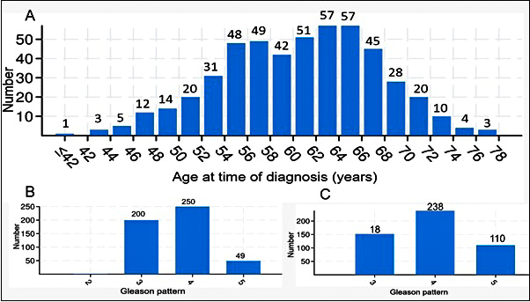
Figure 1| Wide scope of age of diagnosis and Gleason scores. “A” shows age class boundaries of patients diagnosed with PCa. “B” represents different primary whereas “C” shows the secondary Gleason patters making up different Gleason scores of PCa in patients.

Differential gene mutation with increasing age
Increasing age quartiles of PCa diagnosed patients showed differential gene mutations. Three of the differentially mutated genes; ENOX1, CCDC122 and LACC1 had increasing mutations with increasing age at time of diagnosis with 0.0781, 0.124 and 0.124 p-values respectively. (Figure 2)
All three genes were located on the 13q14.11 cytogenetic band having a deep deletion mutation.
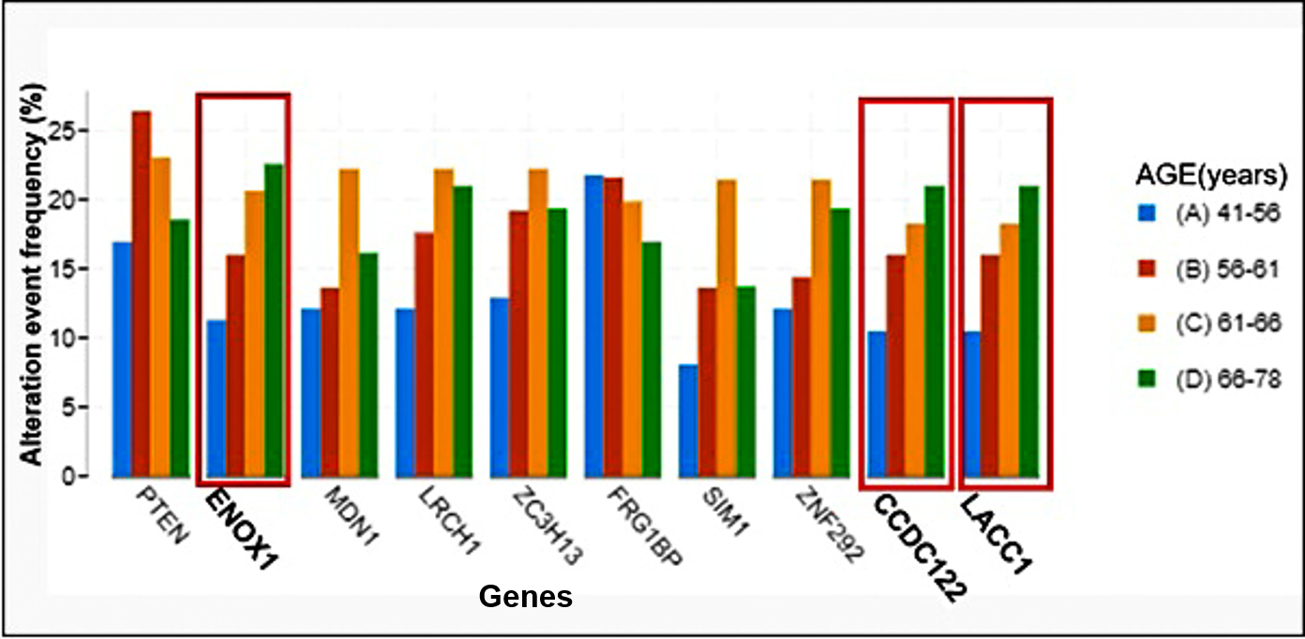
Figure 2| ENOX1, CCDC122 and LACC1 genes are increasingly mutated with increasing age of diagnosis.

Mutation analysis of ENOX1, CCDC122 and LACC1.
Sixteen percent (16%) of the 491 patient cohort had deep deletions of all three genes. All the three gene deep deletions had a co-occurrence tendency with p-values all less than 0.001 (95% CI) (Table1).

Table 1| Table showing expression relationships of ENOX1, CCDC122 and LACC1 in 491 patient samples
A | B | Neither | A Not B | B Not A | Both | Log2 Odds Ratio | p-Value | q-Value | Tendency
ENOX1: HOMDEL | CCDC122: HOMDEL | 412 | 0 | 0 | 79 | >3 | <0.001 | <0.001 | Co-occurrence
CCDC122: HOMDEL | LACC1: HOMDEL | 410 | 2 | 0 | 79 | >3 | <0.001 | <0.001 | Co-occurrence
ENOX1: HOMDEL | LACC1: HOMDEL | 410 | 2 | 0 | 79 | >3 | <0.001 | <0.001 | Co-occurrence

Analysis of any mutational data on the 3 genes irrespective of expression profile showed that ENOX1 had two missense mutations of unknown significance and one truncating (nonsense) mutation all with a COSMIC score of 1. CDC122 and LACC1 had no mutations identified.

Effect of ENOX1, CCDC122 and LACC1 deep deletion in PCa
There was no significant effect and or difference of any of(singly) or all the three genes’(combined) deep deletion on overall survival between PCa patients using Kaplan-Meier plotted data in the study cohort.

Relationship analysis for ENOX1, CCDC122 and LACC1.
CCDC122 and LACC1 were found to be co-expressed corroborated with data from text mining. ENOX1, had no shown relationship with either gene (Figure 3).
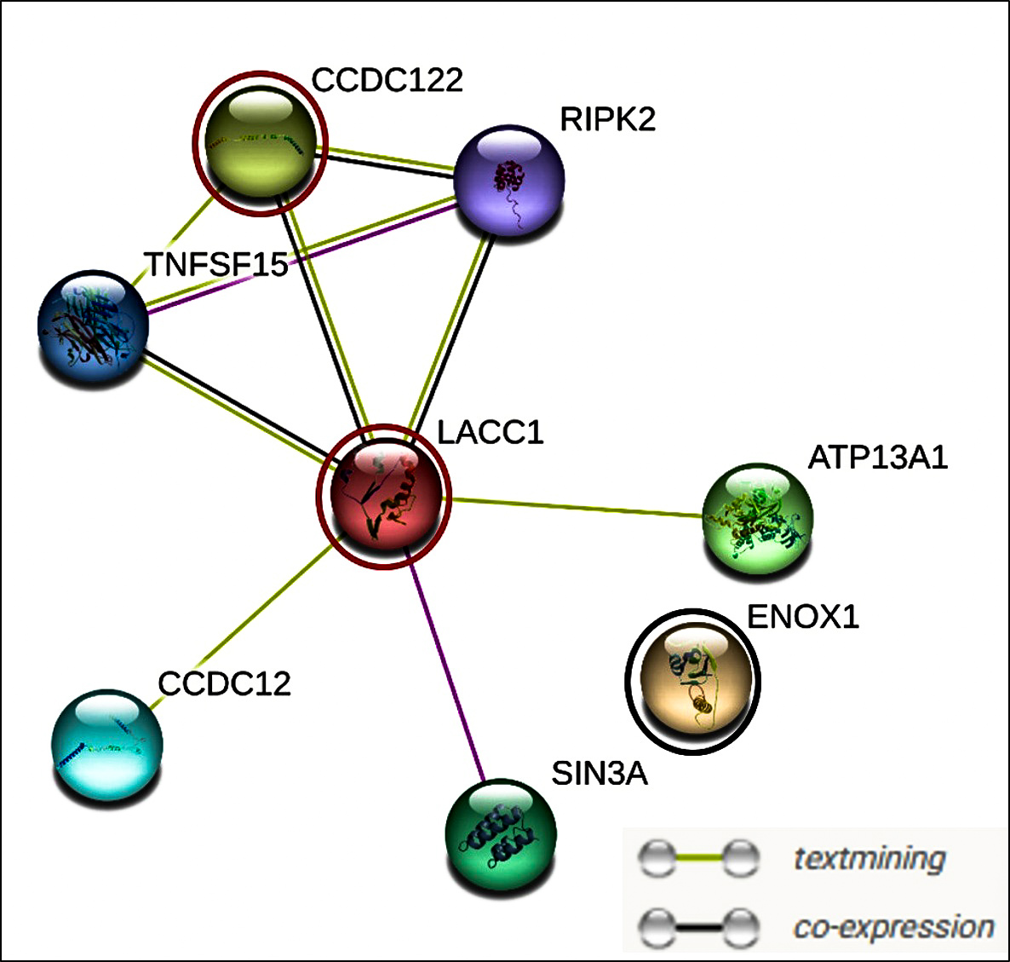
Figure 3| LACC1 and CCDC122 are co-expressed were as ENOX1 has no relationship with them. The three putative interactions were circled in red (LACC1 and CCDC122) and black(ENOX1).

Pathway analysis using Enrichr and Reactome.
Reactome2022 was the database of choice with the highest combines scores and most up-to-date in Enrichr pathway analysis. The individual gene deep deletion implicated pathways were identical between LACC1 and CCDC122 with ENOX1 having a more alike effect to the combined effect of all three gene deep deletions.
The top 5 identified pathways ranking first by descending combined score then by ascending p-value for all three genes’ deep deletion were estrogen biosynthesis, KH-type splicing regulatory protein(KSRP), alpha linoleic and linolelic acid metabolism, and Rap1 signalling with 114.62,110.08,82.59,67.35,56.94(2dp) combine scores respectively (Table 2).

Table 2| Query genes were from Mitochondrial translation pathways.
Index |  | Name/Pathway Identifier | P-value | Odds Ratio | Combined score | Genes overlap
1 | Estrogen Biosynthesis  R-HSA-193144 |  | 0.006562 | 22.8030303 | 114.6185 | AKR1B15;CYP19A1
2 | KSRP (KHSRP) Binds And Destabilizes mRNA  R-HSA-450604 |  | 4.05E-04 | 14.09187534 | 110.0775 | DIS3;EXOSC8;PARN;YWHAZ
3 | Alpha-Linolenic (Omega3) And Linoleic (Omega6) Acid Metabolism  R-HSA-2046104 |  | 0.00242 | 13.70957944 | 82.58704 | ELOVL1;MUSK;SYCP2
4 | Linoleic Acid (LA) Metabolism  R-HSA-2046105 |  | 0.011904 | 15.2004662 | 67.3514 | ELOVL1;MUSK
5 | Rap1 Signalling  R-HSA-392517 |  | 0.004516 | 10.5442128 | 56.93941 | RAP1B;RAP1A;YWHAZ

Results from Reactome corroborated the same pathways as identified by Enrichr displaying genes that overlapped with those from known pathways (False Discovery Rate (FDR)<0.001). The top two of these with respective overlapping genes were highlighted (Figure 3). 184 genes were not mapped to any pathway by Reactome.
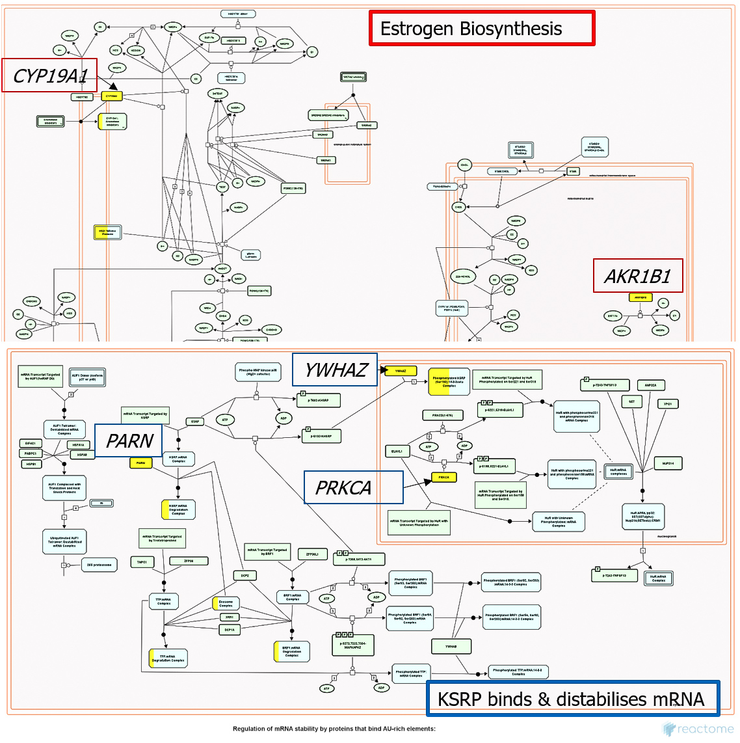
Figure 4| Gene’s overlap(coloured yellow) between query genes mapped to known pathways by Reactome. Top is the estrogen biosynthesis pathway and bottom is the KSRP binding and destabilisation of mRNA pathway.

Discussion
Our study aimed to identify some of the most prevalent mutations and or differentially expressed genes throughout the progression of disease. As age at diagnosis is often positively correlated and had previously been found to be linked with disease progression and poor prognosis, we examined quartiles of ages of patients diagnosed with prostate cancer to identify those genes whose mutational frequency was increasing with age and Gleason score(Figure1)^{35,36}.
Whereas the development and progression of prostate cancer is not pivotal on a single or only genomic mutations, we observed roles such as structural alterations and fusions attributed to TMPRSS2 gene and other chromosome 13q gene deletions among a hallmark of other factors PCa employs to develop, evade and progress in an individual. ENOX1, one of our identified genes is found on the same chromosome arm and we were able to identify its combined role with CCDC122 and LACC1 within the same cytogenetic band of 13q14.11 in progression of PCa as coexpression^{37,38}.

All the top 5 pathways implicated by upregulated genes following deep deletion of ENOX1, LACC1 and, CCDC122 have been previously linked to cancer progression and give insight on the beneficial effect of the three gene deletion to prostate cancer cell survival and disease progression.
Estrogen has been shown to play a role in the development and progression of prostate cancer through its receptor activation on PCa cells that promotes cell proliferation and survival^{39–41}. Estrogen can stimulate the production of growth factors and cytokines that promote angiogenesis and tumour growth^{39,40,42}. Estrogen can inhibit the androgen receptor (AR) signalling pathway, and this is important for prostate cancer growth and survival^{39,42}.

KSRP (KH-type splicing regulatory protein) is an RNA-binding protein that has been shown to promote tumour growth and metastasis in non-small cell lung, breast, ovarian and, prostate cancer⁴³. A study on castration-resistant prostate cancer showed that KSRP regulates type III interferon expression post-transcriptionally, which is an important axis in the progression of prostate cancer especially in advanced stage⁴⁴. KSRP is also known to regulate gene expression on various levels, including gene transcription, mRNA decay, and microRNA precursor maturation⁴³. In colorectal cancer, enhanced expression of KSRP was found in tumour tissue and was associated with worse overall survival. KSRP seemed to drive epithelial cell proliferation in primary and metastatic cells through control of cell cycle progression and promoted angiogenesis by enhancing vascular endothelial growth factor⁴⁵.

Omega-3 and omega-6 fatty acids play a crucial role in the development and progression of prostate cancer. High amounts of omega-6 fatty acids have been linked with an increased risk of prostate cancer, whereas omega-3 fatty acids have been shown to inhibit prostate cancer growth⁴⁶. A study on athymic mouse xenograft model simulating radical prostatectomy showed that prostate tumours can be modulated by the manipulation of omega-6:omega-3 ratios through diet, and the omega-3 fatty acid stearidonic acid (SDA) (precursor of eicosapentaenoic acid (EPA)) can inhibit prostate tumour growth and recurrence⁴⁷. However, a study found that high intake of omega-3 fats in the blood is linked to an increased risk of prostate cancer⁴⁸. Another study showed that there were no significant associations between specific omega-3 or omega-6 PUFA intakes and overall prostate cancer risk⁴⁹. Our current findings show a beneficial role of these two essential acids in PCa.

Ras-proximate-1 (Rap1) signalling has been shown to play a role in prostate cancer metastasis and invasion^{50–52}. Specifically, Rap1 promotes tumour progression by disrupting E-cadherin-mediated cell adhesion, leading to a reduction in E-cadherin⁵³. Activation of Rap1 has also been shown to increase prostate cancer cell migration and invasion through the α4, β3, and αvβ3 integrins⁵². Additionally, a study found that miR-203 down-regulates Rap1A and subsequently suppresses cell proliferation, adhesion, and invasion in prostate cancer⁵². These studies summatively suggest Rap1 contributes to PCa metastasis and, invasion in patients through several pathways

The novelty in our findings is the link between the three identified genes and their combined role in upregulation of genes in PCa cell benefiting pathways for disease progression and poor prognosis.

For a wet lab proof of concept, future work might involve use of PCa cell lines (RWPE-1, LNCaP, PC3, DU145) demonstrating different stage progression or stem cells of the disease and screening for the three genes using fluorescent in-situ hybridisation technique under the expectation of decreasing fluorescence with advancing disease.
As a therapeutic target for PCa and personalised therapy judicial targeting rate limiting steps/enzymes in the identified pathways should the side effect not outweigh the clinical benefit of the intervention.

References
1. Sung, H. et al. Global Cancer Statistics 2020: GLOBOCAN Estimates of Incidence and Mortality Worldwide for 36 Cancers in 185 Countries. CA. Cancer J. Clin. 71, 209–249 (2021).
2. Chhikara, B. S. & Parang, K. Global Cancer Statistics 2022: the trends projection analysis. Chem. Biol. Lett. 10, Vol. 10 No. 1 (2023) (2023).
3. Prostate cancer incidence statistics | Cancer Research UK. https://www.cancerresearchuk.org/health-professional/cancer-statistics/statistics-by-cancer-type/prostate-cancer/incidence#heading-Three (2023).
4. Hatzoglou, V. et al. Brain Metastases from Prostate Cancer: An 11-Year Analysis in the MRI Era with Emphasis on Imaging Characteristics, Incidence, and Prognosis. J. Neuroimaging 24, 166–166 (2014).
5. Caster, J. M., Falchook, A. D., Hendrix, L. H. & Chen, R. C. Risk of pathologic upgrading or locally advanced disease in early prostate cancer patients based on biopsy gleason score and PSA: A population-based study of modern patients. Int. J. Radiat. Oncol. Biol. Phys. (2015) doi:10.1016/j.ijrobp.2015.01.051.
6. Carroll, P. H. & Mohler, J. L. NCCN guidelines updates: Prostate cancer and prostate cancer early detection. JNCCN J. Natl. Compr. Cancer Netw. 16, 620–623 (2018).
7. Held-Warmkessel, J. Treatment of advanced prostate cancer. Semin. Oncol. Nurs. 17, 118–128 (2001).
8. Nanus, D. M. et al. Clinical use of monoclonal antibody HuJ591 therapy: Targeting prostate specific membrane antigen. in Journal of Urology (2003). doi:10.1097/01.ju.0000095151.97404.7c.
9. Luo, C., Chen, J. & Chen, L. Exploration of gene expression profiles and immune microenvironment between high and low tumor mutation burden groups in prostate cancer. Int. Immunopharmacol. 86, (2020).
10. Wang, L., Pan, S., Zhu, B., Yu, Z. & Wang, W. Comprehensive analysis of tumour mutational burden and its clinical significance in prostate cancer. BMC Urol. 21, 1–10 (2021).
11. Lawlor, R. T. et al. Tumor mutational burden as a potential biomarker for immunotherapy in pancreatic cancer: Systematic review and still-open questions. Cancers (Basel). 13, (2021).
12. Kluth, M. et al. 13Q Deletion Is Linked To an Adverse Phenotype and Poor Prognosis in Prostate Cancer. Genes Chromosom. Cancer 57, 504–512 (2018).
13. Chalmers, Z. R. et al. Analysis of 100,000 human cancer genomes reveals the landscape of tumor mutational burden. Genome Med. 9, (2017).
14. Venkateswaran, A. et al. The NADH Oxidase ENOX1, a Critical Mediator of Endothelial Cell Radiosensitization, Is Crucial for Vascular Development. Cancer Res. 74, 38–43 (2014).
15. Jiang, Z., Gorenstein, N. M., Morré, D. M. & James Morré, D. Molecular cloning and characterization of a candidate human growth-related and time-keeping constitutive cell surface hydroquinone (NADH) oxidase. Biochemistry 47, 14028–14038 (2008).
16. Wu, Y. et al. Identification of the Functions and Prognostic Values of RNA Binding Proteins in Bladder Cancer. Front. Genet. 12, 1–19 (2021).
17. Kluth, M. et al. Prevalence of chromosomal rearrangements involving non-ETS genes in prostate cancer. Int. J. Oncol. 46, 1637–1642 (2015).
18. Science for Life laboratory, K. I. NM_001347969.2(ENOX1):c.759_765del (p.Ser254fs) AND Malignant tumor of prostate - ClinVar - NCBI. https://www.ncbi.nlm.nih.gov/clinvar/RCV000149057/ (2023).
19. Uhlen, M. et al. A pathology atlas of the human cancer transcriptome. Science (80-. ). 357, (2017).
20. Expression of ENOX1 in cancer - Summary - The Human Protein Atlas. https://www.proteinatlas.org/ENSG00000120658-ENOX1/pathology (2023).
21. Safran, M. et al. GeneCardsTM 2002: towards a complete, object-oriented, human gene compendium. Bioinformatics 18, 1542–1543 (2002).
22. Xiong, J. H. et al. Association between genetic variants in NOD2, C13orf31, and CCDC122 genes and leprosy among the Chinese Yi population. Int. J. Dermatol. 55, 65–69 (2016).
23. Leturiondo, A. L. et al. Association of NOD2 and IFNG single nucleotide polymorphisms with leprosy in the Amazon ethnic admixed population. PLoS Negl. Trop. Dis. 14, 1–13 (2020).
24. Fagerberg, L. et al. Analysis of the Human Tissue-specific Expression by Genome-wide Integration of Transcriptomics and Antibody-based Proteomics* □ S. (2013) doi:10.1074/mcp.M113.035600.
25. LACC1 Gene - GeneCards | LACC1 Protein | LACC1 Antibody. https://www.genecards.org/cgi-bin/carddisp.pl?gene=LACC1 (2023).
26. Lahiri, A., Hedl, M., Yan, J. & Abraham, C. Human LACC1 increases innate receptor-induced responses and a LACC1 disease-risk variant modulates these outcomes. Nat. Commun. 8, (2017).
27. Huang, C., Hedl, M., Ranjan, K. & Abraham, C. LACC1 Required for NOD2-Induced, ER Stress-Mediated Innate Immune Outcomes in Human Macrophages and LACC1 Risk Variants Modulate These Outcomes. Cell Rep. 29, 4525 (2019).
28. Li, S. et al. Transcriptome analysis of differentially expressed genes and pathways associated with mitoxantrone treatment prostate cancer. J. Cell. Mol. Med. 23, 1987–2000 (2019).
29. Luca, B.-A. Identification of biomarkers for the management of human prostate cancer. (2017).
30. Bartha, Á., Gy, B. & Orffy, ˝. Molecular Sciences TNMplot.com: A Web Tool for the Comparison of Gene Expression in Normal, Tumor and Metastatic Tissues. (2021) doi:10.3390/ijms22052622.
31. Gao, J. et al. Integrative analysis of complex cancer genomics and clinical profiles using the cBioPortal. Sci. Signal. 6, (2013).
32. Szklarczyk, D. et al. STRING v11: protein-protein association networks with increased coverage, supporting functional discovery in genome-wide experimental datasets. Nucleic Acids Res. 47, D607–D613 (2019).
33. Kuleshov, M. V et al. Enrichr: a comprehensive gene set enrichment analysis web server 2016 update. Nucleic Acids Res. 44, W90–W97 (2016).
34. Gillespie, M. et al. The reactome pathway knowledgebase 2022. Nucleic Acids Res. 50, (2021).
35. Pettersson, A. et al. Age at diagnosis and prostate cancer treatment and prognosis: a population-based cohort study. Ann. Oncol. 29, 377–385 (2018).
36. Cooney, M. M., Okuku, F. & Orem, J. Prostate Cancer Burden at the Uganda Cancer Institute. 2, 181–185 (2019).
37. Perner, S. et al. TMPRSS2-ERG fusion prostate cancer: An early molecular event associated with invasion. Am. J. Surg. Pathol. 31, 882–888 (2007).
38. Braun, M. ERG rearrangement is specific to prostate cancer and does not occur in any other common tumor. (2012).
39. Bosland, M. C. SELECTIVE ESTROGEN RECEPTOR MODULATORS The Role of Estrogens in Prostate Carcinogenesis: A Rationale for Chemoprevention. Rev. Urol. 7, (2005).
40. Ramírez-de-Arellano, A. et al. Distribution and Effects of Estrogen Receptors in Prostate Cancer: Associated Molecular Mechanisms. Front. Endocrinol. (Lausanne). 12, 811578 (2022).
41. Malaguarnera, R. et al. estrogens and Their Receptors in Prostate Cancer: Therapeutic implications. 8, (2018).
42. Nelles, J. L., Hu, W.-Y. & Prins, G. S. Estrogen action and prostate cancer. (2011) doi:10.1586/eem.11.20.
43. Gherzi, R., Chen, C. Y., Trabucchi, M., Ramos, A. & Briata, P. The role of KSRP in mRNA decay and microRNA precursor maturation. Wiley Interdiscip. Rev. RNA 1, 230–239 (2010).
44. Schmidtke, L. et al. The KH-type splicing regulatory protein (KSRP) regulates type III interferon expression post-transcriptionally. Biochem. J. 476, 333–352 (2019).
45. Palzer, K. A. et al. The Role of KH-Type Splicing Regulatory Protein (KSRP) for Immune Functions and Tumorigenesis. Cells 11, (2022).
46. Apte, S. A., Cavazos, D. A., Whelan, K. A. & Degraffenried, L. A. A low dietary ratio of omega-6 to omega-3 Fatty acids may delay progression of prostate cancer. Nutr. Cancer 65, 556–562 (2013).
47. Kelavkar, U. P. et al. Prostate tumor growth and recurrence can be modulated by the omega-6:omega-3 ratio in diet: athymic mouse xenograft model simulating radical prostatectomy. Neoplasia 8, 112–124 (2006).
48. Brasky, T. M. et al. Plasma Phospholipid Fatty Acids and Prostate cancer risk in the Select trial. 105, (2013).
49. Huerta-Yépez, S., Tirado-Rodriguez, A. B. & Hankinson, O. Role of diets rich in omega-3 and omega-6 in the development of cancer. Bol. Med. Hosp. Infant. Mex. 73, 446–456 (2016).
50. Zhang, Y. L., Wang, R. C., Cheng, K., Ring, B. Z. & Su, L. Roles of Rap1 signaling in tumor cell migration and invasion. Cancer Biol. Med. 14, 90–99 (2017).
51. Bailey, C. L., Kelly, P. & Casey, P. J. Activation of Rap1 Promotes Prostate Cancer Metastasis. Cancer Res. 69, 4962 (2009).
52. Jaśkiewicz, A., Pajką, B. & Orzechowski, A. The many faces of rap1 GTPase. Int. J. Mol. Sci. 19, 1–20 (2018).
53. Looi, C. K., Hii, L. W., Ngai, S. C., Leong, C. O. & Mai, C. W. The Role of Ras-Associated Protein 1 (Rap1) in Cancer: Bad Actor or Good Player? Biomedicines 8, (2020).

