Program 164a
(straight line depreciation)

Program Description: The straight-line method for computing the yearly depreciation of the value of an item is given by the following formula:

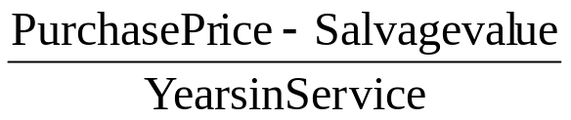


Write a program to compute the yearly depreciation for an item whose purchase price, salvage value, and expected years in service are entered by the user.

Output a depreciation schedule. The schedule should display the yearly depreciation (annual depreciation), accumulated depreciation (total depreciation to date) and the book value (original value less the total depreciation).

Construct the program so that it will terminate when the user enters a zero for the purchase price.

Required Statements: input, output, loop control

Sample output:
Enter Purchase Price 250
Enter Salvage Value 35
Enter Estimated Life 8
1 26.88 26.88 223.12
2 26.88 53.75 196.25
3 26.88 80.62 169.38
4 26.88 107.50 142.50
5 26.88 134.38 115.62
6 26.88 161.25 88.75
7 26.88 188.12 61.88
8 26.88 215.00 35.00
Enter Purchase Price 9654.33
Enter Salvage Value 100
Enter Estimated Life 12
1 796.19 796.19 8858.14
2 796.19 1592.39 8061.94
3 796.19 2388.58 7265.75
4 796.19 3184.78 6469.55
5 796.19 3980.97 5673.36
6 796.19 4777.17 4877.17
7 796.19 5573.36 4080.97
8 796.19 6369.55 3284.78
9 796.19 7165.75 2488.58
10 796.19 7961.94 1692.39
11 796.19 8758.14 896.19
12 796.19 9554.33 100.00
Enter Purchase Price 0
Enter Salvage Value 0
Enter Estimated Life 0

Program Terminated

