
Program 164b
(declining balance depreciation)
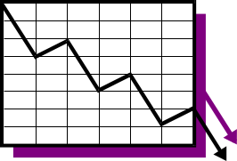
Program description: Various methods of depreciation are used by businesses for various assets. One such method, declining balance, accelerates depreciation through the “life” of an asset. The declining balance method for computing the yearly depreciation of and asset is determined by the following:

A percentage of the asset’s original value is computed on each year’s current book value.
Note: No scrap value is entered but is the remaining portion (bookvalue) at the end of its estimated life.

The percentage = 1 divided by the years of estimated life.

Bookvalue = original – total accumulated depreciation.

Write a program to compute the yearly depreciation for an item whose purchase price and expected years of service are entered by the user.

Required statements: input, output, loop control

Sample output:

Original cost = 1500.00
Estimated life = 6

Method DECLINING BALANCE

Year Annual Accumulated Book
Depreciation Depreciation Value
1 250.00 250.00 1250.00
2 208.33 458.33 1041.67
3 173.61 631.94 868.06
4 144.68 776.62 723.38
5 120.56 897.18 602.82
6 100.47 997.65 502.35

Original cost = 755.00
Estimated life = 4

Method DECLINING BALANCE

Year Annual Accumulated Book
Depreciation Depreciation Value
1 188.75 188.75 566.25
2 141.56 330.31 424.69
3 106.17 436.48 318.52
4 79.63 516.11 238.89

