Program 166f
(karl gauss)

Program Description: The mathematician Karl Gauss when given the problem to calculate the
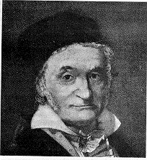sum of the first 200 positive integers quickly determined that if he paired off the numbers (1-200, 2-199, 3-198...) that there would be 100 such pairs, each of whose sum was 201. Therefore the sum of the fist 200 integers would be 20100 or 100 X 201. What about an odd number such as the sum of the first 201 or 203 numbers. Write a program that will generate the sum of all numbers from 1 to 100 to 1 to 110 to assist you in developing any proving a general formula that will determine the answer for the summation of integers from 1 to n.

Turn in this formula as documentation within your program.

Required statements: output, loop control, decision making

Sample Copy:

The sum of the numbers from 1 to 100 is 5050
The sum of the numbers from 1 to 101 is 5151
The sum of the numbers from 1 to 102 is 5253
The sum of the numbers from 1 to 103 is 5356
The sum of the numbers from 1 to 104 is 5460
The sum of the numbers from 1 to 105 is 5565
The sum of the numbers from 1 to 106 is 5671
The sum of the numbers from 1 to 107 is 5778
The sum of the numbers from 1 to 108 is 5886
The sum of the numbers from 1 to 109 is 5995
The sum of the numbers from 1 to 110 is 6105

Photo was taken from the book "A Concise History of Mathematics" by Dirk J. Struik

