Program 212a
(passing trains)

Program Description: A freight train travelling 40 mph leaves at 9 o'clock. A passenger train going the same direction on parallel tracks starts at 11 o'clock going 80 mph. When will the passenger train overtake the freight train? (Find the same information for a passenger train travelling at 75 mph.)
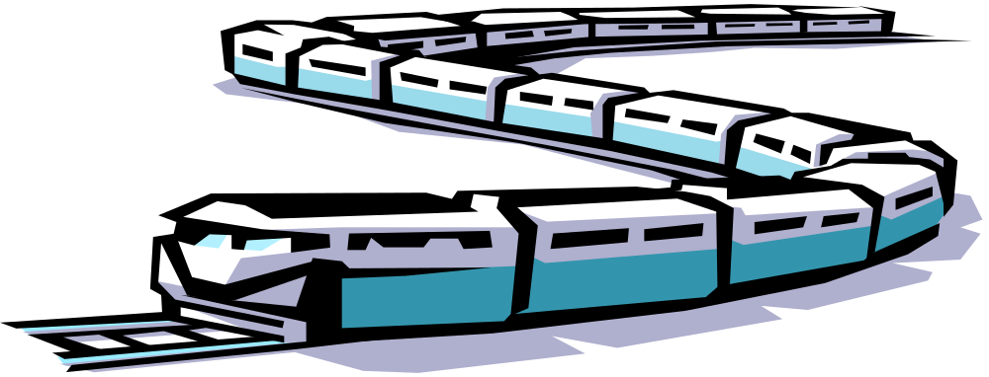
Have time start at 9 and for every hour thereafter let the freight's distance increase by its speed. When time reaches 11, let the passenger train's distance increase by its speed for every hour thereafter. When the passenger train's distance equals or is grater than the freight train, print out an appropriate message. A different message would be appropriate depending on whether is an equal to or greater than the exact hour.

Statements Required: input, output, loop control, decision making

Sample Output:
Enter the speed of the passenger train 80
The passenger train passed the freight train at 1 o'clock
The freight train was traveling 40 mph
The passenger train was traveling 80 mph

Enter the speed of the passenger train 75
The passenger train passed the freight train between 1 and 2 o'clock
The freight train was traveling 40 mph
The passenger train was traveling 75 mph

Enter the speed of the passenger train 85
The passenger train passed the freight train between 12 and 1 o'clock
The freight train was traveling 40 mph
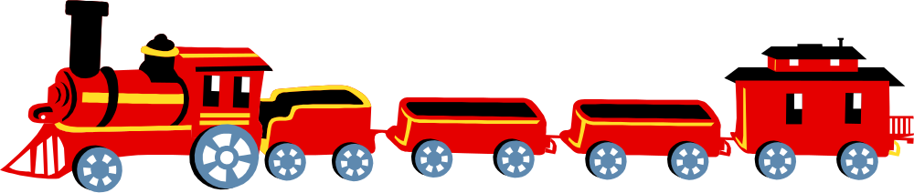The passenger train was traveling 85 mph

