Program 335h
(fatuous dice function)

Program Description: A certain game requires that two dice be rolled, one at a time. If p and q are the numbers rolled on the first and second die, respectively the value of the roll in the game is determined as follows:

P Q Rule (value of the roll and condition)
Even Odd 2P + Q
Odd Even P + 2Q
Even Even P + Q When P not = Q
3P when P = Q
odd Odd P + Q when P not =Q
3Q when P = Q

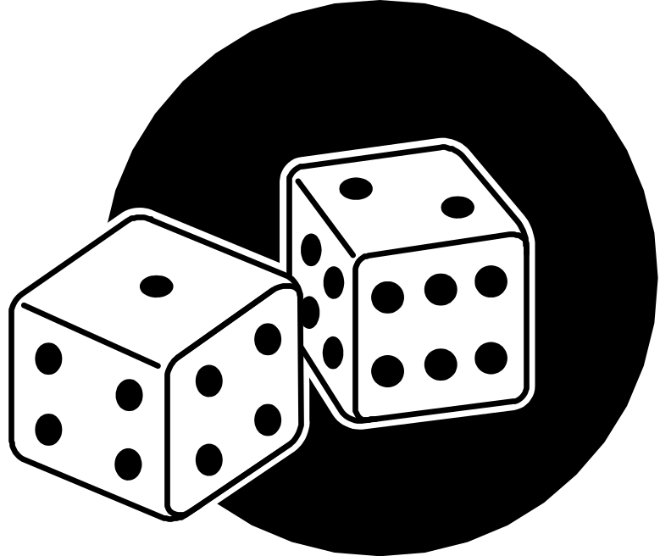
Write a function "diceroll" that will receive a pair of values P and Q that computes the value of the roll.

Required Statements: loop control, decision making, function

Data Location: Prog127a.dat

Sample output:

P Q Value
2 5 9
4 4 12
6 2 8
1 3 4
5 5 15
1 2 5

