Program 336a
(spy vs spy)

Program Description: It is midnight and the moon is hidden by dense clouds. You are on a covert mission behind enemy lines. In order in inflict damage on the enemy your mission is to empty a cylindrical aviation fuel tank and to set a timer to activate an incendiary explosive device. You need to make sure the tank is completely empty and you have time to escape the area. You have your PalmPilot computer with you and you need to quickly write a program that will determine the timer settings.

You determine that the tank is 20 feet tall and 8 feet in diameter. You will open a circular nozzle that is 2 inches in diameter. Information supplied in your dossier tells you that volume of the fuel leaving the tank is:

Volume lost = velocity X (area of the nozzle) X time

and that …

Velocity = 8.02 X (height of fluid in the tank) ^{0.5}

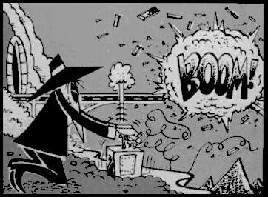
Write a program that calculates the time required for the tank to empty. Convert the elapsed seconds to minutes so that there is no mistake in setting the remote timer. The timer will be set so that it detonates when the tank level is approximately zero.

You recall from your physics class that it would be possible to calculate the volume lost over a short period of time, such as 60 seconds and then assume that the loss of fluid is constant. You then plan to subtract the volume from the tank and determine the new height of the fluid inside the tank at the end of a minute. Then you are able to calculate the loss for the next minute. Repeating this over and over until the tank is completely dry.

Required Statements: output, decision making, loop control, functions

Sample Output:

The time to set would be: 8.923 minutes

