Program 366b
(poly wants a primes)

Program Description: The mathematician Euclid proved that there is an infinite number of prime numbers. One of the greatest challenges to mathematicians was to find a formula that would generate all the prime numbers. Write a program to determine the how many prime numbers (41..?) the following formula generates.

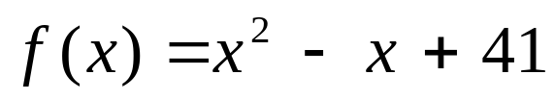

Required statements: output, loop control, decision making, function

Sample Copy:

The following numbers generated by the formula x^2 - x + 41 are:
41 prime
43 prime

47 prime
53 prime
61 prime
71 prime
83 prime
97 prime
113 prime
131 prime
151 prime
173 prime
197 prime

...more output here

853 prime
911 prime
971 prime
1033 prime
1097 prime
1163 prime
1231 prime
1301 prime
1373 prime
1447 prime
1523 prime
1601 prime
1681 test fails/factor=41

