Program 411a
Factors, Factors, Factors

Program Description: There are many applications that depend upon being able to find the factors of a number. For example, how many factors are there for the number 12--not counting 1 or 12.

First 12/2 = 6 Since 2 and 6 are different and each are integers, both 2 and 6 are factors.
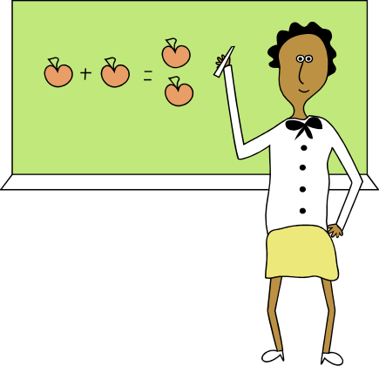Next 12/3 = 4 Again, 3 and 4 are different, each is an integer, so 3 and 4 are both factors.

The factors, of 12 are: 2, 3, 4, and 6. There are 4 factors. We do not count 1 or 12 since every number is exactly divisible by 1 and itself.

Write a program for a math student that finds the factors and number of factors for an inputted integer.

Required Statements: input, output, decision making, loop control

Sample Output:

Enter a number to factor (zero to quit)12
There are 4 factors for the number 12: 2 6 3 4
Enter a number to factor (zero to quit)25
There are 1 factors for the number 25: 5
Enter a number to factor (zero to quit)100
There are 7 factors for the number 100: 2 50 4 25 5 20 10
Enter a number to factor (zero to quit)13
There are 0 factors for the number 13:
Enter a number to factor (zero to quit)0

