Program 435t
(forensic Science)

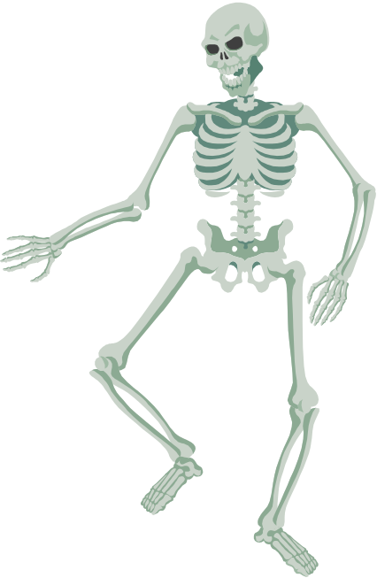Program Description: From an article from the Mathematics Teacher, February 1981. Knowing the exact physical dimensions of a victim of a crime is extremely useful in identifying the victim. When a skeleton is found, a forensic scientist uses the lengths of certain bones to calculate the height of the living person. The bones that are used are the femur (F), the tibia (T), the humerus (H), and the Radius (R). When the length of one of these bones is known, one of the following formulas is used to determine the height. All measurements are in centimeters.

Male
h= 69.089 + 2.238 X F
h= 81.688 + 2.392 X T
h = 73.570 + 2.970 X H
h = 80.405 + 3.650 X R

Female
h = 61.412 + 2.317 X F
h = 72.572 + 2.533 X T
h = 64.977 + 3.144 X H
h = 73.502 + 3.876 X R

.After the age of thirty, the height of a person begins to decrease at the rate of approximately 0.06 cm er year. This shrinkage must be considered when the age of the victim is known.

Write a program that will determine the height of a person from provided data. The data will consist of a lead value indicating the number of bones to be analyzed. Data for each bone will consist of the following information:

1. Male or female (F or M)
2. Type of bone (F, T, H, or R)
3. Estimated age of person
4. Length of bone

The first two columns need to be checked for valid input data. Write out an error message if they are invalid.

Data Location: prog435t.dat

Statements Required: input, output, loop control, decision making, array

Sample Output:
sex bone age length height
F H 45 36.266 178.097
M F 18 46.967 174.201
M H 29 33.309 172.498
M T 95 36.983 166.251
M R 30 23.177 165.000
F F 31 42.550 159.940
F F 65 39.960 151.899
F T 50 30.962 149.799
F R 80 19.375 145.600
M H 3 624.017 144.540
Q F 40 30.000 Wrong Sex Code
M Q 40 30.000 Wrong Bone Code

