Program 512d
(upc)

Program Description: A UPC is printed on almost every item sold these days. It is a series of lines of varying thickness that can be read by a bar code reader. A UPC code has 12 digits. The first digit is a generic product type code (for example 2 for meat), the next five digits correcpond to a unique product. The next five digits represent the manufacturer and the final line in which the digit is not printed is a check digit that determines the validity of the previous code segment.
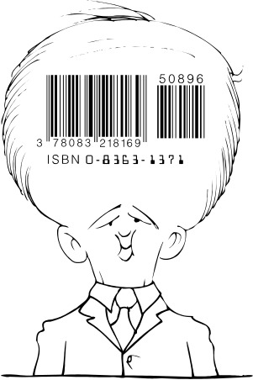

To check the validity of the code you need to analyze each digit in the code including the check digit. Assume that the first digit is in position zero, add the digits in the even positions and multiply the result by 3. Add this to the sum of the odd positioned digts. Only if the total is a multiple of 10 is the UPC number valid.

For example: Given the UPC code of 016499215511 the following summation would prove that the bar code is valid.

3 X (0 + 6 + 9 + 2 + 5 + 1) + 1 + 4 + 9 + 1 + 5 + 1 = 90/10 = 9

Write a program that reads a UPC code from an external file, analyze the code, and output the code and a label “Invalid” or “Valid”.

Required Statements: output, decision making, loop control, functions, apstring

Data Location: prog512d.dat

Sample Output:

UPC code Validity
016499215511 Valid

UPC code Validity
372415613274 Invalid

UPC code Validity
155512994610 Valid

UPC code Validity
011165459192 Invalid

UPC code Validity
838241762110 Invalid

