 Program 512h
(three-letter words)

Program Description: Write a program that reads text and determines the percentage of words having three letters. For simplicity, use text without any punctuation.

Data Location: prog512h.dat

Statements Required: input, output, loop control, decision making, apstring functions

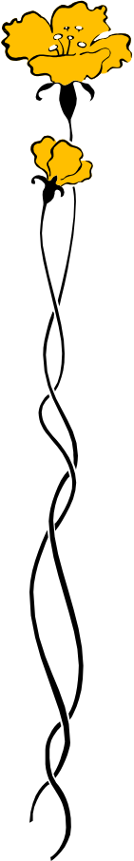
Sample Output:

Good morning life and all
Things glad and beautiful
My pockets nothing hold
But he that owns the gold
The sun is my great friend
His spending has no end
Hail to the morning sky
Which bright clouds measure high
Hail to you birds whose throats
Would number leaves by notes
Hail to you shady bowers
And you green fields of flowers
Hail to you women fair
That make a show so rare
In cloth as white as milk
Be it calico or silk
Good morning life and all
Things glad and beautiful

Total Words = 93
Three Letter Words = 20
Percentage of Occurrence = 21.51%

