Program 58b
(roots)

Program Description: You can find the roots of a quadratic equation in the form:

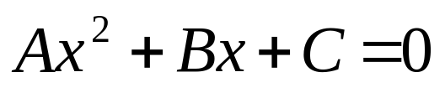
by using the quadratic formula:

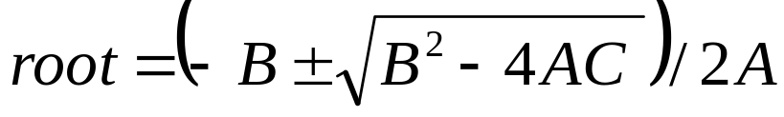

Write a program that inputs three integers A, B, and C and outputs the roots of an equation using the quadratic formula. Your program needs to be concerned with real roots.

Required statements: input, output

Sample Copy:

Enter A, B and C: 1 5 6
The roots are: -2, -3

Enter A, B and C: 1 1 -2
The roots are: 1, -2

Enter A, B and C: 1 1 -6
The roots are: -3, 2



