PROGRAM 615u
(Banking Wait Time)

STATEMENT OF THE PROBLEM: One of the local banks is gearing up for a big advertising campaign and would like to see how long their customers are waiting for service at their drive-in windows. They have asked several employees to keep accurate records for the 24-hour drive-in service. The collected information will be read from a file and each line of input will consist of the time of day in hours, minutes, and seconds that the customer arrived, the time the customer was actually served, and the ID number of the teller.

The bank would like for you to calculate the number of records, mean, standard deviation and range of wait times.

Assume a maximum of 50 lines of input.

Echo print the input data. Print the following values, all properly labeled: number of records, mean, standard deviation, and range.

A range is the largest value - smallest value. A mean is the average waiting time and the standard deviation is determined by the following formula:

Statements Required: input, output, decision making, arrays
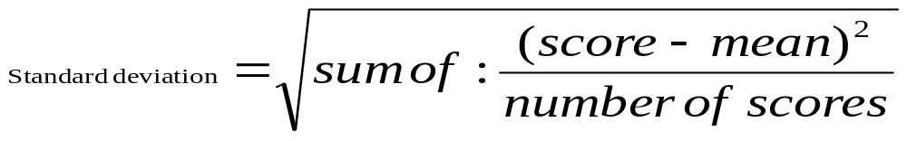
Data Location: waittime.dat

Sample Output
Arrival Departure Lapsed
Hour Min Sec Hour Min Sec Minutes Teller
----------------------------------------------------------------------------------------------
9 30 10 9 40 5 9.92 1
9 41 3 9 43 50 2.78 1
9 42 7 9 44 3 1.93 2
9 45 50 9 46 22 .53 2
9 47 0 9 51 1 4.02 1
9 47 30 9 52 40 5.17 2
9 55 0 9 56 20 1.33 1
9 55 0 9 57 32 2.53 2
9 57 30 10 0 2 2.53 1
9 58 10 9 59 59 1.82 2
----------------------------------------------------------------------------------------------
Standard Deviation 2.5454
Mean (average) 3.2567
Range 9.3833
Number of Records 10

