Program 620h
(bridge hands)

Program Description: Deal a standard deck of cards to four bridge players. Evaluate the "point value" of each player's hand using the following criteria for face cards:

Ace = 4 points
King = 3 points
Queen = 2 points
Jack = 1 point

Other points are awarded for the distribution of the cards within the suit. Four points are awarded if the player holds no cards in a suit {a void}. Two points for a single card in a suit {singleton} (unless it is a face card) and one point for two cards in a suit {a doubleton} unless both are a face cards.

Statements Required: input, output, loop control, decision making, function, class

Sample Output: (the alignment of your output may be in a vertically spaced column)

North = 10 points
◻ 2 3 4 9
 4 6 K
✦ 2 5 6 9 10 K
★
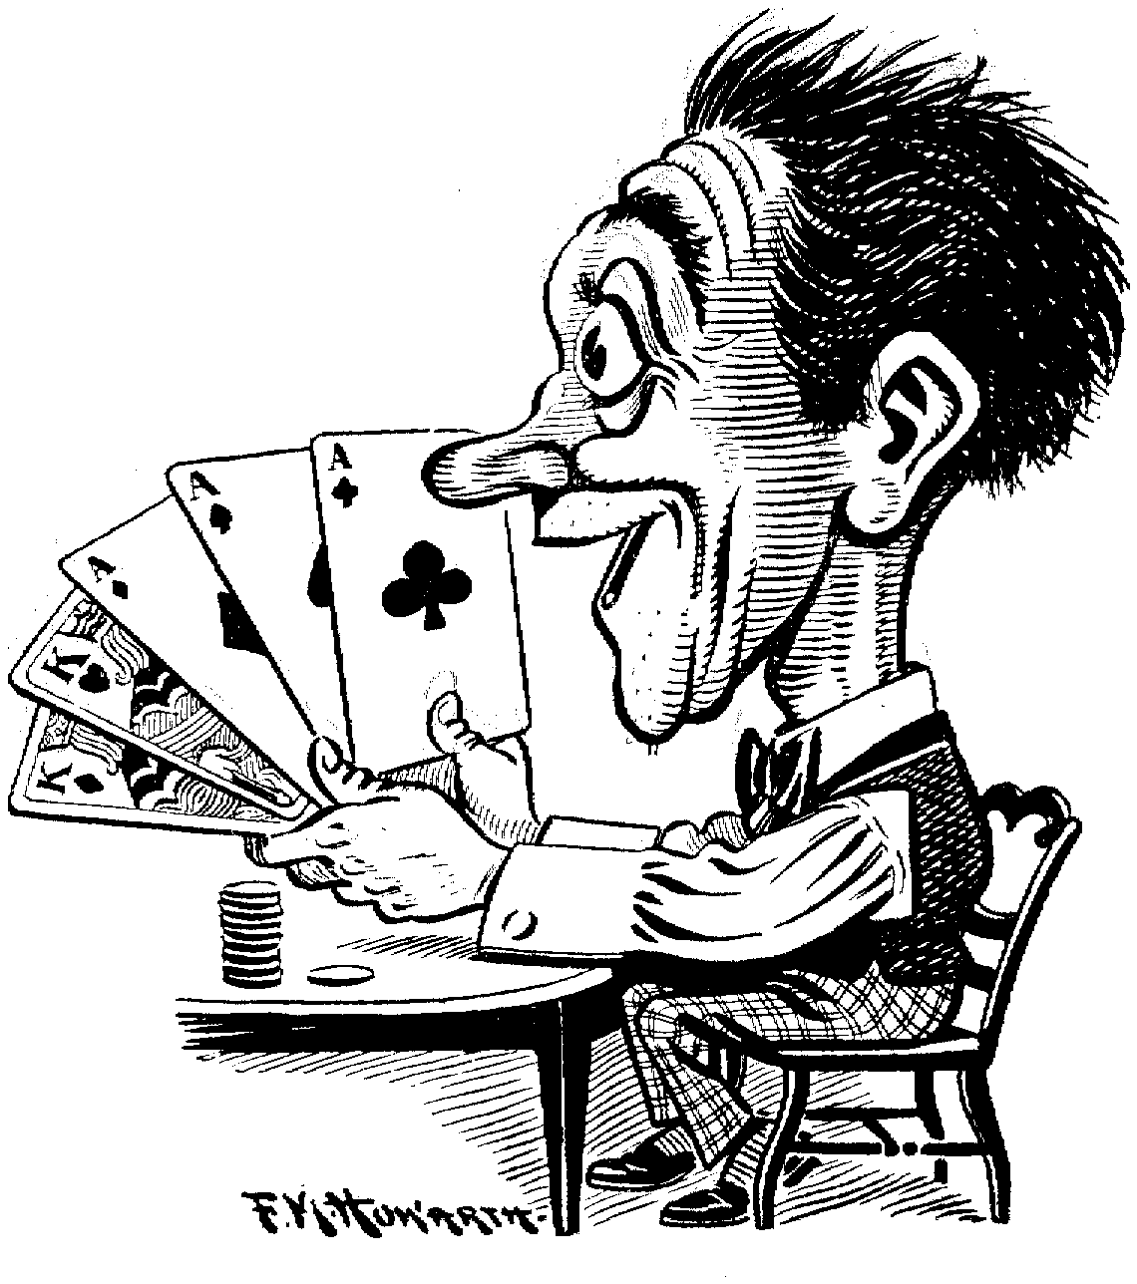

East = 14 West = 13
◻ 8  5 Q A
 9 10 J A  2 3 7
✦ 8 Q  4 7 J A
★ 2 3 6 9 J K  4 10 Q

South = 12
◻ 6 7 10 J K
 5 8 Q
✦ 3
★ 5 7 8 A

