Program Description 650W
(The predator and the Prey)

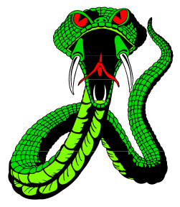
Program Description: You and your partner will write a program to show the paths of two simulated animals as they move across a field. One animal, the prey, tries to reach one or tow “burrow holes” (at the upper left and upper right corners of the screen). Each “turn” consists of two “moves”: one move by the predator and one move by the prey. The other animal, the predator, tries to catch the prey for dinner.

Each animal has some information available to it, and each has unique limitations. Within a certain distance, the animals can see each other and act accordingly. Otherwise, the predator still knows it it’s getting closer and the prey knows where the holes are. The predator can move further in a turn than can the prey.

The animals alternate moves; each move consists of 1) “recalling” where the animal was last, 2) choosing what to do and doing it, and 3) “remembering” where the animal is, for next time.

It is the job of the main program (the partners will write this together) to keep the positions of the two animals stored in variables. To let them “recall” where they were, the main program passes their positions to them as VAR paramethers. They “remember” where they move to by passing those modified var parameter values back to the main program for safe keeping. In this way, the main program acts as the animals’ “memory”.

Moves continue until 1) the predator catches the prey, 2) the prey escapes down one of the holes, or 3) the predator starves to death after 50 turns without food.

The initial predator-prey positions should be set by utilizing the random number generator. This generator should also determine who should move first.


If the distance between the animals is ever less than or equal to 30 then we want the animals to “see” each other. Otherwise the animals are simply aware of the amount of distance separating them.

Programmer #1 will write the predator procedure(s). You may turn once and move once in a single move. Your advantages are 1) you are faster than the prey, and 2) you know whether you’re getting closer or further away from the prey. Your disadvantages are that the prey may escape to two “safe” places, and that you have only 50 turns before you starve to death. You may move up to 15 pixels. And you may attack up to 20 pixels.

Programmer #2 will write the prey procedure(s). You may turn once and move once in a single move. Your disadvantages are 1) you are slower than the predator, and 2) you don’t know how close the predator is until you’re both in sight of each other. When the predator is in sight you may move 15 panicked pixels, otherwise, your maximum move is 10 pixels.

Required Statements: none-use what is necessary

Sample Output: be creative

