Program 82a
(Young A. J. Foyt)


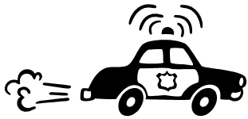
Program Description: Many cities levy traffic fines based on a flat rate and a per dollar charge for each mile over the speed limit the vehicle was traveling. Write a program that determines the fine based on the following: A charge of $20.00 for the ticket and $5.00 for each mile over the speed limit the vehicle was traveling. For example: if a driver was ticketed for driving 42 mph in a 30 mile zone the ticket would be $20.00 + (12 X $5.00) = $80.00. The program should prompt for the speed limit and the rate of speed for the vehicle.

The output for the stated input should appear as you see below. Make sure money has cents behind the decimal.

Statements Required: input, output

Sample Output:

Enter the speed limit: 30
Enter the vehicle speed: 42
Fine-----------------------$80.00

Enter the speed limit: 55
Enter the vehicle speed: 70
Fine-----------------------$95.00

