PROGRAM 1045t
(c++copoly)

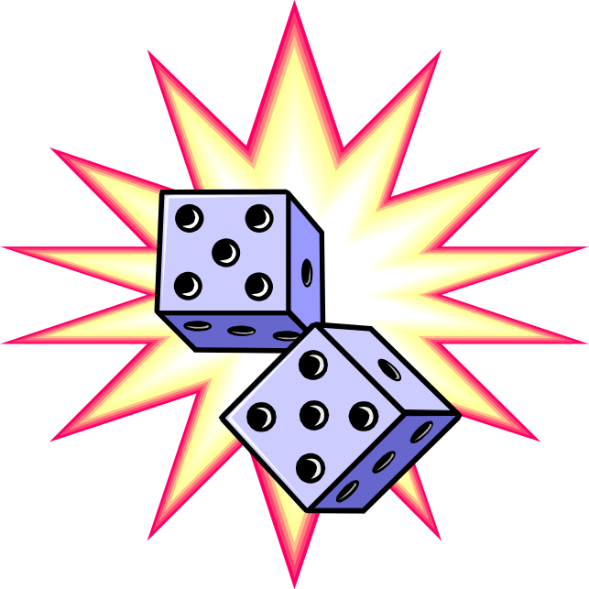Program Description: Write a program that simulates a simple version of a well know board game in which pieces circle a board collecting and paying money as the player "lands" on various properties.

The properties around the board may be named START, CAPSON CASTLE, POINTER PLACE, GRUMAN'S GARAGE, LANGNER'S LOFT, WEIGLE'S WAYSTATION , DENNIS' DELICATESEN, ETC.

You may implement your own rules for the game. Some suggestions are: Multiple players may participate. Each player starts with $500. Players may elect to move either clockwise or counter clockwise. Each time a player passes START in a clockwise move they collect $50. A counter clockwise move past start loses $50. If the piece lands on start the bonus is doubled. Every property on the board cost the player money except start and the LOFT.

This programs data structure should consist of circular linked lists to represent the players turn and the game board. Graphics will enhance the game's appeal

Statements Required: input, output, decision making, loop control, linked list

Exact copy:

Output will vary

