Program 155b
(Shrinking Dollars)

Statement of Problem: The rate of inflation is the annual percent increase in the cost of goods and services. For example, assume that an item costs $10.00 today and the rate of inflation is 10%. Then the cost of the item in one year is $10.00 + .10 x 10.00 or $11.00. In two years, the item will cost $11.00 + .10 x 11.00 or $12.10.

Write a program to find the cost of a $12.00 item in fifteen years if the rate of inflation is 2%, 3%, 4%, and so on up to 16% (one percent per year). That is, the program should give the cost after fifteen years at each inflation rate.

Also, determine the overall increase in the cost of the item. For example, if a $10.00 item costs $18.00 after 15 years, then the increase is 80%; if it costs $24.00, the increase is 140%. Compute the overall increase for the $12.00 item after fifteen years at each inflation rate.

There is no input for this program. Output should list the final results after fifteen years for each inflation rate.

Required Statements: Output, Loop control

Sample Output:
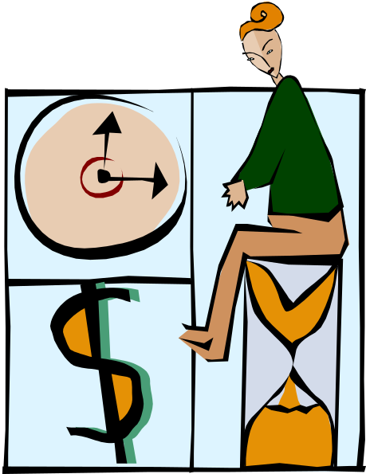
original cost = $12.00

year rate cost
1 2% 12.24
2 3% 12.61
3 4% 13.11
4 5% 13.77
5 6% 14.59
6 7% 15.61
7 8% 16.86
8 9% 18.38
9 10% 20.22
10 11% 22.44
11 12% 25.14
12 13% 28.40
13 14% 32.38
14 15% 37.24
15 16% 43.20
The item has increased in price by 226%

