Program 162a
(small factorials)

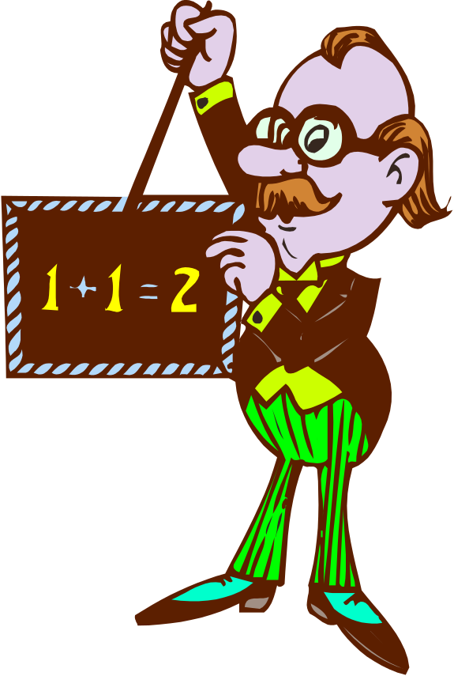
Program Description: Write a program that finds the factorial of a value entered by the user. To calculate 12! (12 factorial) for example the program should calculate the value of

1 x 2 x 3 x 4 x 5 x 6 x 7 x 8 x 9 x 10 x 11 x 12.

The program should continue processing numbers until the user inputs a zero. Be sure not to process the terminal value (zero).

Required Statements: input, output, loop control

Sample Output:
Enter a number 6
the value of 6! is 720
Enter a number 12
the value of 12! is 479001600
Enter a number 0

