Program 170a
(Growing Girl's Best Friends)


Program Description: Write a program to print out a diamond pattern of *'s centered on the screen. The user determines the diamond's size by inputing the width of the diamond. The program should continue to prompt the user for input until they enter an odd number.

Statements required: input, output, loop controls

Sample Output:

Enter diamond size 4
Enter diamond size 8
Enter diamond size 10
Enter diamond size 9
*
***

*****
*******
*********
*******
*****
***
*

Enter diamond size 3
*
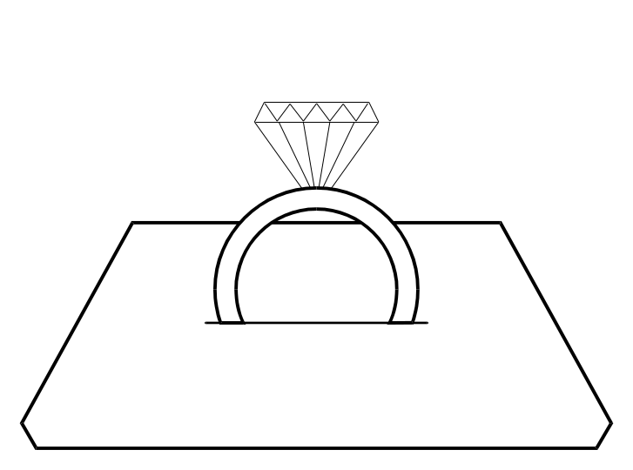
***
*
Enter diamond size 1
*

