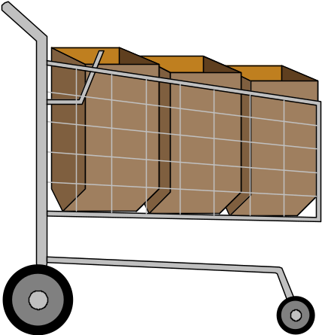Program 210a
(comparison shopping)

Program Description: Write a program that will calculate the unit price of any two items and determine the better buy. Write out the unit price of the better buy. Run an exact copy of that list below.

Use an input statements to enter the weight and cost in cents of each of the two items. Calculate the unit price of each. Then compare them and print out the better buy. Be sure to include an appropriate output statement for cases when the unit price is the same for both items.

Statements required: input, output, loop control, decision making

Sample output:

Enter the weight and cost of each item and the computer will tell you the best buy.

Number of ounces in item #1? 45
Cost of item #1 in cents? 345
Number of ounces in item #2? 78
Cost of item #2 in cents? 456

Item #2 is the better buy.
The unit cost is 5.8 cents/ounce
Do Again? y

Enter the weight and cost of each item and the computer will tell you the best buy.

Number of ounces in item #1? 78
Cost of item #1 in cents? 456
Number of ounces in item #2? 45
Cost of item #2 in cents? 345

Item #1 is the better buy.
The unit cost is 5.8 cents/ounce
Do Again? y

Enter the weight and cost of each item and the computer will tell you the best buy.

Number of ounces in item #1? 2
Cost of item #1 in cents? 67
Number of ounces in item #2? 2
Cost of item #2 in cents? 67

The unit cost of the two items is not significantly different
The unit cost is 33.5 cents/ounce
Do Again? n

