Program 210b
(math drill and practice)

Program Description: Write a program that will display an addition problem made of random 2-digit numbers. Ask the user to supply the correct answer to the problem. If the answer is correct output an appropriate response and the program should terminate. If it is not correct, print out “incorrect” and repeat the same problem again. Repeat this process until the correct answer is eventually supplied.

Statements required: input, output, loop control, decision making

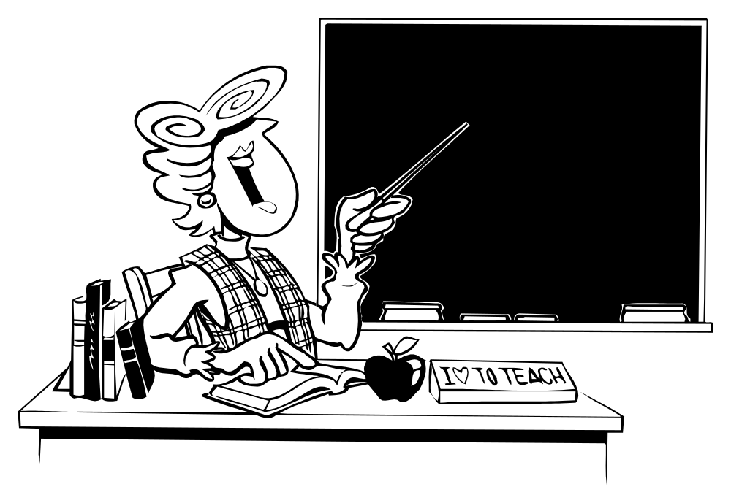

Sample output:

37 Plus 22 Equals? 59
Correct!

71 Plus 43 Equals? 124
Incorrect--Try Again
71 Plus 43 Equals? 104
Incorrect--Try Again
71 Plus 43 Equals? 114
Correct!

