Program 213f
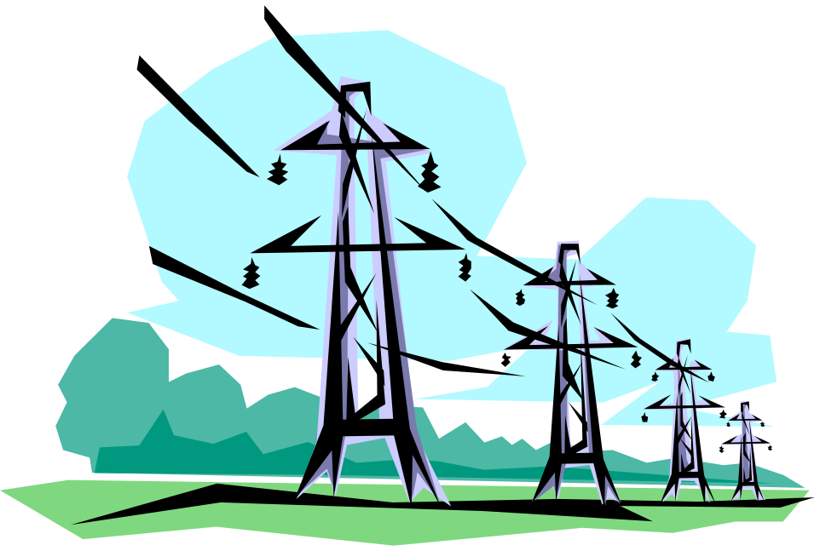(electric bills)

Program Description: Utility rates vary with the amount of energy used per month. One utility company sells electricity at a rate of 7 cents per kilowatt hour for the first 2000 hours, 5 cents/kwh for the next 8000 hours, and 4 cents for all kwh over 10000 hours.

Write a program that will compute electric bills for any amount of electricity used in a month.

The last value in your file will be the terminal value -999 and should not be processed.

Data Location: prog213f.dat

Required Statements: input, output, loop control, decision making

Sample output:

The cost of 1338 is $93.66

The cost of 9631 is $521.55

The cost of 13561 is $682.44

