Program 213g
(solving linear equations)

Program Description: Write a program that solves the following linear equations in the form Ax + B = 0.
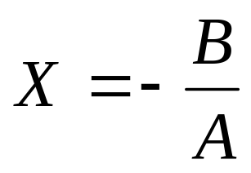
5x - 4 = 0
7x + 12 = 0
0x + 0 = 0
0x + 7 = 0
3.5x - 1.6 = 0
5x + 1.3 = 0

Read A and B from an external file. Be sure to account for all possible cases; that is:

- When A and B are both zero
- When A is non-zero
- When A is zero and B is non-zero

Data Location: prog213g.dat

Required Statements: input, output, loop control, decision making

Sample output:

5x -4 = 0-->x = 0.8
7x +12 = 0-->x = -1.71429
0x +0 = 0-->There are infinite solutions
0x +7 = 0-->There are no solutions
3.5x -1.6 = 0-->x = 0.457143
5x +1.3 = 0-->x = -0.26
5x +0 = 0-->There are infinite solutions

