Program 213u
(playing craps)

Program Description: Write a program to simulate in a random fashion the following version of the dice game "craps".

A player rolls two dice.

- If, on the first roll, the sum of the faces is 7 or 11, the player wins.

- If, on the first roll, the sum is 2 or 3, the player loses.

- If the sum is other than 2, 3, 7, or 11, the player continues to roll the dice until either

- The same sum appears again, in which case the player wins
- The sum of 7 appears, in which case the player loses.

The player continues to roll the dice until he wins or loses

Required Statements: output, loop control, decision making

Sample output: (your output will vary due to random numbers but include one sample of each condition)

Roll Dice 1 Dice 2
A 6 6
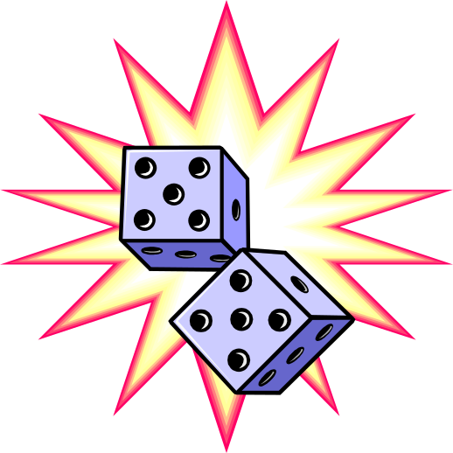Your point is 12
B 3 6
C 1 3
D 6 1 [You lost on roll 4]

Roll Dice 1 Dice 2
A 5 4
You point is 9
B 4 4
C 4 2
D 5 4 [You're a Winner]

Roll Dice 1 Dice 2
A 5 2 [You're a Winner]

Roll Dice 1 Dice 2
A 1 2 [You lost on roll 1]

